1.Using the figure blow, identify each relationship type and write all of the business rules ( for instance: a student can take many courses, a course can be taken by many students**).**

**Answer:**

|  |  |  |
| --- | --- | --- |
| **STUDENT TO SEAT** | **1:1** | * **On student must can only fill one seat** * **On seat must and only must be filled by one student** |
| **STUDENT TO COURSE** | **M:N** | * **One student can take one or many course** * **One course can be taken by at least one or many student** |
| **INSTRUCTOR TO COURSE** | **1:M** | * **One instructor must take teach one course, and can be more than one** * **One course must and only must be taught by one instructor** |
| **COURSE TO SECTION** | **M:N** | * **One course can has one or many sections** * **One section can be own by at least one or many course** |
| **SECTION TO PREOFESSOR** | **M:1** | * **One section must and must be taught by one professor** * **One professor must teach one section, can be more than one** |

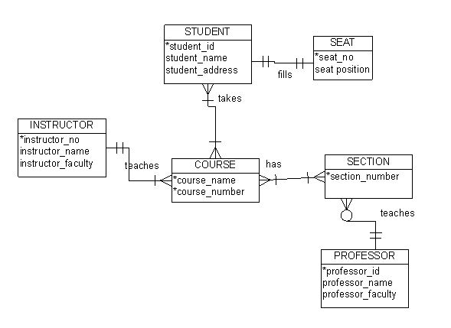

2. Convert the table below to 3NF

Table1

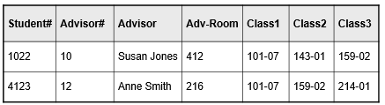

Answer:

|  |  |  |
| --- | --- | --- |
| Student# | StudentName | Advisor# |
| 1022 | xx | 10 |
| 4123 | xx | 12 |

|  |  |
| --- | --- |
| Class# | className |
| 101-07 | xx |
| 143-01 | xx |
| 159-02 | xx |
| 214-01 | xx |

|  |  |
| --- | --- |
| StudentName | className |
| 1022 | 101-07 |
| 1022 | 143-01 |
| 1022 | 159-02 |
| 4123 | 101-07 |
| 4123 | 159-02 |
| 4123 | 214-01 |

|  |  |  |
| --- | --- | --- |
| Advisor# | Advisor | Adv_Room |
| 10 | Susan Jones | 412 |
| 12 | Anne Smith | 216 |

Table 2

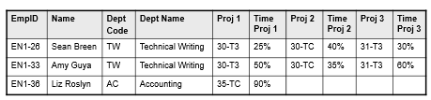

Answer :

|  |  |  |
| --- | --- | --- |
| EmpID | Name | Dept Code |
| EN1-26 | Sean Breen | TW |
| EN1-33 | Amy Guya | TW |
| EN1-36 | Liz Roslyn | AC |

|  |  |
| --- | --- |
| Dept Code | Dept Name |
| TW | Technical Writing |
| TW | Technical Writing |
| AC | Accounting |

|  |  |
| --- | --- |
| Project code | Project Name |
| 30-T3 | xx |
| 30-TC | xx |
| 35-TC | xx |
| 31-T3 | xx |

|  |  |  |
| --- | --- | --- |
| EmpID | Project code | Time in project |
| EN1-26 | 30-T3 | 25 |
| EN1-26 | 30-TC | 40 |
| EN1-26 | 31-T3 | 30 |
| EN1-33 | 30-T3 | 50 |
| EN1-33 | 30-TC | 35 |
| EN1-33 | 31-T3 | 60 |
| EN1-36 | 35-TC | 90 |

Table 3

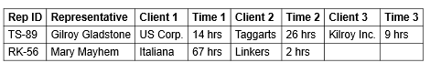

Business rule : one representative can be responsible for one or many clients, but one client can only be responsible by one representative

Answer:

|  |  |
| --- | --- |
| Rep ID | Representative |
| TS-89 | Gilroy Gladstone |
| RK-56 | Mary Mayhem |

|  |  |  |  |
| --- | --- | --- | --- |
| Client ID | Client Name | time | Rep ID |
| US Corp. | US Corp. | 14 | TS-89 |
| Taggarts | Taggarts | 26 | TS-89 |
| Kilroy Inc. | Kilroy Inc. | 9 | TS-89 |
| Italiana | Italiana | 67 | RK-56 |
| Linkers | Linkers | 2 | RK-56 |