Q1. What's the difference between do.call function and lapply function in R. When we try to use searchTwitter function to retrieve info from twitter, what format are the info retrieved as? Is this format open? What are the advantages and disadvantages of this format?

Answer:

1. do_call and lapply are both simpler ways in R to execute function even in functional language we can execute anonymous function directly. The difference is do.call is ‘execute a function call and give a list of parameters’, and lapply is to call function on each member of a list.
2. Object (a long string object), it is open as a plain text in UTF-8.
3. Advantages is retrieved very fast, it only has charset encoding, the disadvantage is that we need to deal with it manually, such as transfer it to a dataframe manually for further usage.

Q2. The data below represents blogs posts discussing and linking to a viral video. The data is in the format of source ⇒ link. For example, huffington.com ⇒ video would be interrupted as huffingtonpost.com linking directly to the video. myblog.com⇒ huffingtonpost.com would be interpreted as myblog.com posting a link to a huffingtonpost.com blog entry about the video

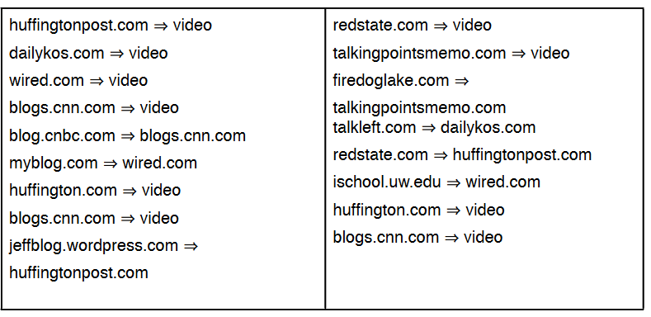

1. Convert the data into a adjacency matrix.

Answer:

|  |  |
| --- | --- |
| 1 | video |
| 2 | huffingtonpost |
| 3 | dailykos |
| 4 | weird |
| 5 | cnn |
| 6 | cnbc |
| 7 | myblog |
| 8 | huffington |
| 9 | jeffblog |
| 10 | redstate |
| 11 | talkingpointsmemo |
| 12 | firedoglake |
| 13 | talkleft |
| 14 | ischool |

|  |  |  |  |  |  |  |  |  |  |  |  |  |  |  |
| --- | --- | --- | --- | --- | --- | --- | --- | --- | --- | --- | --- | --- | --- | --- |
|  | 1 | 2 | 3 | 4 | 5 | 6 | 7 | 8 | 9 | 10 | 11 | 12 | 13 | 14 |
| 1 |  |  |  |  |  |  |  |  |  |  |  |  |  |  |
| 2 | 1 |  |  |  |  |  |  |  |  |  |  |  |  |  |
| 3 | 1 |  |  |  |  |  |  |  |  |  |  |  |  |  |
| 4 | 1 |  |  |  |  |  |  |  |  |  |  |  |  |  |
| 5 | 1 |  |  |  |  |  |  |  |  |  |  |  |  |  |
| 6 |  |  |  |  | 1 |  |  |  |  |  |  |  |  |  |
| 7 |  |  |  | 1 |  |  |  |  |  |  |  |  |  |  |
| 8 | 1 |  |  |  |  |  |  |  |  |  |  |  |  |  |
| 9 |  | 1 |  |  |  |  |  |  |  |  |  |  |  |  |
| 10 | 1 |  |  |  |  |  |  |  |  |  |  |  |  |  |
| 11 | 1 |  |  |  |  |  |  |  |  |  |  |  |  |  |
| 12 |  |  |  |  |  |  |  |  |  |  | 1 |  |  |  |
| 13 |  |  | 1 |  |  |  |  |  |  |  |  |  |  |  |
| 14 |  |  |  | 1 |  |  |  |  |  |  |  |  |  |  |

1. Plot the network graph.

Answer :

|  |  |
| --- | --- |
| Edge list | 2,1,3,1,4,1,5,1,6,5,7,4,8,1,9,2,10,1,11,1,12,11,13,3,14,4 |

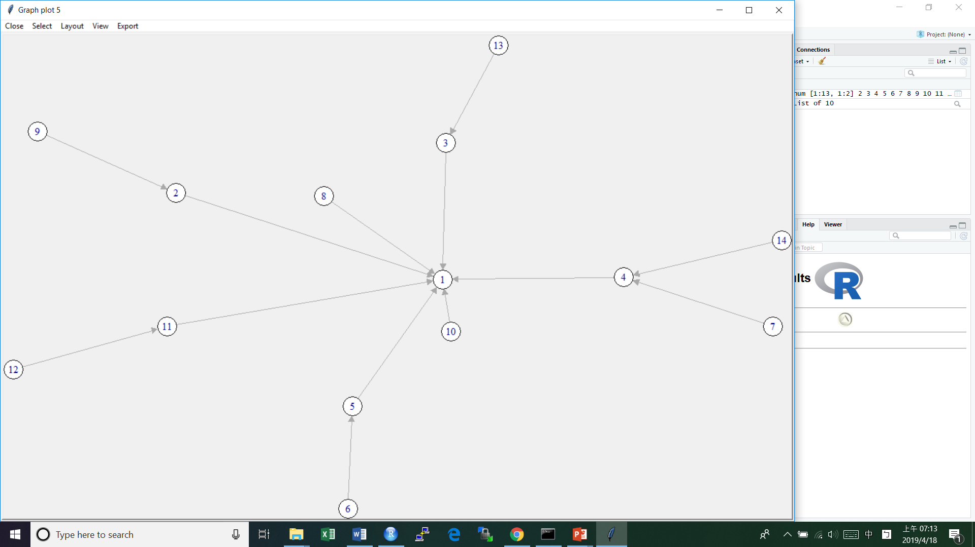

1. What are the number of possible connections?

Answer: 13

1. Calculate the degree centrality of huffingtonpost.com.

Answer :2 (1 is indegree, 1 is outdegree)