# Carla学习记录

## 基础知识

### Client

Carla是一个bs架构，服务端负责渲染，客户端负责获取服务端的渲染结果；因此显而易见，各类API的调用都会出现同步/异步问题；

host = '10.10.32.21'  
port=2000  
client = carla.Client(host,port)  
client.set_timeout(2.0)

### World

可以理解为所有渲染场景的容器，所有的actor的添加，销毁，获取入口

world = client.get_world()

### Settings

settings = world.get_settings()

获取整个世界的设置；

settings.synchronous_mode = True  
settings.fixed_delta_seconds = 0.05

world.apply_settings(settings)

### traffic_manager（可以声明多个）

<https://blog.csdn.net/qq_39537898/article/details/117562578>

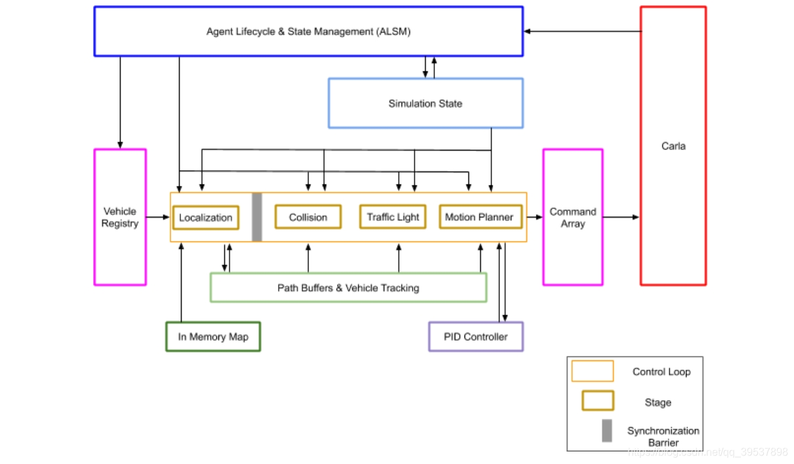

所有交通对象的管理类，车辆，行人都由此获取

traffic_manager = client.get_trafficmanager(8000)

traffic_manager.set_synchronous_mode(True) 设置为同步模式，并且world的设置也要设置为同步，否则碰撞计算就会全部错误；

traffic_manager.set_global_distance_to_leading_vehicle(2.5) 设置与前车的距离

注册：****Vehicle Registry****

计算：****Localization Stage，**** ****Collision Stage.Traffic Light Stage.Motion Planner.****

### 获取相应的蓝图类

bps = world.get_blueprint_library().filter(filter)

获取类之后，即可用已存在的类进行实例的创建

已知的filter：

VEHICLE='vehicle.*'  
WALKER="walker.pedestrian.*"

### 获取可放置车辆的点位（带transform）

spawn_points = world.get_map().get_spawn_points()

### SpawnActor

第一个参数为对象类型，第二个参数为放置的位置

初始化一个蓝图类SpawnActor(blueprint, transform)

### 初始化设置车辆

设置车辆的颜色，id，是否为hero，添加自动模式

blueprint = random.choice(blueprints)  
if blueprint.has_attribute('color'):  
 color = random.choice(blueprint.get_attribute('color').recommended_values)  
 blueprint.set_attribute('color', color)  
if blueprint.has_attribute('driver_id'):  
 driver_id = random.choice(blueprint.get_attribute('driver_id').recommended_values)  
 blueprint.set_attribute('driver_id', driver_id)  
if hero:  
 #如果是hero代表为主控，否则为自动驾驶的车辆  
 blueprint.set_attribute('role_name', 'hero')  
 hero = False  
else:  
 blueprint.set_attribute('role_name', 'autopilot')  
 # spawn the cars and set their autopilot and light state all together  
item = SpawnActor(blueprint, transform)  
 .then(SetAutopilot(FutureActor, True, traffic_manager.get_port()))  
batch.append(item )

SetAutopilot

设置自动驾驶模式；以spawnActor的模式实例化，其中第一个参数为蓝图类，第二个参数为transform；

### 开启/关闭车辆的自动驾驶

SetAutopilot(FutureActor, True, traffic_manager.get_port())

### 批量添加车辆至场景中（同步）

for response in client.apply_batch_sync(batch, synchronous_master):  
 if response.error:  
 logging.error(response.error)  
 else:  
 vehicles_list.append(response.actor_id)

### 添加自行走行人（必须和aiworker关联使用）

walker绑定了一个父级；

SpawnActor(walker_controller_bp, carla.Transform(), walkers_list[i]["id"]

因此实现的逻辑为：

首先获取出walker中的行人类：

然后循环实例化，使用声明式transform设置其几何变换，地图随机选取点；

批量添加；

然后创建同样数量的aiwalker类，父级设定为人

再批量添加；

最后启动ai walker的行走即可；

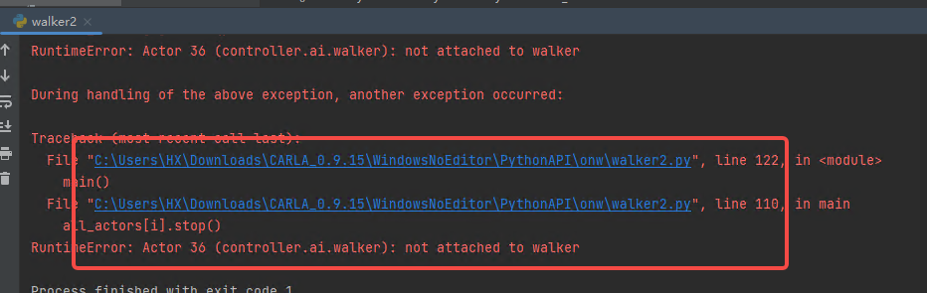

### Weather

### Camera

获取相机蓝图类；

设置相机成像的宽高，设置fov，设置transform

camera_bp = world.get_blueprint_library().find('sensor.camera.rgb')  
camera_bp.set_attribute("image_size_x", str(args.width))  
camera_bp.set_attribute("image_size_y", str(args.height))  
camera_bp.set_attribute("fov", str(args.fov))  
camera = world.spawn_actor(camera_bp, carla.Transform())

其后，如添加自走行人的逻辑一直；添加进入场景

world.set_pedestrians_seed(1235)  
ped_bp = random.choice(world.get_blueprint_library().filter("walker.pedestrian.*"))  
trans = carla.Transform()  
trans.location = world.get_random_location_from_navigation()  
ped = world.spawn_actor(ped_bp, trans)  
walker_controller_bp = world.get_blueprint_library().find('controller.ai.walker')  
controller = world.spawn_actor(walker_controller_bp, carla.Transform(), ped)  
controller.start()  
controller.go_to_location(world.get_random_location_from_navigation())  
controller.set_max_speed(1.7)  
  
# keep tracking of actors to remove  
actor_list.append(camera)  
actor_list.append(ped)  
actor_list.append(controller)

### 传感器观察类（用于场景返回数据）

获取传感器数据，实际上就是sensor_queue.get；

def _retrieve_data(self, sensor_queue, timeout):  
 while True:  
 data = sensor_queue.get(timeout=timeout)  
 if data.frame == self.frame:  
 return data  
# ---------------

Sensor_queue是一个每帧渲染返回的数据

def make_queue(register_event):  
 q = queue.Queue()  
 register_event(q.put)  
 self._queues.append(q)  
  
make_queue(self.world.on_tick)

### 相机跟随actor

# move camera around  
trans = ped.get_transform()  
x = math.cos(turning) * -3  
y = math.sin(turning) * 3  
trans.location.x += x  
trans.location.y += y  
trans.location.z = 2  
trans.rotation.pitch = -16  
trans.rotation.roll = 0  
trans.rotation.yaw = -360 * (turning/(math.pi*2))  
camera.set_transform(tran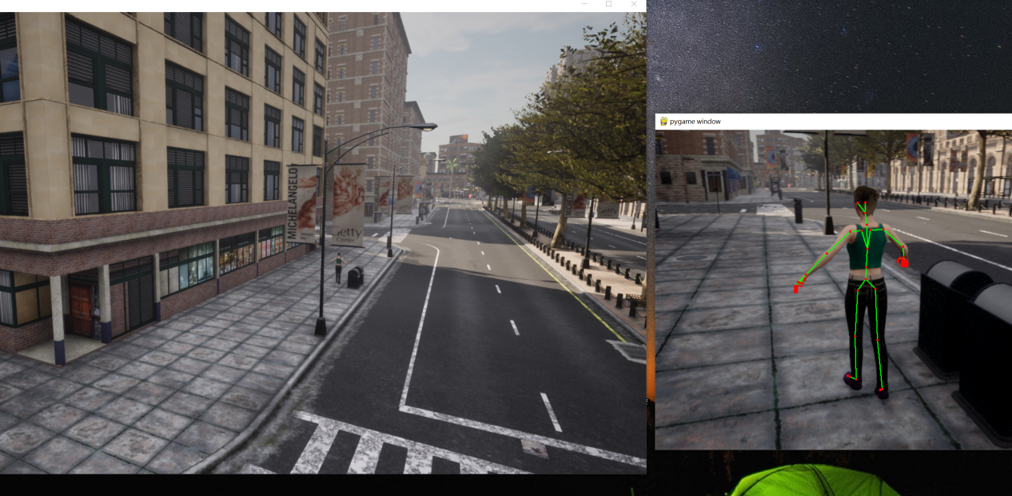s)

图像数据转array

def get_image_as_array(image):  
 array = np.frombuffer(image.raw_data, dtype=np.dtype("uint8"))  
 array = np.reshape(array, (image.height, image.width, 4))  
 array = array[:, :, :3]  
 array = array[:, :, ::-1]  
 # make the array writeable doing a deep copy  
 array2 = copy.deepcopy(array)  
 return array2

### 世界坐标转屏幕坐标

投影矩阵

def build_projection_matrix(w, h, fov):  
 focal = w / (2.0 * np.tan(fov * np.pi / 360.0))  
 K = np.identity(3)  
 K[0, 0] = K[1, 1] = focal  
 K[0, 2] = w / 2.0  
 K[1, 2] = h / 2.0  
 return K

get_screen_points(camera, K, image_w, image_h, points)

def get_screen_points(camera, K, image_w, image_h, points3d):  
   
 # get 4x4 matrix to transform points from world to camera coordinates  
 world_2_camera = np.array(camera.get_transform().get_inverse_matrix())  
  
 # build the points array in numpy format as (x, y, z, 1) to be operable with a 4x4 matrix  
 points_temp = []  
 for p in points3d:  
 points_temp += [p.x, p.y, p.z, 1]  
 points = np.array(points_temp).reshape(-1, 4).T  
   
 # convert world points to camera space  
 points_camera = np.dot(world_2_camera, points)  
   
 # New we must change from UE4's coordinate system to an "standard"  
 # (x, y ,z) -> (y, -z, x)  
 # and we remove the fourth component also  
 points = np.array([  
 points_camera[1],  
 points_camera[2] * -1,  
 points_camera[0]])  
   
 # Finally we can use our K matrix to do the actual 3D -> 2D.  
 points_2d = np.dot(K, points)  
  
 # normalize the values and transpose  
 points_2d = np.array([  
 points_2d[0, :] / points_2d[2, :],  
 points_2d[1, :] / points_2d[2, :],  
 points_2d[2, :]]).T  
  
 return points_2d

### 初始化Transform方式

camera_transform = carla.Transform(carla.Location(x=-5.5, z=2.8), carla.Rotation(pitch=-15))

### 添加lidar传感器

lidar_bp = bp_lib.filter("sensor.lidar.ray_cast")[0]

if args.no_noise:  
 lidar_bp.set_attribute('dropoff_general_rate', '0.0')  
 lidar_bp.set_attribute('dropoff_intensity_limit', '1.0')  
 lidar_bp.set_attribute('dropoff_zero_intensity', '0.0')

#lidar的fov上顶30  
lidar_bp.set_attribute('upper_fov', str(args.upper_fov))

#lidar的fov下限-25  
lidar_bp.set_attribute('lower_fov', str(args.lower_fov))

#lidar线束  
lidar_bp.set_attribute('channels', str(args.channels))  
lidar_bp.set_attribute('range', str(args.range))

#每秒发射的点云数量，10万个  
lidar_bp.set_attribute('points_per_second', str(args.points_per_second))

## 进阶

### Lidar_to_camera

初始化camera，vehicle，lidar

获取图像的输出

im_array = np.copy(np.frombuffer(image_data.raw_data, dtype=np.dtype("uint8")))  
im_array = np.reshape(im_array, (image_data.height, image_data.width, 4))  
im_array = im_array[:, :, :3][:, :, ::-1]

获取lidar的输出

p_cloud_size = len(lidar_data)  
p_cloud = np.copy(np.frombuffer(lidar_data.raw_data, dtype=np.dtype('f4')))  
p_cloud = np.reshape(p_cloud, (p_cloud_size, 4))

intensity = np.array(p_cloud[:, 3])  
  
# Point cloud in lidar sensor space array of shape (3, p_cloud_size).  
local_lidar_points = np.array(p_cloud[:, :3]).T

# Add an extra 1.0 at the end of each 3d point so it becomes of  
# shape (4, p_cloud_size) and it can be multiplied by a (4, 4) matrix.  
local_lidar_points = np.r_[  
 local_lidar_points, [np.ones(local_lidar_points.shape[1])]]  
  
# This (4, 4) matrix transforms the points from lidar space to world space.  
lidar_2_world = lidar.get_transform().get_matrix()

Lidar的局部坐标转换为世界坐标

world_points = np.dot(lidar_2_world, local_lidar_points)

将lidar的世界坐标转换到图像坐标

world_2_camera = np.array(camera.get_transform().get_inverse_matrix())  
  
# Transform the points from world space to camera space.  
sensor_points = np.dot(world_2_camera, world_points)

### 物理引擎

physics_vehicle = vehicle.get_physics_control()

### 传感器安装

#### 初始化车辆

bp = world.get_blueprint_library().filter('charger_2020')[0]  
vehicle = world.spawn_actor(bp, random.choice(world.get_map().get_spawn_points()))  
vehicle_list.append(vehicle)  
vehicle.set_autopilot(True)

#### DisPlayManager()

self.display = pygame.display.set_mode(window_size, pygame.HWSURFACE | pygame.DOUBLEBUF)

#### SensorManager

传感器类

传入world，dm，传感器的类型，放置的位置，看起来仿真中所有的传感器都可以放置到同一个位置，就不存在各个坐标系转换的问题，但是观察到的内容是如何变化的呢？

SensorManager(world, display_manager, 'RGBCamera', carla.Transform(carla.Location(x=0, z=2.4), carla.Rotation(yaw=-90)),   
 vehicle, {}, display_pos=[0, 0])

#### Init初始化构造，事件监听，并键入到displaymanager中；

实现render函数；

def render(self):  
 if self.surface is not None:  
 offset = self.display_man.get_display_offset(self.display_pos)  
 self.display_man.display.blit(self.surface, offset)

sufface是将渲染出来的结果处理为pygame可渲染的对象

def save_rgb_image(self, image):  
 t_start = self.timer.time()  
  
 image.convert(carla.ColorConverter.Raw)  
 array = np.frombuffer(image.raw_data, dtype=np.dtype("uint8"))  
 array = np.reshape(array, (image.height, image.width, 4))  
 array = array[:, :, :3]  
 array = array[:, :, ::-1]  
  
 if self.display_man.render_enabled():  
 self.surface = pygame.surfarray.make_surface(array.swapaxes(0, 1))

其他函数，如save image，lidar，semantilidar_image,lidar_image

### Gbuffer（当前报错-后续查看）

### 根据id获取蓝图中的实体类对象

vehicles_list = world.get_actors().filter('vehicle.*')

### 跟随actor漫游模式

spectator = world.get_spectator()

transform = vehicle.get_transform()

spectator.set_transform(carla.Transform(transform.location + carla.Location(z=50),

carla.Rotation(yaw=int(transform.rotation.yaw), roll=0, pitch=-90)))

### 绘制几何体

debugHelper =world.debug

debugHelper.draw_line(carla.Location(0,0,0),carla.Location(100,100,0))

可以draw arrow point,box等