2048 Report

UML class diagram

|  |
| --- |
| Widget |
| -ui: Ui::Widget pointer  -box[16]: QLabel pointer  -bc[16]: QString  -obstacle[5]: QString  -score: int  -count: int  -countdown: int  -judge[16]: Qstring  -fromleft[4][4]: int  -fromright[4][4]: int  -fromup[4][4]: int  -fromdown[4][4]: int |
| <<constructor>>+Widget(parent: QWidget pointer)  <<destructor>>+*Widget*()  +*keyPressEvent*(event: QKeyEvent pointer)  +appear()  +eachfromleft()  +left()  +eachfromright()  +right()  +eachfromup()  +up()  +eachfromdown()  +down()  +check()  +changecolor()  +pause( )  - on_pushButton_clicked()  - on_pushButton_2_clicked() |

Screen shot

Start

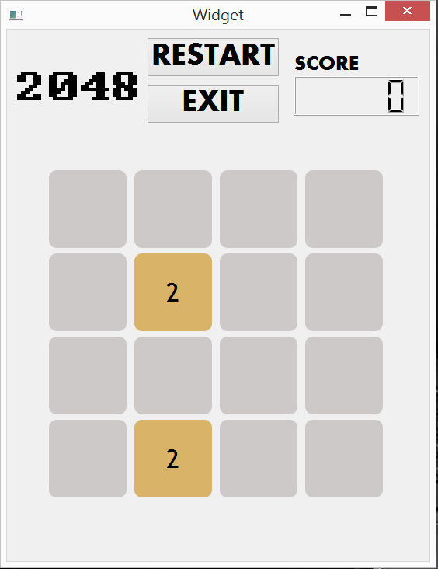

GameOver

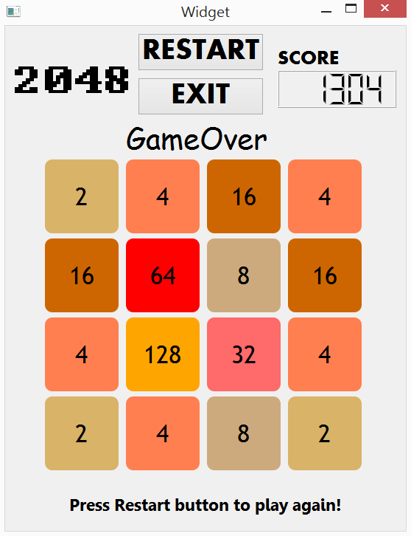

Win

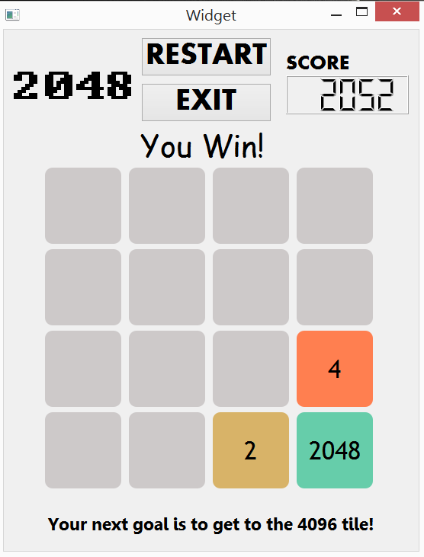

Bonus

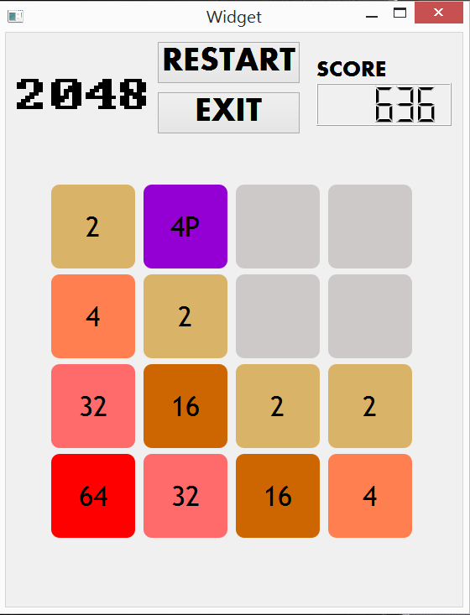

Bonus

我做的bonus是障礙物

當移動的次數達到一定的數量後，會開始出現障礙物

障礙物的設定是五回合，當出現障礙物後再繼續移動五次，障礙物就會消失

障礙物出現的機率為1/20 (與方格2和方格4)

可以更改障礙物出現的機率以即使障礙物消失所需的回合數