Report

蔡婷安 F74032073

UML class diagram

|  |
| --- |
| widget |
| -ui: Ui::Widget pointer  -gamewindow:game pointer  -resultwindow:result pointer |
| <<constructor>>+Widget(parent: QMainWindow pointer)  <<destructor>>+*Widget*()  +on_startgame_clicked() |

|  |
| --- |
| candy |
| +type:int  +R:const int  +C:const int  +button:QPushButton pointer |
| <<constructor>>+candyt(parent: QWidget pointer, color:int, row:int, col:int)  <<destructor>>+*candy*()  +on_startgame_clicked()  +setboard(t:int)  +button_clicked()  +send(r:int, c:int) |

|  |
| --- |
| game |
| -ui: Ui::game pointer  -count:int  -tmp:int  -tmpr:int  -tmpc:int  -sty[10][8][2]:int  -tag[10][8][2]:int  -num:int  -movenum:int  -score:int  -star:int  +c[10][8]:candy pointer |
| <<constructor>>+game(parent: QMainWindow pointer, r:result pointer)  <<destructor>>+*game*()  +checkstart()  +givecandy()  +setstart()  +setboard()  +judge()  +resettagsty()  +eliminate()  +checktag()  +removecandy()  +movedown()  +move()  +all()  +special(row:int, col:int, a:int)  +ball(row:int, col:int)  +bomb(row:int, col:int)  +vertical(row:int, col:int)  +horizontal(row:int, col:int)  +gain(row:int, col:int)  +on_restart_clicked()  +quit(star:int,score:int) |

*其餘的class創建了但沒有寫內容

Screen shot

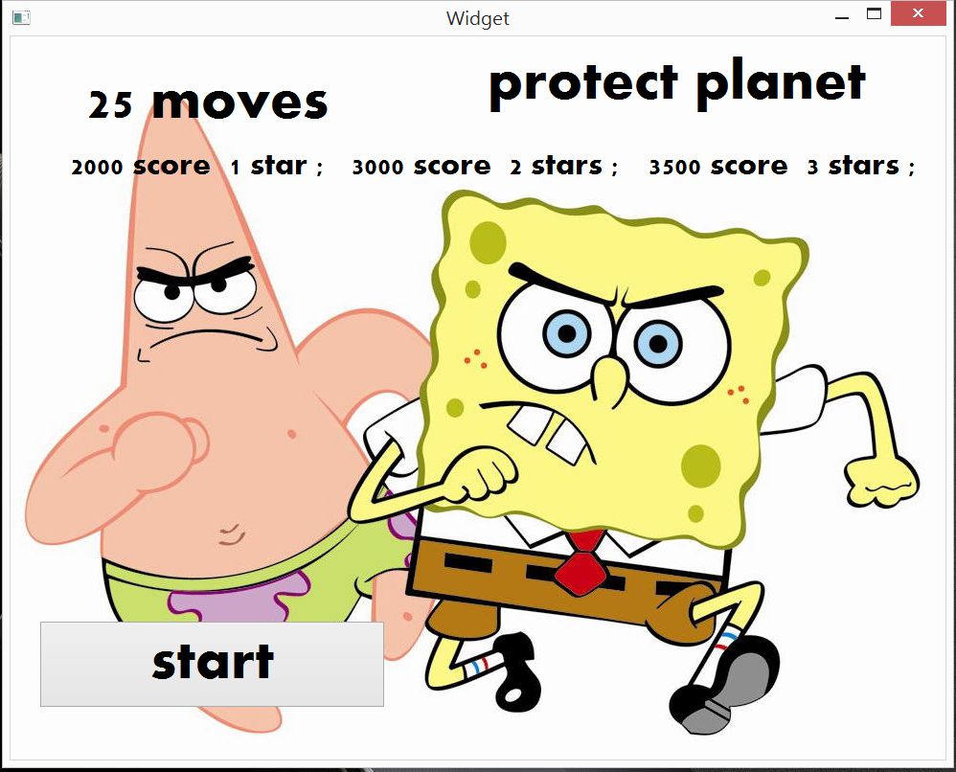start

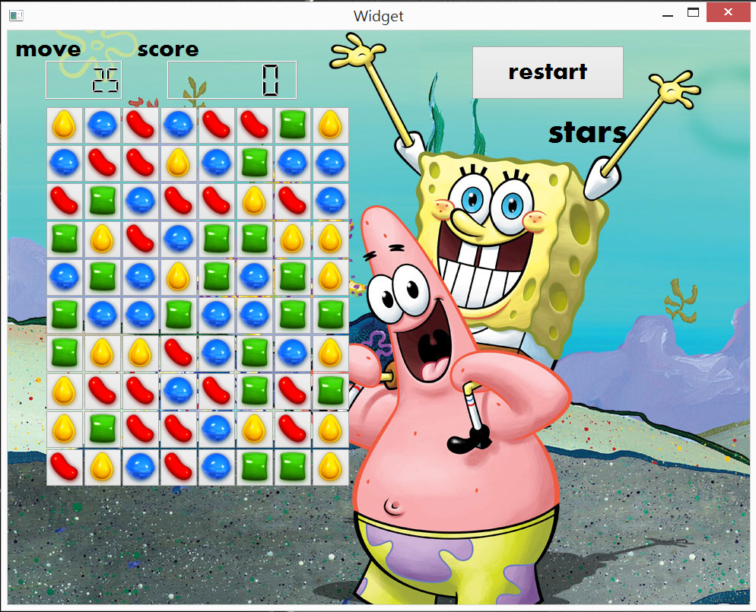game

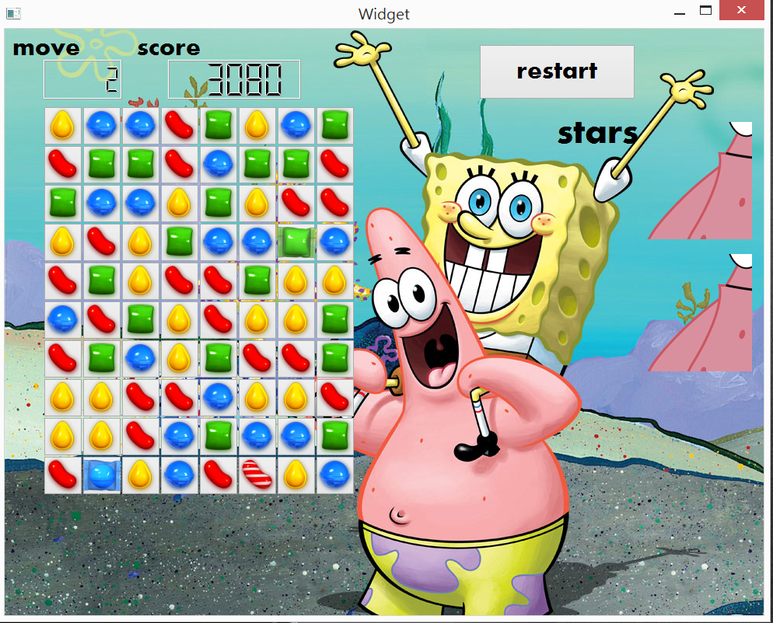2stars

星星是旁邊的派大星

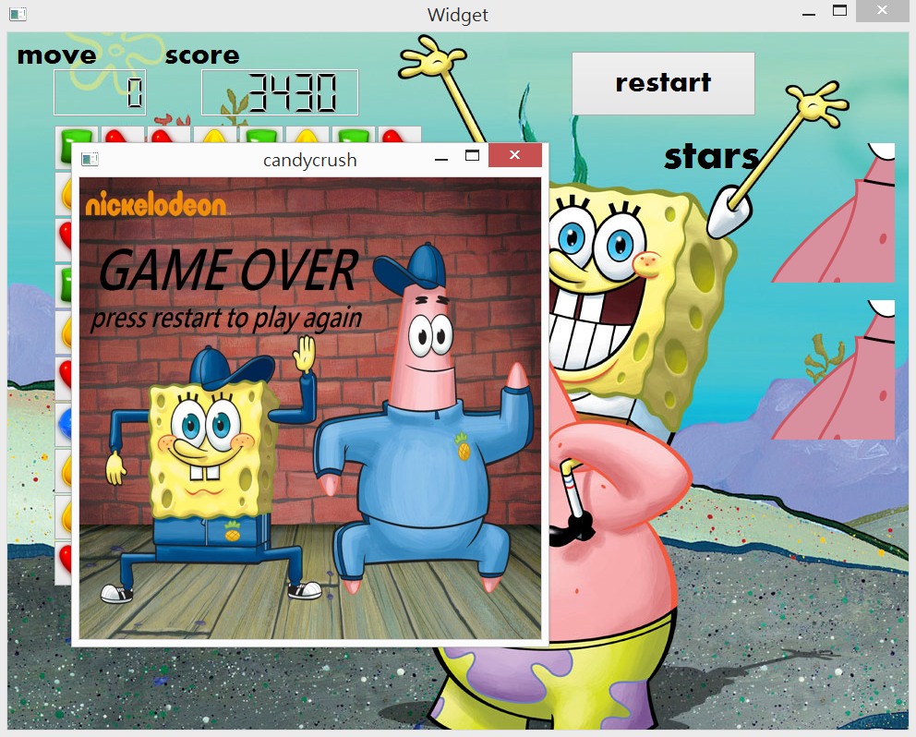gameover