Activity

EX 1:

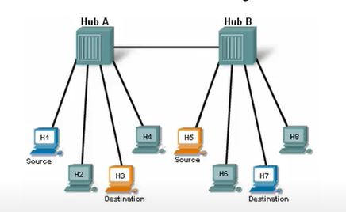

If Host3 sends message to Host6, which host devices will receive the message?

* Host6 only.
* All hosts connected to HubA only.
* All hosts connected to HubB only.
* All hosts on the network

EX 2:



In this network, how many collision domains exisy?

* There is 1 collison domain.
* There are 2 collison domains.
* There are 8 collison domains.
* There are no collison domains.

EX 3:



What occurs if Host3 and Host4 send a message across HubA at the same time?

* The two frames will collide and the hub will forward garbled message to all hosts on the network.
* The two frames will collide and the hub will forward garbled message to the source and intended destination hosts only.
* The two frames will be forwarded to the correct destination device without a collision a collision occurring.
* Two hosts cannot send information across the hub at the same time because the hosts must wait for a “request for data” frame from the hub.

EX 4:



Who receives the garbled message when a collision occurs on a hub network?

* Only the destination PC.
* All PCs connected to the hub where the collision occurred.
* All Pcs connected to every hub on the network.
* A hub will not forward a garbled message from a collision.
* A collision will never occur on a hub network.

EX 5:

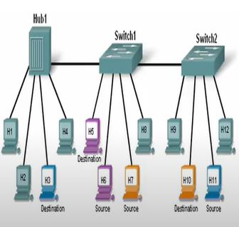

In Host9 sends a message to Host6, and the destination MAC address is in the MAC table for both switch1 and switch2, whitch host devices will receive the message?

* Only Host6
* All hosts connected to Switch1
* All hosts connected to Hub1 and hosts connected to Switch1
* All hosts on the network

#MAC table ->Full

EX 6:



In this network, how many collisions exist?

* There is 1 collision domain.
* There are 2 collision domains.
* There are 3 collision domains.
* There are 10 collision domains.
* There are 12 collision domains.

#Switch1連接Switch2之間也算一個碰撞區域

EX 7:



If Host8 sends message to Host1, and the destination MAC address is in the switch MAC table,which host devices will receive the message?

* Only Host1
* All hosts connected to Hub1
* All hosts connected to Switch1
* All hosts connected to Hub1 and hosts connected to Switch1
* All hosts on the network

#MAC table -> Full

EX 8:

Which of the following are true regarding bridges and switches? (Choose two.)

1. Bridges are faster than switches because they have fewer ports.
2. A switch is a multiport bridge.
3. Bridges and switches learn MAC addresses by examining the source MAC address of each frame received.
4. A bridge will forward a broadcast but a switch will not.
5. Bridges and switches increase the size of a collision domain

#bridges是最早的switches硬體，switches都有繼承bridges的特性，他們是一樣的。

EX 9:

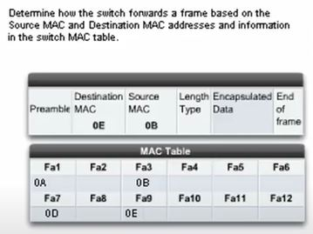

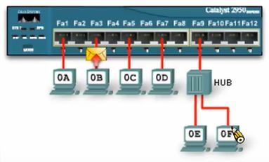

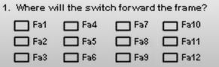

Ans:Fa9

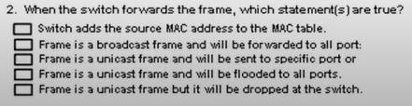

Ans:3