CookBook: Your Virtual Kitchen Assistant

______________

1. Introduction

Team Members:

• VISHWA D K (Team Leader)

• SOUNDAR RAJAN S (Team Member)

• SURAJ PARVESH A (Team Member)

• SOUNDARARAJ C P (Team Member)

______________

2. Project Overview

Purpose:

CookBook is a web-based application that acts as a virtual kitchen assistant, helping users discover, save, and manage recipes. It provides personalized cooking suggestions, step-by-step instructions, ingredient tracking, and the ability to create custom meal plans based on dietary preferences and available ingredients.

Key Features:

• 🍽️ Recipe discovery from multiple cuisines and categories

• 📋 Step-by-step cooking instructions with timers

• 🛒 Smart ingredient list with pantry tracking

• 🧑🎨 Personalized meal recommendations based on user preferences

• 📆 Meal planning calendar and recipe scheduling

• 🔍 Search and filter recipes by cuisine, ingredients, or cooking time

• 🌐 Responsive UI for both mobile and desktop

______________

3. Architecture

Component Structure

Component Description

App.js Entry point managing layout and routing

Header.js Navigation bar (Home, Recipes, Planner, Profile)

RecipeList.js Displays list of recipes with search and filters

RecipeCard.js Displays individual recipe summary

RecipeDetails.js Full recipe view with steps, images, and instructions

SearchBar.js Allows keyword-based and ingredient-based searching

MealPlanner.js Interactive calendar to schedule meals

Pantry.js Tracks available ingredients and shopping needs

UserProfile.js Manages saved recipes, preferences, and history

State Management

Uses React Context API for global state management, including user preferences, recipe data, and meal planning. Data is shared across components using custom context providers.

Routing (React Router v6)

Route Description

/ Home page with featured recipes

/recipes Browse and search all recipes

/recipe/:id Detailed view of a selected recipe

/planner Meal planning and calendar integration

/pantry Manage pantry ingredients

/profile User profile and saved recipes

______________

4. Setup Instructions

Prerequisites

• Node.js v18 or above

• npm v9 or above

Installation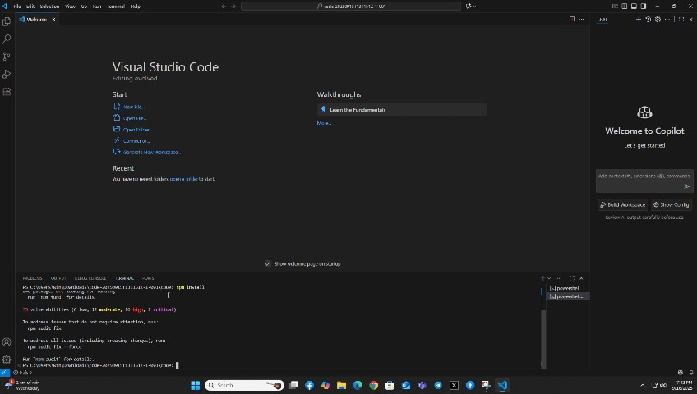

# Clone the repository

git clone https://github.com/palanisamynavitha450-tech/CookBook.git

# Navigate to the client directory

cd cookbook/client

# Install dependencies

npm install

# Create a .env file with necessary API keys

REACT_APP_RECIPE_API_KEY=your_api_key_here

# Start the development server

npm start

The app will run locally at:

➡️ http://localhost:3000/

______________

5. Folder Structure

client/

├── public/

├── src/

│ ├── components/

│ │ ├── Header.js

│ │ ├── RecipeList.js

│ │ ├── RecipeCard.js

│ │ ├── RecipeDetails.js

│ │ ├── SearchBar.js

│ │ ├── MealPlanner.js

│ │ ├── Pantry.js

│ │ └── UserProfile.js

│ ├── context/

│ │ └── AppContext.js

│ ├── pages/

│ │ ├── Home.js

│ │ ├── Recipes.js

│ │ ├── Planner.js

│ │ ├── PantryPage.js

│ │ └── Profile.js

│ ├── utils/

│ │ └── api.js

│ ├── App.js

│ ├── index.js

├── .env

├── package.json

└── README.md

Utilities:

• api.js – Handles requests to the recipe API provider (e.g., Spoonacular, Edamam)

• Custom Hooks:

o useFetchRecipes – Fetch and manage recipe data

o useMealPlanner – Manage calendar and meals

o usePantry – Track ingredients and inventory

______________

6. Running the Application

From the client/ directory, run:

npm start

Your application will be live at:

📍 <http://localhost:3000/>

