# 1.编辑虚拟机设置

# 2.网络适配器-nat模式-确定

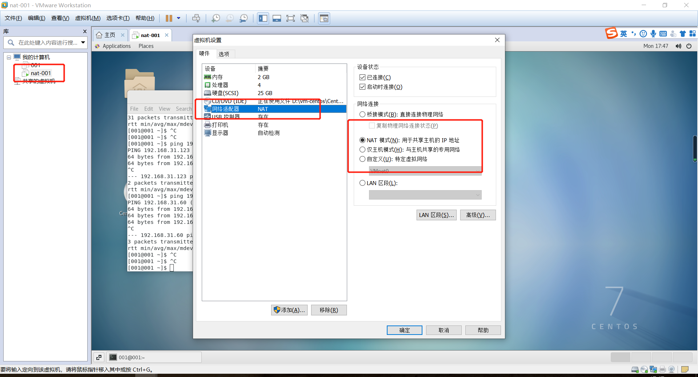

# 3.获取nat区域网网关

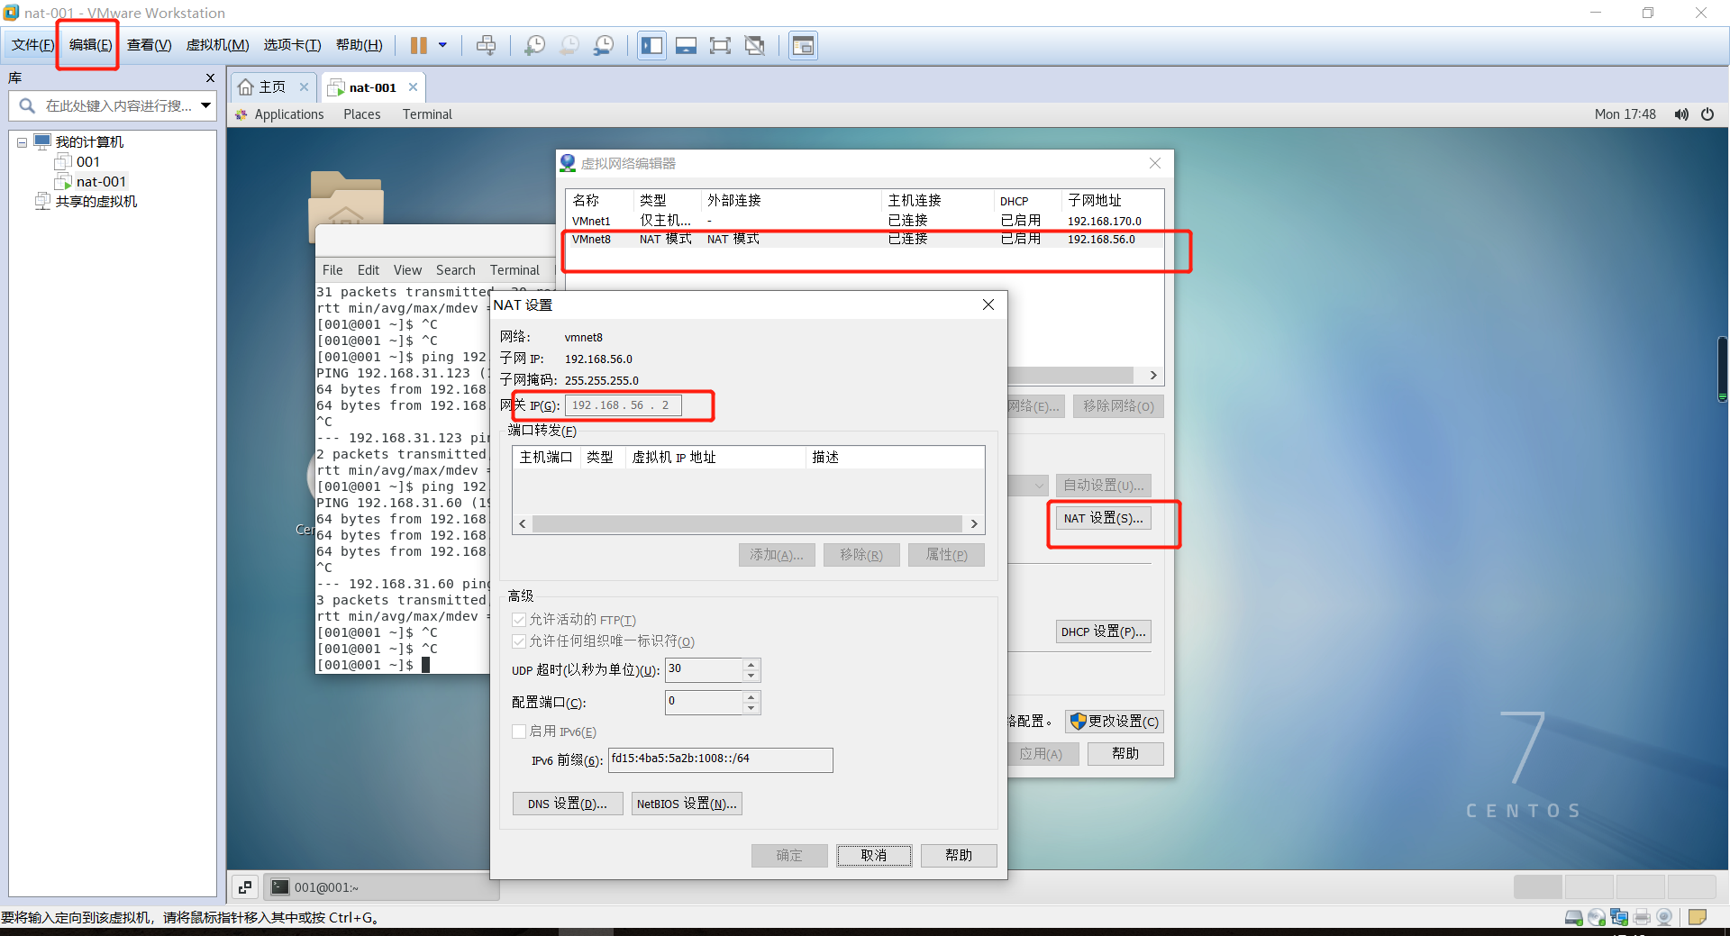

# 4.【虚拟机】编辑虚拟机网卡设置

## vim /etc/sysconfig/network-scripts/ifcfg-ens33

TYPE="Ethernet"  
PROXY_METHOD="none"  
BROWSER_ONLY="no"  
BOOTPROTO="static"  
DEFROUTE="yes"  
IPV4_FAILURE_FATAL="no"  
IPV4INIT="yes"  
IPV6_AUTOCONF="yes"  
IPV6_DEFROUTE="yes"  
IPV6_FAILURE_FATAL="no"  
IPV6_ADDR_GEN_MODE="stable-privacy"  
NAME="ens33"  
UUID="e61213fe-faea-4e8e-8da7-d7b458eca08d"  
DEVICE="ens33"  
ONBOOT="yes"

IPADDR=192.168.56.110

NETMASK=255.255.255.0

GATEWAY=192.168.56.2

DNS1=192.168.56.2

## 重启网卡：service network restart

## 命令：测试虚拟机访问外网 ping [www.baidu.com](http://www.baidu.com)

## Xshell测试：测试主机访问虚拟机连接

# 5.以上此种方式，无法访问外网

## 1.vi /etc/default/grub

在GRUB_CMDLINE_LINUX原有的参数后面加上"net.ifnames=0 biosdevname=0"，注意要与原有参数空格隔开，并放在引号内，保存退出

GRUB_CMDLINE_LINUX="rhgb quiet net.ifnames=0 biosdevname=0"

## 2. grub2-mkconfig -o /boot/grub2/grub.cfg

## 3.reboot

## 4. service network restart可能报错Failed to start LSB: Bring up/down networking 问题

执行 service network restart 出现以下错误

Restarting network (via systemctl):  Job for network.service failed. See 'systemctl status network.service' and 'journalctl -xn' for details.

### 4.1 Loaded: loaded (/etc/rc.d/init.d/network)

#### 错误：我在此处解决完就好了

root@localhost ~]# systemctl status network.service

network.service - LSB: Bring up/down networking

**Loaded: loaded (/etc/rc.d/init.d/network)**

   Active: failed (Result: exit-code) since三 2014-11-05 15:30:10 CST; 1min 5s ago

11月 05 15:30:10 localhost.localdomain network[2920]: RTNETLINK answers: File exists

11月 05 15:30:10 localhost.localdomain network[2920]: RTNETLINK answers: File exists

11月 05 15:30:10 localhost.localdomain network[2920]: RTNETLINK answers: File exists

11月 05 15:30:10 localhost.localdomain network[2920]: RTNETLINK answers: File exists

11月 05 15:30:10 localhost.localdomain network[2920]: RTNETLINK answers: File exists

11月 05 15:30:10 localhost.localdomain network[2920]: RTNETLINK answers: File exists

11月 05 15:30:10 localhost.localdomain network[2920]: RTNETLINK answers: File exists

11月 05 15:30:10 localhost.localdomain systemd[1]: network.service: control process exited, code=exited status=1

11月 05 15:30:10 localhost.localdomain systemd[1]: Failed to start LSB: Bring up/down networking.

11月 05 15:30:10 localhost.localdomain systemd[1]: Unit network.service entered failed

#### 解决

解决的办法（由于centos7中没有70-persistent-net.rules这个文件，复制出来的虚拟机(vmware）需要修改mac地址），就是修改mac地址。

如何查看centos7复制出来的虚拟机的mac地址，需要执行 “ip addr”，输出如下的类似信息：

[root@localhost ~]# **ip addr**

1: lo:

    link/loopback 00:00:00:00:00:00 brd 00:00:00:00:00:00

    inet 127.0.0.1/8 scope host lo

       valid_lft forever preferred_lft forever

    inet6 ::1/128 scope host

       valid_lft forever preferred_lft forever

2: eno16777736:

    link/ether **00:0f:19:10:12:f1** brd ff:ff:ff:ff:ff:ff **【红色的即为mac地址】**

    inet 192.168.38.135/24 brd 192.168.38.255 scope global dynamic eno16777736

       valid_lft 1681sec preferred_lft 1681sec

    inet6 fe80::20c:11aa:ae11:4fe4/64 scope link

       valid_lft forever preferred_lft forever

注意上面加粗加红的字，这就是新的mac地址。

接下来就剩下修改ifcfg-XXX文件了，只修改HWADDR就可以了。接下来执行service network restart就正常了。

**==================================================**

1.查看mac：ip addr

2.配置文件添加mac

vim /etc/sysconfig/network-scripts/ifcfg-ens33

HWADDR=**00:0f:19:10:12:f1**

3.重启网卡：service network restart

4.要是还报此错误：reboot重启后重启网卡就好了

### 4.2 如果还是启动失败    查看是否有如下错误信息

Nov 23 22:09:07 hdcoe02 network[597]: Bringing up loopback interface:  Could not load file '/etc/sysconfig/network-scripts/ifcfg-lo'

Nov 23 22:09:07 hdcoe02 network[597]: Could not load file '/etc/sysconfig/network-scripts/ifcfg-lo'

Nov 23 22:09:08 hdcoe02 network[597]: Could not load file '/etc/sysconfig/network-scripts/ifcfg-lo'

Nov 23 22:09:08 hdcoe02 network[597]: Could not load file '/etc/sysconfig/network-scripts/ifcfg-lo'  Nov 23 22:09:08 hdcoe02 network[597]: [  OK  ]

Nov 23 22:09:08 hdcoe02 network[597]: Bringing up interface enp0s25:  Error: Connection activation failed: Connection 'enp0s25' is not available on the device enp0s25 at this time.

设定开机启动一个名为NetworkManager-wait-online服务，命令为：

systemctl enable NetworkManager-wait-online.service

《三》

我也是上面方法都测试完了 一直不成功，最后发现时因为在VMware 虚拟机里面的系统  右上角显示的连接都没有连接上，虽然报错都一样，最后我在虚拟机设置里面将原来的网络适配器删掉，重新建了一个新的网络适配器，这次进去，显示连接成功，再用上面的方法，问题解决。

要疯了！！！！今天又出现了这样的提示；但用了上面的方法还是没有效果，查看日志也是找不到蛛丝马迹，最后只能Google，

在一个博客上找到了我需要的答案，就是简单的关闭网络服务，然后再加载服务，然后再重启就好了，难道Centos的一个BUG？？

[root@CT71 ~]# systemctl status network.service  
● network.service - LSB: Bring up/down networking  
Loaded: loaded (/etc/rc.d/init.d/network; bad; vendor preset: disabled)  
Active: failed (Result: exit-code) since Fri 2017-08-04 08:20:31 CST; 1min 44s ago  
Docs: man:systemd-sysv-generator(8)  
Process: 62726 ExecStop=/etc/rc.d/init.d/network stop (code=exited, status=0/SUCCESS)  
Process: 63183 ExecStart=/etc/rc.d/init.d/network start (code=exited, status=1/FAILURE)

Aug 04 08:20:31 CT71 network[63183]: RTNETLINK answers: File exists  
Aug 04 08:20:31 CT71 network[63183]: RTNETLINK answers: File exists  
Aug 04 08:20:31 CT71 network[63183]: RTNETLINK answers: File exists  
Aug 04 08:20:31 CT71 network[63183]: RTNETLINK answers: File exists  
Aug 04 08:20:31 CT71 network[63183]: RTNETLINK answers: File exists  
Aug 04 08:20:31 CT71 network[63183]: RTNETLINK answers: File exists  
Aug 04 08:20:31 CT71 systemd[1]: network.service: control process exited, code=exited status=1  
Aug 04 08:20:31 CT71 systemd[1]: Failed to start LSB: Bring up/down networking.  
Aug 04 08:20:31 CT71 systemd[1]: Unit network.service entered failed state.  
Aug 04 08:20:31 CT71 systemd[1]: network.service failed.  
如下：

systemctl stop NetworkManager  
我在执行上面一步后就已经解决了问题，那个博客给出的答案还有下面的步骤，我没有用：

systemctl disable NetworkManager

Removed **symlink** /etc/systemd/**system**/multi-user.target.wants/NetworkManager.service.

Removed **symlink** /etc/systemd/**system**/dbus-org.freedesktop.NetworkManager.service.

Removed **symlink** /etc/systemd/**system**/dbus-org.freedesktop.nm-dispatcher.service.

然后重启网络：

systemctl start network.service  
可以使用了：

[root@123 bin]# ifconfig  
ens33: flags=4163<UP,BROADCAST,RUNNING,MULTICAST> mtu 1500  
inet 192.168.10.128 netmask 255.255.0.0 broadcast 172.17.255.255  
inet6 fe80::20c:29ff:fe84:b4 prefixlen 64 scopeid 0x20<link>  
ether 00:0c:29:84:00:b4 txqueuelen 1000 (Ethernet)  
RX packets 3629648 bytes 315562709 (300.9 MiB)  
RX errors 0 dropped 0 overruns 0 frame 0  
TX packets 2974 bytes 295864 (288.9 KiB)  
TX errors 0 dropped 0 overruns 0 carrier 0 collisions 0

lo: flags=73<UP,LOOPBACK,RUNNING> mtu 65536  
inet 127.0.0.1 netmask 255.0.0.0  
inet6 ::1 prefixlen 128 scopeid 0x10<host>  
loop txqueuelen 1 (Local Loopback)  
RX packets 90 bytes 6748 (6.5 KiB)  
RX errors 0 dropped 0 overruns 0 frame 0  
TX packets 90 bytes 6748 (6.5 KiB)