AUTOMATED PLANTATION ROBOT

THE BLOCK DIAGRAM ABOUT

[Type a quote from the document or the summary of an interesting point. You can position the text box anywhere in the document. Use the Text Box Tools tab to change the formatting of the pull quote text box.]

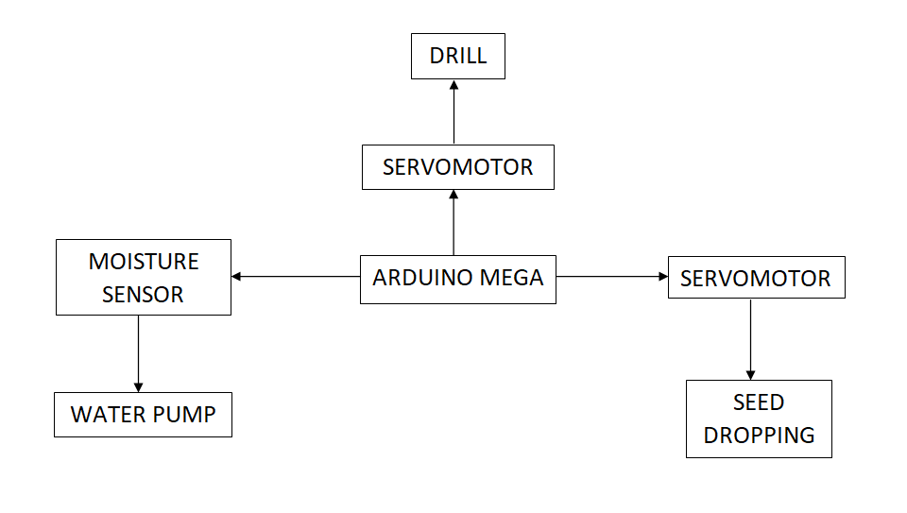

The increasing population in the world indicates the high alarm for the demand of goods and resources for living. To increase the production and decrease the exertion of humans, this can be used. It can be deployed for all the fundamental Plantation purposes.

The major task done by the robot will be **Ploughing, Sowing** and **Irrigation**. These are one of the vital processes of agriculture which needs proper attention and must be taken care of.

Most importantly it doesn’t need a huge group of people to be operated and can work nonstop within a designated area effectively and efficiently.



BENEFITS

SOLUTIONS

PROBLEMS

In order to tackle different problems, the simplest way to describe our project is by explaining about its main functions:

* Ploughing: It is basically done by the drilling process, the tools of which lies on the front of the bot.
* Sowing: It is done with the help of a dropping tube and the servo motor.
* Irrigation: The watering of the seed is done by a basic Arduino irrigation system that uses the Arduino mega coding.
* With the continuous increase in population, much more manpower and resources are required.
* The development of an affordable and effective Plantation robot requires a multi-disciplinary collaboration in several areas such as horticultural engineering, computer science, mechatronics, dynamic control, deep learning and intelligent systems, sensors and instrumentation, software design, system integration, and crop management.
* A Plantation robot can benefit the agricultural industry, including a higher quality of fresh produce and hence low production cost.
* The reason stated above will also lead in the decrease of manual labour which will ultimately lead to the reduction of physical exertion and will also increase the efficiency to a great level.