IWT ASSIGNMENT-1

(By Team-7)

**PS1:** Develop a web application to Create a Flash card game?

**Developed by:**

1. Aadarsh Pokala (21)
2. Adarsh Kumar Akula (22)
3. Aman Rachala (23)
4. Chetan Pande (27)
5. Dhanush Burra (28)
6. Gokul Chinthalapudi (31)

**Acknowledgements :**

We would like to express our special thanks to our IWT sir who gave us this opportunity to do this assignment to prepare a web app of Flash Cards, which helped us in doing a lot of Research and we learned about so many new things doing this project.

**Abstract:**

Flash Card Game is a web application that loads flashcards decks where the user clicks or taps the flashcard to toggle between the word and definition.If the user got the flashcard correct the user updates the score by clicking the button “I got it right” and if wrong the user updates score by clicking the button “I got it wrong” . We have focused this project on the use of flashcards with activities that teachers can use in the teaching-learning process.The use of flashcards helps to know and understand the terminology of basic concepts in programming.It also enhances in learning ,revising the concepts and to take quick quizzes.

**Objectives:**

1)Display questions through flash cards.

2)Allowing the user to choose topics for questions.

3)Updating the score of the user based on the responses.

4)To let the user pick previous and next cards if required.

5) To store the name and score of the user in the database.

**Technologies Used:**

Frontend : HTML,CSS

Backend : Javascript,JSON

**Target Audience :**

1)Students who are new to coding

2)Teachers

3)Work Employees

4)Anyone who likes to play fun games

**Introduction :**

In this application at first we enter into login page by entering the name and there after we choose the topic to display cards.User can check the answers by flipping the cards and then user updates the score after confirmation of answer.There are various topics related to basics of coding such as operators,functions,arrays,strings etc and then they can also check the leaderboard.

**OUTPUT:**

Login page:

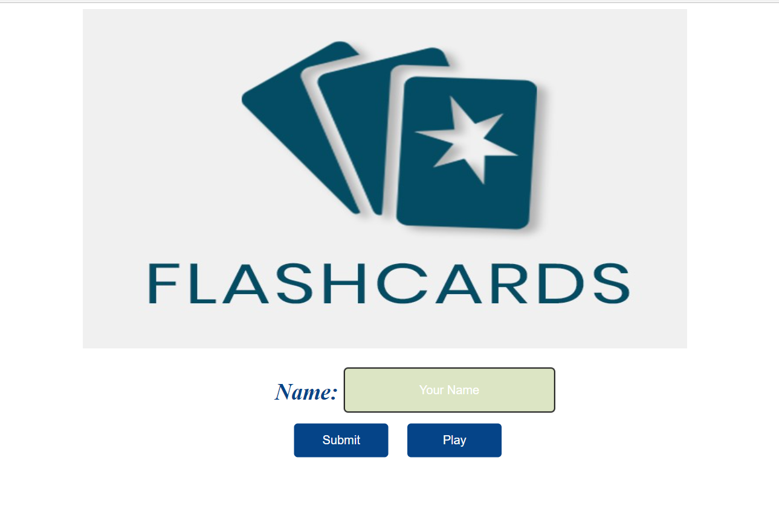Click on play to continue:

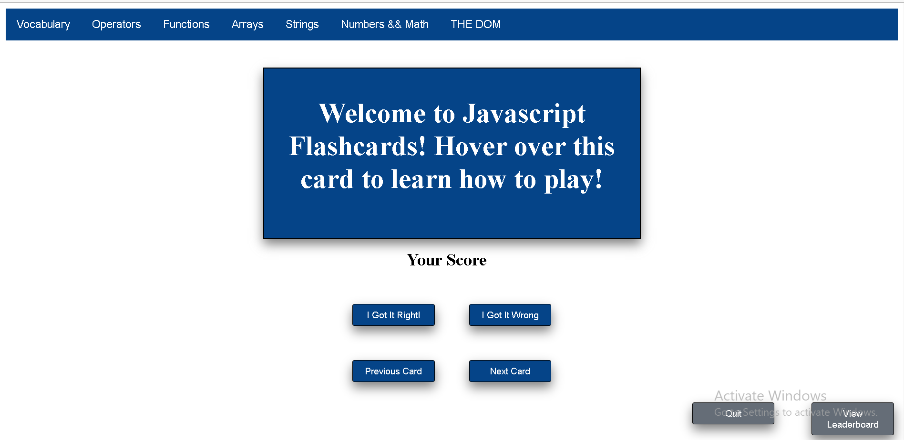

Animation of card:



After selecting a topic:

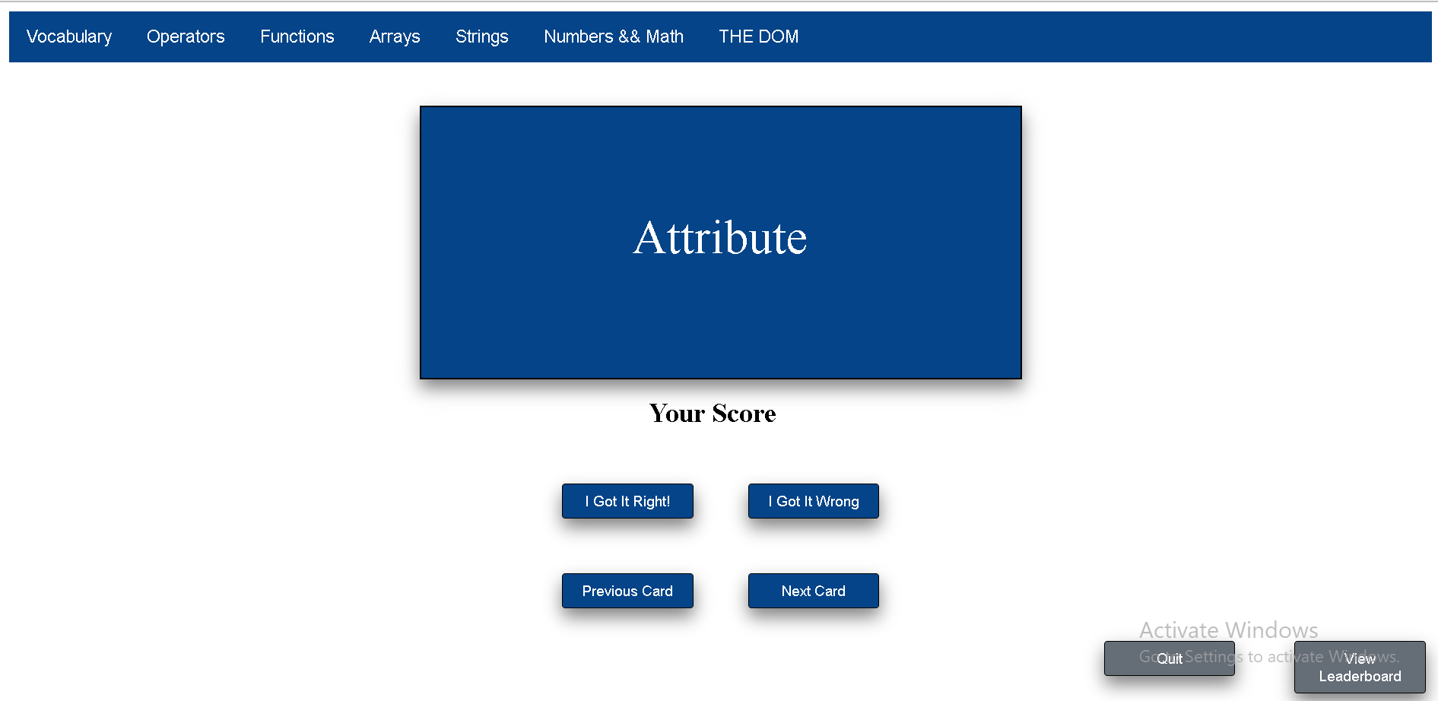

If you got correct answer:

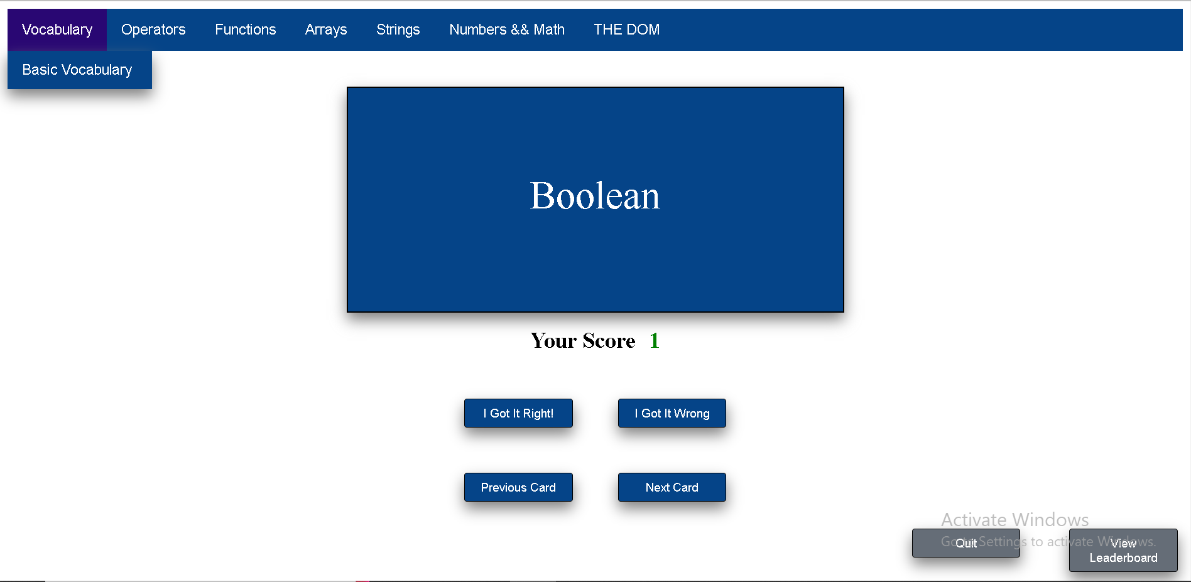

If your answer is wrong:

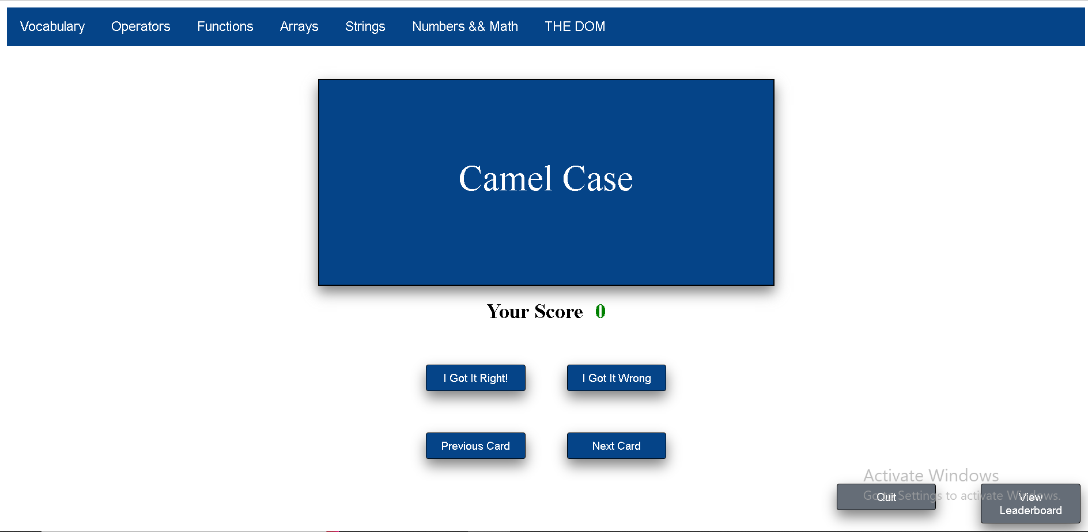

After clicking quit data will be stored in localStorage:

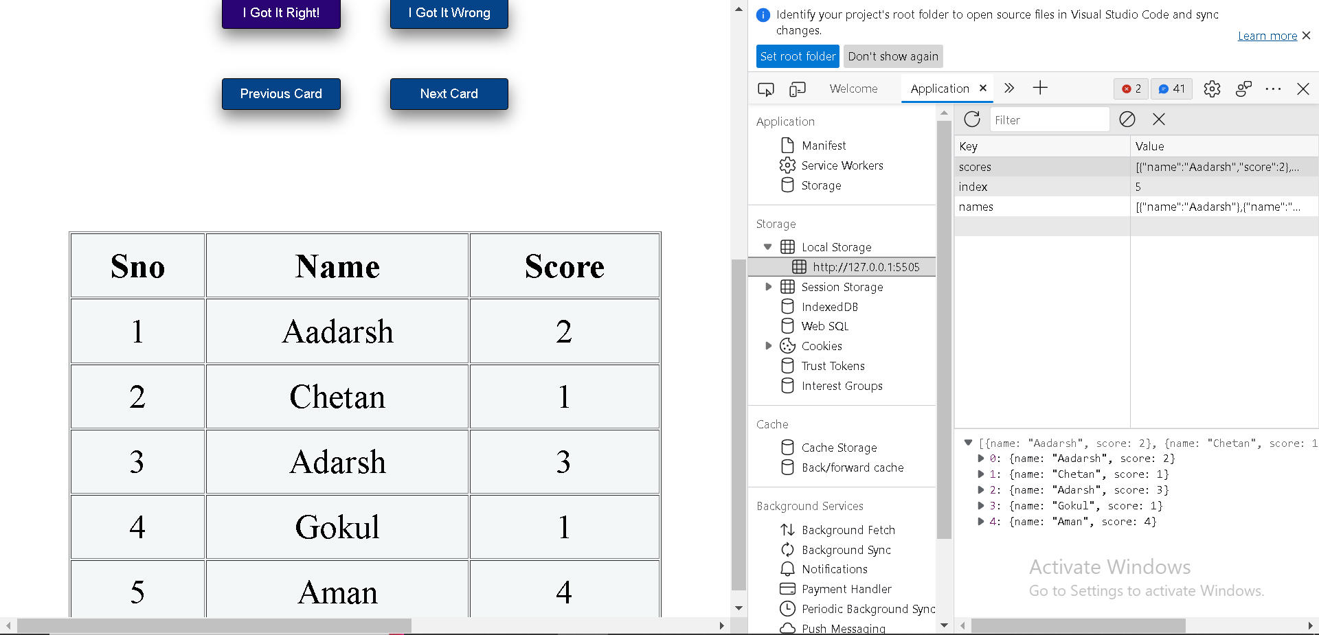

After clicking view leaderboard:

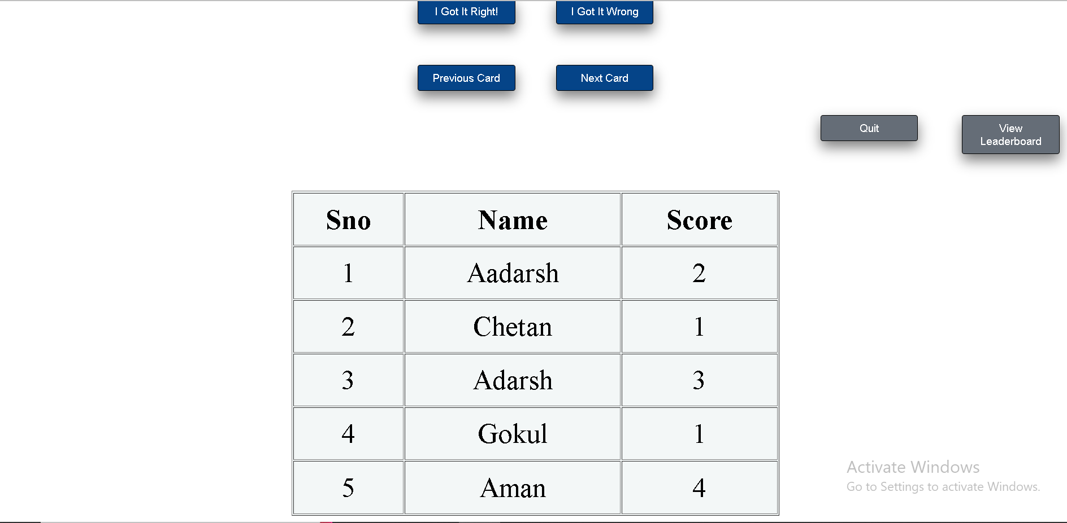

**DB Design:**

localStorageDB is a simple layer over localStorage (and sessionStorage) that provides a set of functions to store structured data like databases and tables. It provides basic insert/update/delete/query capabilities. localStorageDB has no dependencies, and is not based on WebSQL.

We are using localStorage to store data in real-time.Data is stored in the below format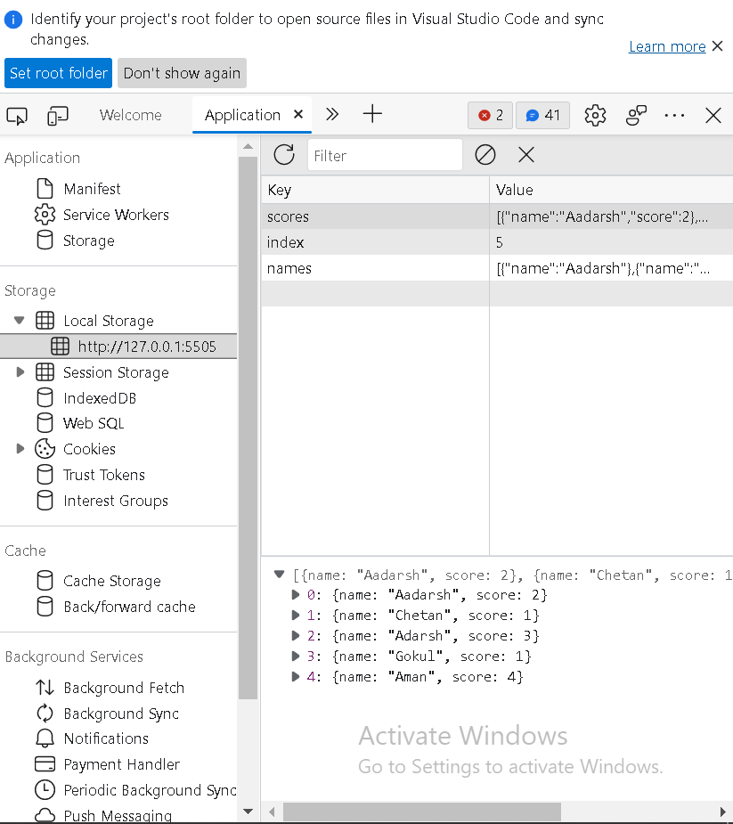

**Future scope:**

1. We can add more topics to attract different age groups.
2. We can add images based flash cards for children.
3. In future we can add register page for users to store there details.
4. We can create separate accounts for users to track their progress and performance.

**Conclusion:**

Learning-Teaching techniques are many and every day there are more adding to them. The tools or methods are also different from the traditional and they help to improve the way students learn.

We also developed some interesting activities for students to encourage them to participate in class and make them to be creative and create a positive environment in the class.We have developed these activities for our project in a positive way to help of students to be confident

**References:**

1. <https://www.w3schools.com/jsref/prop_win_localstorage.asp>
2. <https://web.stanford.edu/class/archive/cs/cs193x/cs193x.1176/homework/3-flashcards>
3. <https://www.youtube.com/watch?v=QGVXmoZWZuw>