CIS 181: Object-Oriented Programming II, Fall 2021

Project #2

Due Date: 11:59 pm, Friday, November 5, 2021

An Array-Based Implementation of John Conway's Game of Life

Objectives
- To practice using two-dimensional arrays
- To learn how to implement methods that satisfy pre-post conditions
- To learn how to use Java interface to specify ADT
- To gain experience with Java Swing GUI

Description
In the following project you will complete an implementation of John Conway's famous Game of Life (http://www.math.com/students/wonders/life/life.html ). The Game of Life is an example of a cellular automaton and is played on a (finite) grid of cells. Each cell is either alive or dead and has at most eight neighbors. The state of the cell changes from one generation to the next according to the following rules:
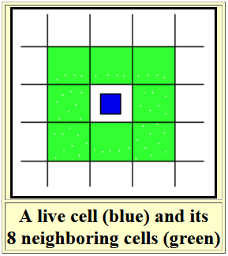
- Birth Rule: A dead cell with exactly three living neighbors is reborn (vivified) in the next generation. Otherwise, a dead cell remains dead!
- Survival Rule: A live cell with two or three living neighbors remains alive for the next generation.
- Death Rule: A live cell with one or fewer living neighbors dies from loneliness in the next generation; a live cell with four or more living neighbors dies from overcrowding in the next generation.
- Using rules 1 to 3, the states of all the cells in the next generation is calculated based on the current alive or dead states of all the grid cells. Then the states of all the cells are transformed to their new states.
- Rules 1 to 4 are repeated as long as is desired!

An Example
If the rules are applied to a row of three live blue cells (see figures below), then in the next generation
- The two end cells (red background) will die because they each have only one live neighbor.
- The two dead North and South cells (green background) will be reborn because they each have exactly three live neighbors
- The center live cell (gray background) survives because it has two live neighbors!
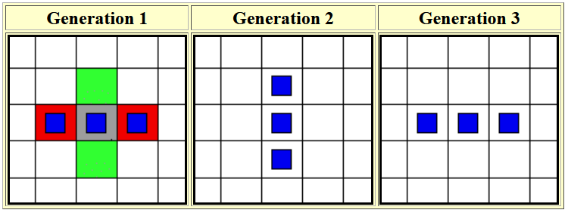
- In fact, the third generation will be the same as the first (why?). So this is an example of an oscillating configuration!

A Working Version
For a complete working version, please download the file "GameOfLife.jar". Run it using the the command "java -jar GameOfLife.jar". From this working version, you can experience rules of the John Conway's Game of Life.

How to Run the Program

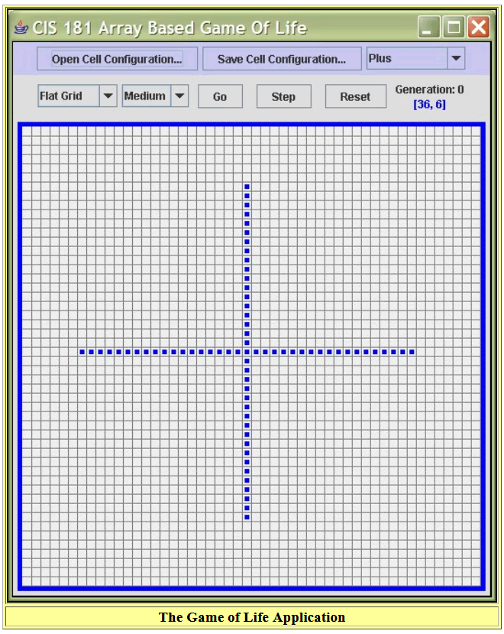

- Use the Go and Step buttons to cause the program to calculate and display future generations of the cells.
- Use the Reset button to restore the board to the initial configuration of cells.
- Use the Slow, Medium, Fast, Light Speed ComboBox to control and set the speed of the program.
- Use the Flat Grid, Torus Grid ComboBox to control the type of grid.
  - In a flat grid, edge and corner cells have fewer than eight neighbors. Thus, the life and death behavior of edge and corner cells is different than other cells.
  - In a torus grid, the bottom and top edges "wrap around" and are considered as identical. Similarly, the left and right edges are considered as identical too. Hence, the four corner cells all have each other as neighbors! Thus, the grid simulates a torus (a donut) and every cell has eight neighbors!.
- Use the Open button to open and read .life configuration files such as the example files.
- Use the Save button to save the current cell configuration in a .life text file (See the bottom of this document file)
- Use the Fish, Plus, Glider, FlyingMachine ComboBox to choose an initial configuration. Run these examples on both Flat Grid and Torus Grid, and see the differences.
- Use the mouse (clicking on a cell toggles its state) to create your own initial configurations or to edit an existing configuration.

Project Starting Code
The starting code can be downloaded in the Zip file from myCourses.
Class Sources
- GameOfLife.java
The only source file that you must change!
- GameInterface.java
- GameGUI.java
- GameBoard.java
- FileIO.java
- gameGrid.gif
Example Cell Configuration Files
- 10CellRow.life
- CatBarberHarvester.life
- Exploder.life
- Fish.life
- FlyingMachine.life
- Glider.life
- GliderGun.life
- Pump.life

Exercises
- In Eclipse, create a new Java project called "Project 2", and import the above 6 files into a default package.

- Compile and run the program. Make sure it works (it shows the game board).

- To complete the project, you will first need to implement the following four private methods in GameOfLife.java for flat grid:
  - private void copyMap(boolean sourceMap[][])
  - private void clearMap(boolean targetMap[][])
  - private int getFlatNeighborCount(int row, int col)
  - private void nextGenerationForFlatGrid()
Then you are asked to implement the game of life for torus grid.

- Write the pre-post conditions for each method you implemented for torus grid.

- Test your program with additional cell configuration files.

- Submit your completed program (GameOfLife.java) to the myCourses!

The Cell Configuration .life Files
A cell configuration file can be made using text-only editor. The contents of the file are up to fifty lines of text consisting of only the '-' and '*' characters. Each line can contain up to fifty such characters. A '-' indicates that a cell is dead while the '*' indicates that a cell is alive. A character in the third line (from the top) and tenth column (from the left) corresponds to the cell with coordinates (2, 9). Thus, the first line of the file corresponds to the zero-th row cells and the first column of text corresponds to the zero-th column of cells. If a file contains fewer than fifty lines or fewer than fifty columns of text, the program will assume that the corresponding cells are dead!
Note: The file must be saved as a text-only file with the .life extension to be readable by the program.
As an example, here is the contents of the Plus.life file:


