CIS 181: Object-Oriented Programming II, Fall 2021

Project #3

Due Date: 11:59 pm, Friday, December 3, 2021

Maintaining an Inventory for a Video Game Store using Linked List

Objectives
- To gain experience with developing application using ADT list and ADT sorted list.
- To learn how to develop the inventory application using the InventoryInterface.
- To gain an understanding of object-oriented design (OOD) for software development.

Description
Imagine that you have a part-time job at a local video game store. Realizing that you know a good deal about computers, the store owner asks you to write an interactive program that will maintain the store's inventory of video games that are for sale. The inventory consists of a list of video game titles and the following information associated with each title:
- Have value: number of video games currently in stock.
- Want value: number of video games that should be in stock.
- Waiting list: list of people waiting for the title if it is sold out.
Because the owner plans to turn off power to the computer when the store is closed, your inventory program will not be running at all times. Therefore, the program must save the inventory in a file before execution terminates and later restore the inventory when it is run again.
The program should be able to execute the following commands:
--------------------------------------------------------------------------------------
H (Help) Help menu (provide a summary of the available commands)
I <title> (inquire) Display the inventory information for a specified title
L (list) List the entire inventory (in alphabetical order by title)
A <title> (add) Add a new title to the inventory (prompt for initial want value)
M <title> (modify) Modify the want value for a specified title
D <title> (delivery) Deliver videos for a specified title to customers on the waiting list
O (order) Display the purchase order for video game titles with insufficient copies
R (return) Display the return order for video game titles with too many copies
S <title> (sell) Sell a specified title to a customer (if the title is sold out, put the customer's name on the waiting list)
Q (quit) Save the inventory information and terminate execution
--------------------------------------------------------------------------------------
Notice that to simplify matters, we have modified the meaning of the 'D' command. In this project, when a user types in the "D <title>" command, the videos with the specified title which are currently in stock will be delivered to the customers on the waiting list. The customer in the front of the waiting list gets served first. If there is not enough video games of the specified title in stock, the customers who have not yet been served remain on the waiting list. The program outputs a list of deliveries of video games (e.g., a delivery information could be "The video game 'aaa' is delivered to Yuchou Chang'."). A sample of the outputs produced by the program for all commands is illustrated in the test case file: testcases.docx (strings in bold font are user inputs).

Software Design
We identify the following objects/nouns from the problem statement: user interface, inventory, movie title, stock item, waiting list, and person. We first define an ADT inventory that consists of operations on an inventory, such as listInventory, findStockItem and displayStockItemInfo. The ADT inventory is specified using Java interface InventoryInterface, and is implemented by the Inventory class. Then we define a class called InventoryApp that implements the user interface, i.e., read user inputs and output results. The InventoryApp class is implemented using operations defined in the InventoryInterface, but according to the principles of ADT, the InventoryApp class does not need to know the implementation details of the Inventory class. Based on the user commands described before, the operations on ADT Inventory (i.e., the Java interface InventoryInterface) are defined as follows:

///////////////////////
// StockItem Management
///////////////////////

public void listInventory();
// List the inventory in alphabetical order by title

public StockItem findStockItem(String title);
// Find the inventory item associated with a title

public void displayStockItemInfo(StockItem item);
// Display the inventory information for a specified stock item

public void replaceStockItem(String title, StockItem newStockItem);
// Replace the inventory item associated with a title

public void insertStockItem(StockItem item);
// Insert a new stock item into the inventory list

public void deleteStockItem(StockItem item);
// Delete a stock item from the inventory list

//////////////////////////
// Waiting List Management
//////////////////////////

public void addToWaitingList(String title, Person person);
// Add a new person to the end of the waiting list (when the video that
// the person wants is sold out)

public Person deleteFromWaitingList(String title);
// Delete the person at the beginning of the waiting list for a
// specified title (when a video is delivered to the person)

public void displayWaitingList(String title);
// Display the names on a waiting list for a specified title

//////////////
// File Access
//////////////

public void saveInventory();
// Save the current inventory and associated waiting lists when
// porgram execution terminates

public SortedList restoreInventory();
// Restore the current inventory and associated waiting lists when
// program execution begins again

An inventory is defined as a sorted list of stock items, which are sorted by the video game title of each item. Each inventory item contains a title, a have value, a want value, and a waiting list of people for that item.
The waiting list is a list of persons or customers. The WaitingList class is defined as a subclass of the ListReferenceBased class. But notice that a waiting list is actually a queue, so when we add a new person to the list, we add it at the end of the list, and when we remove a person from the list, we remove the first person in the list. The relationships among the above classes are illustrated in the following class diagram (UML diagram).
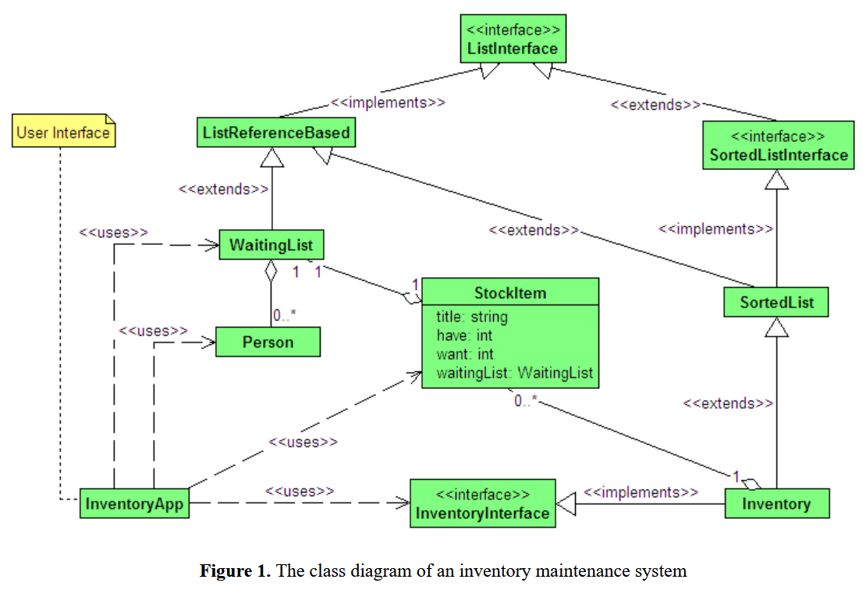

As shown in Figure 1, the SortedList class is defined as a subclass of the ListReferenceBased class, and implements the SortedListInterface. The SortedListInterface extends the ListInterface but contains exactly the same set of operations of ADT sorted list.

A Sample Solution
Download the following jar file, and run it using the command "java -jar InventoryApp.jar" (to open a command console, click on "Start->Run .." in Windows XP. In the pop up window, type in "cmd", click on the "OK" button).
- InventoryApp.jar
If the file name is automatically changed into "InventoryApp.zip", you need to change it back to "InventoryApp.jar".
Note: when you first run the program, you will receive a FileNotFoundException for the file "inventory.dat". The file will be automatically created when you terminate the program.
Run the program and compare with the test case file: testcases.docx (strings in bold font are user inputs).

Exercises
- Download all needed Java source files located in the “sources” folder, which has 3 subfolders.
Download the following reference-based list Java source files into a directory called list.
  - ListInterface.java
  - ListReferenceBased.java
  - ListException.java
  - Node.java
- Download the following reference-based sorted list Java source files into a directory called sortedList.
  - SortedListInterface.java
  - SortedList.java
- Download the following inventory Java source files into a directory called inventory.
  - InventoryInterface.java
  - Inventory.java
  - StockItem.java
  - WaitingList.java
  - Person.java
- Download the following inventory application Java source file into the current directory.
  - InventoryApp.java (The only source file that you must change!)

- In Eclipse, create a new Java project called "Project 3".
- In Eclipse, create a new Java package called "list" inside "Project 3" and import the Java source files from the directory list of step 1 into this package.
- In Eclipse, create a new Java package called "sortedList" inside "Project 3" and import the Java source files from the directory sortedList of step 2 into this package.
- In Eclipse, create a new Java package called "inventory" inside "Project 3" and import the Java source files from the directory inventory of step 3 into this package.
- In Eclipse, import the file InventoryApp.java from the current directory of step 4 into the default package of "Project 3".
- Compile and run the program. Make sure it works: it prints out "-- To be implemented!" when the user input command is: M <title>, O, R, S <title>, or D <title>.
- Implement the class called InventoryApp by completing the following 5 methods:
private void modifyWantValue(String title)
// Modify the want value for a specified title.
// Preconditions: None.
// Postcondition: Prompt the user to input the want value for the specified
// title. If the input is valid, the want value for the title
// is modified. Otherwise, the want value is set to zero.

private void purchaseOrder()
// Print out the purchase order for additional videos based on a comparison
// of the have and want values in the inventory.
// Preconditions: None.
// Postconditoon: For each title in the inventory list, if the want value
// is bigger than the have value, the have vaule is brought
// up to the want value (by ordering addition videos for
// that title), and the purchase order for that title is
// printed out.

private void returnOrder()
// Print out the return order for unwanted videos based on a comparison
// of the have and want values in the inventory.
// Preconditions: None.
// Postconditoon: For each title in the inventory list, if the have value
// is bigger than the want value, the have vaule is reduced
// to the want value (by returning videos for that title),
// and the return order for that title is printed out.

private void sellVideo(String title)
// Sell a video for specified title. If the title is sold out, put a name
// on the waiting list for the title.
// Preconditions: None.
// Postcondition: If the have value is bigger than zero, the have value for
// the specified title is decreased by 1; Otherwise, if the
// title is sold out, prompt the user to input the customer's
// name (first name and last name), and put the name on the
// waiting list for the title.

private void deliverVideo(String title)
// Deliver videos to people on the waiting list for the specified title
// Preconditions: None.
// Postcondition: If the have value for a specified title is bigger than
// zero, deliver videos to the people on the waiting list
// for that title. In case there are not enough videos
// currently in stock, videos are only delivered to those
// people in the front of the waiting list.
- Run your program. Make sure your program is fail-safe for user inputs. In other words, when user input is invalid, the system should not break. Test the test cases in file testcases.docx. Your program should output exactly the same results as the demo program (InventoryApp.jar) does.
- Submit your completed program (InventoryApp.java) to the myCourses!
- Bonus (5 points): Add a customer list in the inventory class. The customer list is a sorted list of persons, sorted by their last names (if the last names are the same, then sorted by their first names).
- Modify the "S <title>" command such that whenever a video is sold or if the video is sold out, prompt the user to input the customer's name (first name and last name), and insert the person into the customer list. If the customer is already in the customer list, do nothing (no duplicates of customer names). Note that, when the video is sold out, the customer should also be added at the end of the waiting list (even if the customer is already in the waiting list).
- Add a 'C' command to display the customer list. See sample test cases: testcases-bonus-1.docx.
- Add a 'X <title>' command to delete a title from the inventory; add a 'Y' command to delete a customer from the customer list. Also add a command 'Z' to delete all elements in the inventory list and the customer list. See sample test cases: testcases-bonus-2.docx.
For the bonus part of the project, you will need to modify the following two files: Inventory.java and InventoryApp.java. Optionally, you may also update the InventoryInterface.java file to include the new operations defined on inventory. Your program should output exactly the same results as shown in the sample test cases: testcases-bonus-1.docx, testcases-bonus-2.docx.
- Submit your completed program (InventoryApp.java and Inventory.java) to the myCourses!

