Visoka škola strukovnih studija za

Informacione i komunikacione

Tehnologije

Portfolio

<http://beri-portfolio-js-jquery.synergize.co/>

Smer: Internet Tehnologije

Modul: Web Programiranje

Predmet: Web Programiranje 1

**Berisavac Aleksa 32/18**

Contents

[1. Uvod 3](#_Toc58780871)

[1.1 Korišćene tehnologije 3](#_Toc58780872)

[1.2 Opis Funkcionalnosti 3](#_Toc58780873)

[1.3 Template 3](#_Toc58780874)

[2. Objašnjenja O Izradi 5](#_Toc58780875)

[2.1 Mapa Sajta 5](#_Toc58780876)

[2.2 #Nav 6](#_Toc58780877)

[2.3 #Home 7](#_Toc58780878)

[2.4 #About 8](#_Toc58780879)

[2.5 #Projects 9](#_Toc58780880)

[2.6 #Contact 10](#_Toc58780881)

[3. Kodovi 11](#_Toc58780882)

[3.1. HTML: 11](#_Toc58780883)

[3.2 SCSS (pregledniji od css-a): 14](#_Toc58780884)

[3.3 Javascript: 26](#_Toc58780885)

[3.3.1 main.js: 26](#_Toc58780886)

[3.3.2 plugins.js: 32](#_Toc58780887)

# 1. Uvod

## 1.1 Korišćene tehnologije

* HTML 5
* CSS 3
* JavaScript
* Visual Studio Code
* jQuery
* Bootstrap

## 1.2 Opis Funkcionalnosti

* Učitan plugins.js kao biblioteka funkcija.
* Dinamičko učitavanje nav menija javascriptom iz niza.
* Promena naslovne slike pomoću bootstrapa.
* Dodavanje i Oduzimanje klase .active preko .eventListener u zavisnosti od toga gde se pointer nalazi na stranici. Sam kod za izvršavanje poziva se preko funkcije.
* NavBar se prikazuje samo kad se skrola naviše.
* Dinamičko učitavanje sličnih blokova iz nizova.
* Provera polja forme korišćenjem regExpova i tajmera za uklanjanje obaveštenja nakon 5-10s. Isprogramirano dugme za prosleđivanje podataka sa alertom.
* Iskorišćen jQuery za dinamicko dodeljivanje margina main diva kao i promenu velicine slova, u zavisnosti od dimenzija prozora.

## 1.3 Template

* Korišćen je template sa prethodnog sajta <http://beri-portfolio.synergize.co> koji sam pravio pošto smatram da je pogodan da se na njega primeni javascript ne bi li postao funkcionalniji. Dodat je .js .bootstrap, mnoge klase i izmene u css-u i html-u.

**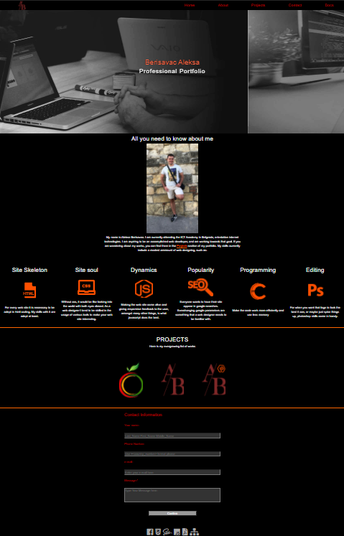**

# Objašnjenja O Izradi

## 2.1 Mapa Sajta

<urlset xmlns="http://www.sitemaps.org/schemas/sitemap/0.9">

<url>

<loc>http://sadnjavoca.byethost8.com/index.html</loc>

<lastmod>2018-12-11</lastmod>

<changefreq>monthly</changefreq>

<priority>1.0</priority>

</url>

</urlset>

## 2.2 #Nav

Navigacija sajta je napravljena tako da se elementi dinamički ispišu iz niza parametara. Responzivna je i kada se rezolucija dovoljno smanji pojavljuje se hamburger iza kojeg stoji meni. Funkcionalnost ovog menija odradjena je pomocu javascripta. Na klik na meni on se pojavi i kada se nesto izabere on nestane. Prelaskom miša preko većih delova sajta u meniju unutar navigacije se signalizira korisniku gde se na sajtu nalazi. Ovo je odradjeno preko dinamičkih dodavanja i oduzimanja klasa koje su povezane sa elementima menija. Navigacija se prilikom skrolovanja na dole sakrije, i onda kada se detektuje scroll na gore ona se pojavi i ostane dok se ponovo ne skrola na dole. Takodje se pojavi ako se mišem dovoljno priđe vrhu stranice. Ovim omogućavam bolju preglednost celog sajta.

**C:\Users\aleks_eg16h3h\AppData\Local\Microsoft\Windows\INetCache\Content.Word\navBar.png**

Ispod se može videti padajući meni iz hamburgera koji se otvara na pritisak preko mobilnog, ili na hover ako je sa mišem.

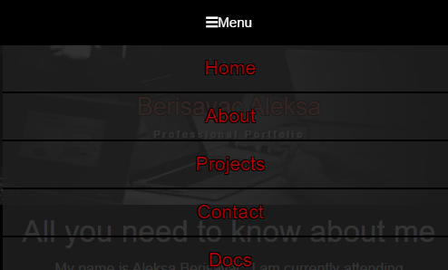

## 2.3 #Home

Kao i ostatak sajta i ovaj deo je responzivan. Ovde se nalazi naziv cele stranice koji je pozicioniran preko slajdera slika koje daju bolji ambijent. Slajder nije interaktivan već je odrađen preko tajmera. Ovo je postignuto pomoću bootstrap-a Dolazi do minimalnih prilagodjavanja fonta slova teksta u zavisnosti or rezolucije, koji je realizovan dinamički preko javascripta i njegovih jQuery pogodnosti, u zavisnosti od dimenzija prozora. Drugi deo responzivnosti dolazi preko @media u css-u.

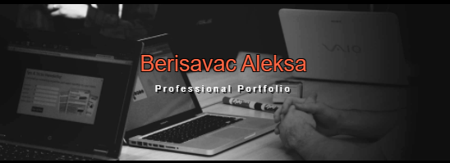

## 2.4 #About

U ovom delu stranice nalazi se kratka biografija ispod koje se nalaze trenutna znanja u vidu figura. Ove figure se kao i sve stvari koje se ponavljaju više puta ispisuju dinamički iz nizova. Koristeći flex u potpunosti su responzivne bez obzira na rezoluciju. Na njih je pomoću css-a dodat efekat skaliranja kako bi sajt postao interaktivniji sa tim efektom. Ovo je moglo da se postigne i pomoću javascripta ali nije bilo potrebe da opterećujem kod.

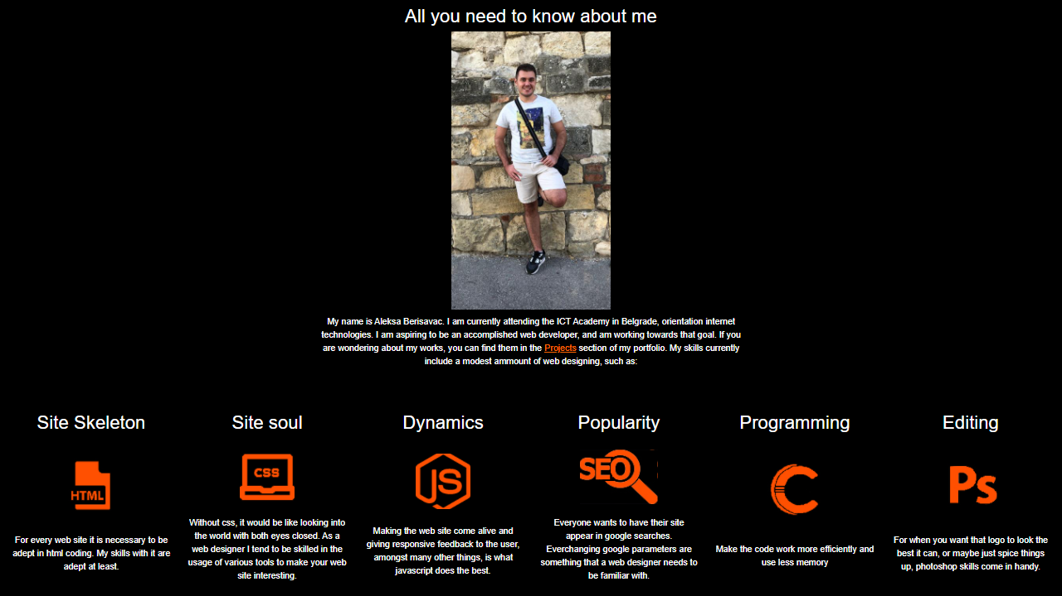

## 2.5 #Projects

Slicno kao u abouts, ovde se nalaze projekti koje sam odradio za školu. Klikom na jedan od logoa odlazi se na te web sajtove. Takođe se ispisuju dinamički iz niza i responzivni su. Ovde se nalazi i stari sajt koji sam preradio pa se može uočiti razlika u dinamici.

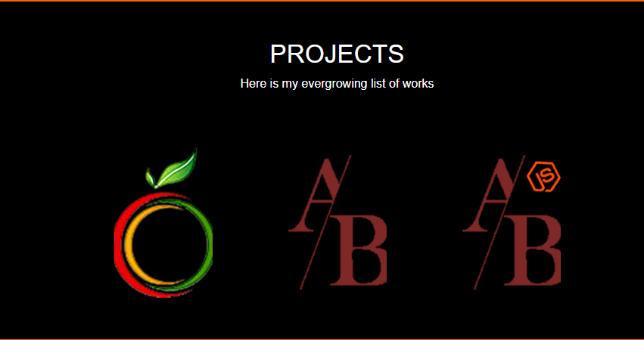

## 2.6 #Contact

Unutar futera nalazi se forma za slanje poruke, a ispod nje niz logoa koji vode ka source fajlovima koji su korišćeni u izradi ovog sajta. Što se tiče forme, od korisnika se očekuje da posalje neku poruku, ne zahteva se. Ako se odluči da pošalje poruku proveriće se da li je nešto uneo u required input polje. Može, ali ne mora uneti svoje lične podatke, sa tim što ako ih unese moraju proći određeni proces provere što se postiže regularnim izrazima. Neće moći da pošalje poruku sa neispravnim podacima. Najmanja provera se vrši u samom mejlu gde se zahteva da ima samo ’@’ pošto mejlova ima svakakvih i tu jedino verifikacija pomaže. Ograničen je broj karaktera koji korisnik može da pošalje. Korisnik dobija feedback kada nešto upiše, koji mu govori da li je pogrešio i daje mu primer kako treba tačno uneti. Ove informacije su dodatno uslovljene tajmerima da se vrate na početno stanje nakon određenog vremena. Nakon što pritisne na dugme preko alerta mu se ispisuje da li je uspešno završio radnju i briše se već uneti sadrzaj za slučaj da hoće ponovo da unese nešto.

. 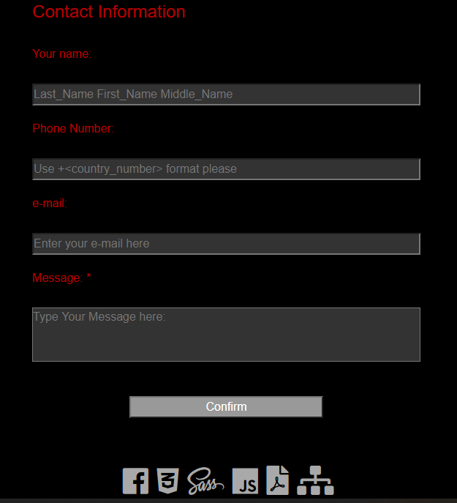

# 3. Kodovi

## 3.1. HTML:

<!DOCTYPE html>

<html>

    <head>

        <link rel="stylesheet" href="https://maxcdn.bootstrapcdn.com/bootstrap/4.0.0/css/bootstrap.min.css" integrity="sha384-Gn5384xqQ1aoWXA+058RXPxPg6fy4IWvTNh0E263XmFcJlSAwiGgFAW/dAiS6JXm" crossorigin="anonymous">

        <title> Dynamic Portfolio - Berisavac Aleksa </title>

        <meta name="keywords" content="css, html, web, js, jquery">

        <meta name="description" content="Dinamican Poslovni porfolio Berisavac Alekse">

        <link rel="shortcut icon" href="assets/img/logo.ico"/>

        <meta charset="utf-8"/>

        <meta name="viewport" content="width=device-width,initial-scale=1.0, maximum-scale=1.0">

        <link href="https://fonts.googleapis.com/css?family=Questrial&display=swap" rel="stylesheet">

        <link rel="stylesheet" href="https://use.fontawesome.com/releases/v5.5.0/css/all.css" integrity="sha384-B4dIYHKNBt8Bc12p+WXckhzcICo0wtJAoU8YZTY5qE0Id1GSseTk6S+L3BlXeVIU" crossorigin="anonymous">

        <link rel="stylesheet" type="text/css" href="assets/css/style.css"/>

        <script type="text/javascript" src="/assets/js/plugins.js"></script>

    </head>

    <body>

        <nav id="nav" class="sirina">

                <a href="#backgroundimage"><div id="logo"></div></a>

                <div id="meni">

                    <button id="btnmeni"><i class="fa fa-bars"></i>Menu</button>

                </div>

                <div class="cleaner"></div>

        </nav>

        <header id="header">

            <div id="carouselExampleSlidesOnly" class="carousel slide" data-ride="carousel">

                <div class="carousel-inner">

                    <div class="carousel-item active">

                        <img class="d-block w-100" src="assets/img/BckgrImg.jpg" alt="First slide">

                    </div>

                    <div class="carousel-item">

                        <img class="d-block w-100" src="assets/img/BckgrImg2.jpg" alt="Second slide">

                    </div>

                </div>

            </div>

                <div id="caption">

                <h1>

                    Berisavac Aleksa

                </h1>

                <h2>

                    Professional Portfolio

                </h2>

            </div>

            <div class="cleaner"></div>

        </header>

        <main id="main" class="sirina">

            <div id="about" class="dimensions">

                <div>

                    <h3>All you need to know about me</h3>

                    <img src="assets/img/profile.jpg" alt="profil"/>

                    <div id="info">

                        <p>My name is Aleksa Berisavac. I am currently attending the ICT Academy in Belgrade, orientation internet technologies. I am aspiring to be an accomplished web developer, and am working towards that goal. If you are wondering about my works, you can find them in the <a href="#projects">Projects</a> section of my portfolio. My skills currently include a modest ammount of web designing, such as: </p>

                    </div>

                </div>

            </div>

            <div id="projects" class="dimensions">

                <div class="sirina">

                    <h3>PROJECTS</h3>

                    <div id="info">

                        <p>Here is my evergrowing list of works</p>

                    </div>

                </div>

                <div>

                </div>

            </div>

        </main>

        <footer id="contact">

            <form action="1.php" method="GET" name="form">

                <fieldset>

                    <legend>Contact Information</legend>

                        <label for="name">Your name:</label><span id="inputName" color="#fff"></span>

                        <input type="text" placeholder="Last\_Name First\_Name Middle\_Name" id="name" name="name" maxlength="30"/>

                        <label for="phone">Phone Number:</label><span id="inputPhone"></span>

                        <input type="text" placeholder="Use +<country\_number> format please" id="phone" name="phone" maxlength="15"/>

                        <label for="emailaddress">e-mail:</label><span id="inputMail"></span>

                        <input type="email" id="emailaddress" name="emailaddress" placeholder="Enter your e-mail here">

                        <label for="message">Message:</label><span id="inputText">&nbsp;\*</span>

                        <textarea required="required" placeholder="Type Your Message here:" id="message" rows="3" cols="20" name="message"></textarea>

                    <div id="btn">

                    <input type="button" value="Confirm" id="button"/>

                    </div>

                </fieldset>

            </form>

            <div id="icons">

                <ul>

                </ul>

            </div>

        </footer>

        <script src="https://code.jquery.com/jquery-3.2.1.slim.min.js" integrity="sha384-KJ3o2DKtIkvYIK3UENzmM7KCkRr/rE9/Qpg6aAZGJwFDMVNA/GpGFF93hXpG5KkN" crossorigin="anonymous"></script>

        <script src="https://cdnjs.cloudflare.com/ajax/libs/popper.js/1.12.9/umd/popper.min.js" integrity="sha384-ApNbgh9B+Y1QKtv3Rn7W3mgPxhU9K/ScQsAP7hUibX39j7fakFPskvXusvfa0b4Q" crossorigin="anonymous"></script>

        <script src="https://maxcdn.bootstrapcdn.com/bootstrap/4.0.0/js/bootstrap.min.js" integrity="sha384-JZR6Spejh4U02d8jOt6vLEHfe/JQGiRRSQQxSfFWpi1MquVdAyjUar5+76PVCmYl" crossorigin="anonymous"></script>

        <script type="text/javascript" src="/assets/js/main.js"></script>

    </body>

</html>

## 3.2 SCSS (pregledniji od css-a):

\* {

  box-sizing: border-box;

  margin: 0px;

  padding: 0px;

  scroll-behavior: smooth;

  //word-wrap: break-word;

  text-shadow:

    -1px -1px 0 #000,

    1px -1px 0 #000,

    -1px 1px 0 #000,

    1px 1px 0 #000;

  font-family: 'Acme', sans-serif;

}

.cleaner{

    clear:both;

}

.white{

    color:#fff;

}

body {

    position:absolute;

    nav{

        background-color:rgba(0,0,0,1);

        width:100%;

        height:50px;

        margin:0px auto;

        z-index:999;

        position: fixed;

        top: 0;

        transition: top 0.4s ease-in-out;

        &.show{

            top: -50px;

        }

        #logo{

            height:100%;

            width:50px;

            background-image:url('../img/logo.png');

            float:left;

            margin-left:5%;

        }

        #btnmeni{

            display: none;

            width:100%;

            height:100%;

            background-color: #000;

            border-color: #000;

            color: #fff;

            font-size: 15px;

        }

        #meni{

            width:50%;

            height:50px;

            float:right;

            color:ffffff;

            ul{

                list-style-type:none;

                height:50px;

                display:flex;

                flex-direction:row;

                justify-content:space-around;

                align-items:stretch;

                li{

                    margin-left:5px;

                    display:flex;

                    align-items:center;

                    justify-content:space-around;

                    flex-grow: 1;

                    color:rgba(180,0,0,1);

                    font-size:16pt;

                    &:hover{

                        color:#A9A9A9;

                        transition: .5s;

                    }

                    &.liactive{

                        color:#A9A9A9;

                        transition: .5s;

                    }

                }

                #first{

                    border-left:none;

                    margin-left:none;

                }

            }

            a{

                position:relative;

                text-decoration:none;

                display:flex;

                flex-direction:row;

                justify-content:space-around;

                align-items:stretch;

                flex-grow: 1;

                &:before{

                    content: "";

                    position: absolute;

                    width: 100%;

                    height: 4px;

                    bottom: 0%;

                    left: 1.5%;

                    right:1.5%;

                    background-color: rgba(180,0,0,0.7);

                    visibility: hidden;

                    -webkit-transform: scaleX(0);

                    transform: scaleX(0);

                    -webkit-transition: all 0.3s ease-in-out 0s;

                    transition: all 0.3s ease-in-out 0s;

                }

                &:hover:before{

                    visibility: visible;

                    -webkit-transform: scaleX(1);

                    transform: scaleX(1);

                }

                &.aactive{

                    position:relative;

                text-decoration:none;

                display:flex;

                flex-direction:row;

                justify-content:space-around;

                align-items:stretch;

                flex-grow: 1;

                &:before{

                    content: "";

                    position: absolute;

                    width: 100%;

                    height: 4px;

                    bottom: 0%;

                    left: 1.5%;

                    right:1.5%;

                    background-color: rgba(180,0,0,0.7);

                    visibility: visible;

                    -webkit-transform: scaleX(1);

                    transform: scaleX(1);

                    -webkit-transition: all 0.3s ease-in-out 0s;

                    transition: all 0.3s ease-in-out 0s;

                }

                }

            }

        }

    }

    #header{

        width:100%;

        position: relative;

        /\* overflow: hidden; \*/

        z-index: 3;

        display:flex;

        flex-direction:row;

        flex-wrap:wrap;

        justify-content:center;

        align-items:stretch;

        text-align:center;

        /\* left: 5px; \*/

        top: 40px;

        #carouselExampleSlidesOnly{

            position:absolute;

        }

        #caption{

                position: absolute;

                width: 100%;

                z-index: 100;

                display:flex;

                flex-direction:row;

                flex-wrap:wrap;

                justify-content:center;

                align-items:stretch;

                text-align:center;

                h1{

                    //font-size: 30pt;

                    color: #f64;

                    width:100%;

                }

                h2{

                    font-size:23;

                    letter-spacing:3px;

                    text-shadow: 2px 2px #000;

                    color:#fff;

                    width:100%;

                }

        }

    }

    main{

        .dimensions{

            width:100%;

            min-height:450px;

            max-width:1920px;

        }

        #about{

            background-color:#000;

            display:flex;

            flex-direction:row;

            flex-wrap: wrap;

            justify-content:center;

            img:first-child{

                width: 15%;

                height: auto;

            }

            a{

                text-decoration:underline;

                color:#FF6600;

                &:hover{

                    color:#ff0000;

                }

            }

            figure{

                width:15%;

                min-width:230px;

                min-height:200px;

                margin:15px;

                display:flex;

                flex-direction:row;

                flex-wrap:wrap;

                justify-content:center;

                align-items:stretch;

                text-align:center;

                div{

                    &.img{

                        width:100px;

                        height:100px;

                        background-size:cover;

                        background-position:center center;

                        margin:20px 0px;

                    }

                }

                #css{

                    &:hover{

                        transform: scale(1.2,1.2);

                        transition: all 0.3s ease-in-out;

                    }

                    background-image:url('../img/css3.jpg');

                }

                #html{

                    &:hover{

                        transform: scale(1.2,1.2);

                         transition: all 0.3s ease-in-out;

                    }

                    background-image:url('../img/html.jpg');

                }

                #c{

                    &:hover{

                        transform: scale(1.2,1.2);

                      transition: all 0.3s ease-in-out;

                    }

                    background-image:url('../img/c.jpg');

                }

                #photoshop{

                    &:hover{

                        transform: scale(1.2,1.2);

                        transition: all 0.3s ease-in-out;

                    }

                    background-image:url('../img/ps.jpg');

                }

                #seo{

                    &:hover{

                        transform: scale(1.2,1.2);

                        transition: all 0.3s ease-in-out;

                    }

                    background-image:url('../img/seo.jpg');

                    width:140px;

                }#javascript{

                    &:hover{

                        transform: scale(1.2,1.2);

                          transition: all 0.3s ease-in-out;

                    }

                    background-image:url('../img/JavaScript.png');

                }

                figcaption{

                    color:#ffffff;

                    width:100%;

                }

                p{

                    color:#ffffff;

                }

            }

            overflow: auto;

            color:#fff;

            text-align:center;

            #info{

                width:40%;

                margin:10px auto;

            }

            h4{

                margin-top:50px;

                font-size:25pt;

            }

            h3{

                margin-top:50px;

                font-size:25pt;

            }

        }

        #projects{

            overflow: auto;

            color:#fff;

            border-top:3px solid #FF6600;

            background-color:#000;

            display:flex;

            flex-direction:row;

            flex-wrap: wrap;

            justify-content:center;

            text-align:center;

            h3{

                margin-top:50px;

                font-size:25pt;

            }

            &>:nth-child(2){

                display:flex;

                flex-direction:row;

                flex-wrap: wrap;

                justify-content:center;

                text-align:center;

            }

            div{

                &>.aproject{

                    width:130px;

                    height:200px;

                    margin:50px;

                    display:flex;

                    flex-direction:row;

                    flex-wrap:wrap;

                    justify-content:center;

                    align-items:stretch;

                    background-size:cover;

                    background-position:center center;

                }

                a{

                    width:100%;

                    text-decoration:none;

                    margin:auto auto;

                    height:100%;

                    color:#fff;

                    position:relative;

                    display:flex;

                    flex-direction:row;

                    justify-content:space-around;

                    align-items:stretch;

                    flex-grow: 1;

                    &:before{

                    content: "";

                    position: absolute;

                    width: 100%;

                    height: 4px;

                    top:0%;

                    left: 0%;

                    background-color: #FF6600;

                    visibility: hidden;

                    -webkit-transform: scaleX(0);

                    transform: scaleX(0);

                    -webkit-transition: all 0.3s ease-in-out 0s;

                    transition: all 0.3s ease-in-out 0s;

                }

                &:hover:before{

                    visibility: visible;

                    -webkit-transform: scaleX(1);

                    transform: scaleX(1);

                }

                    &:hover{

                        color:rgba(180,0,0,1);

                        background-color:rgba(255,255,255,0.1);

                    }

                    font-size:20pt;

                }

            }

            #sadnja{

                background-image:url('../img/sadnjavoca.png');

            }

            #portfolio{

                background-image:url('../img/portfolio.png');

            }

            #portfolioJS{

                background-image:url('../img/portfolioJS.png');

            }

        }

    }

    footer{

        width:100%;

        min-height:500px;

        background-color:#000;

        border-top:3px solid #FF6600;

        color:rgba(180,0,0,1);

        fieldset{

            min-width:500px;

            width:30%;

            padding:10px;

            margin:20px auto;

            padding:20px;

            border-width:2px !important ;

            border-style: groove !important;

            border-color: threedface !important;

            border-image: initial !important;

            legend{

                width: auto;

            }

            input{

                width:100%;

                height:30px;

                margin:20px 0px;

                text-shadow:none;

                background-color:rgba(255,255,255,0.2);

                color:#fff;

            }

            textarea{

                width:100%;

                margin:20px 0px;

                text-shadow:none;

                background-color:rgba(255,255,255,0.2);

                resize:none;

                color:#fff;

            }

            #inputName{

                color:#fff;

            }

            #inputPhone{

                color:#fff;

            }

            #inputMail{

                color:#fff;

            }

            #submit{

                width:50%;

            }

            #btn{

                margin:0px auto;

                width:50%;

                text-align:center;

                input{

                    background-color:rgba(255,255,255,0.6);

                }

            }

        }

        #icons{

            width:20%;

            max-width:300px;

            height:50px;

            margin:0px auto;

            ul{

                list-style-type:none;

                height:50px;

                display:flex;

                flex-direction:row;

                justify-content:space-around;

                align-items:stretch;

                li{

                    margin-left:5px;

                    display:flex;

                    align-items:center;

                    justify-content:space-around;

                    flex-grow: 1;

                    font-size:30pt;

                    color:#A9A9A9;

                    &:hover{

                        transition: .5s;

                    }

                }

            }

            a{

                position:relative;

                text-decoration:none;

                display:flex;

                flex-direction:row;

                justify-content:space-around;

                align-items:stretch;

                flex-grow: 1;

                &:before{

                    content: "";

                    position: absolute;

                    width: 100%;

                    height: 4px;

                    bottom: 0%;

                    left: 0%;

                    background-color: rgba(180,0,0,0.7);

                    visibility: hidden;

                    -webkit-transform: scaleX(0);

                    transform: scaleX(0);

                    -webkit-transition: all 0.3s ease-in-out 0s;

                    transition: all 0.3s ease-in-out 0s;

                }

                &:hover:before{

                    visibility: visible;

                    -webkit-transform: scaleX(1);

                    transform: scaleX(1);

                }

            }

        }

    }

    .sirina{

        max-width: 1920px;

        width:100%;

    }

}

@media screen and (max-width: 700px)

{

    body{

        #nav{

            #logo{

                display:none;

            }

            #meni{

                width:100%;

                #btnmeni{

                    display:block;

                }

                ul{

                    display:none;

                    li{

                        background-color: rgba(30, 30, 30, 0.9);

                         border:2px solid #000;

                         border-top:0px;

                         border-left:0px;

                         padding:10px;

                    }

                    .show{

                        display:block;

                    }

                }

                &:hover ul{

                    //display:block;

                }

                .show{

    display:block;

}

            }

        }

        #contact{

            fieldset{

                min-width:200px;

                width:80%;

            }

        }

        main{

            #about{

                img{

                    width:40%;

                }

                figure{

                width:80%;

                }

            #info{

                width:80%;

            }

            }

        }

        #caption{

            h1{

                font-size:20pt;

            }

            h2{

                font-size:8pt;

            }

        }

    }

}

# 3.3 Javascript:

## 3.3.1 main.js:

$(document).ready(function(){

    //preloading src-a da bih sprecio bljesak svetlosti pri prvoj promeni slike u background-u.

    img1 = new Image();

    img1.src = "../assets/img/BckgrImg2.jpg";

    //Dinamicki ispis menija

    var meniElementi = new Array (

        ['#', 'first', 'Home'],

        ['#about', 'About'],

        ['#projects', 'Projects'],

        ['#contact', 'Contact'],

        ['assets/pdf/docs.pdf', 'Docs']

        );

    var ispis='<ul>';

    for (var i=0; i<meniElementi.length; i++){

        if (i==0){

            ispis+=`<a href=${meniElementi[i][0]}><li id=${meniElementi[i][1]}>${meniElementi[i][2]}</li></a>`

        } else{

            ispis+=`<a href=${meniElementi[i][0]}><li>${meniElementi[i][1]}</li></a>`

        }

    }

    var ispis=ispis+'</ul>';

    var meni1=document.querySelector("#meni");

    meni1.innerHTML+=ispis;

    //Funkcija za dodavanje/oduzimanje klase .active

    function toggle(i){

        var liElement = document.querySelectorAll("#meni li");

        liElement[i].classList.toggle("liactive");

        var aElement = document.querySelectorAll("#meni a");

        aElement[i].classList.toggle("aactive");

    }

    //Koriscenje gornje funkcije

    var nizZaActive = new Array ("header", "about", "projects", "contact");

    for(var i=0; i<nizZaActive.length; i++){

        document.getElementById(`${nizZaActive[i]}`).addEventListener("mouseenter", toggle.bind(null, i));

        document.getElementById(`${nizZaActive[i]}`).addEventListener("mouseleave", toggle.bind(null, i));

    }

    //NavBar se pokazuje samo kad se skrola nagore ili kada je mis blizu vrha strane:

    window.addEventListener("scroll", logScrollDirection);

    window.addEventListener("mousemove", logMouseMove );

    function logMouseMove(event) {

        var e = e || window.event;

        mousePos = { x: e.clientX, y: e.clientY };

        if(mousePos.y<130) {

                nav.classList.remove("show")

            } else nav.classList.remove("add");

    }

    function logScrollDirection() {

        var previous = window.scrollY;

        window.addEventListener('scroll', function(){

            window.scrollY > previous ? nav.classList.add("show") : nav.classList.remove("show");

            previous = window.scrollY;

        });

    }

    //Dinamicki ispis figura:

    var nizFigura = new Array (

        ["Site Skeleton", "html", "For every web site it is necessary to be adept in html coding. My skills with it are adept at least."],

        ["Site soul", "css", "Without css, it would be like looking into the world with both eyes closed. As a web designer I tend to be skilled in the usage of various tools to make your web site interesting."],

        ["Dynamics", "javascript", "Making the web site come alive and giving responsive feedback to the user, amongst many other things, is what javascript does the best."],

        ["Popularity", "seo", "Everyone wants to have their site appear in google searches. Everchanging google parameters are something that a web designer needs to be familiar with."],

        ["Programming", "c", "Make the code work more efficiently and use less memory"],

        ["Editing", "photoshop", "For when you want that logo to look the best it can, or maybe just spice things up, photoshop skills come in handy."],

    );

    var ispis = "";

    for (var i = 0; i<nizFigura.length; i++){

        ispis+=`<figure><figcaption><h4>${nizFigura[i][0]}</h4></figcaption><div id="${nizFigura[i][1]}" class="img"></div><p>${nizFigura[i][2]}</p></figure>`

    }

    var about1=document.querySelector("#about");

    about1.innerHTML+=ispis;

    //Dinamicki ispis projekata:

    var nizProjekata = new Array (

        ["sadnja", "http://sadnjavoca.byethost8.com/index.html"],

        ["portfolio", "http://beri-portfolio.synergize.co"],

        ["portfolioJS", "http://beri-portfolio-js-jquery.synergize.co"]

    );

    var ispis="";

    for (var i=0; i<nizProjekata.length; i++){

        ispis+=`<div id="${nizProjekata[i][0]}" class="aproject"><a href="${nizProjekata[i][1]}"></a></div>`

    }

    var projects1=document.querySelector("#projects>div:nth-child(2)");

    projects1.innerHTML+=ispis;

    //Dinamicki ispis futer elemenata:

    var nizFuter = new Array (

        ["https://www.facebook.com/alexa.berisavac", "fab fa-facebook"],

        ["assets/css/style.css", "fab fa-css3-alt"],

        ["assets/css/style.scss", "fab fa-sass"],

        ["assets/js/main.js", "fab fa-js"],

        ["assets/pdf/docs.pdf", "fas fa-file-pdf"],

        ["assets/xml/sitemap.xml", "fas fa-sitemap"]

    );

    var ispis="";

    for (var i=0; i<nizFuter.length; i++){

        ispis+=`<a href="${nizFuter[i][0]}"><li> <i class="${nizFuter[i][1]}"></i> </li></a>`

    }

    var footer1=document.querySelector("#icons ul");

    footer1.innerHTML+=ispis;

    //Provera Razlicitih Stringova unutar Futera regExpom:

    var reIme = /^[A-Z][a-z]{1,11}(\s[A-Z][a-z]{1,11}){1,2}/;

    var reBroj = /(^\+[\d]{10,13})|(^\+[\d]{3,5}(\s\d{2,4}){1,4})/;

    var reMail = /^\S{1,15}@\S{1,15}$/ //dozvoljavam da unesu bez .com jer moze da bude .yahoo itd. Za detaljnije mejlove bih koristio slozenije regexpove.

    var ime=0;

    var telefon=0;

    var mail=0;

    form.name.addEventListener("blur", function(){

        if(form.name.value.match(reIme))

        {

            inputName.textContent="  Name Format is correct.";

            setTimeout(()=>inputName.textContent="",5000);

            ime = 0;

        }  else if(!form.name.value){

            inputName.textContent="  Field is empty.";

            setTimeout(()=>inputName.textContent="",10000);

            ime=0;

        }  else{

            inputName.textContent="  Word begins with a capital letter followed by a non capital.";

            setTimeout(()=>inputName.textContent="",10000);

            ime=1;

        }

    });

    form.phone.addEventListener("blur", function(){

        if(form.phone.value.match(reBroj))

        {

            inputPhone.textContent="  Phone Format is correct.";

            setTimeout(()=>inputPhone.textContent="",5000);

            telefon=0;

        }  else if(!form.phone.value){

            inputPhone.textContent="  Field is empty.";

            setTimeout(()=>inputPhone.textContent="",10000);

            telefon=0;

        }  else{

            inputPhone.textContent="  Wrong phone format. Example: +381648586055";

            setTimeout(()=>inputPhone.textContent="",10000);

            telefon=1;

        }

    });

    form.emailaddress.addEventListener("blur", function(){

        if(form.emailaddress.value.match(reMail))

        {

            inputMail.textContent="  E-Mail format is correct. You will be asked to verify it.";

            setTimeout(()=>inputMail.textContent="",5000);

            mail=0;

        }  else if(!form.emailaddress.value){

            inputMail.textContent="  Field is empty.";

            setTimeout(()=>inputMail.textContent="",10000);

            mail=0;

        }  else{

            inputMail.textContent="  Write the e-mail correctly. Example: name@yahoo.com";

            setTimeout(()=>inputMail.textContent="",10000);

            mail=1;

        }

    });

    form.message.addEventListener("blur", function(){

        if (!(inputText.getAttribute("class")=="white")){

            if(form.message.value==""){

                inputText.textContent="  Write something if you want to send a message.";

                setTimeout(()=>inputText.textContent="\*",10000);

                inputText.setAttribute("class", "white");

                setTimeout(()=>inputText.setAttribute("class", ""),10000);

            }

        }

    });

    //Funkcija za resetovanje elemenata forme prilikom slanja podataka

    function resetuj(){

        var nizReset = new Array();

        nizReset = $('input');

        nizReset.push($('#message')[0]);

        console.log(nizReset);

        for(i=0;i<nizReset.length;i++){

            if (nizReset[i].id!="button"){

                nizReset[i].value="";

                console.log(nizReset[i].id);

            }

        }

    }

    //Alert na submit

    button.addEventListener("click", function(){

        if ((form.message.value!="")&&!((ime)||(telefon)||(mail))){

            window.alert("You have successfully sent a message! Thank you for your commitment.");

        } else{

            window.alert("You did not fulfill all the conditions! Please enter the information correctly, or don't fill it at all if you want to keep your privacy.");

        }

        resetuj();

    });

    $('#meni').click(()=>{

          document.querySelector("ul").classList.toggle('show');

        })

});

## 3.3.2 plugins.js:

window.onload=()=>{

    var visina=carouselExampleSlidesOnly.clientHeight;

$('main').css('margin-top',`${visina}px`);

$('#caption').css('padding',`${visina/2.5}px`);

}

window.addEventListener('resize', function(){

    var visina=carouselExampleSlidesOnly.clientHeight;

    var duzina=carouselExampleSlidesOnly.clientWidth;

    $('main').css('margin-top',`${visina}px`);

    if(duzina<400){

        $('#caption').css('padding',`10%`);

        $('#caption h1').css('fontsize','20pt');

    } else{

        $('main').css('margin-top',`${visina}px`);

    $('#caption').css('padding',`${visina/2.5}px`);

    $('#caption h1').css('fontsize','30pt')

    }

});