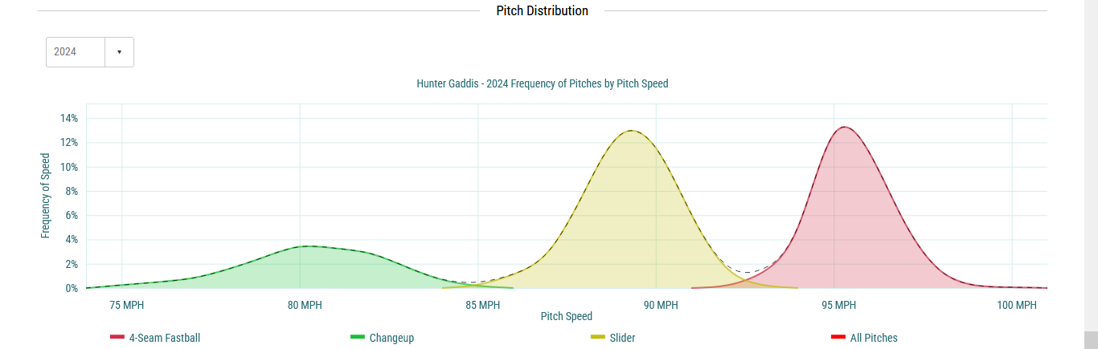
Previously, I had done a sabermetric breakdown of a plate appearance in the Wild Card game between BOS @ NYY this season, and now I wanted to do one for a PA that I believe we all remember from the 2024 ALCS. A game where Juan Soto became the hero for the “Bronx Bombers” and carried NYY to the World Series that same season.
Cleveland struck first in Game 5, scoring one run in the 2nd inning and another in the 5th. NYY responded quickly with two runs to tie the game in the 6th, and no runs were scored over the next two and a half innings. The game went to extra innings, bringing us to the top of the 10th inning at Progressive Field.
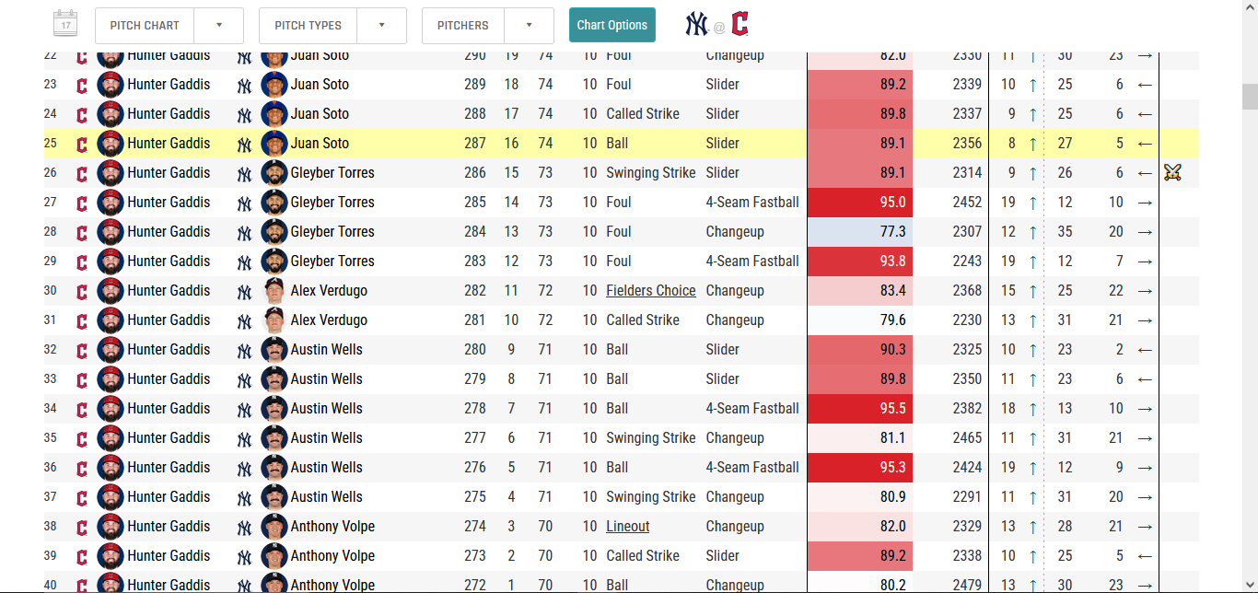
The CLE manager called on Hunter Gaddis to face Anthony Volpe and the bottom of the Yankees lineup, assuming he could get through the next three hitters quickly. And that’s exactly what happened with Anthony Volpe, who was retired in three pitches with a lineout to shortstop.
Anthony Volpe:
https://baseballsavant.mlb.com/sporty-videos?playId=24c19e53-98d5-469d-a247-3f2b18723fc5
Next up was Austin Wells, who worked a walk on six pitches.
Austin Wells:
https://baseballsavant.mlb.com/sporty-videos?playId=524f728c-c534-409a-a8e0-d8c60da85e0b
Then Alex Verdugo came up for his 4th PA, with Wells on first. Verdugo saw only two pitches, and the second was an 83.4 MPH changeup (CH) that Verdugo read well and hit toward second base. The second baseman fielded it cleanly and threw to the shortstop covering second for the out, but the ball slipped out of his hand at the bag, and the final ruling was fielder’s choice. Verdugo reached safely at first.
Verdugo fielder’s choice:
https://baseballsavant.mlb.com/sporty-videos?playId=8c12aa15-c705-48b1-8e80-b328d370e0b4
With runners on first and second, right-handed hitter Gleyber Torres came to the plate. The first pitch was a 93.8 MPH four-seam fastball, which Torres fouled off, very close to being a home run. Torres eventually struck out on a slider (SL) after fouling off three four-seamers. That final slider at 89.1 MPH was labeled by Baseball Savant as a power duel .

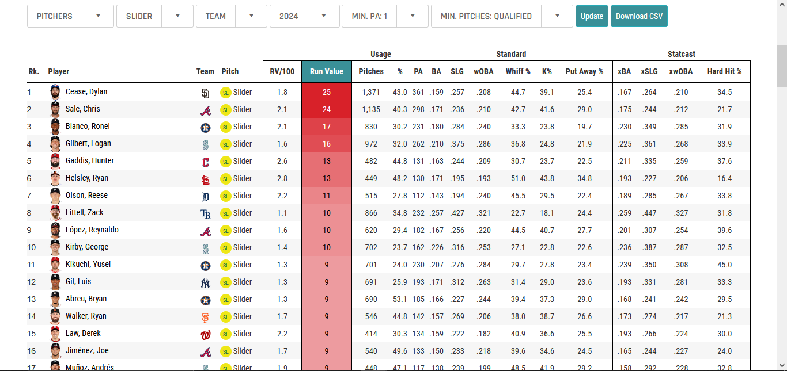
And this is where I ask: Why would Savant consider this a power duel?
Well, if we look closely at the pitch, it’s a very nasty and very fast slider. We don’t often see sliders thrown at this velocity, which is why Hunter Gaddis finished 2024 with the 5th-best slider in MLB, with a Run Value (RV) of +13.
If we break down the pitch that struck out Gleyber, we see it was thrown at 89.1 MPH, with +9 inches of IVB and 26 inches of drop. League-average IVB on sliders is typically around 0–4 inches, because sliders are breaking pitches that are expected to drop quickly due to spin. But this +9 IVB causes the pitch to stay in the air longer than expected before finally dropping nearly 29 inches. The hitter expects it to fall sooner, not to stay up before breaking late like a “normal” slider.
Gaddis’ slider is no joke. It deserves respect.
The pitch was located in Zone 14, and Torres chased it. Torres posted a 21.4% Chase Rate during the season, ranking among the top 8 hitters in MLB in that category. I don’t know if this was the result of being behind in the count, but the strikeout itself is incredible. I could go on with more data, but the point is that this slider was deceptive — it stayed in the air longer, broke late, and was thrown high only to finish well below the zone, while also being located toward the right side of the catcher, knowing Gleyber was expecting another fastball.
Sabermetrics forces you to ask why every action happens, but hitters have only milliseconds to decide whether to swing or not.
Strikeout Gleyber Torres:
https://baseballsavant.mlb.com/sporty-videos?playId=ab3d3d08-9733-439c-b9b1-53ed7a54e4f7
With two outs and the same runners in scoring position, Juan Soto stepped in for his fifth PA of the night. In Game 2 of the series, when he previously faced Gaddis, Soto had flown out, and in Game 3, Gaddis walked him. Out of 16 total pitches Gaddis had thrown to Soto in the ALCS, 10 were sliders. Five were called balls, four were fouled off, and only one was called a strike.
Before diving into this PA, we can already see the magnitude of Juan Soto as a hitter. We already mentioned how nasty Gaddis’ slider is, and how difficult it is even to foul it off. That slider stays up longer, which is why hitters struggle to make contact. Yet Soto fouled off four of them, and never once swung and missed. In fact, Soto posted a 19.5% K rate against sliders, ranking 25th in MLB, with a Run Value of +5 against the pitch. He knew what that slider was.

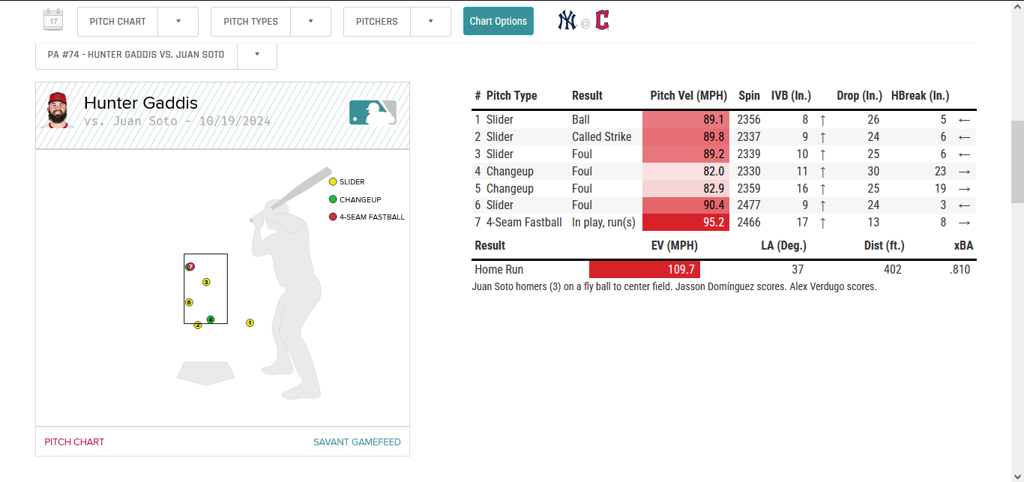
Now Soto steps into the box, and Gaddis opens with a 89.1 MPH slider, which Soto takes for a ball. This pitch was similar to the one thrown to Gleyber Torres, except Torres is right-handed and Soto is left-handed. Also, this pitch to Soto was released slightly lower out of Gaddis’ hand.
Soto 1–0:
https://baseballsavant.mlb.com/sporty-videos?playId=1a148a1c-79b9-4168-8a77-5146aba10256
On the second pitch, Gaddis goes back to the slider, which lands in the gray area of the zone analysts refer to as Edge%, slightly below the strike zone, but the umpire calls it a strike. This pitch was slightly faster and had +9 IVB, compared to +8 on the previous pitch, meaning it stayed in the air a bit longer and had better drop.
Gaddis continues throwing sliders, again at 89+ MPH, and on the third pitch Soto swings and fouls it off. The slider continues to show increased IVB — 8 on the first, 9 on the second, 10 on the third. Even though the pitch was over the heart of the plate, Soto couldn’t put it in play. His Attack Angle was 15° with an Attack Direction of 21° pull. What’s incredible is that a pull swing means you’re turning on the ball, not letting it travel — and you can see Soto’s surprise at being challenged like that.
Soto 1–2:
https://baseballsavant.mlb.com/sporty-videos?playId=58d7801b-e6d0-42a0-9eb4-76ed553fcfb4
On the fourth pitch, Gaddis switches to a changeup (CH) with +11 IVB and 30 inches of drop. Thirty inches of drop is extreme, and Soto still fouls it off. The fifth pitch is another changeup, this time with +16 IVB and 25 inches of drop, and the result is the same — Soto swings, not on time for solid contact, but still giving Gaddis problems.
On the sixth pitch, Gaddis goes back to the slider, knowing the changeup isn’t getting Soto to swing and miss. This slider is the fastest he’s thrown all night: 90.4 MPH, essentially four-seam velocity at the minor-league level. It comes in with 2,477 RPM of spin, and Soto fouls it off yet again.
Gaddis has now covered the entire plate with sliders and changeups. He’s in trouble. With only three pitches in his arsenal, Soto knows a fastball has to come at some point — and it does.
Slider 90.4 MPH, Soto 1–2:
https://baseballsavant.mlb.com/sporty-videos?playId=49a3295c-78b4-427d-aab0-b651e1e2c8da
On the seventh pitch, Gaddis throws a 95.2 MPH four-seam fastball in the inner third of the plate. It comes with 2,466 RPM of spin, +17 IVB, and 13 inches of drop. A fastball with that level of IVB makes the home run allowed even more meaningful.
Soto entered the ALCS hitting .667 against four-seam fastballs, with a .521 xBA. In four PA, he had two hits and a walk. He was hot, and the night before he had homered in the first inning.
Soto HR:
https://baseballsavant.mlb.com/sporty-videos?playId=e4cc9bd3-a50f-4b9d-be6c-b45ed1a8d6c6
The contact produced an xBA of .806, which is excellent, but in 6 fields, 3 parks, and 1 stadium, this ball would not have been a home run. I want to break down the contact to show how, even with elite contact, a few fewer mph or a slightly higher launch angle could turn this into a double or triple instead of a home run.

Key metrics on the HR pitch:

1. ⁠The pitch was perceived 0.4 MPH faster than its actual velocity. That may not sound like much, but it still matters if you aren’t sitting on a fastball — it makes the pitch feel like it’s getting on Soto faster.
2. ⁠A 2,466 RPM spin rate for a four-seam fastball creates a flatter pitch with less drop.
3. ⁠The pitch had a Vertical Release Point of 6.24 and a Horizontal Release Point of -2.48, meaning it was released high and entered the zone at an uncomfortable angle.
4. ⁠The Plate Vertical was 3.14 and Plate Horizontal was -0.49, making this a high-and-in pitch — extremely dangerous against elite left-handed hitters like Juan Soto.
5. ⁠The Arm Angle was 34.3°, which falls right into the range that allows hitters to get the barrel to the ball. If this pitch had entered from the glove-side edge, the outcome might have been different.
6. ⁠The contact came off the bat at 109.7 MPH, with a 37° launch angle, and traveled 402 feet. That’s a no-doubt home run. 109.7 MPH is elite, and the launch angle is well within the home run range. What’s important here is that the ball left the bat extremely hard but with a relatively high launch angle, meaning it was still close to being a non-HR outcome. Even so, Soto squared it up perfectly. His Barrel/Hit% was 100%, because this was the best possible contact he could make.
7. ⁠He posted an Attack Angle of 16°, an Attack Direction of 2° toward the opposite field, and an Ideal Attack Angle% of 100%. This is absolute insanity. These metrics measure bat positioning and swing mechanics. Soto’s mechanics were optimal — full body rotation, perfect timing, and zero wasted energy. This was not luck. This was an elite, trained swing.

If the EV had been 104–105 MPH, or if the launch angle had been 40°-44°, this is probably not a home run. And because the pitch was elevated, Soto had to swing more upward than his “normal” swing, which makes the result even more impressive.
Gaddis threw great sliders and changeups, but throwing that four-seam fastball into Soto’s ideal swing zone was a location mistake. On top of that, Soto was expecting it — it was the only pitch Gaddis hadn’t shown him yet. Gaddis and his catcher buried Cleveland’s hopes at Progressive Field that night.
After the game, Soto gave an interview where he said Gaddis threw him one of the “fanciest” sliders he had ever seen — and that he was waiting for the fastball to beat him.
Juan Soto interview:
https://www.youtube.com/shorts/i6TgaT8Wkjc
Gaddis’ sliders were — and still are — nasty, but that night he became the “culprit” for not being able to hold the game. Since then, his numbers have dipped, and he’s no longer among the very best in MLB when it comes to slider metrics.
I’m guessing he’s still dreaming about Juan Soto from that night.

