Anthony Castronuovo(ajc320), Jake Taubner(jdt97)

RUBT Phase 1 Write-Up

Brief Overview:

This program works first by basic checking to see if the command line arguments are valid. Once the checks have been performed, the valid torrent file is decoded/parsed using the TorrentParse class to gain access to the metadata. Once the parsing is complete, we call the Tracker class to perform the actions to first call the tracker, and receive the initial GET request. Once the tracker gives us the response we want, in the form of the peer list and other information, we call the Peer class. Peer deals with all of the connections to the peer. We send the appropriate messages to the peer, get the appropriate responses back, and download each piece from here. We put together the file bytes in the Peer class, and return those bytes to RUBTClient, where the file is created according to the second command line argument, and the bytes written to that file. The file from the peer has been downloaded by this point.

Classes:

-- RUBTClient: This class holds the main method that calls the other classes in order to run the program fully

–- Peer: This class holds all the functions that deal with interacting with the peer. Creating messages, sending messages, getting messages are all done here. This class also puts together the pieces together for the file and then returns them to RUBTClient

–- Tracker: This class is responsible for interacting with the tracker. The initial get request is done here, as well as updating the tracker with the event status.

–- TorrentParse: This class is responsible for the parsing/decoding of the torrent file. This class calls the given classes, specifically Bencoder2 and TorrentInfo, to parse the torrent file

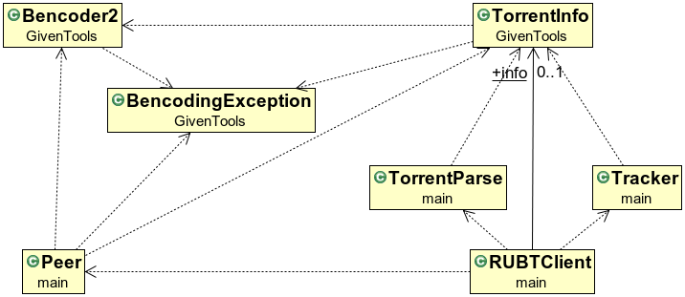

Feedback:

Although this project was perfectly doable, it’s obvious that many students had trouble with it. The difference in difficulty between this and the socket assignment is gigantic, far greater than the usual increase of difficulty between the first and second assignments for any arbitrary course. Additionally, it felt disconnected from lecture. For future classes, it may be better to split this assignment into two parts.