Group: E4150 Yuhe Yan(yy2892) Jipeng Chen(jc5057) Jianxing Wan(jw3695)

c) For stock AAPL, we preliminarily choose three histograms of the close prices that cover 755 pieces of data from 2015-01-01 to 2018-01-01. From left to right, the bin numbers are 10, 30 and 50 respectively. The horizontal axis denotes the close price and the vertical axis denotes frequency of different close price ranges.

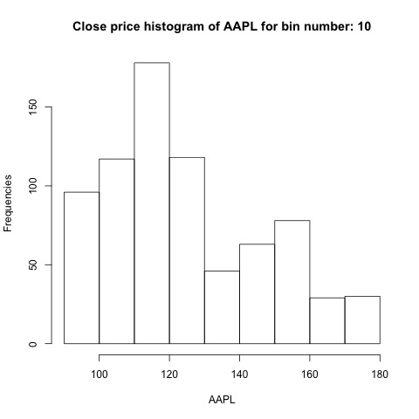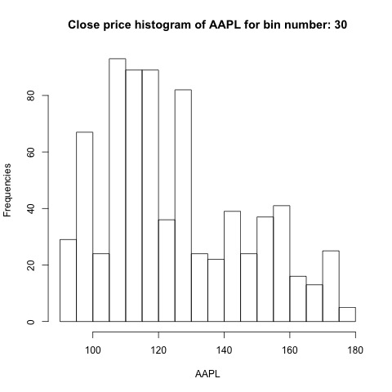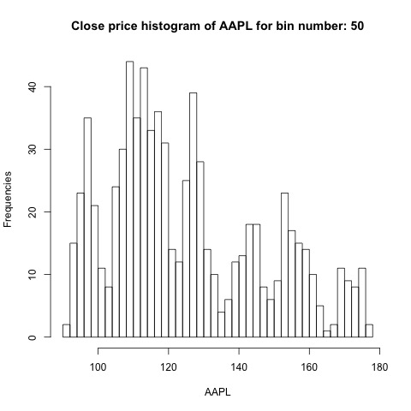

We can see from the histogram on the left that the bin width is too large and it only provides very limited information of the data. As for the histogram on the right, it shows similar distribution trend, compared to the histogram in the middle, but reveals too much unnecessary individual data. Therefore, we finally choose the histogram in the middle with appropriate bin number of 30.

We regard bin size as the ratio of range and bin number. $bin size=\frac{max-min}{bin number}$

d) Similarly, we derive histograms for the log-returns of the ten stocks. From left to right, from top to bottom, the following ten histograms are the ones we finally choose for the log-returns of AAPL, AMZN, FB, GOOG, GOOGL, MSFT, MU, NFLX, NOW, NVDA, respectively. Based on same bin size experiment in part c), we also choose the bin number of 30 for each of the histogram. The horizontal axis denotes the log-return and the vertical axis denotes frequency of each different log-return range.

