Advanced Graphics Programming |  | Unit 07a Lab
Dutch Solitaire | 100 Point Version
Assignment Purpose:

Complete the first stage of a video game that provides no preliminary stages or help.

Unit 07 will provide a unique challenge. You are provided with the rules and the appearance of a solitaire card game. You have not created any program from scratch, but that is the case with this assignment where nothing is provided besides the requirements.

You are expected to create a fully functional solitaire game that is called Dutch Solitaire. The Solitaire game that many people play on a PC actually is called Klondike Solitaire and is totally different from the game you will create. The only thing that all solitaire games have in common is that the card game is designed for one player.

This game starts by placing all 52 cards of one card deck in a matrix of 4 rows of 13 cards with the cards facing up. After the cards are placed the aces are removed from their random locations and placed at the end of each row in a style shown by the picture below. The display is now 4 rows of 14 spaces, which includes 4 blank spaces.

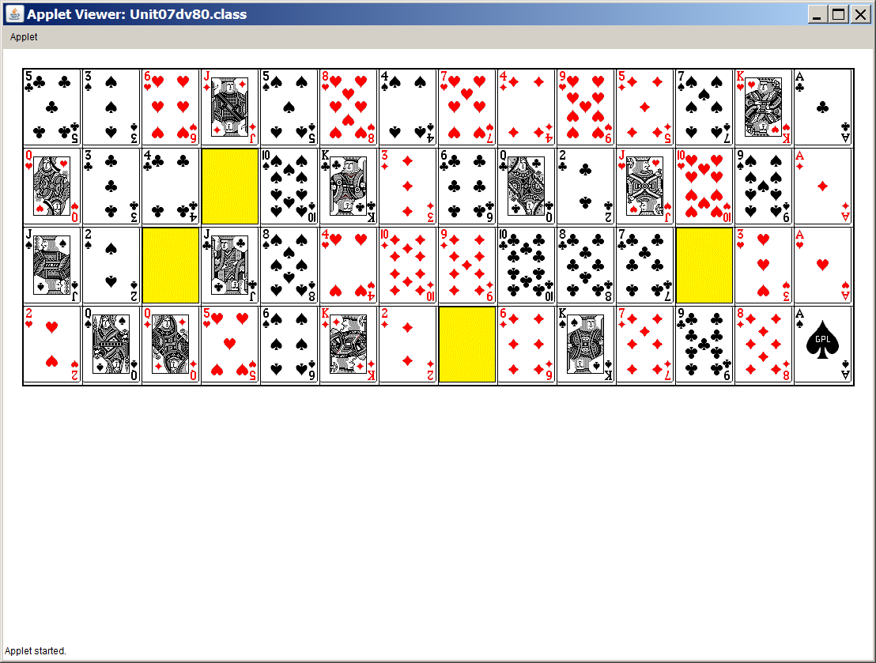

The object of the game is to create 4 ordered rows of each suit as shown below. This is achieved by moving cards in the blank spaces following a set of rules. Leon Schram learned this game while growing up in Holland which was called solitaire much like the different game in the US. It is called Dutch Solitaire, for the country where the game is popular, for lack of an official name, which probably does exist, but at this stage is not known

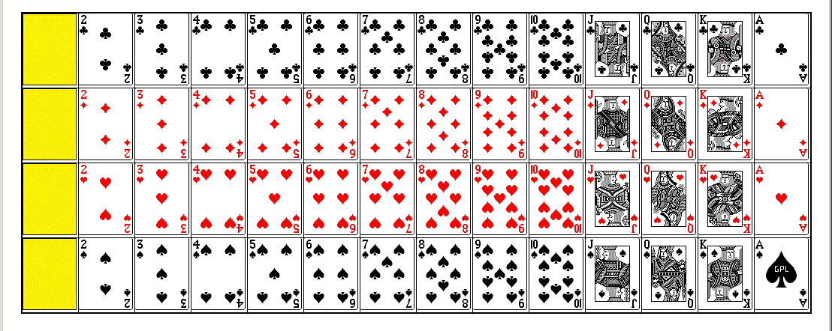

Dutch Solitaire Game Rules

- Place one shuffled card deck in a matrix of 4 rows and 13 cards with cards facing up.
- Remove the 4 aces and place them at the end of each row leaving four blank spaces.
- Manipulate the cards by making them into the blank spaces.
- The 4 aces may never be moved.
- The 2-of-clubs can be moved in the first row if the far-left position is blank.
- The same applies to the 2-of-diamonds, 2-of-hearts and the 2-of spades,
- A card can moved in a blank space using left-order sequence or right-order sequence. Consider the picture blow-up below. You can move the 9-of-spaces, which follows left order sequence. You can also move the 5-of-clubs, which follows right-order sequence.

Unit 07a 100-Point Version

The Dutch Solitaire game is done in four stages, each which will earn a grade. The first three stages only have a 100-point version.

The goal for the Unit07a lab assignment is to import the card images, provided to you in the CardImages folder and display them in a matrix. This includes the four blank spaces, which are identified by four yellow rectangle pictures. The picture below shows the required program display.

