Advanced Graphics Programming |  | Unit 07d Lab
Dutch Solitaire | 80 & 100 Point Versions
Assignment Purpose:

Complete the final stage of a video game that provides no preliminary stages or help.

Unit 07d allows the video game to be played interactively using mouse clicks. When you click on one card, it becomes highlighted and then when you click on a blank space the cards are exchanged. The two pictures below show the sequence after clicking twice. Note how the 7-of-diamonds is now placed in the fourth row on the left.

After first click on the 7-of-diamonds
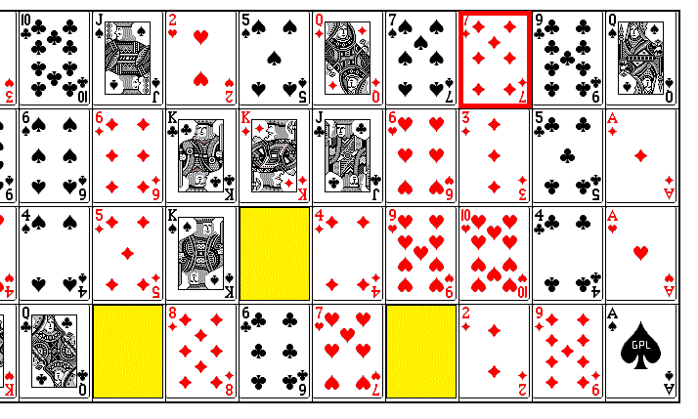

After second click on the bottom-left blank space
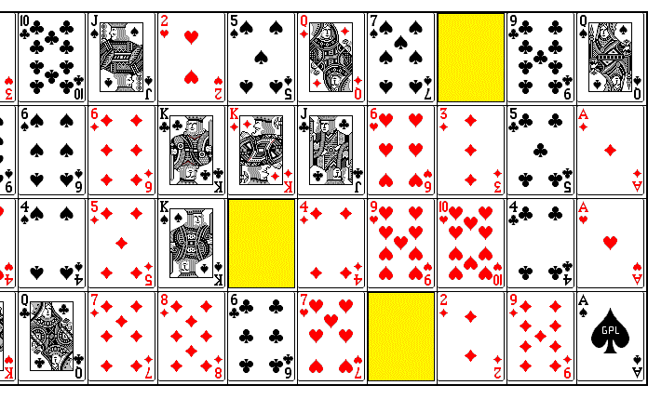

Unit 07d 80-Point Version

The 80-point version lets you play the game, but does not enforce the rules. This version lets the cards be moved, but does not protect against moves that are improper.

Unit 07d 100-Point Version

The 100-point version is the complete game that only lets a player play correctly using the card movement rules shown below.

Dutch Solitaire Game Rules

- The 4 aces may never be moved.
- The 2-of-clubs can be moved in the first row if the far-left position is blank.
- The same applies to the 2-of-diamonds, 2-of-hearts and the 2-of spades,
- A card can moved in a blank space using left-order sequence or right-order sequence. Consider the picture blow-up below. You can move the 9-of-spaces, which follows left order sequence. You can also move the 5-of-clubs, which follows right-order sequence.

