Andrew Derringer  
CS 261 – 400 Spring 19  
Assignment 0: Introduction

**Introduction:**  
 I go by Andrew and I’m originally from the Lincoln City on the Oregon coast. I attended Oregon State University as an undergraduate and earned a Dietetics degree in 2014. After a few years working in public health research, I wasn’t earning any money and no one on the team had the skills necessary to effectively impact or regularly evaluate the study we were implementing. I saw opportunities for data analysis and either web or app development everywhere, and I began teaching myself beginner Python to help find correlations in our survey data.  
 I’m now in the OSU post-bacc CS program. I still have a strong passion for nutrition and would love to find my way into a field or company that wants to utilize my previous education in health and wellness. I run and weight lift daily, and have expanded my cooking after becoming a vegetarian a couple years ago. I’m a big fan of the NBA and I hope to complete a pet project I started before the CS program of creating a stat database that can crawl through websites to auto-update stats and then provide options for advanced statistics or the opportunity to experiment with creating my own.  
 I think any lack of interest in CS from incoming traditional students may be well reflected by my personal experience where I didn’t even consider CS as an option coming into college. And that’s even coming from someone whose father’s occupation has evolved into essentially an electrical engineer over the years. I saw binary and envisioned a tired and bored old man stuck in front of a computer. It took me seeing problems in the real world and feeling the excitement of solving them by programming to understand how exciting a lot of that time in front of the screen can be. I would love to dive deeper into the world of CS and even research. Frankly even 6 months ago I wouldn’t be able to tell you what that means. Course work on computer architecture, comparing program complexity, and programming principles set out by different languages has quickly expanded my understanding of where the debates and research in the field are happening.   
**Programming Experience:**  
 I took up to a dozen introductory programming courses on code academy about a year before beginning the program. We touched on using the command line, gcc, python, javascript, html, and css. Beyond that I’ve learned python using notepad++ and pycharm on windows, and both HTML and CSS using notepad++ on windows. Through the program I’ve learned C++ using vim on linux and Visual Studios on windows, and MASM using Visual Studios. I intend to use a combination of Visual Studios and vim for traditional C in this course. I will be learning Javascript and brushing up on HTML and CSS in my Web Development course this term as well.

**Source Code (Visual Studios 2017):**

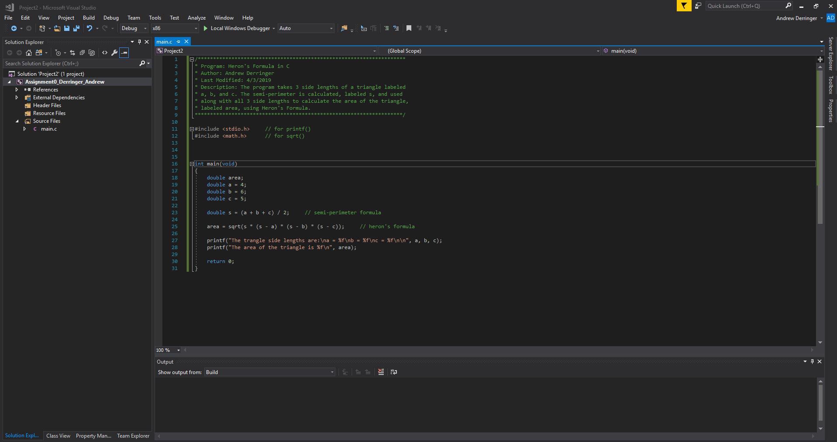

**IDE Output:**

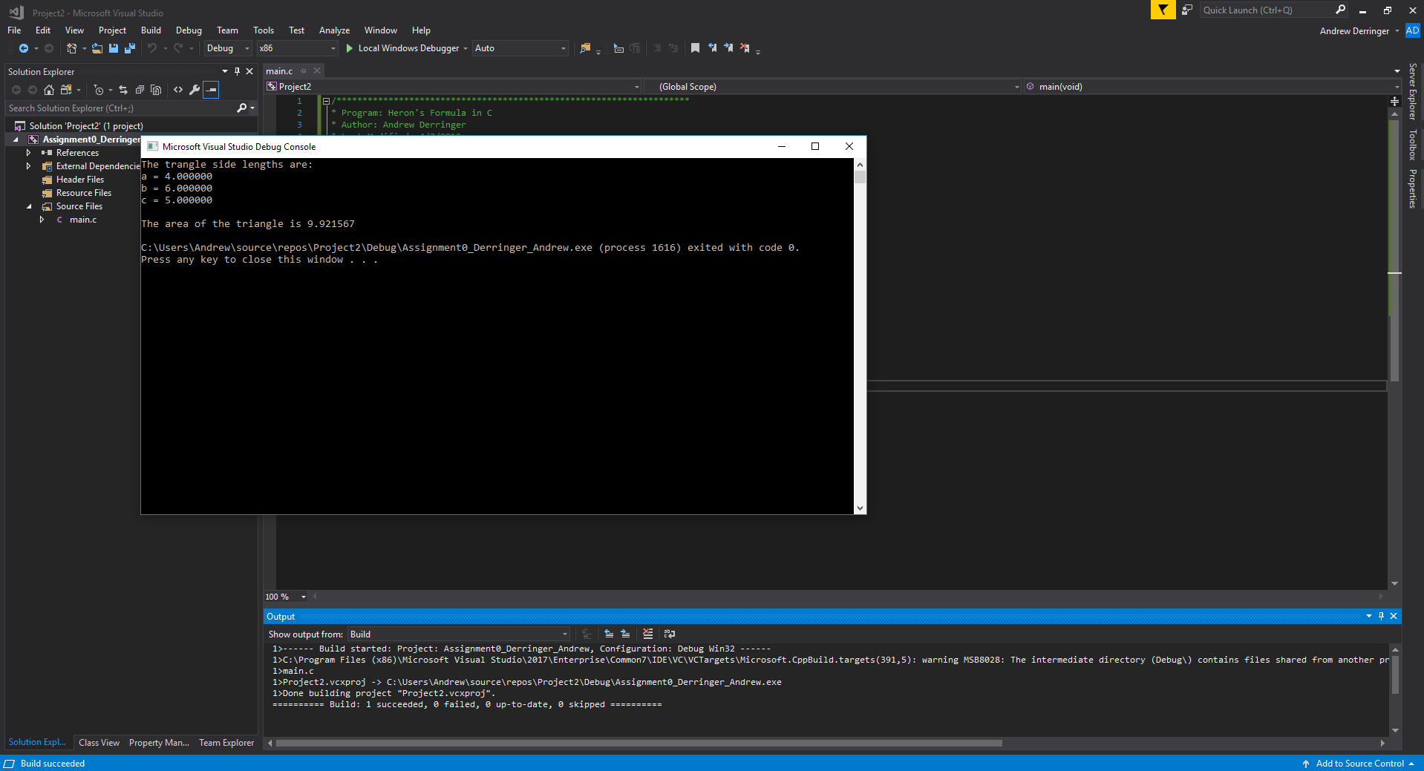

**PUTTY Output:  
