**21st Club Application Task**

Premier League clubs recruiting for any position should try to adhere to the Venn Diagram above.

**Wilfred Ndidi - 22:**

In order of importance:

1. Tackles % - The percentage of successful tackles
2. Interceptions Pm – The average amount of interceptions per match
3. Ground Pass % - The percentage of successful ground passes
4. Blocks PM – The average amount of blocks per match
5. Def Ground Duels % - The percentage of successful defensive ground duels

|  |  |  |  |  |  |  |  |
| --- | --- | --- | --- | --- | --- | --- | --- |
| **Name** | **Season** | **Tackle %** | **Interceptions PM** | **Ground Pass %** | **Blocks PM** | **Def Ground Duel %** | **Def Aerial Duel %** |
| **W. Ndidi** | 2017 | 38.3 | 1.58 | 86.7 | 2.35 | 61.3 | 65.9 |
| **W. Ndidi** | 2018 | 48.4 | 2.03 | 88.6 | 1.86 | 66.7 | 56.6 |

1. Def Aerial Duels % - The percentage of successful defensive aerial duels

As you would expect with age and experience, this data implies there has been a general improvement in Ndidi’s understanding of the game. There has been an increase in Ndidi’s tackling and interceptions. This perhaps negates the need to block, as much, in a last ditched attempt to protect the goal. Ndidi’s improvement has played a hand in Leicester conceding 60 goals in 2017 vs 48 in 2018. Unfortunately, relative to other midfielders of Ndidi’s standard his Ground Passing is lacking.

Leicester City FC

Before any club considers what players to buy they should first look within their current roster.

|  |  |  |  |  |  |  |  |
| --- | --- | --- | --- | --- | --- | --- | --- |
| **Name** | **Season** | **Tackle %** | **Interceptions PM** | **Ground Pass %** | **Blocks PM** | **Def Ground Duel %** | **Def Aerial Duel %** |
| **H. Choudhury** | 2016 | 33.3 | 2.02 | 83.1 | 1.56 | 66.7 | 80 |
| **H. Choudhury** | 2017 | 20 | 2.15 | 87.3 | 2.39 | 61.5 | 0 |
| **H. Choudhury** | 2018 | 58.3 | 2.81 | 89 | 1.95 | 60 | 80 |
| **N. Mendy** | 2018 | 33.3 | 1.16 | 92.8 | 1.16 | 53.1 | 25 |
| **M. James** | 2016 | 38.5 | 2.06 | 91 | 1.26 | 79.5 | 51.9 |
| **M. James** | 2017 | 30 | 1.54 | 90.8 | 1.36 | 44.7 | 62.1 |
| **D. Amartey** | 2016 | 40 | 1.46 | 90.3 | 1.68 | 41.2 | 48.8 |
| **D. Amartey** | 2017 | 42.9 | 1.29 | 92 | 2.21 | 50 | 50 |
| **D. Amartey** | 2018 | 66.7 | 2.39 | 91.4 | 1.27 | 61.5 | 61.1 |

Fortunately, there’s a wealth of players that can fill in for Ndidi. This means there is more of a risk can be taken on who is brought in to replace Ndidi and Leicester can offset the money gained from Ndidi’s departure to pay extra for Chilwell’s replacement.

I had already identified Choudhury as someone who could replace Ndidi, and he has the right age profile and home-grown status. The major setback to Choudhury is his lack of playing time, Choudhury would likely get burnt out with the psychological and physical demands of being a first team player for a full season.

Amartey is another player Leicester could rely on when Ndidi leaves. Amartey is definitely a player Leicester City could give much more responsibility to as he would only be marginally worse than Ndidi.

The rest of the players may have better offensive statistics but they are lacking the defensive capabilities needed for a defensive midfielder.

Suggestions

The four players I believe could fill Ndidi’s boots are (including Choudhury):

* Ruben Neves – 22 – Wolves
* Ezri Konsa – 21 – Brentford (Championship, home-grown)
* Denis Zakaria – 22 – Borussia Monchengladbach
* Declan Rice – 20 – West Ham (home-grown)
* Hamza Choudhury – 21 – Leicester City

|  |  |  |  |  |  |  |  |
| --- | --- | --- | --- | --- | --- | --- | --- |
| **Name** | **Season** | **Tackle %** | **Interceptions PM** | **Ground Pass %** | **Blocks PM** | **Def Ground Duel %** | **Def Aerial Duel %** |
| **R. Neves** | 2017 | 29.8 | 1.764 | 90.6 | 1.516 | 63.4 | 59.3 |
| **R. Neves** | 2018 | 33.3 | 2.131 | 89.8 | 1.718 | 55.6 | 48.5 |
| **E. Konsa** | 2018 | 80.6 | 1.204 | 95.9 | 0.909 | 56.4 | 58.5 |
| **D. Rice** | 2017 | 60 | 1.772 | 93.6 | 1.646 | 80.8 | 46.4 |
| **D. Rice** | 2018 | 44.9 | 1.384 | 94 | 1.446 | 79 | 60.3 |

Unfortunately, the data I am using to write this report has no information on Denis Zakaria. However, having watched Zakaria play a number of times I believe he is actually better than Ndidi. Zakaria is 1.89m tall making him more imposing than Ndidi. Only two teams conceded fewer goals than Monchengladbach. This is something Zakaria heavily contributed to.

Ruben Neves has good Premier League experience and fully understands the demands of the league. He has an excellent range of passing and is more likely to chip in with goals and assists as opposed to Ndidi. Although his defensive capabilities are not as astute.

Ezri Konsa is a young English player contracted to Brentford, a Championship side, and would relish the opportunity to join a Premier League club. Konsa has already played well over 3000 minutes.

Declan Rice is a hot prospect having recently gained his first England call up. Rice’s statistics show he is a far superior player than Ndidi at the same age, only having less blocks. Rice has the added combination of a good age profile and home-grown status.

Statistics

Using statistics alone I found the following left backs are better than Ndidi in relation to Tackle %, Interceptions PM and Ground Pass %:

|  |  |  |  |  |  |  |  |
| --- | --- | --- | --- | --- | --- | --- | --- |
| **Name** | **Season** | **Tackle %** | **Interceptions PM** | **Ground Pass %** | **Blocks PM** | **Def Ground Duel %** | **Def Aerial Duel %** |
| **J. Lowe** | 2016 | 51.9 | 2.178 | 92.4 | 1.241 | 57.4 | 56.9 |
| **J. Ledley** | 2016 | 48 | 2.169 | 91 | 0.775 | 65 | 43.5 |
| **A. Oxlade-Chamberlain** | 2017 | 66.7 | 2.231 | 89.2 | 2.603 | 75 | 44.4 |
| **J. Hegeler** | 2017 | 50 | 3.475 | 92.4 | 1.042 | 25 | 40 |
| **Semedo** | 2016 | 50 | 2.432 | 94.6 | 2.78 | 50 | 54.5 |
| **R. Morrison** | 2016 | 100 | 2.213 | 91.5 | 1.475 | 0 | 0 |
| **D. Amartey** | 2018 | 66.7 | 2.391 | 91.4 | 1.266 | 61.5 | 61.1 |
| **C. Kouyaté** | 2016 | 55.6 | 2.639 | 93.4 | 1.056 | 54.1 | 63.3 |

Ravel Morrison is an interesting conundrum that a worthwhile risk could be taken on. Leicester would be getting a player who has known potential coming into the peak of his career. Perhaps he has matured past his previous offield turmoil and is ready to concentrate on football. He would also prove to be an easy and willing target with his contract at Ostersund only being six months long. He is also home-grown. Unfortunately, he would have to adapt his playing style to become more defensive.

Interestingly, Amartey has found himself to be amongst these players. Due to this, Leicester City should look to go for more economical options as there is enough cover for Ndidi’s departure.

Alex Oxlade-Chamberlain is unrealistic target from Liverpool.

The rest do not fit the age profile.

Below are players considered but omitted:

* Ronaldo Vieira – 20 – Sampdoria (home-grown)
* Arne Maier – 20 – Hertha
* Tom Davies – 20 – Everton (home-grown)
* Marcus McGuanne – 20 – Barcelona (home-grown)
* Ainsley Maitland-Niles – 21 – Arsenal (home-grown)
* Igor Zubeldia – 22 – Real Sociedad
* Lucas Tousart – 22 - Lyon
* Marc Roca – 22 – Espanyol
* Lewis Cook – 22 - Bournemouth
* Mikel Merino – 22 – Real Sociedad
* Igor Zubeldia – 22 – Real Sociedad
* Eduard Lowen – 22 – Nuremburg
* Julian Weigl – 23 – Borussia Dortmund

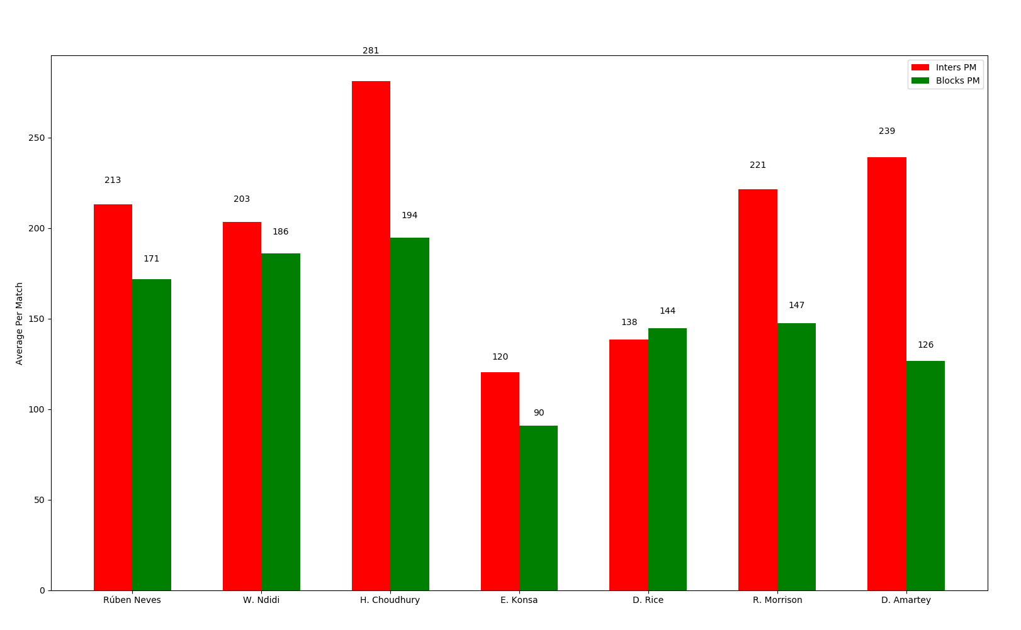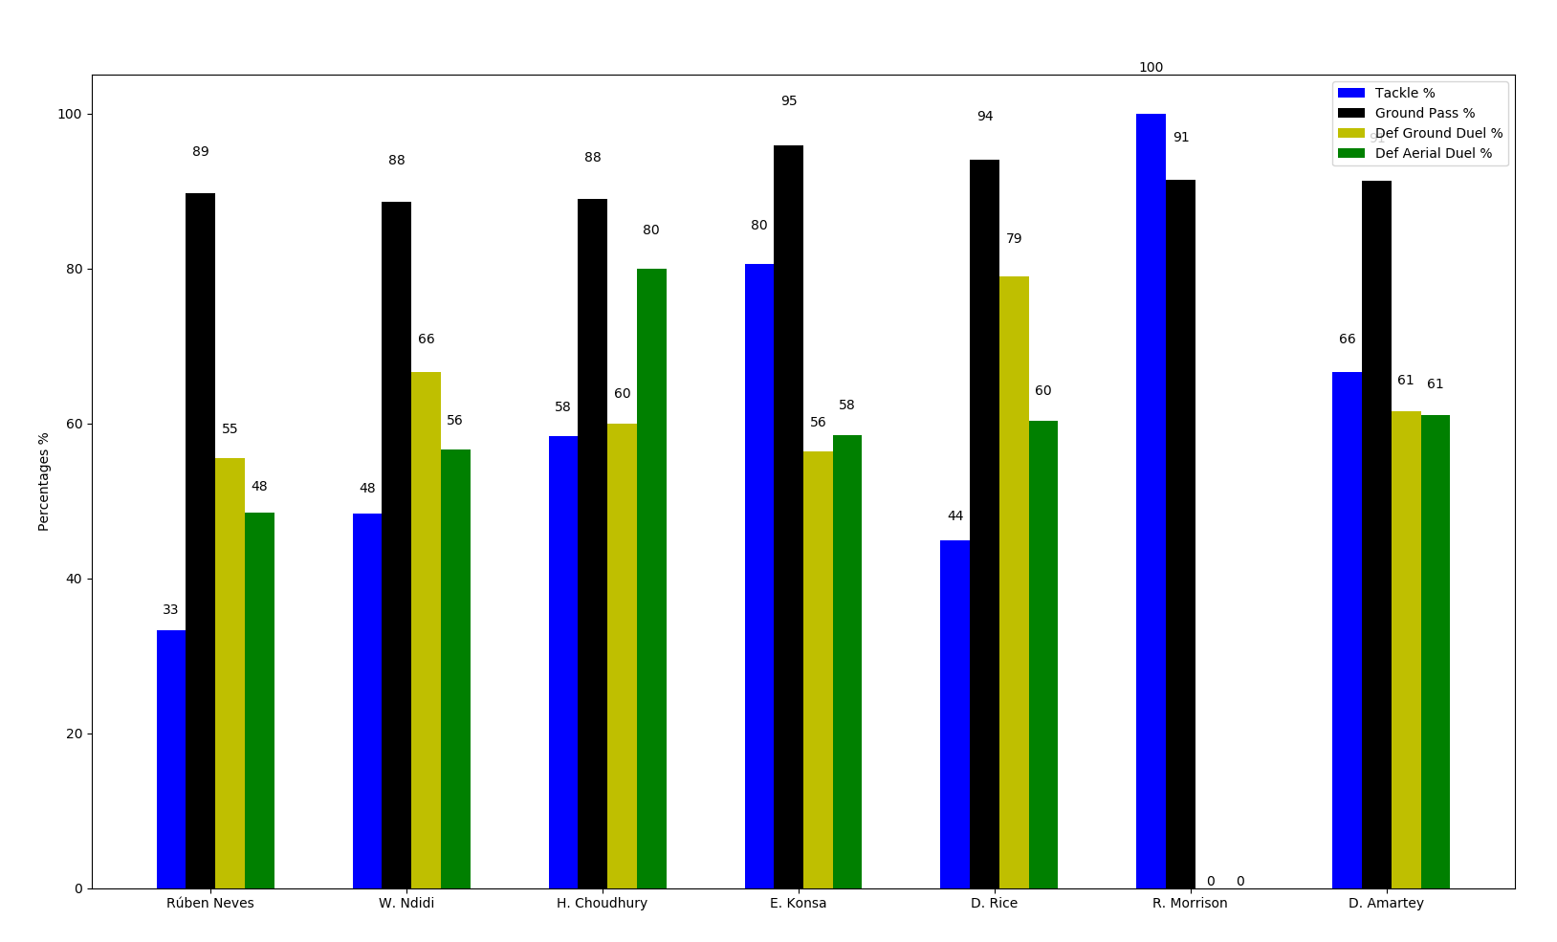

The bar charts should allow you to compare each player’s key statistics against Ndidi’s seamlessly.

I suggest Leicester sign Ezri Konsa whilst relying on Amartey and Choudhury to ease Konsa in. Having watched Konsa many times I believe his energy translates better as a Defensive Midfielder than a Centre Back. The left-over funds can be put to better use on other transfers. Leicester can expect anything from £30-40M for Ndidi whilst paying no more than £10M for Konsa. This would leave a net of +£20M to £30M.

**Ben Chilwell - 22:**

In order of importance:

1. Def Ground Duel % - The percentage of successful ground duels
2. Tackles % - the percentage of successful tackles
3. Crosses % - The percentage of successful crosses
4. Pass Location % - The percentage of passes received in the attacking third (used to indicate attack minded positioning)
5. Offensive Ground Duel % - The percentage of successful offensive ground duels (important to win these often to negate counter attacks from being out of position)
6. Attacking Pass % - The percentage of successful ground passes in the attacking third (important to keep high to negate counter attacks from being out of position)

|  |  |  |  |  |  |  |  |
| --- | --- | --- | --- | --- | --- | --- | --- |
| **Name** | **Season** | **Def Ground Duel %** | **Tackles %** | **Crosses %** | **Pass Location %** | **Offensive Ground Duel %** | **Attacking Pass %** |
| **B. Chilwell** | 2017 | 63.6 | 46.9 | 22.4 | 29.4 | 55 | 78.5 |
| **B. Chilwell** | 2018 | 52.7 | 44 | 18.1 | 32.1 | 47.1 | 74.2 |

This data implies Ben Chilwell’s ability has remained stagnant, and possibly worsened over the seasons. However, Chilwell has increased in playing minutes from 1852 to 3060 respectively. Chilwell’s extra involvement has contributed to Leicester conceding 60 goals in 2017 vs 48 in 2018.

Leicester City FC

Before any club considers what players to buy they should first look within their current roster.

|  |  |  |  |  |  |  |  |
| --- | --- | --- | --- | --- | --- | --- | --- |
| **Name** | **Season** | **Def Ground Duel %** | **Tackles %** | **Crosses %** | **Pass Location %** | **Offensive Ground duel %** | **Attacking Pass %** |
| **C. Fuchs** | 2016 | 69.3 | 47.4 | 32.9 | 19.1 | 33.3 | 83.6 |
| **C. Fuchs** | 2017 | 69.2 | 35 | 15.9 | 22.1 | 26.7 | 82.4 |
| **C. Fuchs** | 2018 | 57.1 | 50 | 26.7 | 39 | 50 | 86.7 |

Chilwell’s only cover is Fuchs, a player in the twilight years of his career. Fuchs’ statistics seem to be just as good as Chilwell’s. With Fuchs being 33 and nearing retirement, it is important to bring in someone who has the right age profile and ability to compete in the Premier League straight away.

The lack of cover requires prospects who are more likely to hit the ground running and can be relied upon.

Suggestions

The four players I believe could fill Chilwell’s boots are:

* Jay DaSilva – 21 – Chelsea (home-grown)
* Lloyd Kelly – 20 – Bristol City (Championship, home-grown)
* Luke Shaw – 23 – Manchester United (home-grown)
* Kieran Tierney – 21 - Celtic

|  |  |  |  |  |  |  |  |  |
| --- | --- | --- | --- | --- | --- | --- | --- | --- |
| **Name** | **Season** | **Team** | **Def Ground Duel %** | **Tackles %** | **Crosses %** | **Pass Location %** | **Offensive Ground Duel %** | **Attacking Pass %** |
| **J. Dasilva** | 2018 | Bristol City | 58.5 | 71.4 | 18.3 | 32.8 | 38.2 | 81.3 |
| **L. Kelly** | 2017 | Bristol City | 60 | 40 | 30.8 | 12.1 | 50 | 63 |
| **L. Kelly** | 2018 | Bristol City | 59 | 75 | 21 | 19.6 | 60.4 | 68.9 |
| **L. Shaw** | 2016 | Man United | 46 | 60 | 35.3 | 28.4 | 50 | 85.7 |
| **L. Shaw** | 2017 | Man United | 63.6 | 61.1 | 8.3 | 27.7 | 66.7 | 83.6 |
| **L. Shaw** | 2018 | Man United | 38 | 61.7 | 18.2 | 20 | 57.1 | 76.9 |

Unfortunately, the data I am using to write this report has no information on Kieran Tierney. However, his performances at Celtic; a team who have comfortably won the Scottish Premier League, demonstrates his ability. Although, he lacks the home-grown status the others have.

Jay DaSilva is a hot prospect on Chelsea’s books. He is a player Leicester could nurture into a world-class talent. Having won many trophies at youth level, DaSilva has since proven himself in the Championship.

Lloyd Kelly is another player I believe can make the step up from the Championship. Current information available in the media suggest Kelly is already eyeing up the prospect of a Premier League move.

Luke Shaw would be an easy option as a direct replacement. I would expect Shaw to return slightly worse numbers for Leicester as Manchester United are a better team.

Statistics

Using statistics alone I found the following left backs are better than Chilwell in relation to Def Ground Duel %, Tackle %, Cross % and Offensive Ground Duel %:

|  |  |  |  |  |  |  |  |  |
| --- | --- | --- | --- | --- | --- | --- | --- | --- |
| **Name** | **Season** | **Team** | **Def Ground Duel %** | **Tackles %** | **Crosses %** | **Pass Location %** | **Offensive Ground Duel %** | **Attacking Pass %** |
| **L. Baines** | 2017 | Everton | 69.6 | 64.3 | 33.3 | 25.9 | 63 | 75.3 |
| **R. Martina** | 2018 | Stoke City | 61.5 | 50 | 30.5 | 33.3 | 61.9 | 82.2 |
| **T. Kongolo** | 2017 | Huddersfield Town | 79.2 | 63.6 | 30 | 24.2 | 64.3 | 78.1 |

Baines and Martina would affect Leicester’s age profile too heavily.

Kongolo is stepping into his prime as he is 25 years of age. Considering Huddersfield finished bottom of the Premier League, Kongolo has done very well for himself. It should be an easy acquisition because of Huddersfield’s relegation.

Below are players considered but omitted:

* Nethaniel Ogbeta – 18 – Man City (home-grown)
* Ryan Sessegnon – 19 - Fulham (home-grown)
* Steven Sessegnon – 19 - Fulham (home-grown)
* Pierre N’Soki – 20 – Paris Saint-Germain
* Rogerio Da Silva – 21 – Juventus
* Theo Hernandez – 21 – Real Madrid
* Blas Riveros – 21 – Basel
* Jose Angel Esmoris Tasende (Angelino) – 22 – PSV Eindhoven
* Aaron Caricol – 22 – Espanyol
* Junior Firpo – 22 – Real Betis
* Mason Aaron Martin – 22 - FSV Mainz
* Fode Ballo-Toure – 22 – Monaco
* Demetri Mitchel – 22 – Man utd (home-grown)
* Sergio Regulilon Rodriquez – 22 – Real Madrid
* Maximilian Mittelstadt – 22 – Hertha Bsc
* Alfonso Pedraza Sag – 23 - Villarreal
* Ferland Mendy – 23 - Lyon
* Joose Gaya – 23 – Valencia
* Alejandro Grimaldo – 23 – Benfica
* Jack Robinson – 25 – Nottingham Forest (home-grown)

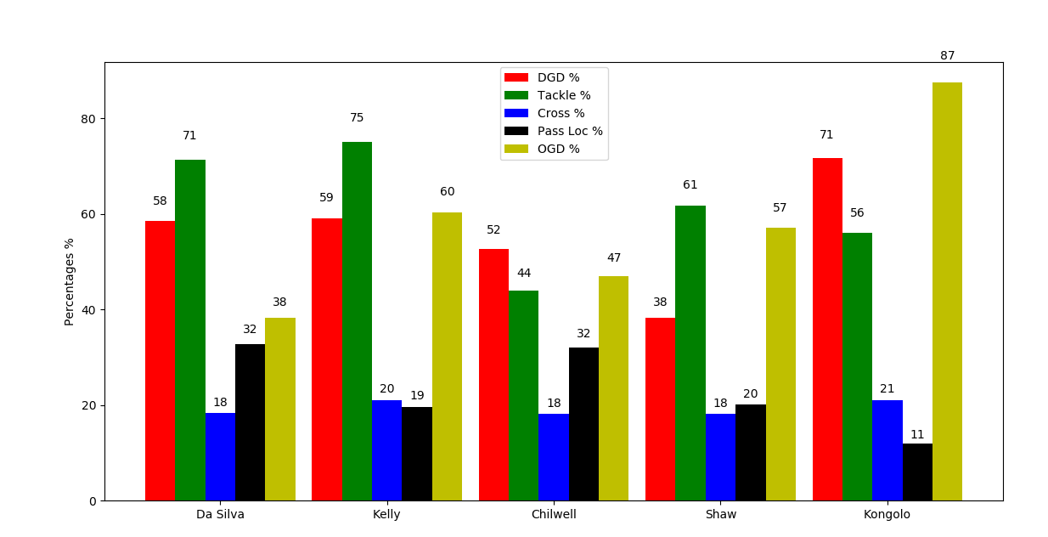

The bar chart should allow you to compare each player’s statistics vs Chilwell’s seamlessly.

I suggest bringing in two left backs. A combination of Kongolo and either Da Silva or Kelly. The money garnered from Chilwell’s sale and being more economical about Ndidi’s replacement should allow for this. Two players are needed as Fuchs’ retirement is imminent and therefore a long-term succession plan is needed. Going after Tierney and Shaw would require a bidding war for two players that would only provide marginally better returns. Leicester can expect anything from £25-35M for Chilwell whilst paying £15-20M for Kongolo and £10-15M for either Da Silva or Kelly. This would leave a net of -£10M to +£10M.

**James Maddison - 22:**

In order of importance:

1. Goals
2. Assists
3. GPATS (ground passes attacking third successful) % - The percentage of successful passes in the attacking third
4. PRB (passes received box) % – The percentage of passes received in the box of those in the attacking third
5. GPBS (ground passes box successful) % – The percentage of successful passes into the box
6. OGDS (offensive ground duels successful) % – The percentage of offensive ground duels won

|  |  |  |  |  |  |  |  |
| --- | --- | --- | --- | --- | --- | --- | --- |
| **Name** | **age** | **Goals** | **Assists** | **GPATS %** | **PRB %** | **GPBS %** | **OGDS %** |
| **J. Maddison** | 21 | 14 | 8 | 84.3 | 6.2 | 74.7 | 71.7 |
| **J. Maddison** | 22 | 7 | 7 | 81.1 | 7.2 | 68.2 | 66.7 |

The way statistics translate moving up from the Championship to the Premier League means Maddison has maintained his high-performance levels. Maddison is Leicester’s talisman, single handily turning games on their head in Leicester’s favour.

Leicester City FC

Before any club considers what players to buy they should first look within their current roster.

|  |  |  |  |  |  |  |  |
| --- | --- | --- | --- | --- | --- | --- | --- |
| **Name** | **Season** | **Goals** | **Assists** | **GPATS %** | **PRB %** | **GPBS %** | **OGDS %** |
| **Adrien Silva** | 2017 | 0 | 1 | 75 | 2.8 | 70 | 32 |
| **A. King** | 2016 | 1 | 0 | 83.3 | 20.7 | 100 | 65.4 |
| **H. Barnes** | 2017 | 5 | 4 | 68.6 | 19.6 | 62.5 | 28.2 |
| **H. Barnes** | 2018 | 9 | 6 | 78.5 | 12.3 | 66.2 | 59.8 |
| **H. Barnes** | 2018 | 1 | 2 | 77.1 | 11.7 | 54.3 | 25 |

If Barnes got more playing minutes perhaps he could influence his statistics in the right direction. A return of 9 goals and 6 assists in the Championship is enough of a reason to give him a chance.

Suggestions

The four players I believe could fill Maddison’s boots are:

* Jack Grealish – 23 – Aston Villa (Championship, home-grown)
* Houssem Aouar – 20 - Lyon
* Mason Mount – 20 – Chelsea (home-grown)
* David Brooks – 21 – Bournemouth (home-grown)

|  |  |  |  |  |  |  |  |
| --- | --- | --- | --- | --- | --- | --- | --- |
| **Name** | **Season** | **Goals** | **Assists** | **GPATS %** | **PRB %** | **GPBS %** | **OGDS %** |
| **D. Brooks** | 2017 | 3 | 4 | 77.3 | 13.8 | 59.5 | 44.4 |
| **D. Brooks** | 2018 | 7 | 5 | 64.4 | 14.7 | 53.9 | 51.1 |
| **M. Mount** | 2018 | 8 | 4 | 75.1 | 14.5 | 56.6 | 39.8 |
| **J. Grealish** | 2016 | 5 | 2 | 79.4 | 5.7 | 66.7 | 64.5 |
| **J. Grealish** | 2017 | 3 | 6 | 84.4 | 4 | 81 | 62.6 |
| **J. Grealish** | 2018 | 6 | 6 | 85.2 | 5.8 | 74.6 | 68.7 |

Unfortunately, the data I am using to write this report has no information on Houssem Aouar. However, his 7 goals and 8 assists in Ligue 1 speak for themselves. Although, Aouar lacks the home-grown status the others have.

Jack Grealish is a hot prospect on the Aston Villa books. Grealish has all the potential to become a world-class talent. For this very reason there are a number of clubs vying for his signature.

Mason Mount is another player I believe can make the step up from the Championship. With limited opportunity to play for Chelsea, it is likely Mount will be looking for consistent Premier League experience elsewhere.

David Brooks is of similar standing to Maddison. As Leicester are a better team than Bournemouth, I would expect all of Brooks’ key statistics to improve.

Statistics

Using statistics alone I found the following midfielders that GPATS % > 81.1, PRB % > 7.2 and GPBS % > 73

|  |  |  |  |  |  |  |  |
| --- | --- | --- | --- | --- | --- | --- | --- |
| **Name** | **Season** | **Goals** | **Assists** | **GPATS %** | **PRB %** | **GPBS %** | **OGDS %** |
| **Evandro** | 2018 | 3 | 4 | 82.9 | 13.9 | 75 | 57.7 |
| **R. Barkley** | 2018 | 3 | 5 | 88.5 | 10 | 85.7 | 45.6 |
| **G. Wijnaldum** | 2016 | 6 | 9 | 85.1 | 11.5 | 85.1 | 35.7 |
| **J. Howson** | 2016 | 6 | 7 | 81.5 | 10.1 | 74.5 | 26 |
| **F. Fabregas** | 2016 | 5 | 12 | 87.4 | 9.2 | 86.7 | 65.4 |
| **C. Hourihane** | 2016 | 6 | 11 | 83.8 | 9.4 | 73.3 | 61.2 |
| **C. Hourihane** | 2018 | 7 | 10 | 86.9 | 11.1 | 76.9 | 64.6 |
| **M. Duffy** | 2018 | 6 | 6 | 83.2 | 7.8 | 73.2 | 34.8 |

Barkley is the only viable option as the rest would affect Leicester’s age profile too heavily.

Players considered but omitted:

* Emille smith-rowe – 18 – Arsenal (home-grown)
* Reiss Nelson – 19 – Arsenal (home-grown)
* Joao felix – 19 – Benfica
* Marcus Edwards – 20 – Spurs (home-grown)
* Martin odegaard - 20 – Real Madrid
* Houssem Aouar – 20 – Lyon
* Xaver Schlager - 21 – Red Bull Salzburg
* Lucas Paqueta – 21 – AC Milan
* Jeff Adelaide – 21 – Angers
* Maxime lopez – 21 – Marseille
* Salih ozcan – 21 – Koln
* Harry Wilson – 22 – Liverpool (home-grown)
* Kasey palmer – 22 – Chelsea (home-grown)
* Kieran dowell – 22 – Everton (home-grown)
* Josh onomoah – 22 – Spurs (home-grown)
* Charly masunda – 22 – Chelsea (home-grown)
* Van de beek – 22 - Ajax
* Aleksandr Golovin – 22 - Monaco
* Ruben Loftus-cheek – 23 – Chelsea (home-grown)
* Carlos soler – 22 – Valencia
* Abdelhamid sabiri – 22 – Huddersfield Town (home-grown)
* Nadiem Amiri – 22 - Hoffenheim
* Florian Neuhaus – 22 – Borussia Monchengladbach
* Maximilian eggestein – 22 – Werder Bremen
* Pablo Fornals – 23 – Villarreal
* Max meyer – 23 – Crystal Palace
* Mijat Gacinovic – 24 – Eintracht Frankfurt
* Leandro Trossard – 24 – Genk
* Luciano Acosta – 24 – DC United
* Thorgan Hazard – 26 – Borussia Monchengladbach
* Pablo Sarabia – 27 - Sevilla

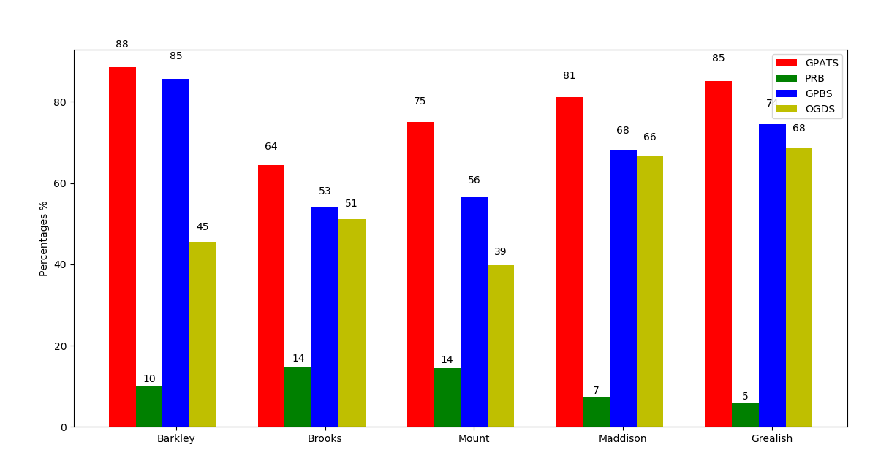

|  |  |  |  |  |
| --- | --- | --- | --- | --- |
| **Name** | **Team** | **Goals** | **Assists** | **Age** |
| **R. Barkley** | Chelsea | 3 | 5 | 25 |
| **D. Brooks** | AFC Bournemouth | 7 | 5 | 21 |
| **M. Mount** | Derby County | 8 | 4 | 20 |
| **J. Maddison** | Leicester City | 7 | 7 | 22 |
| **J. Grealish** | Aston Villa | 6 | 6 | 23 |
| **H. Aouar** | Lyon | 7 | 8 | 20 |

Maddison is extremely important to Leicester’s success. I would argue only Aouar is on par with Maddison’s ability therefore, more analysis is needed of players outside the domestic leagues. Perhaps it would better to comb through the list of players I’ve considered but omitted in more detail. Despite Aouar’s relatively high price tag, I would still pick Aouar as there needs to be an emphasis on ability in order to replace Maddison. The hype surrounding Grealish has inflated his price therefore, I believe he will only be marginally better than Mount yet worse than Brooks. Leicester should expect over £40M for Maddison and should not pay anything more for Aouar than what they receive from the sale of Maddison. This is to ensure a positive net spend.

**Conclusion**

In 🡪Konsa; Out🡪 Ndidi: +£25M

In 🡪Kongolo, Kelly or DaSilva; Out🡪 Chilwell: ±£0M

In🡪Aouar; Out🡪 Maddison: ±£0M

By following the suggestions outlined in this report Leicester can hope to achieve a slightly higher finishing position in the Premier League next season. Leicester will also have an extra £25M to bolster the squad in other areas. It is likely Konsa’s and Kelly or DaSilva’s performance will dip as they will be adjusting to a more difficult league. This will be offset by Kongolo improving this season as Leicester are a stronger team than Huddersfield. If Aouar is able to overcome the more physical aspects of the Premier League his output for Lyon should translate very well to Leicester’s.

Antoine Fontaine