Respuestas
Tema 1:
- = $\frac{{[\sqrt{2},\frac{7}{4}π]}^{10}}{{[2,\frac{π}{6}]}^{5}}= \frac{[32,\frac{3}{2}π]}{[32,\frac{5}{6}π]}=\left[1,\frac{2}{3}π\right]= -\frac{1}{2}+ \frac{\sqrt{3}}{2} j (2do cuadrante)$
$$\ln\left(-\frac{1}{2}+ \frac{\sqrt{3}}{2} j\right)=\frac{2}{3}π j$$
- Función impar: t entre -$π y π$
Sólo bn no nulo

$$b_{n}=\frac{-2{(-1)}^{n}}{n}$$
$$C_{n}=\frac{{(-1)}^{n}}{n}j$$
STF:
$$S\left(t\right)= -2\sum_{n=1}^{∞}{\frac{{ \left(-1\right)}^{n}}{n} sen\left(nt\right)}$$
SEF:
$$S\left(t\right)= \sum_{-∞}^{∞}{\frac{{ \left(-1\right)}^{n}}{n} j e^{jnt}}$$

- A) $Y\left(s\right)= \frac{\left(s-2\right)\left(s+1\right)}{s{\left(s-1\right)}^{2}}= \frac{-2}{s}-\frac{2}{{\left(s-1\right)}^{2}}+\frac{3}{s-1}y\left(t\right)= -2-2te^{t}+3e^{t}$
B)
$${L\left(\frac{sen t}{t}\right)}_{\left[0\right]}= F\left(0\right)= \frac{π}{2} \\ F\left(s\right)=\int_{s}^{∞}{\frac{du}{u^{2}+1}={arctan⁡(u)}_{s}^{∞}=\frac{π}{2}-arctan\left(s\right) }$$
- Si k = 3:
$$G\left(s\right)=\frac{10\left(s-1\right)\left(s-3\right)}{\left(s^{2}+6s+10\right)\left(s-1\right)}= \frac{10\left(s-3\right)}{\left(s^{2}+6s+10\right)} \\ Y\left(s\right)= \frac{10\left(s-3\right)}{s\left(s^{2}+6s+10\right)}= \frac{-3}{s}+\frac{3s+28}{{\left(s+3\right)}^{2}+1}= \frac{-3}{s}+\frac{3\left(s+3\right)}{{\left(s+3\right)}^{2}+1} +\frac{19}{{\left(s+3\right)}^{2}+1}$$$y\left(t\right)= -3+3\cos\left(t\right)e^{-3t}+19 sen\left(t\right)e^{-3t}$ (Rta. Oscilatoria Amortiguada y Desplazada 3 unidades hacia abajo)
- A) $X\left(z\right)=\sum_{k=0}^{∞}{ {\left(\frac{1}{9z^{2}}\right)}^{k}}+\frac{10}{z}\sum_{k=0}^{∞}{ {\left(\frac{4}{z^{2}}\right)}^{k}}=\frac{1}{1-\left(\frac{1}{9z^{2}}\right)}+ \frac{10}{z} \frac{1}{1-\left(\frac{4}{z^{2}}\right)}=\frac{9z^{2}}{9z^{2}-1}+\frac{10z}{z^{2}-4}$
R.C.
$$\left|\frac{1}{9z^{2}}\right|<1→ \left|z\right|>\frac{1}{3} \\ \left|\frac{4}{z^{2}}\right|<1→ \left|z\right|>2$$Rta: $\left|z\right|>2$
B) $\sum_{0}^{∞}{n.2^{-n}}={Z(n)}_{[2]}={[\frac{z}{{(z-1)}^{2}}]}_{[2]}=2$

Tema 2
- $z^{1}-\left(3+j\right)z+4+3j=0$$$z_{0}=2-j \\ z_{1}=1+2j \\ \left|2-j-1\right|=\left|1-j\right|=\sqrt{2}<2 \left(Cumple\right) \\ \left|1+2j-1\right|=\left|2j\right|=2 (No cumple)$$

A) $k=2 \left(Impar desplazada con valor medio 3\right)$
B) Sólo bn no nulo
$$b_{n}=\frac{-8}{nπ} ({\left(-1\right)}^{n}-1)$$
$$C_{n}=\frac{4 {((-1)}^{n}-1)}{nπ}j$$
STF:
$$S\left(t\right)= \frac{16}{π}\sum_{k=0}^{∞}{\frac{sen[(2k+1)\frac{π}{2}x]}{2k+1} }$$
SEF:
$$S\left(t\right)=\frac{-8}{π} \sum_{-∞}^{∞}{\frac{e^{j(2k+1)\frac{π}{2}t}}{2k+1} j }$$
- A) $Y\left(s\right)=\frac{2}{{\left(s-1\right)}^{2}}$$$y\left(t\right)=2te^{t}$$
B)
$$2.{L\left(\frac{sen t}{t}\right)}_{\left[0\right]}= 2.F\left(0\right)= π (se multiplica por 2 porque la función es par) \\ F\left(s\right)=\int_{s}^{∞}{\frac{du}{u^{2}+1}={arctan⁡(u)}_{s}^{∞}=\frac{π}{2}-arctan\left(s\right) }$$
- Si k = 1:
$$G\left(s\right)=\frac{5\left(s+1\right)\left(s-2\right)}{\left(s^{2}+2s+2\right)\left(s-2\right)(s+3)}= \frac{5\left(s+1\right)}{\left(s^{2}+2s+2\right)(s+3)} \\ Y\left(s\right)= \frac{5}{\left(s^{2}+2s+2\right)(s+3)}= \frac{1}{s+3}+\frac{-s+1}{{\left(s+1\right)}^{2}+1}= \frac{1}{s+3}-\frac{\left(s+1\right)}{{\left(s+1\right)}^{2}+1} +\frac{2}{{\left(s+1\right)}^{2}+1} \\ y\left(t\right)= e^{-3t}-\cos\left(t\right)e^{-t}+2 sen\left(t\right)e^{-t}$$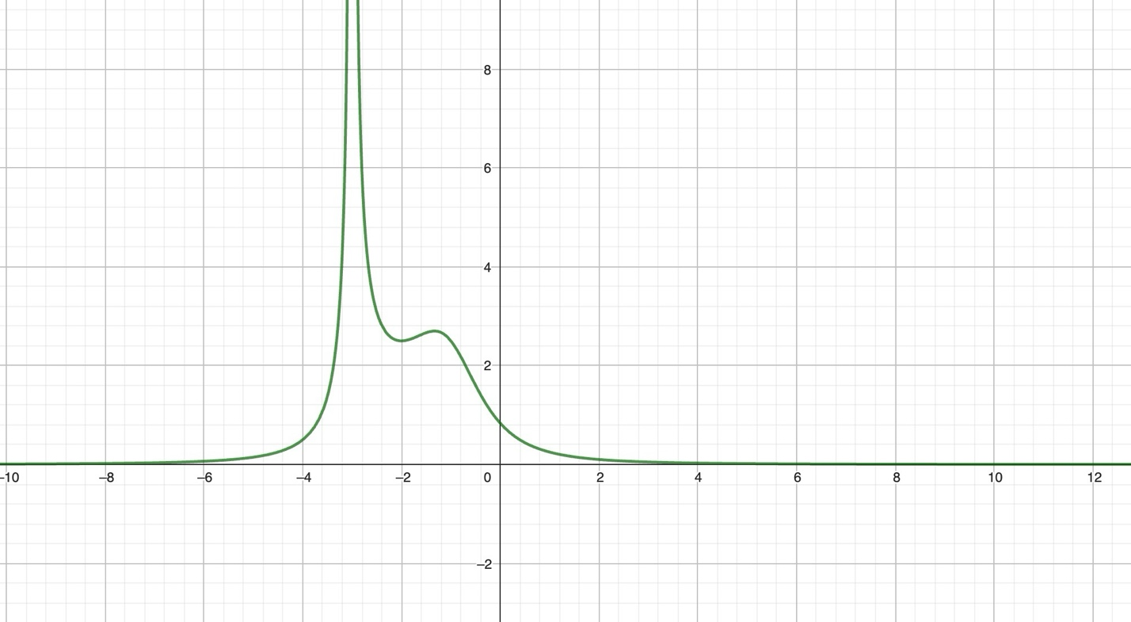
- A)) $X\left(z\right)=\sum_{k=0}^{∞}{ {\left(\frac{4}{z^{2}}\right)}^{k}}+\frac{4}{z}\sum_{k=0}^{∞}{ {\left(\frac{16}{z^{2}}\right)}^{k}}=\frac{1}{1-\left(\frac{4}{z^{2}}\right)}+ \frac{10}{z} \frac{1}{1-\left(\frac{16}{z^{2}}\right)}=\frac{z^{2}}{z^{2}-4}+\frac{4z}{z^{2}-16}$
R.C.
$$\left|\frac{4}{z^{2}}\right|<1→ \left|z\right|>2 \\ \left|\frac{16}{z^{2}}\right|<1→ \left|z\right|>4$$Rta: $\left|z\right|>4$
B) $\sum_{0}^{∞}{n^{2}.4^{-n}}={Z(n^{2})}_{[4]}={[\frac{z(z+1)}{{(z-1)}^{3}}]}_{[4]}=\frac{20}{27}$

