$lnln \left(4-4j\right) =4.lnln \left(2\right) +\left(\frac{7}{4}π+2kπ\right)j , k∈Z$${\left|z\right|}^{2}-Re\left(z^{2}\right)≤200a^{2}+b^{2}-\left(a^{2}-b^{2}\right)≤200 \left|b\right|<10 Rta: la$
intersección es de 3 elementos
$z_{1}=4.lnln \left(2\right) + \frac{7}{4}π.j{ z}_{2}= 4.lnln \left(2\right) - \frac{1}{4}π.jz_{3 }=4.lnln \left(2\right) - \frac{9}{4}π.j$
$C_{0}=\frac{1}{5}$$Cn=\frac{1}{5} \frac{sen\left(\frac{nπ}{5}\right)}{\frac{nπ}{5}}$
- $S\left(t\right)=\frac{1}{5}+ \frac{1}{5} \frac{sen\left(\frac{nπ}{5}\right)}{\frac{nπ}{5}} e^{jnt}$
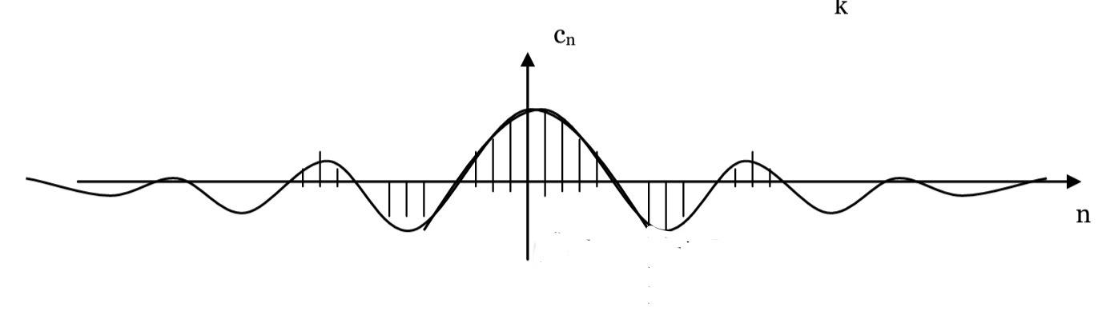
A) $\cos^{3}\left(t\right)={\left(\frac{e^{jt}+e^{-jt}}{2}\right)}^{3}=\frac{1}{4}coscos \left(3t\right) +\frac{3}{4}coscos \left(t\right)$$Y\left(s\right)=\frac{1}{4}\frac{s}{s^{2}+9}+\frac{3}{4}\frac{s}{s^{2}+1}$
B) $y\left(t\right)= \int_{0}^{t}{}sen\left(u\right).sen\left(t-u\right) du$$y\left(t\right)= -\frac{1}{2}.t.cos\left(t\right)+\frac{1}{2}.sen\left(t\right)$
A)
$b≥ 0 \left(Para evitar que se convierta en un polo en el semiplano derecho\right)a=10 (Para simplificar con el \left(s-5\right) del denominadorB) Y\left(s\right)=\frac{34\left(s+2\right)}{s\left(s^{2}+8s+17\right)}=\frac{A}{s}+\frac{Bs+C}{s^{2}+8s+17}=\frac{4}{s}+\frac{-4s+2}{{\left(s+4\right)}^{2}+1}y\left(t\right)=4-4.coscos \left(t\right) .e^{-4t}+18.sen\left(t\right).e^{-4t}$
$X\left(z\right)= \frac{-z^{2}+4z}{{\left(z-1\right)}^{2} \left(z-2\right)}= -\frac{3z}{{\left(z-1\right)}^{2}}-\frac{2z}{z-1}+\frac{2z}{z-2}$$x\left(n\right)= -3n-2+2^{n+1}x\left(2\right)= -6-2+2^{3}=0En la$
ecuación en diferencia:
$x\left(1\right)=2.0+3.0-1=-1x\left(2\right)= 2.\left(-1\right)+3.1-1=0$

