**Assignment Series 5**

Code Transformation and Optimisation

Andrea & Aynel

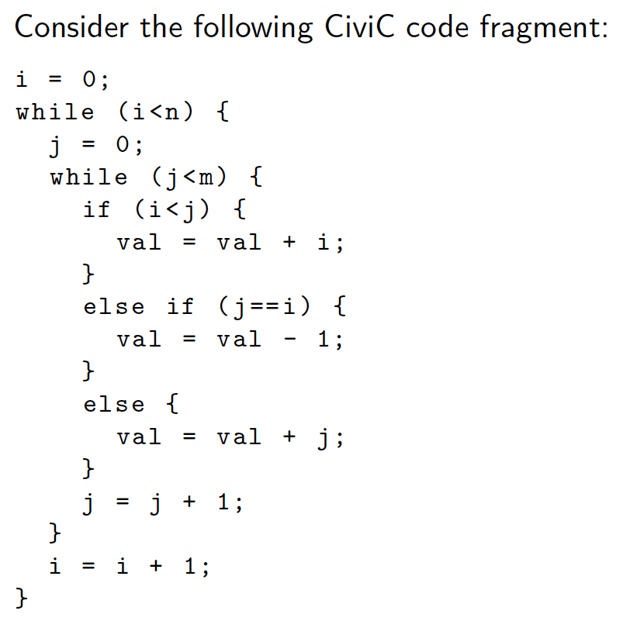

**Assignment 18: Static Single Assignment Form**

i_0 = 0;  
p_0 = i_0 < n;  
  
while ( phi(p_0, p_1) )  
{

j_0 = 0;  
 q_0 = j_0 < m;  
  
 while( phi(q_0, q_1) )  
 {

i_1 = phi(i_0, i_2);

j_1 = phi(j_0, j_2);

val_4 = phi(val_1, val_2, val_3);

val_5 = phi(val_0, val_4);

if (i_1 < j_1) {  
 val_1 = val_5 + i_1;

} else if (j_1 == i_1) {

val_2 = val_5 - 1;

} else {

val_3 = val_5 + j_1;

}

j_2 = j_1 + 1;  
 q_1 = j_2 < m;

}

i_2 = i_1 + 1;

p_1 = i_2 < n;

}

**Assignment 19: Machine-Independent Optimisation**



After loop-unrolling:  
  
i = 0;  
while (i < n) {  
 j = 0;

if (i < j ) {  
 while (j < m ) {  
 val += i;  
 j += 1;  
 }  
 }  
   
 if ( j == i ) {  
 while (j < m) {  
 val -= 1;  
 j += 1;  
 }  
 }  
  
 if (i > j) {  
 while (j < m) {  
 val += j;  
 j += 1;  
 }  
 }  
  
 i += 1;  
}

Of omgeschreven naar for loops:

for (int i = 0; i < n; i++) {

for (int j = 0; j < i; j++) {

val += j;

}

val -= 1;

for (j = i + 1; j < m; j++) {

val += i;

}

}

**Assignment 20: Compilation Scheme**

Original:

| while (condition) { |

C | *Body* |

| } |

| *Rest* |

Replacement:

| if (condition) { |

-> | do { |

| C|*Body*| |

| } while (condition) |

| } |

| C|*Rest|* |