SGN-14006 Audio and Speech Processing

Project work report

Vili Saura 240264

Jonas Nikula 240497

- Overview
In the project work we created a psychoacoustic lossy audio coder by using a uniform filterbank and simplified psychoacoustic model. We’ll go through the process step by step and provide related illustrations. Consulting the Matlab code simultaneously will help at understanding the underlying principles. Later we analyze questions regarding quantization with and without the psychoacoustic filter.
  - Analysis-Synthesis filterbank
First, we created an Analysis-Synthesis filterbank to obtain M-subband signals. The filterbank used here is similar we created in exercise 3. We also test the filter by reconstructing the signal.
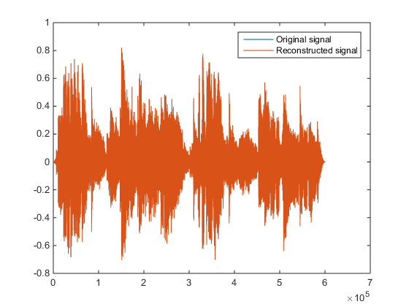
  - Psychoacoustic model
    - Obtaining normalized Sound pressure level (SPL) from amplitude spectrum
    - Obtain maximum SPL for each subband
    - Computing masking threshold from SPL levels
    - Threshold with Temporal Masking consideration
    - Computing Signal to Mask Ratio (SMR)
    - Bit allocation
  - Quantization
  - Decoder

- Psychoacoustic model quantization
Quantize the signal with the psychoacoustic model. Try different threshold values (TH_MASK) to obtain average bitrates between 2 and 4 bits/sample. How does the residual error look like, and how does the signal sound?
- Quantization without the psychoacoustic model
Quantize the input signal directly (without the psychoacoustic model) using the same number of bits (use the function myquantize directly for the input signal). How does the residual error look like, and how does the signal sound perceptually? Is there a difference to the psychoacoustic model’s output signal and if so, what is it?

