ISTM-622 PROJECT GIGAVOLT MILESTONE-1
~Atharva Kedar
TABLE OF CONTENTS
PROJECT GIGAVOLT · ISTM-622 · MILESTONE 1

Table of Contents | 1
1. Overview & Youtube Video Link | 2
2. Objectives | 2
3. Bronze / Staging Layer | 2
4. Silver Layer / 3NF Design | 2-3
5. Design Decisions & Rationale | 3
6. Code Artifacts | 3-14
6a. Bronze Layer – DDL | 3-5
6b. Bronze Layer – DML & Sample Output | 5
6c. Silver Layer – DDL | 5-8
6d. Silver Layer – DML / Transformation & Sample Output | 8-14
7. Entity Relationship Diagram | 15
8. Data Quality Verification & Sample Output | 15-23
9. 4D’s of AI Fluency | 23

1) Overview
Milestone 1 establishes the relational foundation by ingesting the ERP CSV files into an AWS environment, preserving raw source data in a Bronze/Staging layer, cleansing and transforming the records, and loading a normalized Silver/production layer. The implementation uses AWS EC2, Ubuntu, MariaDB, Bash, SQL, regular expressions, and CSV-based ingestion. The Silver/production layer is implemented with InnoDB tables, primary keys, and foreign keys to support relational integrity.
MY YOUTUBE VIDEO LINK -> https://youtu.be/OVbF-JS58dM
COMPLETE SCRIPT -> Github repo with whole E2E script
2) Objectives
Objective | Implementation
Raw ingestion | Loaded five ERP CSV datasets into Bronze tables using LOAD DATA LOCAL INFILE.
Cleansing | Standardized dates, whitespace, HTML markup, phone values, status/country formatting, and numeric currency fields.
Duplicate handling | Retained a canonical row for duplicate business keys and excluded non-canonical records from Silver.
Normalization | Created five production entities designed around 3NF principles.
Integrity | Implemented primary/foreign keys and validation queries for orphan and quality checks.
Documentation | Prepared SQL scripts, ERD, transformation logic, validation evidence, and screencast structure.

3) Bronze / Staging Layer
The Bronze layer preserves the incoming ERP data with minimal interpretation. Source attributes are stored primarily as TEXT so that malformed dates, formatted currency values, HTML tags, blank strings, and other source irregularities can be retained for downstream cleansing. Five Bronze tables are created: bronze_customers_raw, bronze_equipment_raw, bronze_dispatches_raw, bronze_parts_raw, and bronze_warranty_claims_raw.
Data is loaded with LOAD DATA LOCAL INFILE after the source ZIP is downloaded and extracted to /opt/data.

4) Silver Layer / 3NF Design
The Silver layer contains five production entities. The schema uses primary keys for row identity, foreign keys for relationships, typed DATE/DECIMAL/INT fields for clean analytics, and InnoDB for relational integrity.
Table | Primary key | Foreign keys | Purpose
customers | customer_id | None | Customer master data.
equipment_units | equipment_id | customer_id → customers.customer_id | Equipment owned by customers.
service_logs | dispatch_id | equipment_id → equipment_units.equipment_id | Technician/service dispatch history.
parts_inventory | part_id | None | Parts catalog and inventory data.
warranty_claims | claim_id | equipment_id; dispatch_id; part_id | Warranty claim transactions and related entities.

5) DESIGN DECISIONS & RATIONALE
- Bronze preserves source fidelity and gives the pipeline a reproducible starting point.
- Silver uses typed InnoDB tables because downstream analytics require consistent values and referential integrity.
- Primary keys identify business entities; foreign keys enforce relationships between dependent tables.
- Duplicate selection uses a deterministic minimum staging id because the source did not provide a trustworthy update timestamp.
- Optional warranty dispatch and part relationships remain nullable because missing optional references are not equivalent to orphaned references.
- Regex-based transformations make the cleansing logic explicit, repeatable, and easy.

6) CODE ARTIFACTS
6a) BRONZE LAYER (DDL Script) -> Stg_layer.sql (name as used in the script)
echo "[$(date '+%Y-%m-%d %H:%M:%S')] Creating stg layer schema..."
cat << 'EOF' > /tmp/stg_layer.sql
CREATE DATABASE IF NOT EXISTS app_db;
CREATE USER IF NOT EXISTS 'app_user'@'localhost' IDENTIFIED BY 'StrongPassword123!';
GRANT ALL PRIVILEGES ON app_db.* TO 'app_user'@'localhost';
FLUSH PRIVILEGES;
USE app_db;

CREATE TABLE stg_customers_raw (
id INT AUTO_INCREMENT PRIMARY KEY,
customer_id TEXT, company_name TEXT, contact_name TEXT, phone TEXT, email TEXT,
address TEXT, city TEXT, state TEXT, zip TEXT, country TEXT, created_date TEXT, status TEXT
) ENGINE=MyISAM;

CREATE TABLE stg_dispatches_raw (
id INT AUTO_INCREMENT PRIMARY KEY,
dispatch_id TEXT, equipment_id TEXT, customer_id TEXT, dispatch_date TEXT,
technician TEXT, service_type TEXT, hours_spent TEXT, labor_cost TEXT,
resolution_summary TEXT, status TEXT
) ENGINE=MyISAM;

CREATE TABLE stg_equipment_raw (
id INT AUTO_INCREMENT PRIMARY KEY,
equipment_id TEXT, customer_id TEXT, model TEXT, serial_number TEXT,
install_date TEXT, capacity_kw TEXT, voltage TEXT, warranty_expiration TEXT,
status TEXT, location_notes TEXT
) ENGINE=MyISAM;

CREATE TABLE stg_parts_raw (
id INT AUTO_INCREMENT PRIMARY KEY,
part_id TEXT, part_name TEXT, category TEXT, manufacturer TEXT, supplier TEXT,
unit_cost TEXT, unit_price TEXT, stock_quantity TEXT, reorder_level TEXT
) ENGINE=MyISAM;

CREATE TABLE stg_warranty_claims_raw (
id INT AUTO_INCREMENT PRIMARY KEY,
claim_id TEXT, equipment_id TEXT, dispatch_id TEXT, part_id TEXT,
claim_date TEXT, claim_amount TEXT, approved_amount TEXT, status TEXT,
denial_reason TEXT, claim_notes TEXT
) ENGINE=MyISAM;
EOF
mariadb < /tmp/stg_layer.sql

6b) BRONZE LAYER (DML SCRIPT) -> 2_stg_load.sql (name as used in the script)
USE app_db;
SET GLOBAL local_infile = 1;
LOAD DATA LOCAL INFILE '/opt/data/customers.csv' INTO TABLE stg_customers_raw FIELDS TERMINATED BY ',' ENCLOSED BY '"' LINES TERMINATED BY '\n' IGNORE 1 ROWS (customer_id,company_name,contact_name,phone,email,address,city,state,zip,country,created_date,status);
LOAD DATA LOCAL INFILE '/opt/data/dispatches.csv' INTO TABLE stg_dispatches_raw FIELDS TERMINATED BY ',' ENCLOSED BY '"' LINES TERMINATED BY '\n' IGNORE 1 ROWS (dispatch_id,equipment_id,customer_id,dispatch_date,technician,service_type,hours_spent,labor_cost,resolution_summary,status);
LOAD DATA LOCAL INFILE '/opt/data/equipment.csv' INTO TABLE stg_equipment_raw FIELDS TERMINATED BY ',' ENCLOSED BY '"' LINES TERMINATED BY '\n' IGNORE 1 ROWS (equipment_id,customer_id,model,serial_number,install_date,capacity_kw,voltage,warranty_expiration,status,location_notes);
LOAD DATA LOCAL INFILE '/opt/data/parts.csv' INTO TABLE stg_parts_raw FIELDS TERMINATED BY ',' ENCLOSED BY '"' LINES TERMINATED BY '\n' IGNORE 1 ROWS (part_id,part_name,category,manufacturer,supplier,unit_cost,unit_price,stock_quantity,reorder_level);
LOAD DATA LOCAL INFILE '/opt/data/warranty_claims.csv' INTO TABLE stg_warranty_claims_raw FIELDS TERMINATED BY ',' ENCLOSED BY '"' LINES TERMINATED BY '\n' IGNORE 1 ROWS (claim_id,equipment_id,dispatch_id,part_id,claim_date,claim_amount,approved_amount,status,denial_reason,claim_notes);
EOF
mariadb --local-infile=1 < /tmp/2_stg_load.sql

EXAMPLE OUTPUT -
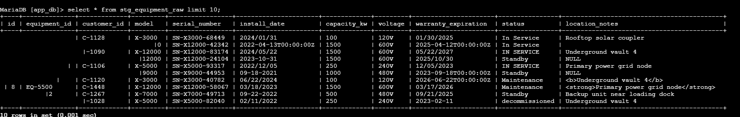
6c) SILVER LAYER (DDL SCRIPT) -> prod_table.sql (Name as used in the script)
USE app_db;
CREATE TABLE IF NOT EXISTS customers (
customer_id VARCHAR(50) PRIMARY KEY,
company_name VARCHAR(255),
contact_name VARCHAR(255),
email VARCHAR(255),
phone VARCHAR(50),
address VARCHAR(500),
city VARCHAR(100),
state VARCHAR(100),
postal_code VARCHAR(20),
country VARCHAR(100),
status VARCHAR(50),
created_date DATE
) ENGINE=InnoDB;

CREATE TABLE IF NOT EXISTS equipment_units (
equipment_id VARCHAR(50) PRIMARY KEY,
customer_id VARCHAR(50) NOT NULL,
serial_number VARCHAR(100),
model VARCHAR(100),
capacity_kw DECIMAL(10,2),
voltage VARCHAR(50),
install_date DATE,
warranty_expiration DATE,
status VARCHAR(50),
location_notes VARCHAR(1000),
CONSTRAINT fk_equipment_customer
FOREIGN KEY (customer_id)
REFERENCES customers(customer_id)
) ENGINE=InnoDB;

CREATE TABLE IF NOT EXISTS service_logs (
dispatch_id VARCHAR(50) PRIMARY KEY,
equipment_id VARCHAR(50) NOT NULL,
dispatch_date DATE,
technician VARCHAR(255),
service_type VARCHAR(255),
resolution_summary VARCHAR(2000),
hours_spent DECIMAL(10,2),
labor_cost DECIMAL(12,2),
status VARCHAR(50),
CONSTRAINT fk_service_equipment
FOREIGN KEY (equipment_id)
REFERENCES equipment_units(equipment_id)
) ENGINE=InnoDB;

CREATE TABLE IF NOT EXISTS parts_inventory (
part_id VARCHAR(50) PRIMARY KEY,
part_name VARCHAR(255),
category VARCHAR(100),
manufacturer VARCHAR(255),
supplier VARCHAR(255),
quantity_in_stock INT,
unit_cost DECIMAL(12,2),
unit_price DECIMAL(12,2),
reorder_level INT
) ENGINE=InnoDB;

CREATE TABLE IF NOT EXISTS warranty_claims (
claim_id VARCHAR(50) PRIMARY KEY,
equipment_id VARCHAR(50) NOT NULL,
dispatch_id VARCHAR(50),
part_id VARCHAR(50),
claim_date DATE,
claim_amount DECIMAL(12,2),
approved_amount DECIMAL(12,2),
status VARCHAR(50),
denial_reason VARCHAR(1000),
claim_notes VARCHAR(2000),
CONSTRAINT fk_claim_equipment
FOREIGN KEY (equipment_id)
REFERENCES equipment_units(equipment_id),
CONSTRAINT fk_claim_dispatch
FOREIGN KEY (dispatch_id)
REFERENCES service_logs(dispatch_id),
CONSTRAINT fk_claim_part
FOREIGN KEY (part_id)
REFERENCES parts_inventory(part_id)
) ENGINE=InnoDB;
EOF
mariadb < /tmp/prod_table.sql

6d) SILVER LAYER (DML SCRIPT) -> prod_load.sql (Name as used in the script)
USE app_db;
SET FOREIGN_KEY_CHECKS = 0;
-- Clear all silver tables
TRUNCATE TABLE customers;
TRUNCATE TABLE equipment_units;
TRUNCATE TABLE service_logs;
TRUNCATE TABLE parts_inventory;
TRUNCATE TABLE warranty_claims;

SET FOREIGN_KEY_CHECKS = 1;

INSERT INTO customers (
customer_id, company_name, contact_name, email, phone, address,
city, state, postal_code, country, status, created_date
)
SELECT
TRIM(customer_id),
TRIM(REGEXP_REPLACE(REGEXP_REPLACE(company_name, '<[^>]+>', ''), '\\s+', ' ')),
TRIM(REGEXP_REPLACE(contact_name, '\\s+', ' ')),
TRIM(LOWER(email)),
CASE
WHEN REGEXP_REPLACE(phone, '[^0-9]', '') REGEXP '^1[0-9]{10}$'
THEN RIGHT(REGEXP_REPLACE(phone, '[^0-9]', ''), 10)
WHEN REGEXP_REPLACE(phone, '[^0-9]', '') REGEXP '^[0-9]{10}$'
THEN REGEXP_REPLACE(phone, '[^0-9]', '')
ELSE NULL
END,
TRIM(REGEXP_REPLACE(REGEXP_REPLACE(address, '<[^>]+>', ''), '\\s+', ' ')),
TRIM(REGEXP_REPLACE(city, '\\s+', ' ')),
TRIM(state),
TRIM(zip),
CASE
WHEN TRIM(country) IN ('US', 'USA', 'United States') THEN 'United States'
WHEN TRIM(country) = '' OR country IS NULL THEN NULL
ELSE TRIM(country)
END,
LOWER(TRIM(status)),
CASE
WHEN created_date REGEXP '^[0-9]{2}/[0-9]{2}/[0-9]{4}$' THEN STR_TO_DATE(created_date, '%m/%d/%Y')
WHEN created_date REGEXP '^[0-9]{2}-[0-9]{2}-[0-9]{4}$' THEN STR_TO_DATE(created_date, '%m-%d-%Y')
WHEN created_date REGEXP '^[0-9]{4}-[0-9]{2}-[0-9]{2}' THEN STR_TO_DATE(SUBSTRING(created_date, 1, 10), '%Y-%m-%d')
WHEN created_date REGEXP '^[0-9]{4}/[0-9]{2}/[0-9]{2}$' THEN STR_TO_DATE(created_date, '%Y/%m/%d')
ELSE NULL
END
FROM stg_customers_raw b
WHERE b.id IN (SELECT MIN(id) FROM stg_customers_raw GROUP BY customer_id)
AND customer_id IS NOT NULL AND TRIM(customer_id) != '';

INSERT INTO equipment_units(
equipment_id, customer_id, serial_number, model, capacity_kw, voltage,
install_date, warranty_expiration, status, location_notes)
SELECT
TRIM(e.equipment_id),
TRIM(e.customer_id),
TRIM(e.serial_number),
TRIM(e.model),
CAST(NULLIF(TRIM(e.capacity_kw), '') AS DECIMAL(10,2)),
TRIM(e.voltage),
CASE
WHEN e.install_date REGEXP '^[0-9]{4}/[0-9]{2}/[0-9]{2}$' THEN STR_TO_DATE(e.install_date, '%Y/%m/%d')
WHEN e.install_date REGEXP '^[0-9]{2}/[0-9]{2}/[0-9]{4}$' THEN STR_TO_DATE(e.install_date, '%m/%d/%Y')
WHEN e.install_date REGEXP '^[0-9]{2}-[0-9]{2}-[0-9]{4}$' THEN STR_TO_DATE(e.install_date, '%m-%d-%Y')
WHEN e.install_date REGEXP '^[0-9]{4}-[0-9]{2}-[0-9]{2}' THEN STR_TO_DATE(SUBSTRING(e.install_date, 1, 10), '%Y-%m-%d')
ELSE NULL
END,
CASE
WHEN e.warranty_expiration REGEXP '^[0-9]{4}-[0-9]{2}-[0-9]{2}' THEN STR_TO_DATE(SUBSTRING(e.warranty_expiration, 1, 10), '%Y-%m-%d')
WHEN e.warranty_expiration REGEXP '^[0-9]{2}/[0-9]{2}/[0-9]{4}$' THEN STR_TO_DATE(e.warranty_expiration, '%m/%d/%Y')
WHEN e.warranty_expiration REGEXP '^[0-9]{2}-[0-9]{2}-[0-9]{4}$' THEN STR_TO_DATE(e.warranty_expiration, '%m-%d-%Y')
WHEN e.warranty_expiration REGEXP '^[0-9]{4}/[0-9]{2}/[0-9]{2}$' THEN STR_TO_DATE(e.warranty_expiration, '%Y/%m/%d')
ELSE NULL
END,
LOWER(TRIM(e.status)),
TRIM(
REGEXP_REPLACE(
REGEXP_REPLACE(e.location_notes, '<[^>]+>', ''),'\\s+',' '))
FROM stg_equipment_raw e
WHERE e.id IN (SELECT MIN(id) FROM stg_equipment_raw GROUP BY equipment_id)
AND e.equipment_id IS NOT NULL AND TRIM(e.equipment_id) != ''
AND EXISTS (SELECT 1 FROM customers c WHERE TRIM(e.customer_id) = c.customer_id);

INSERT INTO service_logs (
dispatch_id, equipment_id, dispatch_date, technician,
service_type, resolution_summary, hours_spent, labor_cost, status
)
SELECT
TRIM(d.dispatch_id),
TRIM(d.equipment_id),
CASE
WHEN d.dispatch_date REGEXP '^[0-9]{4}-[0-9]{2}-[0-9]{2}' THEN STR_TO_DATE(SUBSTRING(d.dispatch_date, 1, 10), '%Y-%m-%d')
WHEN d.dispatch_date REGEXP '^[0-9]{2}/[0-9]{2}/[0-9]{4}$' THEN STR_TO_DATE(d.dispatch_date, '%m/%d/%Y')
WHEN d.dispatch_date REGEXP '^[0-9]{2}-[0-9]{2}-[0-9]{4}$' THEN STR_TO_DATE(d.dispatch_date, '%m-%d-%Y')
WHEN d.dispatch_date REGEXP '^[0-9]{4}/[0-9]{2}/[0-9]{2}$' THEN STR_TO_DATE(d.dispatch_date, '%Y/%m/%d')
ELSE NULL
END,
NULLIF(TRIM(REGEXP_REPLACE(d.technician, '\\s+', ' ')), 'NULL'),
TRIM(d.service_type),
TRIM(
REGEXP_REPLACE(
REGEXP_REPLACE(d.resolution_summary, '<[^>]+>', ''),
'\\s+',' ')),
CAST(NULLIF(TRIM(d.hours_spent), '') AS DECIMAL(10,2)),
CAST(TRIM(REGEXP_REPLACE(REGEXP_REPLACE(REGEXP_REPLACE(d.labor_cost, 'USD', ''), '\\$', ''), ',', '')) AS DECIMAL(12,2)),
LOWER(TRIM(d.status))
FROM stg_dispatches_raw d
WHERE d.id IN (SELECT MIN(id) FROM stg_dispatches_raw GROUP BY dispatch_id)
AND d.dispatch_id IS NOT NULL AND TRIM(d.dispatch_id) != ''
AND EXISTS (SELECT 1 FROM equipment_units e WHERE TRIM(d.equipment_id) = e.equipment_id);

INSERT INTO parts_inventory (
part_id, part_name, category, manufacturer, supplier,
quantity_in_stock, unit_cost, unit_price, reorder_level
)
SELECT
TRIM(part_id),
TRIM(REGEXP_REPLACE(part_name, '\\s+', ' ')),
TRIM(category),
TRIM(manufacturer),
TRIM(supplier),
CAST(NULLIF(TRIM(stock_quantity), '') AS SIGNED),
CAST(TRIM(REGEXP_REPLACE(REGEXP_REPLACE(REGEXP_REPLACE(unit_cost, 'USD', ''), '\\$', ''), ',', '')) AS DECIMAL(12,2)),
CAST(TRIM(REGEXP_REPLACE(REGEXP_REPLACE(REGEXP_REPLACE(unit_price, 'USD', ''), '\\$', ''), ',', '')) AS DECIMAL(12,2)),
CAST(NULLIF(TRIM(reorder_level), '') AS SIGNED)
FROM stg_parts_raw
WHERE id IN (SELECT MIN(id) FROM stg_parts_raw GROUP BY part_id)
AND part_id IS NOT NULL AND TRIM(part_id) != '';

INSERT INTO warranty_claims (
claim_id, equipment_id, dispatch_id, part_id, claim_date,
claim_amount, approved_amount, status, denial_reason, claim_notes)
SELECT
TRIM(w.claim_id),
TRIM(w.equipment_id),
-- Set dispatch_id to NULL if it does not exist in service_logs
CASE
WHEN EXISTS (SELECT 1 FROM service_logs s WHERE s.dispatch_id = TRIM(w.dispatch_id))
THEN TRIM(w.dispatch_id)
ELSE NULL
END,
-- Set part_id to NULL if it does not exist in parts_inventory
CASE
WHEN EXISTS (SELECT 1 FROM parts_inventory p WHERE p.part_id = TRIM(w.part_id))
THEN TRIM(w.part_id)
ELSE NULL
END,
CASE
WHEN w.claim_date REGEXP '^[0-9]{4}-[0-9]{2}-[0-9]{2}' THEN STR_TO_DATE(SUBSTRING(w.claim_date, 1, 10), '%Y-%m-%d')
WHEN w.claim_date REGEXP '^[0-9]{2}/[0-9]{2}/[0-9]{4}$' THEN STR_TO_DATE(w.claim_date, '%m/%d/%Y')
WHEN w.claim_date REGEXP '^[0-9]{2}-[0-9]{2}-[0-9]{4}$' THEN STR_TO_DATE(w.claim_date, '%m-%d-%Y')
WHEN w.claim_date REGEXP '^[0-9]{4}/[0-9]{2}/[0-9]{2}$' THEN STR_TO_DATE(w.claim_date, '%Y/%m/%d')
ELSE NULL
END,
CAST(TRIM(REGEXP_REPLACE(REGEXP_REPLACE(REGEXP_REPLACE(w.claim_amount, 'USD', ''), '\\$', ''), ',', '')) AS DECIMAL(12,2)),
CAST(TRIM(REGEXP_REPLACE(REGEXP_REPLACE(REGEXP_REPLACE(w.approved_amount, 'USD', ''), '\\$', ''), ',', '')) AS DECIMAL(12,2)),
LOWER(TRIM(w.status)),
CASE
WHEN TRIM(REGEXP_REPLACE(REGEXP_REPLACE(w.denial_reason, '<[^>]*>', ''), '\\s+', ' ')) IN ('', 'N/A')
THEN 'N/A'
ELSE TRIM(REGEXP_REPLACE(REGEXP_REPLACE(w.denial_reason, '<[^>]*>', ''), '\\s+', ' '))
END,
TRIM(REGEXP_REPLACE(w.claim_notes, '\\s+', ' '))
FROM stg_warranty_claims_raw w
WHERE w.id IN (SELECT MIN(id) FROM stg_warranty_claims_raw GROUP BY claim_id)
AND w.claim_id IS NOT NULL AND TRIM(w.claim_id) != ''
AND EXISTS (SELECT 1 FROM equipment_units e WHERE TRIM(w.equipment_id) = e.equipment_id);
EOF
mariadb --local-infile=1 < /tmp/prod_load.sql

EXAMPLE OUTPUT -
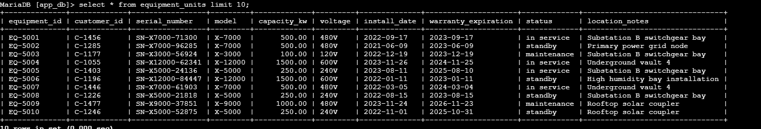
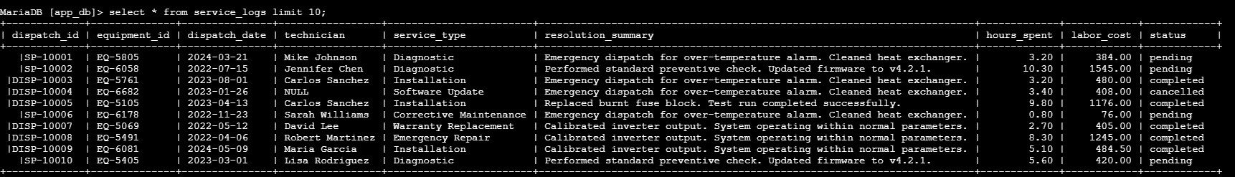

7) ENTITY RELATIONSHIP DIAGRAM.
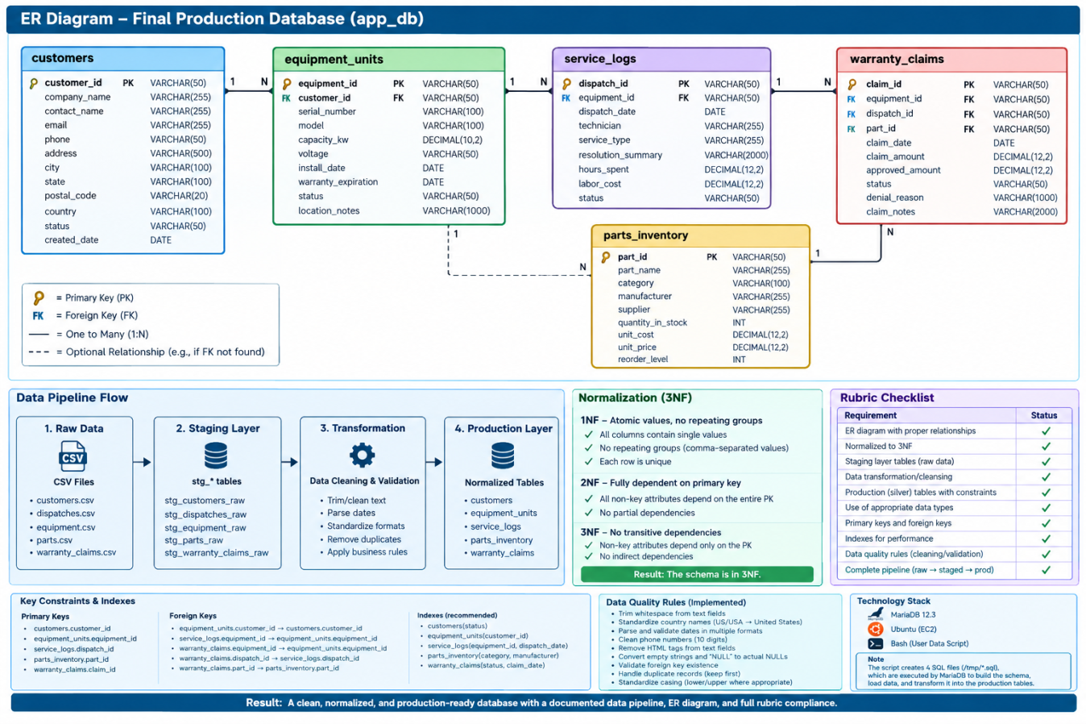

8) DATA QUALITY VERIFICATION SCRIPT (verify.sql, created internally after VM Provisioning)
USE app_db;
-- =========================================================
-- 1. ROW COUNTS
-- =========================================================
SELECT 'stg_customers_raw' AS table_name, COUNT(*) AS row_count
FROM stg_customers_raw
UNION ALL
SELECT 'customers', COUNT(*) FROM customers
UNION ALL
SELECT 'stg_equipment_raw', COUNT(*) FROM stg_equipment_raw
UNION ALL
SELECT 'equipment_units', COUNT(*) FROM equipment_units
UNION ALL
SELECT 'stg_dispatches_raw', COUNT(*) FROM stg_dispatches_raw
UNION ALL
SELECT 'service_logs', COUNT(*) FROM service_logs
UNION ALL
SELECT 'stg_parts_raw', COUNT(*) FROM stg_parts_raw
UNION ALL
SELECT 'parts_inventory', COUNT(*) FROM parts_inventory
UNION ALL
SELECT 'stg_warranty_claims_raw', COUNT(*) FROM stg_warranty_claims_raw
UNION ALL
SELECT 'warranty_claims', COUNT(*) FROM warranty_claims;
-- =========================================================
-- 2. CONFIRM FOREIGN KEYS EXIST
-- =========================================================
SELECT
TABLE_NAME,
CONSTRAINT_NAME,
COLUMN_NAME,
REFERENCED_TABLE_NAME,
REFERENCED_COLUMN_NAME
FROM information_schema.KEY_COLUMN_USAGE
WHERE TABLE_SCHEMA = 'app_db'
AND REFERENCED_TABLE_NAME IS NOT NULL
ORDER BY TABLE_NAME, CONSTRAINT_NAME;

-- =========================================================
-- 3. EQUIPMENT -> CUSTOMER ORPHANS
-- Expected: 0
-- =========================================================

SELECT COUNT(*) AS orphan_equipment_customers
FROM equipment_units e
LEFT JOIN customers c
ON e.customer_id = c.customer_id
WHERE c.customer_id IS NULL;

-- =========================================================
-- 4. SERVICE LOG -> EQUIPMENT ORPHANS
-- Expected: 0
-- =========================================================

SELECT COUNT(*) AS orphan_service_equipment
FROM service_logs s
LEFT JOIN equipment_units e
ON s.equipment_id = e.equipment_id
WHERE e.equipment_id IS NULL;

-- =========================================================
-- 5. WARRANTY -> EQUIPMENT ORPHANS
-- Expected: 0
-- =========================================================
SELECT COUNT(*) AS orphan_claim_equipment
FROM warranty_claims w
LEFT JOIN equipment_units e
ON w.equipment_id = e.equipment_id
WHERE e.equipment_id IS NULL;
-- =========================================================
-- 6. WARRANTY -> DISPATCH ORPHANS
-- NULL dispatch_id is allowed
-- Expected: 0
-- =========================================================
SELECT COUNT(*) AS orphan_claim_dispatch
FROM warranty_claims w
LEFT JOIN service_logs s
ON w.dispatch_id = s.dispatch_id
WHERE w.dispatch_id IS NOT NULL
AND s.dispatch_id IS NULL;
-- =========================================================
-- 7. WARRANTY -> PART ORPHANS
-- NULL part_id is allowed
-- Expected: 0
-- =========================================================
SELECT COUNT(*) AS orphan_claim_part
FROM warranty_claims w
LEFT JOIN parts_inventory p
ON w.part_id = p.part_id
WHERE w.part_id IS NOT NULL
AND p.part_id IS NULL;
-- =========================================================
-- 8. PRIMARY KEY DUPLICATE CHECK
-- Expected: 0 for every table
-- =========================================================
SELECT 'customers' AS table_name,
COUNT(*) - COUNT(DISTINCT customer_id) AS duplicate_keys
FROM customers
UNION ALL
SELECT 'equipment_units',
COUNT(*) - COUNT(DISTINCT equipment_id)
FROM equipment_units
UNION ALL
SELECT 'service_logs',
COUNT(*) - COUNT(DISTINCT dispatch_id)
FROM service_logs
UNION ALL
SELECT 'parts_inventory',
COUNT(*) - COUNT(DISTINCT part_id)
FROM parts_inventory
UNION ALL
SELECT 'warranty_claims',
COUNT(*) - COUNT(DISTINCT claim_id)
FROM warranty_claims;
-- =========================================================
-- 9. PHONE VALIDATION
-- Expected: 0
-- =========================================================
SELECT COUNT(*) AS invalid_phone_numbers
FROM customers
WHERE phone IS NOT NULL
AND phone NOT REGEXP '^[0-9]{10}$';-- =========================================================
-- 10. HTML VALIDATION
-- Expected: 0
-- =========================================================
SELECT
'customers.company_name' AS field_name,
COUNT(*) AS html_remaining
FROM customers
WHERE company_name REGEXP '<[^>]+>'
UNION ALL
SELECT
'customers.address',
COUNT(*)
FROM customers
WHERE address REGEXP '<[^>]+>'
UNION ALL
SELECT
'equipment_units.location_notes',
COUNT(*)
FROM equipment_units
WHERE location_notes REGEXP '<[^>]+>'
UNION ALL
SELECT
'service_logs.resolution_summary',
COUNT(*)
FROM service_logs
WHERE resolution_summary REGEXP '<[^>]+>'
UNION ALL
SELECT
'warranty_claims.denial_reason',
COUNT(*)
FROM warranty_claims
WHERE denial_reason REGEXP '<[^>]+>'
UNION ALL
SELECT
'warranty_claims.claim_notes',
COUNT(*)
FROM warranty_claims
WHERE claim_notes REGEXP '<[^>]+>';
-- =========================================================
-- 11. PHONE / IMPORTANT NULL CHECKS
-- =========================================================
SELECT
'equipment_units.customer_id' AS field_name,
COUNT(*) AS null_count
FROM equipment_units
WHERE customer_id IS NULL
UNION ALL
SELECT
'service_logs.equipment_id',
COUNT(*)
FROM service_logs
WHERE equipment_id IS NULL
UNION ALL
SELECT
'warranty_claims.equipment_id',
COUNT(*)
FROM warranty_claims
WHERE equipment_id IS NULL
UNION ALL
SELECT
'customers.customer_id',
COUNT(*)
FROM customers
WHERE customer_id IS NULL;
-- =========================================================
-- 12. CHECK SILVER DUPLICATES
-- =========================================================
SELECT customer_id, COUNT(*) AS occurrences
FROM customers
GROUP BY customer_id
HAVING COUNT(*) > 1;
SELECT equipment_id, COUNT(*) AS occurrences
FROM equipment_units
GROUP BY equipment_id
HAVING COUNT(*) > 1;
SELECT dispatch_id, COUNT(*) AS occurrences
FROM service_logs
GROUP BY dispatch_id
HAVING COUNT(*) > 1;

SELECT part_id, COUNT(*) AS occurrences
FROM parts_inventory
GROUP BY part_id
HAVING COUNT(*) > 1;
SELECT claim_id, COUNT(*) AS occurrences
FROM warranty_claims
GROUP BY claim_id
HAVING COUNT(*) > 1;

SAMPLE OUTPUT OF VERIFICATION CODE-
table_name | row_count
stg_customers_raw | 525
customers | 500
stg_equipment_raw | 2575
equipment_units | 2500
stg_dispatches_raw | 5000
service_logs | 4941
stg_parts_raw | 150
parts_inventory | 150
stg_warranty_claims_raw | 1248
warranty_claims | 1200

TABLE_NAME | CONSTRAINT_NAME | COLUMN_NAME |  |  | REFERENCED_TABLE_NAME | REFERENCED_COLUMN_NAME
equipment_units | fk_equipment_customer | customer_id |  |  | customers | customer_id
service_logs | fk_service_equipment | equipment_id |  |  | equipment_units | equipment_id
warranty_claims | fk_claim_dispatch | dispatch_id |  |  | service_logs | dispatch_id
warranty_claims | fk_claim_equipment | equipment_id |  |  | equipment_units | equipment_id
warranty_claims | fk_claim_part | part_id |  |  | parts_inventory | part_id
validation |  |  | value
orphan_equipment_customers |  |  | 0
orphan_service_equipment |  |  | 0
orphan_claim_equipment |  |  | 0
orphan_claim_dispatch |  |  | 0
orphan_claim_part |  |  | 0

9) 4D’S OF AI FLUENCY
Delegation: I used AI to help organize my data-cleansing approach, refine SQL scripts and ER Diagram. I made the final decisions about the schema, cleaning rules, and validation.
Description: I provided the project requirements, dataset findings, SQL errors, and my existing scripts. I used AI to help translate these into practical SQL transformations and validation queries.
Diligence: I tested the suggested SQL against my MariaDB data and checked the results myself. I corrected issues when the output did not match the actual dataset.
Discernment: I used AI mainly as a technical assistant for troubleshooting, formatting, and improving my approach. The dataset analysis, schema decisions, and final implementation were reviewed and decided by me.

