GaTher3DEvo
Instruction
How to modify the software

In the following instructions we will answer the following question:

* How to add more game problems?

!!! If you would like to add a new reproduction function, mortality, neighbourhood, or resource function follow the implementation would be identical. In case of any problems create a github issue.

Step 1 Information needed for creating a new fitness problem:

* Problem matrix
* Parameteres of the fitness problem
* Number of phenotypes for a given problem.
* Is the problem dynamic? Or the problem shall not change during the simulation.

To explain the problem lets implement together the Dynamic Hawk Dove problem.
The fitness matrix looks as follows:

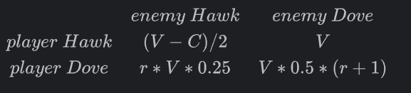

The problem contains 2 phenotypes (Hawk and Dove), 2 parameters (V and C) and is dependent on the chosen resource function.

Step 2 Create a problem class:

The problem class shall be located in a new file named as the class in a problem directory and shall inherit from the ProblemController class.
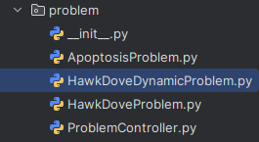

At the top of the file the requried packages shall be imported. They may differ a bit depending on an implementation.

from typing import List, Dict, Optional, Tuple
from neighbourhood.NeighbourController import NeighbourController
from problem.ProblemController import ProblemController
from resource.ResourceFunctionController import ResourceFunctionController
from utils.ParamHandler import ParamHandler

The declare a class name inhetiting from a ProblemController class. Below the class declaration parameters and phenotype_names shall be declared.

class HawkDoveDynamicProblem(ProblemController):
V_param: int
C_param: int
phenotype_names: Dict[int, str]

The new class must have 2 function.

1) __init__

def __init__(self, param_handler: ParamHandler, neighbour_controller: NeighbourController, resource_function_controller: Optional[ResourceFunctionController]):
super().__init__(param_handler, neighbour_controller, resource_function_controller)
if self.resource_function is None:
raise Exception('Resource function cannot be None in the following problem')
self.supported_num_dims = [2, 3]
self.num_phenotypes = 2
self.phenotype_names = {0: 'Hawk',
1: "Dove"}

It is important to fill the supported_num_dim list with supported dimensions, the num_phenotypes with required number of phenotypes and the dictionary phenotype_names with the names of phenotypes.

The user uses only the names in the yaml file ale they are automatically ‘translated’ into selected numbers.

If the problem is not dynamic – remove checking if the resource function is None.

2) Fitness problem function

def fitness_problem(self, player: int, enemy: int, idx: Optional[Tuple[int, int] | Tuple[int, int, int]] = None) -> float:
r = self.resource_function.get_function_value(idx)
if player == 0 and enemy == 0:
return (self.V_param - self.C_param) / 2
elif player == 0 and enemy == 1:
return r * self.V_param * 0.25
elif player == 1 and enemy == 0:
return self.V_param
elif player == 1 and enemy == 1:
return (r+1) * self.V_param * 0.5
else:
raise Exception('Invalid player or enemy number')

This is just a fitness matrix transposed into if statements.

!!!
If the problem is not dynamic remove the r=self.resource_function line.
!!!

Step 3
Import the class name into the MainController.py file.

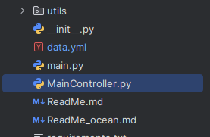

Step 4 file the Yaml file with the following properties.

1) Set the problem_name to class name. The names must match!!!.

2) Set the problem_params to ones declared in a problem class. Assign the required values to them.
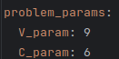

3) **Optional** Set the initial probabilities for the initialized game matrix. If this is not set the phenotypes will be drawn evenly.
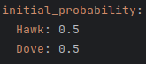

4) **Only for the dynamic problems**

If the selected dynamic function uses the information about the alocated phenotypes (Global, Local) fill the resource_phenotypes with a chosen phenotype name.

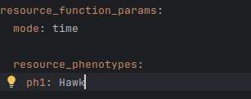

Step 5 – contribute to the github reposotory.
:)

