Bode Plot & Simple Filter Design
Name: Mikal, Andrew
ID:

Abstract:
A first-order low-pass filter with a voltage gain of 10 and a cutoff frequency of 3 kHz was designed and verified in LTspice using an LT1630 operational amplifier in a non-inverting configuration. Simulations included the frequency response, step response, and sinusoidal responses at 30 Hz, 3 kHz, and 300 kHz. The LT1368 op-amp was initially used but replaced due to signal attenuation. The LTspice results closely matched the theoretical transfer function, with minor deviations due to op-amp limitations.

Design:

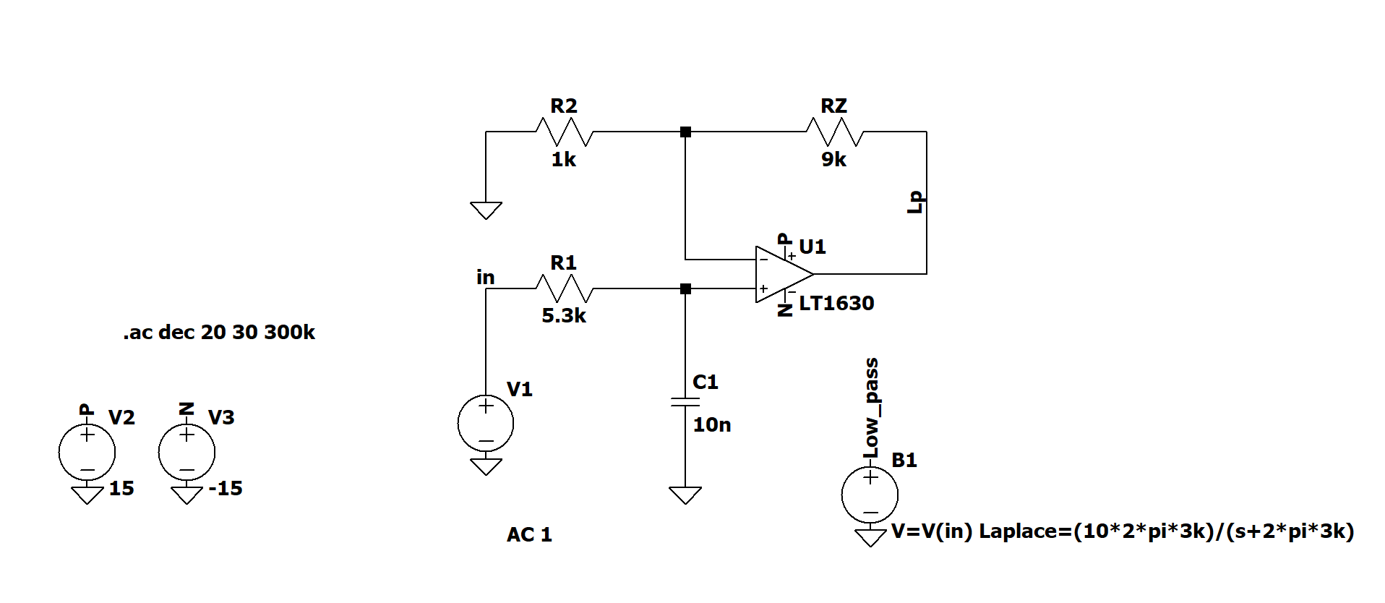

Figure 1: A first-order low-pass filter with a gain of 10 and a cutoff frequency of 3 kHz

$H(s) = \frac{V_{out}}{V_{in}} = \frac{A_{v}}{1 + sRC}$ (eq. 1)

Where:
${ A}_{v} = 1 + \frac{R_{f}}{R_{2}}$ (eq. 2)

$H(s) = \frac{V_{out}}{V_{in}} = gain ×\frac{ω_{0}}{ω_{0} + s}$ (eq. 3)
$ω_{0} = 2πf_{0}$
$f_{0} = \frac{1}{2π × R_{1}C_{1}}$
$ω_{0} = 2π × \frac{1}{2π × R_{1}C_{1}} = \frac{1}{R_{1}C_{1}}$
Gain = 10

$H(s) =10 ×\frac{\frac{1}{R_{1}C_{1}}}{\frac{1}{R_{1}C_{1}} + s}$ (eq. 4)

Cutoff frequency $f_{c}$ is defined as:

$f_{c} = \frac{1}{2πRC}$ (eq. 5)

For the design, the target parameters were $A_{v}$ = 10 and $f_{c}$ = 3 kHz. The values were chosen by rearranging equation (5). From this, RC = $5.03 × 10^{-5} s.$

A standard capacitor value $C_{1} = 10nF$

$R_{1} = \frac{1}{2π{ × f}_{c} × C_{1}} = \frac{1}{2π(3 kHz)(10 nF) } ≃5.3 kΩ$ (eq. 6)

A standard 5.3 $kΩ$ resistor was selected.

To achieve the desired gain of 10, the ratio of the feedback resistor from equation (2).

$A_{v} = 1 + \frac{R_{f}}{R_{2}}$

Choosing $R_{2} = 10 kΩ$ && $R_{f} = 90 kΩ$

Using the transfer function from equation (4)

$Y(s) = \frac{1}{s} × 10 ×\frac{\frac{1}{R_{1}C_{1}}}{\frac{1}{R_{1}C_{1}} + s}$
Now taking the inverse Laplace

$y(t) = L^{-1} \{ \frac{1}{s} × 10 ×\frac{\frac{1}{R_{1}C_{1}}}{\frac{1}{R_{1}C_{1}} + s}\} = 10(1-e^{-\frac{1}{R_{1}C_{1}}})u(t)$
Where again, $R_{1 }× C_{1} =5.03 × 10^{-5} s$

The LT1368 op-amp was tested initially, but the amplitude response exhibited attenuation due to internal compensation capacitance. The LT1630, with a higher gain-bandwidth product (GBW), was substituted and provided accurate performance near the designed cutoff.

Verification:

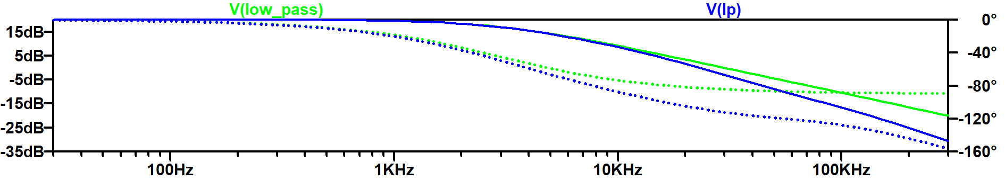
Figure 2. AC Analysis (Bode Plot) using LT1368

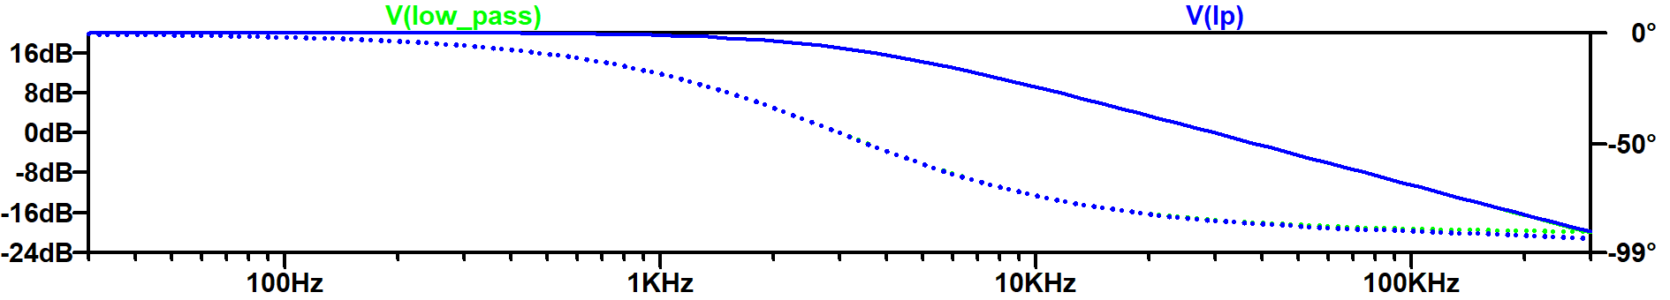
Figure 3. AC Analysis (Bode Plot) using LT1630
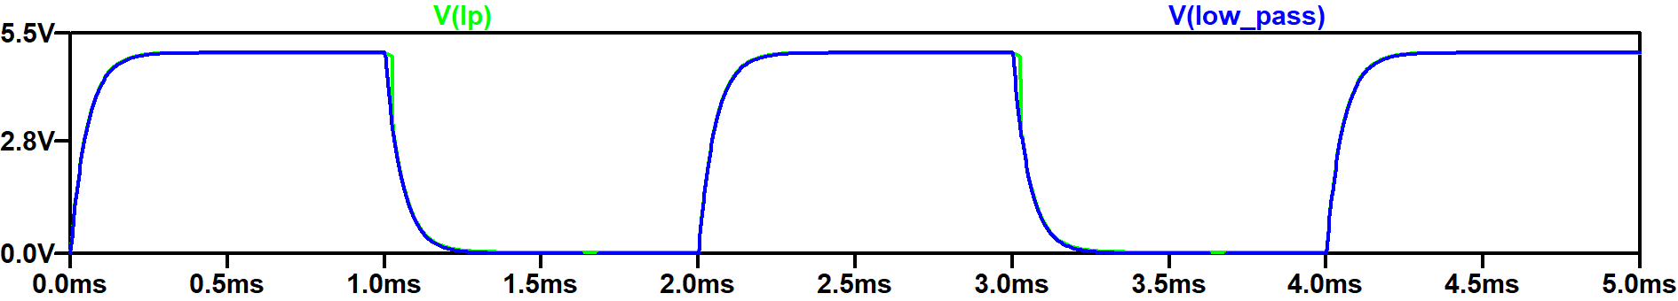
Figure 4. Transient Analysis (Step Response) using LT1630, where → .tran 0 5m 0 10u & → PULSE(0 0.5 0 1u 1u 1m 2m)

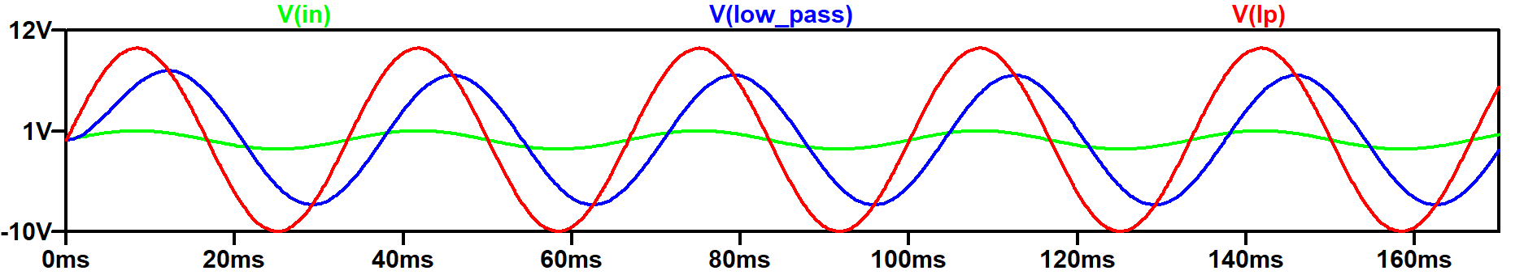
Figure 5. Sine Response using LT1630 of 30 Hz, where → Sine(0 1 30Hz) & → .tran 0 170m

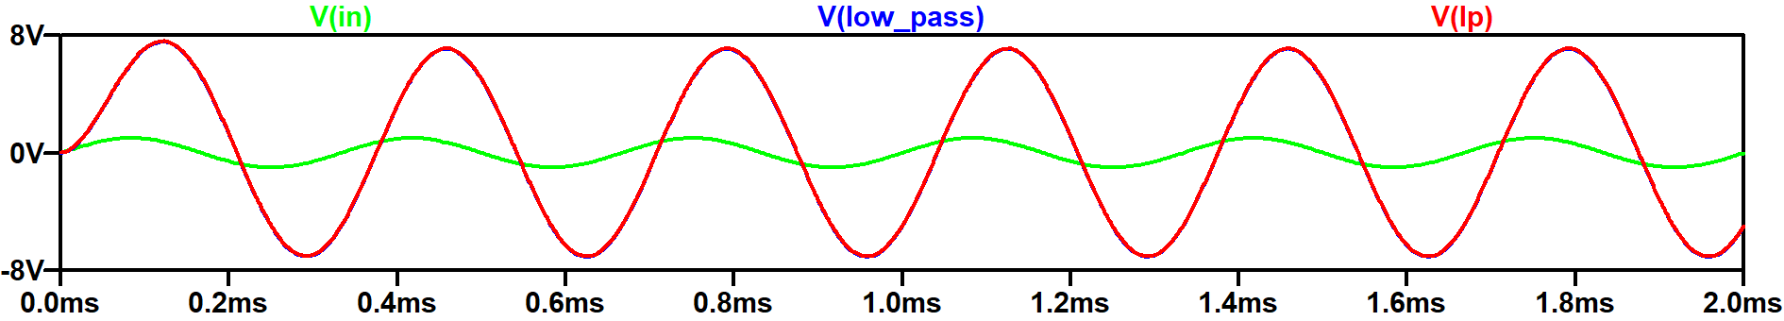
Figure 6. Sine Response using LT1630 of 3 kHz, where → Sine(0 1 3 kHz) & → .tran 0 2m

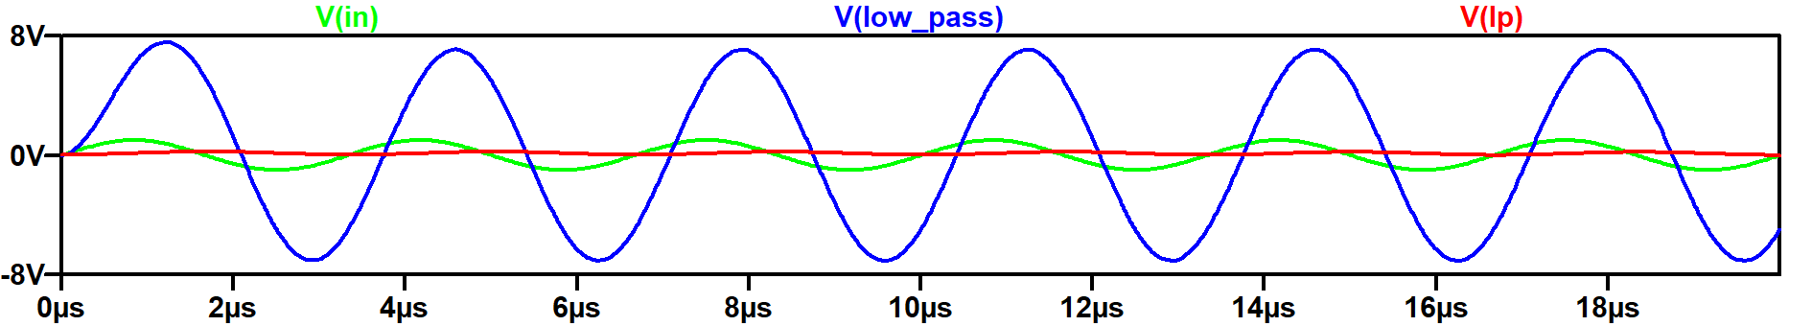
Figure 6. Sine Response using LT1630 of 3 kHz, where → Sine(0 1 300 kHz) & → .tran 0 20u

Sine-Wave Measurements (Transient)

Input amplitude: 1 V peak SINE(0 1 f)
Measured output: red trace (Vlp, op-amp output)
Gain in dB: 20 × log10(Vout_peak / Vin_peak)
Phase: $φ = −360 × (\frac{Δt}{T})$, where Δt is the delay between input and output zero crossings and $T= \frac{1}{f}$

Frequency | Period (T) | Output Peak (V) | Gain (dB) | Phase (Theory) | Notes
30 Hz | 33.3 ms | 10.0 V | +20.0 dB | $≈ - 0.6^{∘}$ | Correct gain
3 kHz | 0.333 ms | 7.07 V | +17.0 dB | $≈ - 45^{∘}$ | Correct phase lag
300 kHz | 3.33 $μ$s | 0.3 V | -10.46 dB | $≈ - 89.4^{∘}$ | Strong attenuation

Discussion/Summary:
Initial tests with the LT1368 op-amp showed reduced output amplitude near and above the cutoff frequency, consistent with an insufficient gain-bandwidth product (GBW). Replacing it with the LT1630 restored the expected response.
Minor discrepancies between theory and simulation are due to finite op-amp GBW, input offsets, and parasitic capacitances.
At 300 kHz (100× the cutoff), theory predicts −20 dB attenuation, while the measured output (0.3 V peak) corresponds to −10.46 dB—acceptable considering non-ideal effects and measurement precision.
The LT1630-based low-pass filter achieved the target 3 kHz cutoff and gain of 10, matching theoretical predictions and demonstrating expected phase behavior of first-order filters.

References
20251010_EE10L_LOWPASS_FILTER_AM.asc

