Following are the details of the challenges and hackathons that were conducted through GESH
Event / Programme | Event Brief | Date | Collaborators | Teams | Team Size | Participants | Attendees
Global Sustainability Challenge (GSC) 2025–26 – South Asia Region | The Global Sustainability Challenge, is an annual competition where students design, implement, and showcase real-world sustainability solutions. The initiative is a collaboration among leading global institutions. Structured the challenge into three phases:  IGNITE: Problem identification, team formation, and solution ideation. (Late August - Early November 2025)  BUILD: Mentorship, solution validation, prototype development, and regional evaluation. (Late November 2025 - January / Early February 2026)  SHINE: Global showcase, advanced mentorship, and international finale at TUM - Germany. (February - April 2026)  GESH IIT Bombay is a founding partner and regional ambassador for GSC | Regional Finale - 7th Feb, 2026, Global Finale - 29th April 2026 | Stanford Doerr School of Sustainability, Maker Bhavan Foundation, IIT Bombay, IIT Hyderabad, Centre for Climate Studies IIT Bombay, TUM, Imperial College London, HKUST, Zhejiang University, Makerghat, YGA | Phase 0 - 906, Phase 1 - 131, Phase 2 - 54, Phase 3 - 10  (participation received from 91 countries) | 1–4 members per team | Phase 1 - Approx 3000 | Regional Finale - 200
Greenovate 2025 – World Environment Day Innovation Challenge | A platform to spotlight student-led innovations in sustainability. The event aimed to nurture early-stage ideas with potential for real-world impact and align them with IIT Bombay’s broader sustainability goals. | 5 June 2025 | GESH IITB, Centre for Climate Studies, ESED, DSSE, IIC | 21 | 1–4 members per team | 31 | 50
HPCL-IITB Energy Transition Challenge | Designed to bring together students, startups, researchers, and HPCL professionals to co-create practical and scalable solutions for decarbonizing refinery operations and advancing the net-zero transition.  Focused on key themes including refinery decarbonization, future fuels, digital innovation, sustainable mobility, and energy transition technologies. | 30 Aug 2025 | HPCL, CoE–OGE IIT Bombay, GESH IITB | 54 | 1–4 members per team | 126 | 75
IITB–IOCL Product Innovation Hackathon | Focused on enhancing the SuryaNutan Indoor Solar Cooking System, an innovative clean cooking solution developed by IOCL.  Engaged IIT Bombay students from diverse disciplines to develop practical and scalable product innovations.  Addressed two challenge tracks: Operational Efficiency & Cost Reduction and Design & Usability  Launched on 10 March 2026 with a prototype demonstration and technical briefing by the IOCL R&D team.  Conducted a dedicated participant interaction session for technical clarifications, feedback, and mentoring support on 8 April.  Report submissions were made on 15 May. Reports were evaluated and six shortlisted teams were selected for the final round based on solution quality and innovation potential and presented on 16 June. | 16 April 2026 | IOCL, CoE–OGE IIT Bombay, GESH IITB | 60 | 1–4 members per team | 85 | NDA Signing - 60

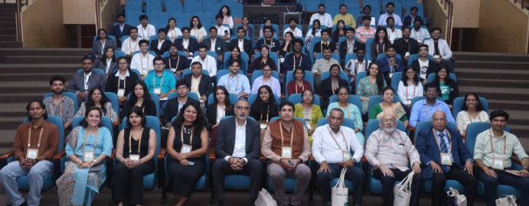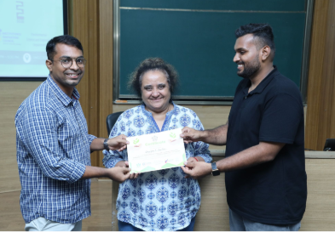
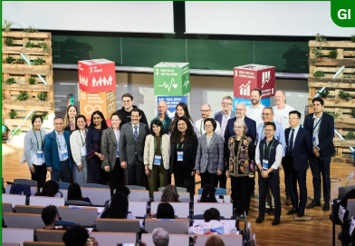 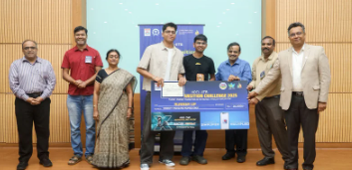 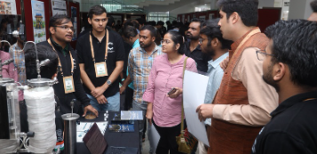s

