Worksheet1

Output: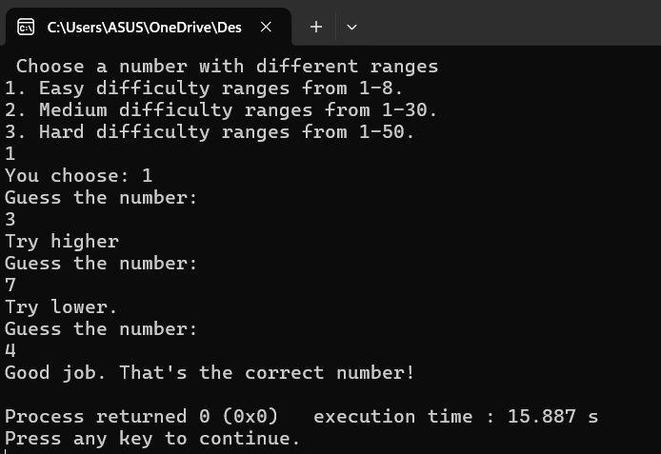

3. 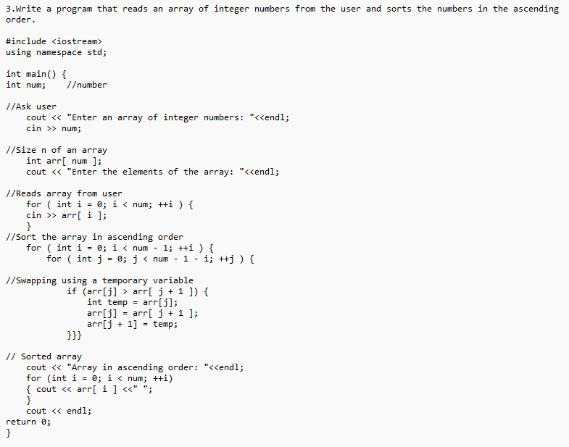

4. 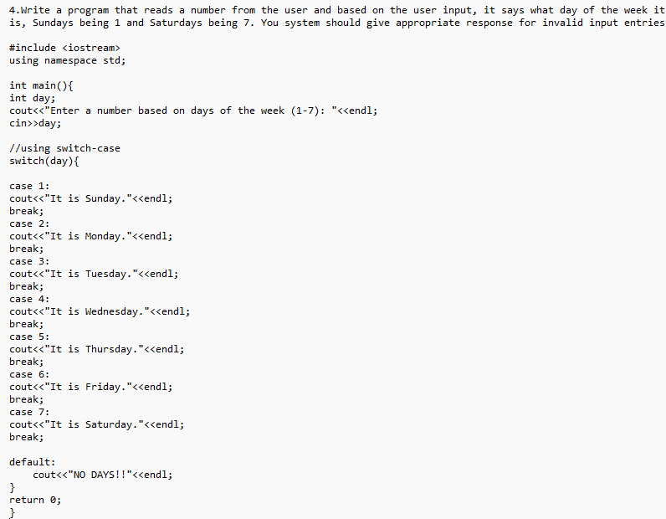

Output:

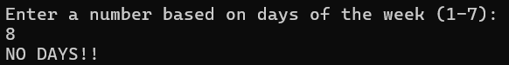

Task2

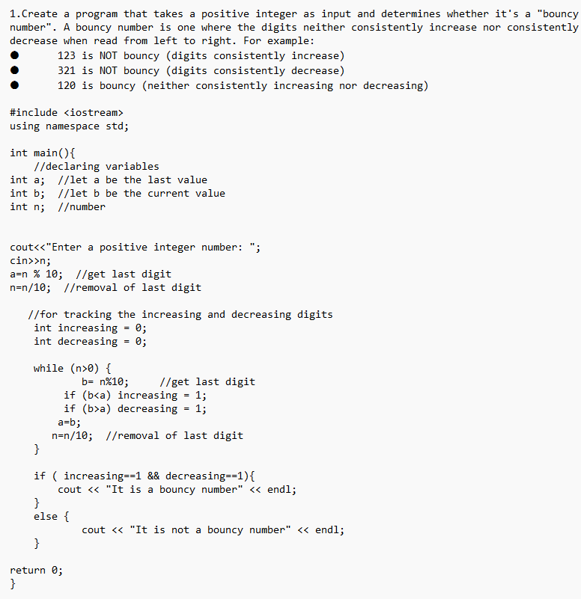



Task 3

