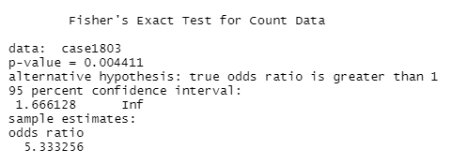

Through Fisher’s Exact Test we find that the null hypothesis: (the odds of lung cancer for smokers are equal to the odds of lung cancer for nonsmokers) can be rejected due to its p-value of 0.004411.

1. (a)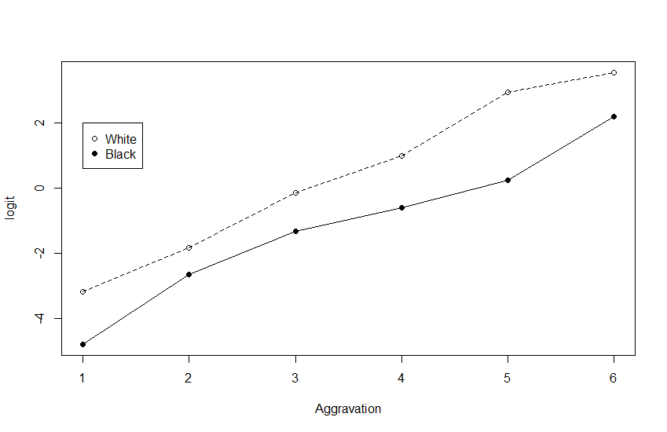

(b)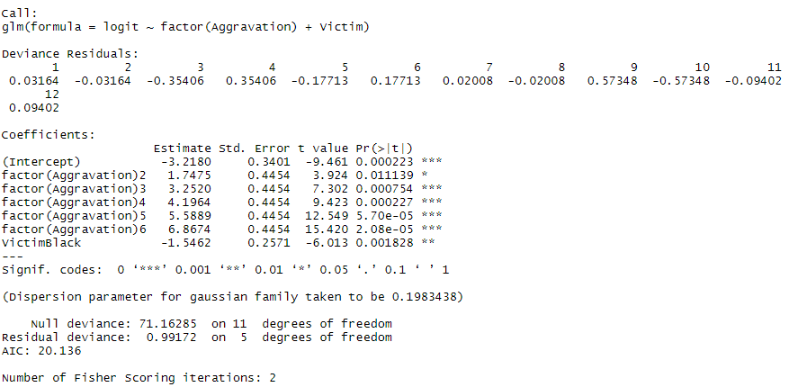

(c) 

There is no evidence that the model is inadequate.

(d) (e)

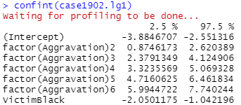

The coefficient of the indicator variable for race is not equal to 0.

As the level of aggravation increase, the logit will be higher.

There will be more possibility to give a crime death sentence when the victim is white.

(f)

There is no change.