1. SELECT Author, Review, NegativeScore, ShopID

FROM shopcomment

ORDER BY NegativeScore DESC

LIMIT 0, 10;

1. SELECT C.Author, C.Review, C.NegativeScore, S.ShopName, S.AvgPrice

FROM shopcomment AS C LEFT OUTER JOIN shop AS S ON S.ShopID = C.ShopID

ORDER BY C.NegativeScore DESC

LIMIT 0, 10;

1. SELECT COUNT(\*)

FROM shop AS SH, shopcity AS SC, city AS C

WHERE SH.ShopID = SC.ShopID and SC.CityID = C.CityID and C.Cityname = "上海";

1. SELECT SH.ShopName, COUNT(\*)

FROM shop AS SH, shopcomment AS SCO, shopcity AS SC, city AS C

WHERE SCO.ShopID = SH.ShopID and SH.ShopID = SC.ShopID and SC.CityID = C.CityID and C.Cityname = "上海"

GROUP BY SCO.ShopID

ORDER BY COUNT(\*) DESC

LIMIT 0, 10;

1. SELECT SH.ShopName

FROM shop AS SH, shopcity AS SC, city AS C

WHERE SH.ShopID = SC.ShopID and SC.CityID = C.CityID and C.Cityname = "上海";

ORDER BY SH.AvgPrice DESC

LIMIT 0, 10;

SELECT SH.ShopName FROM shop AS SH, shopcity AS SC, city AS C WHERE SH.ShopID = SC.ShopID and SC.CityID = C.CityID and C.Cityname = "上海" ORDER BY SH.AvgPrice DESC LIMIT 0, 10

1. SELECT D.DishName

FROM dish AS D, shopdish AS SD

WHERE D.DishID = SD.DishID

GROUP BY SD.DishID

ORDER BY COUNT(\*) DESC

LIMIT 0, 10;

1. SELECT SC.Review, SC.Author, (S.CommentMagnitude+SC.CommentTaste+SC.CommentEnvironment+SC.CommentService) AS TotalGrade

FROM shopcomment AS SC, shop AS S

ORDER BY TotalGrade

LIMIT 0, 10;

SELECT Author, Review, NegativeScore, ShopID

FROM shopcomment

ORDER BY NegativeScore DESC

LIMIT 0, 10

JOIN

1.

SELECT Author, Review, NegativeScore

FROM shopcomment

ORDER BY NegativeScore DESC LIMIT 0,10;

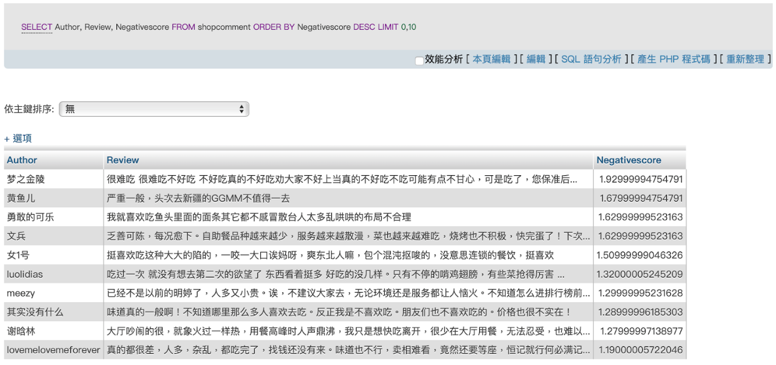

2.

SELECT C.Author, C.Review, C.NegativeScore, S.ShopName, S.AvgPrice

FROM shopcomment AS C LEFT OUTER JOIN shop AS S

ON S.ShopID = C.ShopID

ORDER BY C.NegativeScore DESC LIMIT 0,10;

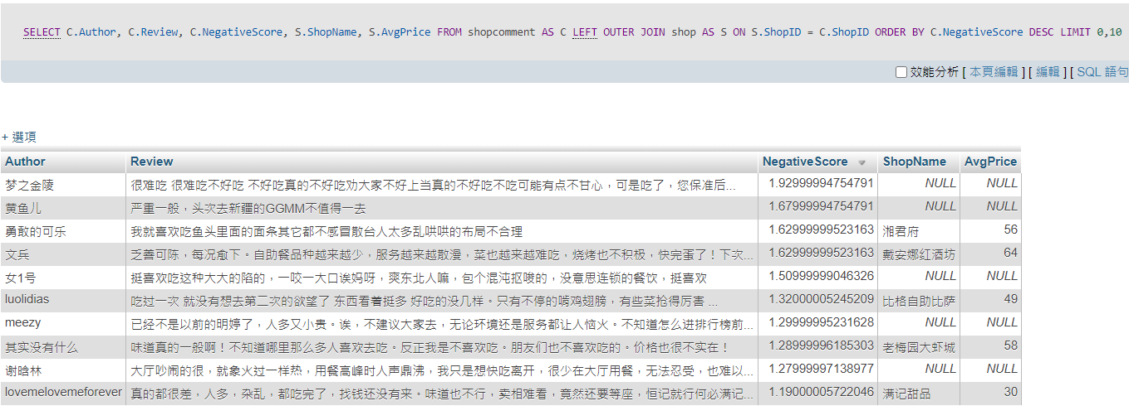

承上題，我們發現第一題的前十大負評評論中，某幾家店的ShopID並沒有在Shop table裡面，因此ShopName及AvgPrice為空值。

3.

SELECT COUNT(\*)

FROM shopcity AS S, city AS C

WHERE S.CityID = C.CityID AND C.CityName=’上海’;

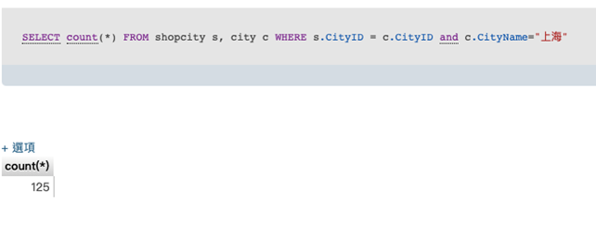

4.

SELECT SH.ShopName, COUNT(\*)

FROM shop AS SH, shopcomment AS SCO, shopcity AS SC, city AS C

WHERE SCO.ShopID = SH.ShopID and SH.ShopID = SC.ShopID and SC.CityID = C.CityID and C.Cityname = "上海"

GROUP BY SCO.ShopID

ORDER BY COUNT(\*) DESC

LIMIT 0, 10;

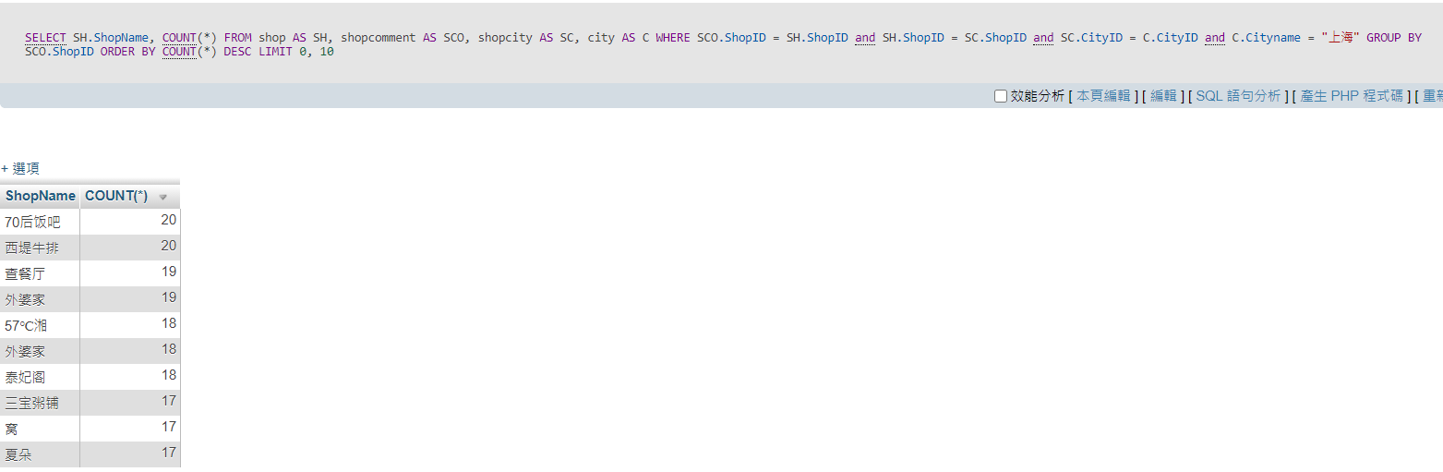

5.

SELECT SH.ShopName, SH.AvgPrice

FROM shop AS SH, shopcity AS SC, city AS C

WHERE SH.ShopID = SC.ShopID and SC.CityID = C.CityID and C.Cityname = "上海" ORDER BY SH.AvgPrice DESC LIMIT 0, 10;

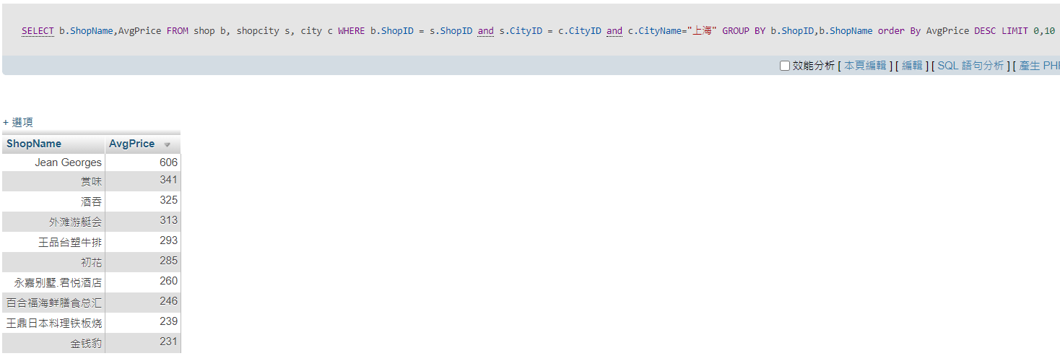

6.

SELECT D.DishName, COUNT(\*)

FROM dish AS D, shopdish AS SD

WHERE D.DishID = SD.DishID

GROUP BY SD.DishID

ORDER BY COUNT(\*) DESC

LIMIT 0, 10;

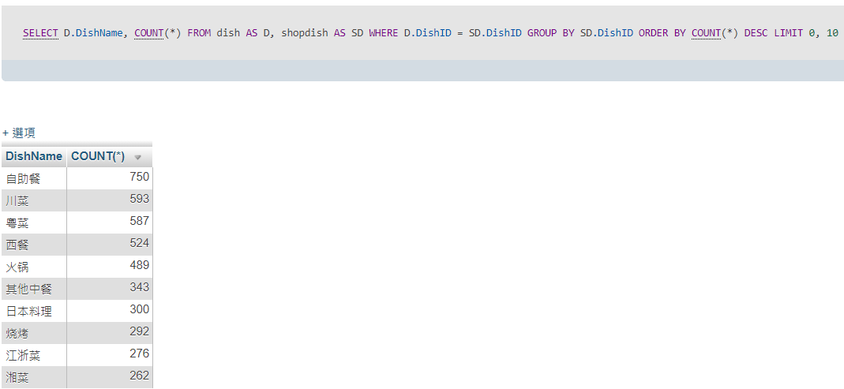

7.

SELECT Review, Author, CommentMagnitude+CommentTaste+CommentEnvironment+CommentService

FROM shopcomment

ORDER BY CommentMagnitude+CommentTaste+CommentEnvironment+CommentService DESC

LIMIT 0,10;

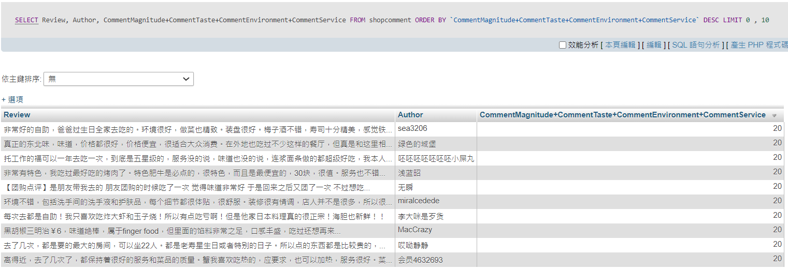

8 .

SELECT C.CityName, COUNT(\*)

FROM shopcity AS S, city AS C, shop AS SH

Where C.CityID = S.CityID and SH.ShopID = S.ShopID AND SH.ShopName ="西堤牛排"

Group by C.CityID;

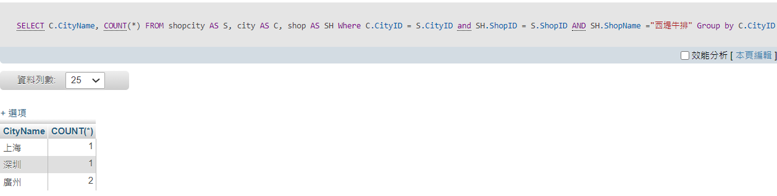

9.

SELECT ShopName, COUNT(\*)

FROM shop

GROUP BY ShopName

ORDER BY COUNT(\*) DESC LIMIT 0,10;

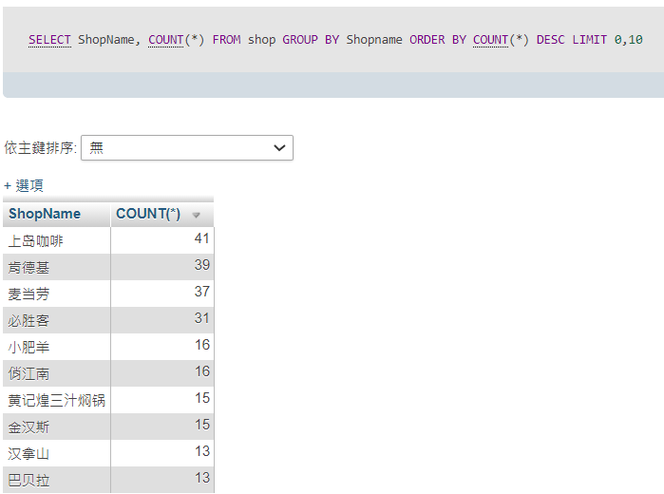

10.

Select d.DishName,count(\*) from dish d, shopdish sd, shopcity sc, city c

where d.DishId = sd.DishID and sd.ShopID = sc.ShopID and sc.CityID = c.CityID and (c.CityName ="上海" or c.CityName ="北京")

group by d.DishID,d.DishName order by count(\*) desc LIMIT 0,10;

shopcomment=>shop=>shopdish, shopregion=>dish, region

(SELECT DishName, CityName, COUNT(\*)

FROM shopcomment AS SCO, shop AS S, shopdish AS SD, shopcity AS SC, dish AS D, city AS C

Where SCO.ShopID=S.ShopID and S.ShopID=SD.ShopID and S.ShopID=SC.ShopID and SD.DishID=D.DishID and SC.CityID=C.CityID and C.CityName='上海'

GROUP BY D.DishName

ORDER BY COUNT(\*) DESC

LIMIT 0, 10)

UNION

(SELECT DishName, CityName, COUNT(\*)

FROM shopcomment AS SCO, shop AS S, shopdish AS SD, shopcity AS SC, dish AS D, city AS C

Where SCO.ShopID=S.ShopID and S.ShopID=SD.ShopID and S.ShopID=SC.ShopID and SD.DishID=D.DishID and SC.CityID=C.CityID and C.CityName='北京'

GROUP BY D.DishName

ORDER BY COUNT(\*) DESC

LIMIT 0, 10);

11.

因為發現上海的川菜餐廳只有15家，因此我們用UNION ALL函數連接從高排到低和從低排到高的表格，而非UNION函數，使重複的資料不會被刪除。

(SELECT s.ShopName,s.CommentMagnitude+s.CommentTaste+s.CommentEnvironment+s.CommentService

FROM dish d, shopdish sd, shopcity sc, city c,shop s

WHERE d.DishID = sd.DishID AND s.ShopID = sd.ShopID AND s.ShopID = sc.ShopID AND sc.CityID = c.CityID AND c.CityName ="上海" AND d.DishName = "川菜"

GROUP BY s.ShopID

ORDER BY s.CommentMagnitude+s.CommentTaste+s.CommentEnvironment+s.CommentService  DESC

LIMIT 0,20)

UNION ALL

(SELECT s.ShopName,s.CommentMagnitude+s.CommentTaste+s.CommentEnvironment+s.CommentService

FROM dish d, shopdish sd, shopcity sc, city c,shop s

WHERE d.DishID = sd.DishID AND s.ShopID = sd.ShopID AND s.ShopID = sc.ShopID AND sc.CityID = c.CityID AND c.CityName ="上海" AND d.DishName = "川菜"

GROUP BY s.ShopID

ORDER BY s.CommentMagnitude+s.CommentTaste+s.CommentEnvironment+s.CommentService  ASC

LIMIT 0,20)

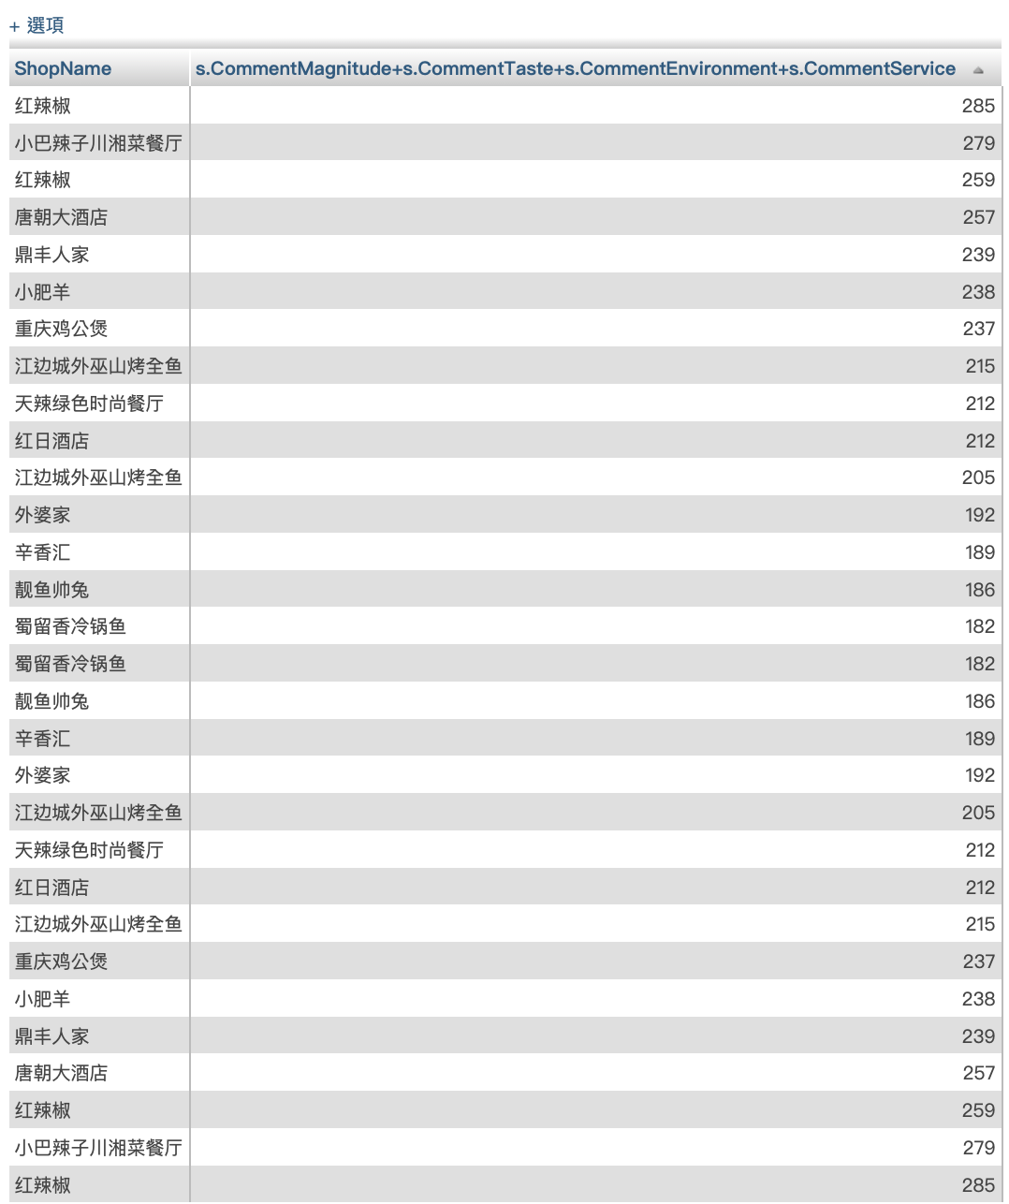

12.

SELECT C.CityName, R.RegionName, D.DishName, S.AvgPrice

FROM shop AS S, city AS C, region AS R, dish AS D, shopcity AS SC,shopregion AS SR, shopdish AS SD

WHERE S.ShopID=SC.ShopID and S.ShopID=SR.ShopID and S.ShopID=SD.ShopID and SC.CityID=C.CityID and SR.RegionID=R.RegionID and SD.DishID=D.DishID

ORDER BY C.CityName, R.RegionName, D.DishName, S.AvgPrice;

13. 列出 「給川菜菜系的評論數」前十多的熱門商家

SELECT b.ShopName,count(\*)

FROM shopcomment a,shop b, shopdish s, dish c

WHERE a.ShopID=b.ShopID and a.ShopID = s.ShopID and s.dishID = c.dishID and c.dishName="川菜"

GROUP BY a.ShopID,b.ShopName

ORDER BY count(\*) DESC LIMIT 0,10 ;

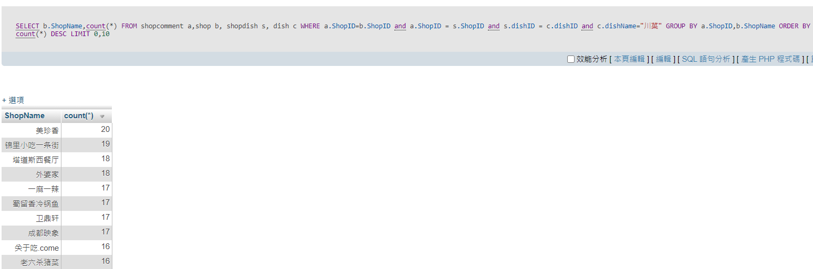

14. 列出北京市「前十高的單一評分」屬於哪幾家餐廳

SELECT b.review, a.shopname,b.positivescore

FROM shopcomment b,shop a,shopcity c,city d

WHERE a.shopid=b.shopid and a.shopid=c.shopid

and c.cityid=d.cityid and d.cityname ="北京"

ORDER BY positivescore DESC LIMIT 0,10

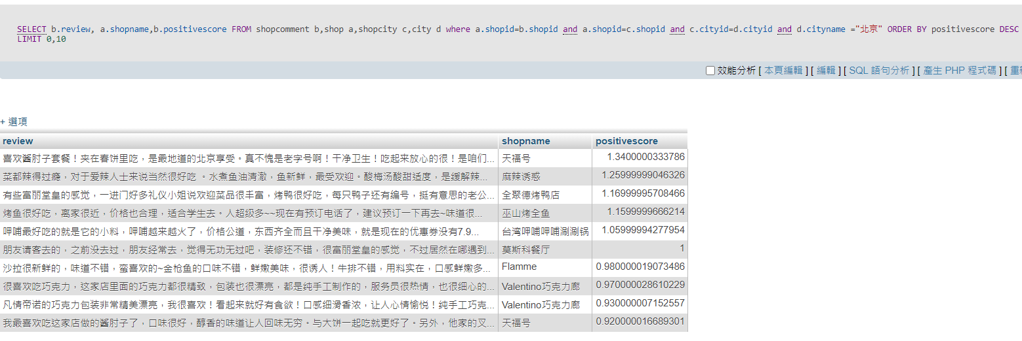

15. 分別有幾則評論在評論麥當勞和肯德基

SELECT ShopName, COUNT(\*)

FROM shopcomment AS SC,shop AS S

WHERE SC.ShopID=S.ShopID and (ShopName="肯德基" or ShopName="麦当劳")

GROUP BY ShopName;

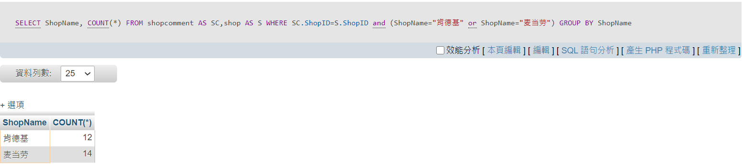

16. 取出客源是由大眾點評網來的店家

SELECT a.ShopName

FROM ‘source’ AS s, shop AS a

WHERE s.SourceID = a.SourceID and s.SourceName = "大眾點評網";

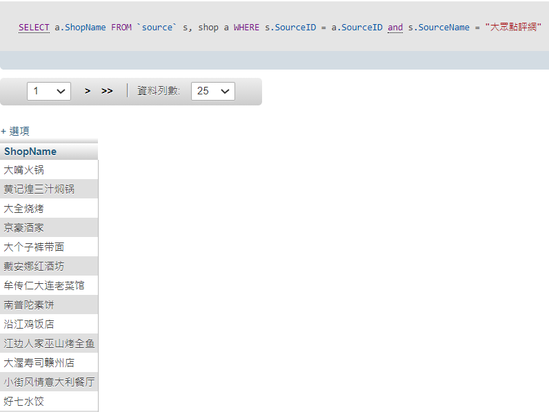

17. 接續16題，直接查詢URL 有“http://www.dianping.com/” 字串的店家，這是大眾點評的網址，發現也有4635筆，表示沒遺失資料

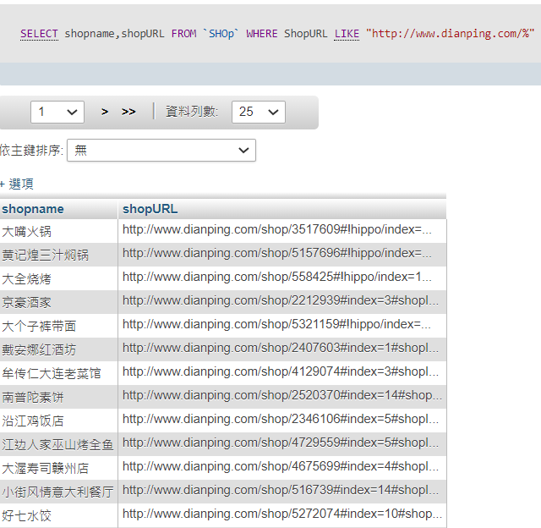

18. 列出前十大餐廳數量最多的區域

SELECT r.RegionName,COUNT(\*)

FROM region AS r, shopregion AS s

Where r.RegionID = s.RegionID

GROUP BY r.RegionID, r.RegionName

ORDER BY COUNT(\*) DESC LIMIT 0,10;

