T.C.
ALANYA ALAADDİN KEYKUBAT UNIVERSITY
RAFET KAYIŞ FACULTY OF ENGINEERING
COMPUTER ENGINEERING DEPARTMENT
GRADUATION/COURSE PROJECT PROPOSAL
1. PROJECT TITLE
Natural Language to SQL Conversion Using Large Language Models

2. PROBLEM DESCRIPTION
Accessing data from relational databases typically requires knowledge of SQL, which can be a barrier for non-technical users. In many organizations, users need assistance from technical staff to retrieve data, creating delays and inefficiencies. Although some tools offer visual query builders, they lack the flexibility and expressiveness of natural language. With the rise of Large Language Models (LLMs), it is now possible to bridge this gap by translating user queries written in natural language into structured SQL queries. However, deploying such a solution requires integration between NLP models, databases, and user interfaces—posing both technical and design challenges.

3. PURPOSE OF PROJECT
The purpose of this project is to design and implement a system that allows users to write natural language questions and automatically receive their equivalent SQL queries using an AI-powered model. The system aims to simplify data access for non-technical users, improve productivity, and demonstrate the practical use of LLMs in real-world database querying tasks.

4. PROJECT SCOPE AND RELATION WITH THE PURPOSE
Scope:
- Integration of a pre-trained LLM model (e.g., T5, SQLCoder, or similar) capable of translating natural language to SQL.
- Backend system using Java Spring Boot for API handling and Python FastAPI for AI model serving.
- Development of a web-based user interface for query input and result display.
- Support for various SQL features (SELECT, JOIN, GROUP BY, etc.).
- Use of benchmark datasets such as Spider and WikiSQL for training and testing.
Relation with Purpose:
The scope directly supports the purpose by delivering a complete, interactive solution that enables natural language query execution over relational databases. The combination of Java backend and Python model server demonstrates a hybrid system architecture and promotes modular design, enabling future scalability and improvements.

5. PROJECT MEMBERS INFORMATION
Project  Member  #1 | Name and Surname | Ramazan Bozkurt
 | Birth Place and Date | 25.11.2002 – Gemlik / Bursa
 | Student Number | 200254031
 | Inclusion Date | 15.07.2025
 | Address | Gemlik / Bursa
 | Phone | +90 539 943 95 27
 | E-Mail Address | 200254031@ogr.alanya.edu.tr
 | Student Signature
Project  Member  #2 | Name and Surname | Abdulkadir Sözgen
 | Birth Place and Date | 11.01.2002 – Merkez / Karaman
 | Student Number | 210254031
 | Inclusion Date | 15.07.2025
 | Address | Merkez / Karaman
 | Phone | +90 533 447 83 18
 | E-Mail Address | 210254031@ogr.alanya.edu.tr
 | Student Signature

6. ADVISOR INFORMATION
 |  | 1. Advisor | 2. Advisor
Title, Name and  Surname |  | Dr. Yılmaz Kemal Yüce
Address
Phone | Work | +90 242 510 6060/2532
 | Mobile | +90 530 346 63 49
E-Mail Address |  | yilmaz.yuce@alanya.edu.tr

7. PROJECT COMPLETING DATE/TIME
16.05.2025

8. LITERATURE

9. PROJECT MATERIALS (Hardware, software, platform and etc.)
Hardware:
- PC/Laptop (2 units)
- Optional: Cloud GPU (RunPod, Google Colab Pro)
Software:
- Java 17 (Spring Boot)
- Python 3.10 (FastAPI, HuggingFace Transformers)
- SQLite or PostgreSQL
- Postman, GitHub
Platform:
- Backend: Java Spring Boot + REST
- AI Model API: Python FastAPI
- Frontend: HTML/JavaScript or React

10. BASIC DESIGN REQUIREMENTS, PRINCIPLES AND ARCHITECTURE (Draft)
- Modular architecture separating model logic and backend logic.
- REST API-based communication between Java and Python components.
- SQL query validation before database execution.
- Clean and responsive user interface for ease of use.
- Dataset-based evaluation for model performance (BLEU, accuracy).

10. ENGINEERING APPROACHES AND METHODS
We will follow Agile methodology using short development cycles and weekly meetings. GitHub Projects and issues will be used for task tracking. Communication will be maintained via GitHub, Notion, and messaging apps. Python-based Jupyter Notebooks will be used for early testing and prompt engineering. Unit and integration tests will be written for each module.

11. PROJECT COST(HUMAN RESOURCE, TIME, MONEY)
Human : 2 people
Time : 8 months

12. WORK PACKAGES
1 – Dataset Selection and Model Integration
2 – Backend System with Spring Boot
3 – Python API for LLM Model Serving
4 – User Interface Development
5 – Testing, Evaluation and Report Writing

13. WORK SCHEDULE
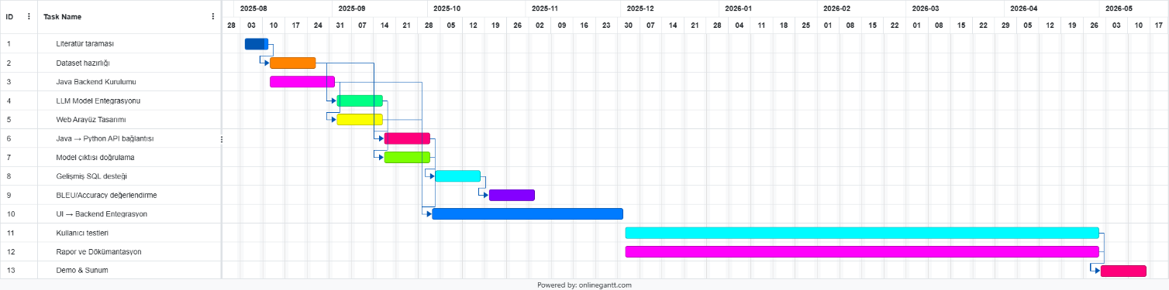

 | Title-Name and Surname | Signature
1. Advisor
2. Advisor

The subject of the project was / was not found worthy of execution.
…………………..…

Advisor
Title, Name and Surname
Date
Signature

