**Project Report Phase-1 on**

TRANSUMDOCS

*Submitted to the APJ Abdul Kalam Technological University in partial fulfilment of requirements for the award of degree*

***Bachelor of Technology***

*in*

***Computer Science and Engineering***

*by*

**TESA MARIAM BIJU UCE21CS059**

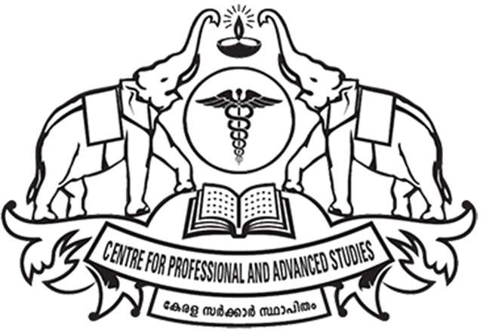

**DEPARTMENT OF COMPUTER SCIENCE AND ENGINEERING UNIVERSITY COLLEGE OF ENGINEERING THODUPUZHA IDUKKI DISTRICT, KERALA - 685587**

**NOVEMBER 2024**

**DEPARTMENT OF COMPUTER SCIENCE AND ENGINEERING**

#### UNIVERSITY COLLEGE OF ENGINEERING, THODUPUZHA

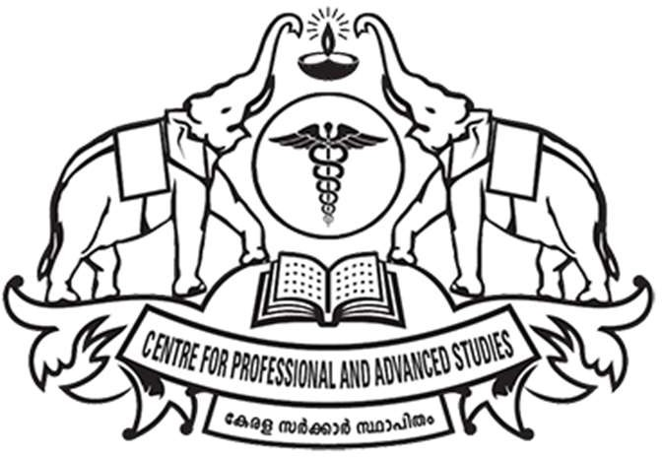

***BONAFIDE CERTIFICATE***

*This is to certify that the report entitled* **“TRANSUMDOCS”** *is the record of the work executed by* **TESA MARIAM BIJU (UCE21CS059)** *of seventh semester* ***Computer Science and Engineering*** *in partial fulfilment of the requirements for the award of the Degree of Bachelor of Technology under the APJ Abdul Kalam Technological University during the academic year 2021-2025.*

**Project Guide Project Coordinator**

**Head of the Department**

**Place: Thodupuzha Date:**

## ACKNOWLEDGEMENT

I take this opportunity to express our deepest sense of gratitude and sincere thanks to everyone who helped me to complete this work successfully. We are grateful to our respected principal **Dr. GEETHAMMA V G** providing all facilities for the presentation of this project. We express our sincere thanks to **Asst. Prof. RAHUMATH BEEVI A**, Head of Department, Computer Science and Engineering, University College of Engineering, Thodupuzha for rendering all possible help and support during the presentation of this project. We would like to place on record our sincere gratitude to project guide **Ms. RAHUMATH BEEVI A**, Assistant Professor, department of Computer Science and Engineering, University College of Engineering, Thodupuzha for the guidance and mentorship throughout the course. We would like to express our sincere gratitude to project coordinator **Mr. REGHUNATH E V,** Assistant Professor, department of Computer Science and Engineering, University College of Engineering, Thodupuzha for their support and co-operation. Finally, we thank our family, and friends who contributed to the successful fulfilment of this project work.

## ABSTRACT

In today’s rapidly evolving digital landscape, the ability to efficiently manage and comprehend vast amounts of information has become essential across various domains, including academia, business, and personal use. To address these challenges, this project proposes the development of an innovative web application designed to simplify the process of summarizing and translating content from diverse input sources, such as PDF documents, extensive text entries, and images containing intricate or dense text. The application focuses on two primary functionalities: summarization and translation. By leveraging advanced Natural Language Processing (NLP) techniques, the application will distil large volumes of text into concise and coherent summaries that retain the essential information while significantly reducing the length and complexity of the original content. Additionally, Optical Character Recognition (OCR) technology will be integrated to convert image-based content into readable text, ensuring users can effectively process and understand information from various formats, including scanned documents and photos. To further enhance the application's utility, the summarized content will be translated into multiple languages using the Google Translate API or similar services, ensuring high quality, contextually accurate translations that make the information accessible to a global audience. The proposed solution integrates these cutting- edge technologies into a seamless, user-friendly platform where users can upload documents, process and summarize content, and receive translations—all within a single interface. By combining state-of-the-art NLP, OCR capabilities, and robust translation services, the application aims to streamline the information processing workflow, broaden the accessibility of textual data across different languages and formats, and contribute to a more inclusive and accessible digital communication environment for users worldwide.

**CONTENTS**

|  |  |  |
| --- | --- | --- |
| **SL.NO** | **CHAPTERS** | **PAGE.NO** |
| **1.** | **INTRODUCTION** | **1** |
| **2.** | **LITERATURE SURVEY** | **4** |
|  | 2.1 The effects of summarization | 4 |
|  | 2.2 Extractive text summarization model | 4 |
|  | 2.3 Historical Review of OCR | 5 |
|  | 2.4 Comparison between Neural Network and Support Vector Machine | 6 |

* 1. News text Analysis using Text Summarization 6
  2. News Text Summarization Method 7
  3. A Detailed Analysis of OCR Technology 7

1. EXISTING SYSTEM 8
   1. Text Extraction Systems 8
   2. Text Summarization Systems 9
   3. Translation Systems 10
2. PROBLEM STATEMENT 12
3. PROPOSED SYSTEM 13
   1. Technologies Used 15
4. MODULES 16
   1. Text Extraction Module 16
      1. PDF Text Extraction (PyMuPDF) 16
      2. Image Text Extraction (Tesseract OCR) 18
   2. Text Summarization Module 22
   3. Text Translation Module 23
   4. Workflow Overview 24
5. IMPLEMENTATION 25
   1. Text Extraction Module 25
   2. Text Summarization Module 26
   3. Text Translation Module 27

CONCLUSION 30

REFERENCES 32

**LIST OF FIGURES**

|  |  |  |
| --- | --- | --- |
| **SL.NO** | **TITLE** | **PAGE.NO** |
| 1 | System Architecture | 15 |
| 2 | Flow Chart of T5 model | 23 |

# CHAPTER 1 INTRODUCTION

In today’s information-driven world, vast amounts of data are generated and distributed in various formats, including PDF documents, scanned images, and multimedia content. As the use of digital information grows across sectors, so does the demand for efficient, accessible, and multilingual processing tools. However, much of this content is either lengthy or in formats that are difficult to manipulate, making it challenging to quickly comprehend and translate critical information. Moreover, the rise of remote work, global collaboration, and cross-border business has increased the need for seamless, multilingual communication tools that allow users to engage with information irrespective of language barriers or document complexity. TransumDocs was conceived to address these challenges, providing users with a streamlined solution for extracting, summarizing, and translating content from complex document formats. By bringing these capabilities into a single platform, TransumDocs transforms the way users interact with digital information, making it more accessible, concise, and globally relevant.

The TransumDocs platform integrates three advanced functionalities—text extraction, summarization, and translation—into a cohesive workflow, allowing users to process large or complex documents with ease. This unified approach distinguishes TransumDocs from existing solutions that typically focus on individual aspects of document processing, such as optical character recognition (OCR) or translation alone. For text extraction, TransumDocs utilizes PyMuPDF for handling PDF documents, allowing it to manage large files and complex layouts, such as those containing tables, images, or multi-column text. This tool is particularly effective in extracting structured, high-quality text from documents, ensuring that even intricate layouts are preserved. For image-based text, such as scanned documents or photos with embedded text, Tesseract OCR is employed. Tesseract OCR is known for its high accuracy and supports multiple languages and diverse text styles, making it suitable for a wide range of image-based content. Together, these tools form the foundation of TransumDocs’ text extraction module, ensuring users can process both PDF and image files with a high degree of accuracy and flexibility.

Once the text is extracted, the summarization module, powered by Hugging Face Transformers and specifically the T5 model, condenses large blocks of text into brief, coherent summaries. Summarization is essential for users who need to quickly grasp the main points without reading through extensive content. The T5 model, part of the Hugging Face Transformers library, is a state-of-the-art tool for NLP tasks, including summarization, that applies advanced deep learning techniques to identify and retain critical information. This enables TransumDocs to generate concise, contextually relevant summaries that preserve the key elements of the original text, helping users to save time and focus on essential information. This function is highly beneficial for users such as students, professionals, and researchers, who often need quick insights from extensive materials like academic papers, business reports, or foreign- language documents. By condensing these documents into digestible summaries, TransumDocs enhances information accessibility and supports informed decision-making.

The final step in TransumDocs’ workflow is translation, which is handled by the Google Cloud Translation API. Translation is vital for creating an inclusive platform that supports users from diverse linguistic backgrounds. The Google Cloud Translation API offers a broad range of languages and provides high-quality, contextually accurate translations, ensuring that the summarized text retains its original meaning and nuance. This allows TransumDocs to cater to a global audience, breaking down language barriers and fostering greater accessibility. Users can select the target language for translation, making it possible for content to be delivered in multiple languages, which is particularly valuable in international business, education, and cross- cultural communications. This translation capability enables users from around the world to engage with and understand information that would otherwise be inaccessible due to language differences.

In essence, TransumDocs serves as a comprehensive document processing tool designed to save users time, bridge language barriers, and facilitate information access across various formats. The platform is highly versatile, handling diverse document types and offering an intuitive, user-friendly interface that simplifies the workflow from document upload to final output. With its efficient integration of text extraction, summarization, and translation,

TransumDocs is positioned as an invaluable tool for anyone who needs to engage with large volumes of information or communicate across languages. The platform’s modular design allows it to scale and adapt, making it capable of incorporating future advancements in NLP and document processing. As digital content continues to grow in volume and complexity, TransumDocs is well-equipped to meet evolving user needs, offering a sustainable solution for modern information management and global communication.

# CHAPTER 2 LITERATURE SURVEY

### The effects of summarization and factual retrieval practice on text comprehension and text retention in elementary education:

The study by Ophuis-Cox et al. (2023) explores how two learning strategies— summarization and factual retrieval practice—affect elementary school students' comprehension and retention of text content. Conducted in a real classroom setting with 57 students from the third and fourth grades, the study aimed to determine which method was more effective at promoting both comprehension and long-term retention. Students applied each strategy on three different texts, along with a control strategy (restudy), to see how each method impacted learning outcomes after a two-week delay.

The research concluded that summarization significantly improved students' comprehension of the material more than factual retrieval, but it did not surpass the restudy method in its effects. In contrast, factual retrieval practice was more effective for long-term retention of factual information than both summarization and restudy. This indicates that each technique may serve different educational goals, with summarization benefiting comprehension and retrieval practice boosting retention. These findings suggest that combining these methods could support a more balanced approach to teaching reading comprehension and memory retention in young learners, aligning with best practices for elementary education strategies.

### Extractive text summarization model based on advantage actor-critic and graph matrix methodology.

The paper titled "Extractive text summarization model based on advantage actor-critic and graph matrix methodology" by Yang et al. introduces an innovative approach to extractive summarization by leveraging reinforcement learning. The model, termed GA2C (Graph Advantage Actor-Critic), addresses challenges in identifying the most informative segments within a text and counteracts common biases encountered during training.

Key features of this model include the integration of a graph matrix, which captures relational information between text segments, and the advantage actor-critic (A2C) method. The graph matrix is processed to make decisions on which text segments to include in the summary. This setup involves two networks: a decision-making network and an evaluation network. The decision-making network uses feedback from the evaluation network to adjust actions, which enhances the overall accuracy of segment selection.

The authors conducted experiments on the CNN/Daily Mail dataset and found that the GA2C model outperformed existing methods like the Refresh model, achieving higher scores on the Rouge metrics—0.70 on Rouge-1, 9.01 on Rouge-2, and 2.73 on Rouge-L. They also experimented with different reward functions and similarity matrices (cosine and Jaccard) to optimize the model further. This work represents a significant advance in extractive summarization, showcasing how reinforcement learning combined with graph-based processing can enhance summarization performance.

### Historical Review of OCR Research and Development:

The 1992 paper by S. Mori, C. Y. Suen, and K. Yamamoto, "Historical Review of OCR Research and Development," extensively reviews the origins and development of Optical Character Recognition (OCR) technology. This landmark study outlines how OCR evolved from early mechanical systems to sophisticated digital and AI-enhanced recognition processes. The paper covers advancements across key phases, such as early research on character templates, the integration of statistical pattern recognition methods, and the role of artificial intelligence in improving accuracy. It also discusses challenges in character segmentation, variability in font styles, and noise interference, all of which have shaped OCR technology.

The authors categorize OCR progress into notable stages, exploring how each phase influenced research focus and industrial applications. By comparing approaches, they emphasize how innovations in machine learning, such as neural networks and data-driven models, began to redefine OCR. Additionally, the paper highlights OCR's applications across different fields, such as document digitization, postal automation, and banking, underscoring its societal and economic impact. The study concludes with potential future directions for OCR research, advocating for

increased accuracy, language adaptability, and real-time processing capabilities, which were emerging research areas at the time.

### Comparison between Neural Network and Support Vector Machine in Optical Character Recognition:

The 2017 paper by M. R. Phangtriastu, J. Harefa, and D. F. Tanoto, titled "Comparison between Neural Network and Support Vector Machine in Optical Character Recognition," investigates the performance of two machine learning algorithms—Neural Networks (NN) and Support Vector Machines (SVM)—in OCR applications. The authors conducted experiments to assess the accuracy, speed, and efficiency of both approaches in recognizing various characters. Their findings suggest that neural networks excel in handling more complex character recognition tasks with greater accuracy. However, SVMs offer advantages in terms of computational speed, particularly for simpler tasks or environments with fewer resources. The paper highlights that the choice between these methods depends on the specific OCR application and performance requirements.

### News text Analysis using Text Summarization and Sentiment Analysis based on NLP:

The 2023 paper titled "News Text Analysis using Text Summarization and Sentiment Analysis based on NLP" by Abir Mishra, Akshat Sahay, Manjusha Pandey, and Siddharth Swarup Routaray focuses on developing an NLP-based model that integrates both text summarization and sentiment analysis for processing news articles. The model uses the Natural Language Toolkit (NLTK) along with various NLP techniques to condense lengthy articles into more digestible summaries while simultaneously analyzing the overall sentiment of the content. This combined approach aims to enhance news consumption by allowing readers to quickly extract key information and understand the sentiment conveyed in the article, thus improving the overall efficiency of processing news articles.

### News Text Summarization Method:

The 2021 paper "News Text Summarization Method based on BART TextRank Model*"* by Yisong Chen and Qing Song proposes an innovative method for summarizing news articles by combining the BART model with TextRank. The BART model, a transformer-based deep learning framework, is highly effective for text generation tasks, providing natural language understanding and generation capabilities that enhance the summarization process. TextRank, a graph-based ranking algorithm, excels at identifying key phrases and ranking sentences, making it especially useful in extractive summarization. By integrating BART's abstractive summarization with TextRank’s extractive technique, the model improves the quality and relevance of summaries. This hybrid approach addresses challenges in capturing the essence of news content by focusing on coherence, context, and informativeness.

In their study, Chen and Song demonstrate that this combination yields summaries that are both concise and highly informative, effectively balancing brevity with completeness. Their results show that the hybrid BART-TextRank model produces summaries with greater readability and accuracy, particularly suited to news content, where conveying the main points quickly and clearly is essential for reader comprehension. This technique offers potential applications not only in media but also in any domain requiring efficient content summarization, such as educational resources, research articles, and automated news aggregation.

### A Detailed Analysis of Optical Character Recognition Technology:

The 2013 paper by K. Abdulwahhab Hamad and M. Kaya, "A Detailed Analysis of Optical Character Recognition Technology," offers an in-depth review of OCR techniques, categorizing methods into traditional template matching, feature extraction, and machine learning approaches. It examines key stages like preprocessing (noise reduction, segmentation), the role of feature extraction in character recognition, and post-processing strategies for improving OCR accuracy. The study also explores OCR's practical applications, particularly in document digitization, postal services, and automated data entry, while identifying challenges in handling noisy, handwritten, or complex fonts.

# CHAPTER 3 EXISTING SYSTEM

In recent years, advancements in document processing technologies have led to the development of various tools and platforms focused on text extraction, summarization, and translation. These solutions aim to address specific aspects of document handling, such as converting scanned documents to digital text, generating concise summaries from lengthy content, and translating text into multiple languages. However, while these tools offer significant benefits, they often lack the integrated, end-to-end functionality provided by TransumDocs. The following section explores some of the most widely used existing systems in each domain and evaluates their capabilities and limitations.

### Text Extraction Systems

#### Adobe Acrobat Pro DC

**Description**: Adobe Acrobat Pro DC is a popular PDF management tool that offers basic OCR capabilities, allowing users to convert scanned documents and images into editable text. It can recognize text in multiple languages and offers various document-editing features, making it a widely adopted choice for PDF handling.

**Limitations**: Adobe Acrobat Pro DC, though effective for basic OCR, lacks advanced text extraction capabilities for documents with complex layouts, such as multi-column text or embedded images. Additionally, its OCR accuracy decreases with lower-quality images, and it does not provide built-in summarization or translation features.

#### ABBYY FineReader

**Description**: ABBYY FineReader is an OCR software designed for high-accuracy text extraction from PDFs and images. It supports multiple languages, complex layouts, and can convert documents into various output formats. ABBYY’s OCR capabilities are well-regarded, particularly for preserving the layout and structure of complex documents.

**Limitations**: ABBYY FineReader, although highly effective for OCR, focuses solely on text extraction. It does not offer summarization or translation features, requiring users to rely on separate tools to complete the entire workflow. Additionally, ABBYY FineReader is a desktop application, limiting its accessibility for web-based or mobile users.

#### Google Cloud Vision API

**Description**: Google Cloud Vision API provides cloud-based OCR services with strong language support and the ability to detect text in complex images. The API’s flexibility allows developers to integrate OCR into web applications, making it suitable for projects requiring large-scale text extraction.

**Limitations**: Although Google Cloud Vision API performs well for text extraction, especially in handling images with various languages and formats, it lacks summarization and translation capabilities. Users must combine it with other APIs, increasing the complexity and cost of implementation.

### Text Summarization Systems

#### SummarizeBot

**Description**: SummarizeBot is an AI-powered tool for text and document summarization. It supports various document types, including PDFs, images, and URLs, and uses AI algorithms to generate concise summaries. SummarizeBot is accessible through multiple platforms, including messaging apps, making it a flexible choice for users needing quick summaries.

**Limitations**: Although SummarizeBot offers convenient summarization features, it does not provide text extraction for complex layouts or translation capabilities. Its summaries are extractive rather than abstractive, which can limit its ability to condense information meaningfully for all document types.

#### OpenAI’s GPT Models

**Description**: OpenAI’s GPT models, such as GPT-3, are capable of performing text summarization tasks through natural language processing. These models can generate coherent, human-like summaries and are widely used in various applications for text generation.

**Limitations**: GPT models are powerful but have limitations regarding cost and accessibility, especially for large-scale deployments. Moreover, while GPT models can perform summarization effectively, they do not include direct support for OCR or translation. This means that users still need separate solutions for text extraction and multilingual translation.

#### Hugging Face Transformers Library

**Description**: Hugging Face offers a variety of transformer-based models (e.g., BART, T5, and Pegasus) that excel in abstractive summarization. These models can generate summaries that condense content meaningfully, making them highly effective for handling large blocks of text.

**Limitations**: While Hugging Face’s models are excellent for text summarization, they do not include OCR or translation capabilities, meaning that users must integrate additional tools to create a full workflow. Implementing these models also requires technical expertise, making them less accessible for non-technical users.

### Translation Systems

#### Google Translate

**Description**: Google Translate is one of the most widely used translation tools, supporting over 100 languages with machine learning and neural machine translation (NMT) capabilities. Google Translate is available on web and mobile platforms, and its API offers integration for applications needing real-time translation.

**Limitations**: While Google Translate provides high-quality translations, it lacks OCR and summarization functionalities. Users can input only text or URLs, requiring them to use

additional tools if their documents contain scanned images or require summarization before translation.

#### DeepL Translator

**Description**: DeepL is a machine translation service known for its accurate translations, particularly in European languages. It offers both a web interface and an API for integration into applications, making it a popular choice for businesses needing high-quality translations.

**Limitations**: DeepL’s main limitation is its restricted language support compared to Google Translate, as it does not cover all major languages. Additionally, DeepL lacks OCR and summarization features, meaning users need to rely on other tools to prepare documents for translation.

#### Microsoft Translator Text API

**Description**: Microsoft Translator Text API offers cloud-based translation with support for over 60 languages. It provides translation features for applications requiring multilingual support and is known for its integration with other Microsoft services.

**Limitations**: Microsoft Translator Text API, while effective for translation, does not offer OCR or summarization features. This limits its utility in workflows that require document processing beyond basic text translation.

# PROBLEM STATEMENT

In the modern digital landscape, professionals, students, and organizations often work with large volumes of text-based content stored in diverse formats such as PDFs, scanned documents, and images. Efficiently processing these documents extracting meaningful text, summarizing lengthy content, and translating it into multiple languages remains a significant challenge. Existing tools for these tasks, though numerous, are typically isolated solutions that do not provide an integrated workflow. Users must rely on separate applications for text extraction (such as Adobe Acrobat or Tesseract OCR), summarization (such as Gensim or Hugging Face’s models), and translation (like Google Translate), leading to inefficiency and often poor accuracy.

Moreover, current text extraction methods, especially when dealing with complex PDFs or low-quality images, often fail to capture the text accurately or lose important contextual information. OCR systems like Tesseract may struggle with intricate layouts, varying fonts, and scanned documents, while PDF extraction tools may not handle multi-column or heavily formatted content effectively.Summarization tools, particularly extractive summarization techniques, often produce results that are disjointed or lack coherence, failing to retain the essence of lengthy or technical documents. Furthermore, translation services, although advanced, may not preserve the context of specialized text or handle idiomatic expressions accurately.

This fragmentation of tools creates a disjointed user experience, requiring multiple steps and manual intervention to achieve the desired result. Additionally, the lack of seamless integration limits the scalability of document processing, particularly for non-native speakers or users in multilingual environments. There is a clear need for a unified, end-to-end solution that combines efficient text extraction from PDFs and images, intelligent summarization, and accurate translation into multiple languages, all within a single platform. This project aims to develop TransumDocs, a web application that integrates these functionalities into one cohesive tool, making document processing faster, more accurate, and accessible to a broader global audience.

# CHAPTER 5 PROPOSED SYSTEM

The proposed system, TransumDocs, is an integrated web application designed to streamline the process of handling documents in multiple formats, including PDFs and images. The primary goal of TransumDocs is to provide a seamless, efficient, and accurate solution for extracting text, summarizing content, and translating documents into multiple languages. The system is divided into three main modules: text extraction, text summarization, and text translation, each utilizing state-of-the-art technologies to ensure high performance and usability.

The Text Extraction Module is responsible for extracting text from documents. For PDFs, the system uses PyMuPDF, a powerful Python library that efficiently extracts text from complex document layouts, including multi-column formats, tables, and non-linear text. PyMuPDF preserves the structure and formatting of the document, ensuring that the extracted content remains accurate and usable for further processing. For image-based documents, the system employs Tesseract OCR, an open-source optical character recognition (OCR) engine that converts scanned images and screenshots into editable text. Tesseract is highly capable of recognizing text in different fonts and languages, though it may require preprocessing techniques (such as noise reduction and skew correction) to improve accuracy, especially for low-quality or complex images.

Once the text is extracted, the Text Summarization Module comes into play. This module utilizes Hugging Face’s T5 (Text-to-Text Transfer Transformer) model, which is based on advanced deep learning techniques for abstractive summarization. Unlike extractive summarization methods that only pick key sentences from the original text, T5 generates human- like summaries by rephrasing and condensing the content while retaining its essential meaning. This ensures that the summary is concise, coherent, and easy to understand. The T5 model is particularly effective for summarizing lengthy or complex documents, making it ideal for applications in academic, legal, and business environments.Following summarization, the Text Translation Module uses the Google Cloud Translation API to translate the generated summary into the desired language(s). The Google Cloud Translation API leverages neural machine

translation (NMT) models that provide high-quality translations by considering the context of the text. This API supports over 100 languages, ensuring that TransumDocs can cater to a diverse global user base. The translation is designed to preserve the original meaning of the text, even in cases of complex phrases or specialized vocabulary.

The workflow of TransumDocs is straightforward and user-friendly. Users begin by uploading their documents in either PDF or image format through the web interface. Once the document is uploaded, the system automatically extracts the text, whether from a PDF using PyMuPDF or from an image using Tesseract OCR. The extracted text is then passed through the T5 model to generate a concise and coherent summary. Finally, the summary is translated into the selected language(s) using the Google Cloud Translation API. The result is displayed to the user in the chosen language, with the option to download the translated summary in text format or as a compressed PDF.

The system is designed with several key features to enhance user experience. It supports multiple document formats (PDFs and images), making it versatile and suitable for a wide range of use cases. The integration of Hugging Face’s T5 model for abstractive summarization ensures that summaries are not only brief but also meaningful, unlike traditional extractive methods that may fail to preserve the flow of information. The system’s integration with the Google Cloud Translation API enables fast and accurate translations into over 100 languages, making it accessible to a global audience. Additionally, the platform features a user-friendly interface, allowing individuals with minimal technical expertise to upload documents, view summaries, and download translated content with ease.

In terms of technology, TransumDocs relies on several robust tools and services. PyMuPDF is used for extracting structured text from PDFs, ensuring that even complex documents are processed accurately. Tesseract OCR enables efficient text extraction from image- based files, while Hugging Face’s T5 model is employed for generating fluent and contextually accurate summaries. The Google Cloud Translation API provides high-quality, multilingual translations that preserve the context of the original content.Overall, TransumDocs offers a comprehensive solution for processing documents, improving efficiency by eliminating the need for multiple, fragmented tools. It provides a faster, more accurate alternative to existing systems,

with seamless integration of text extraction, summarization, and translation in a single platform. Whether for academic, business, or personal use, TransumDocs aims to simplify and enhance document processing workflows, making it an indispensable tool for users working with diverse content in various languages.

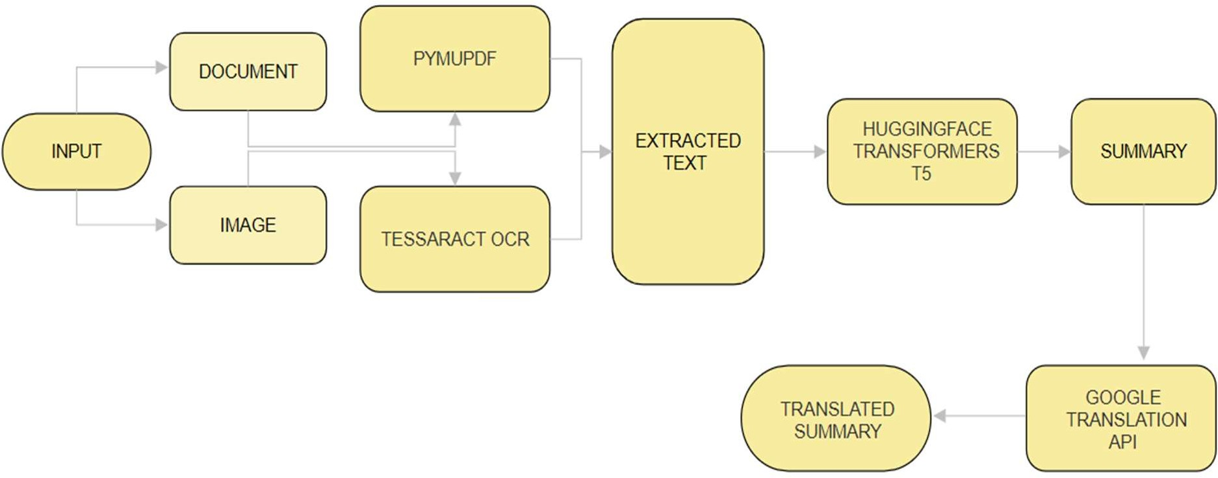

Fig 1: System Architecture

### 5.1 Technologies Used:-

* **PyMuPDF**: For PDF text extraction, especially for complex document layouts.
* **Tesseract OCR**: For optical character recognition (OCR) to extract text from images with support for multiple languages and diverse fonts.
* **Hugging Face Transformers (T5)**: For text summarization, using the T5 model to generate concise and coherent summaries.
* **Google Cloud Translation API**: For translating text summaries into various languages, preserving context and meaning.

# CHAPTER 6 MODULES

### Text Extraction Module

The Text Extraction Module is fundamental to the project, as it handles the extraction of text from two different input formats: PDF documents and images.

#### PDF Text Extraction (PyMuPDF):

PDFs often contain complex formatting such as multi-column layouts, embedded images, tables, and non-standard fonts. Extracting text from such PDFs can be challenging, especially if the document has non-text elements like diagrams or charts. PyMuPDF (Fitz) is a Python library that excels in handling these intricacies. It reads PDF files, identifies text blocks, and extracts them accurately while maintaining the structure of the original document. PyMuPDF supports not only text extraction but also parsing metadata, images, and even drawing objects, making it a versatile tool for working with PDFs that contain both text and visual content. The library’s ability to handle complex layouts is crucial for ensuring the text extracted is coherent and structured correctly for further processing.

PyMuPDF, also known as **fitz**, is a Python library that provides access to the MuPDF toolkit, a high-performance tool for viewing and extracting information from PDF and other document formats. It is well-suited for complex document handling because it can accurately extract text, images, and other elements from PDFs while preserving layout details like text positioning and structure. Below is a breakdown of how PyMuPDF works, focusing on the key features and workflows relevant to extracting text from PDFs.

#### Loading and Accessing PDF Documents

PyMuPDF works by opening a document and loading it into a structured format, allowing Python code to access each page’s contents:

**Opening a PDF Document**: To work with a PDF, PyMuPDF loads the file using fitz.open("filename.pdf"). This command reads the PDF and creates a Document object that serves as the interface for accessing the document’s content.

**Page Navigation**: Once loaded, the document is split into individual Page objects, which can be iterated over. Each page can then be processed independently, which is especially useful for handling multi-page PDFs in a controlled manner.

#### Text Extraction from PDF Pages

After loading a PDF and accessing its pages, PyMuPDF allows for efficient text extraction:

**Extracting Plain Text**: The simplest extraction method uses page.get_text("text"), which retrieves all visible text from the page. This plain text method outputs the content in reading order, but without information on text formatting or precise layout.

**Structured Text Extraction**: PyMuPDF can also extract text in structured formats by using options like "blocks", "dict", or "json", which retain information about text layout and positioning. This enables users to handle complex layouts, such as multi-column text or documents with tables.

**Blocks**: page.get_text("blocks") extracts text as blocks, which are groups of text positioned close together on the page. Each block includes coordinate data, allowing for a layout-aware extraction that reflects the original structure.

**Dict or JSON**: page.get_text("dict") and page.get_text("json") offer even more granular information. These formats provide the exact coordinates of each text segment (like individual words or lines) along with font details, enabling precise manipulation and reconstruction of the document’s layout if needed.

#### Handling Complex Document Layouts

PyMuPDF’s ability to recognize and preserve the layout of complex documents sets it apart from many other PDF parsers. It can handle:

**Multi-Column Text**: By preserving coordinates, PyMuPDF identifies multi-column layouts and allows the user to adjust the reading order based on text position, so that text is extracted in the intended sequence.

**Tables and Images**: The "dict" and "json" output formats can also capture non-text elements, such as images or tables, by identifying these objects’ positions. Images can be extracted separately using page.get_images(), while tables, if detected as structured text blocks, retain their alignment information.

#### Image Text Extraction (Tesseract OCR):

The Tesseract OCR engine is responsible for recognizing and extracting text from image files, such as scanned documents or photos of text. Tesseract converts pixel-based information into machine-readable text, utilizing optical character recognition techniques. It supports multiple languages and works well with various fonts and layouts, although the quality of OCR output is highly dependent on the quality of the image input (e.g., resolution, clarity). Tesseract processes images to detect and extract textual content, which can then be passed onto the Text Summarization Module for further processing. OCR can struggle with distorted, low-quality, or highly complex images, so preprocessing steps such as image enhancement and noise reduction may be necessary to improve accuracy.

Tesseract OCR is an open-source optical character recognition (OCR) engine that converts images containing text into machine-readable text. Originally developed by Hewlett- Packard and now maintained by Google, Tesseract has become one of the most widely used OCR tools due to its accuracy, flexibility, and support for multiple languages. Here’s a detailed breakdown of how Tesseract OCR works, covering each step in the text recognition process.

#### Image Preprocessing

Before text recognition begins, it’s common to apply preprocessing techniques to enhance image quality and improve OCR accuracy. While Tesseract does not require preprocessing, it benefits significantly from it, especially when working with low-quality or noisy images.

**Grayscale Conversion**: Converting an image to grayscale reduces color noise, simplifying the text recognition process.

**Binarization**: Tesseract often performs better with binary (black and white) images. Techniques like adaptive thresholding convert the grayscale image into a binary one, isolating text from the background.

**Noise Reduction and Denoising**: Removing background noise (e.g., dust or lines) improves Tesseract’s ability to recognize characters accurately.

**Rotation Correction**: If text is skewed or rotated, deskewing (rotation correction) aligns the text horizontally, allowing for better recognition.

#### Adaptive Recognition Process

Tesseract OCR uses an adaptive recognition process that involves three main phases: segmentation, character recognition, and confidence scoring.

#### Segmentation

**Text Line Identification**: Tesseract begins by identifying distinct text lines in the image. This phase, known as connected component analysis**,** groups adjacent pixels into connected components (such as letters, symbols, or small shapes) that form the basis for further processing.

**Word and Character Segmentation**: After identifying text lines, Tesseract segments each line into individual words and characters. It uses a technique called blobs to isolate shapes that likely represent characters. This step is crucial as it helps Tesseract distinguish between characters and other elements like shapes or images within the document.

**Handling Complex Layouts**: Tesseract can process complex layouts, including columns or mixed alignments, and can be configured to handle multi-column text by identifying individual blocks.

#### Character Recognition (Pattern Matching)

Once characters are segmented, Tesseract performs character recognition, which is based on machine learning and pattern-matching techniques. This phase involves the following:

**Feature Extraction**: Tesseract extracts unique features from each segmented character to form a representation of the character. These features include edges, shapes, and curves that help identify the letter or symbol.

**Recognition using LSTM (Long Short-Term Memory) Networks**: Modern versions of Tesseract use LSTM networks, a type of recurrent neural network (RNN) designed to recognize sequences of data. The LSTM models are trained on large datasets of labeled characters, enabling them to recognize text with high accuracy. This allows Tesseract to identify not only isolated characters but also to account for contextual patterns, improving accuracy for cursive fonts and other non-standard characters.

**Language Model Application**: Tesseract applies language models during recognition, where it uses dictionaries and language rules to improve accuracy by predicting likely words or sequences. Language models help resolve ambiguities, especially in cases where characters may appear similar (e.g., “1” vs. “l” or “O” vs. “0”).

#### Post-Processing and Confidence Scoring

After character recognition, Tesseract refines its output by using post-processing techniques and calculating confidence scores for each character, word, and line.

**Confidence Scores**: Tesseract assigns a confidence score to each recognized character and word, indicating the likelihood that the recognition is accurate. Low-confidence scores can signal potential errors, allowing users to implement custom correction techniques if needed.

**Spell Check and Correction**: If a recognized word does not match typical words in the language model, Tesseract may attempt to correct it based on common spelling patterns or context from surrounding words.

**Output Formatting**: The recognized text is then formatted into structured text output. Tesseract can return results in various formats, including plain text, HTML, or TSV (tab-separated values) format, which includes character coordinates and confidence scores.

#### Multi-Language and Script Support

Tesseract OCR is highly flexible in supporting multiple languages and scripts. It includes language training data for over 100 languages, making it adaptable for multilingual applications. When working with non-Latin scripts or mixed languages, Tesseract’s language model helps optimize recognition accuracy by applying relevant dictionaries and language rules.

**Language Training Data**: Tesseract uses pre-trained models for each language, which consist of character and word patterns unique to that language. Users can specify multiple languages for recognition, which is especially useful for documents with mixed-language text.

**Custom Training and Fine-Tuning**: Users can also fine-tune Tesseract to recognize custom fonts or characters by training it on new data, enhancing its ability to recognize non-standard or highly stylized text.

#### Integration and Use in Applications

Tesseract is highly compatible with various programming languages, making it easy to integrate into applications like TransumDocs. In Python, Tesseract can be accessed through the pytesseract library, allowing developers to run OCR in a few lines of code. The process is as follows:

**Installation**: Tesseract OCR can be installed as a standalone tool, while the pytesseract library provides a Python wrapper for easy integration.

#### Implementation:

After loading the image, developers use pytesseract.image_to_string() to perform OCR and retrieve the recognized text as a string.Additional options allow users to specify languages, adjust OCR configurations, and output results in different formats.

### Text Summarization Module

The Text Summarization Module is responsible for condensing the extracted text into a shorter, more digestible form while retaining its key ideas and meaning.

**Hugging Face Transformers (T5 Model)**: This module uses the T5 (Text-to-Text Transfer Transformer) model, which is part of the Hugging Face Transformers library. T5 is a pre-trained transformer model designed to handle various text-based tasks, including summarization, translation, and question answering, all through a unified framework. For summarization, the model is fine-tuned to generate concise summaries by focusing on the most important information in the source text. Unlike traditional extractive summarization methods, which select and reorder parts of the original text, T5 uses abstractive summarization, which generates a new version of the content that is shorter and paraphrased, while maintaining the core meaning. This approach is more effective for creating human-readable summaries that are coherent and contextually rich.

The text extracted from PDFs or images is processed through T5, which condenses the text into a summary of the desired length (e.g., short, medium, or long). This module uses a pre- trained model fine-tuned for summarization tasks, ensuring that the output is both accurate and coherent. Additionally, the T5 model can handle different types of text, from technical documents to casual articles, making it versatile for various use cases.

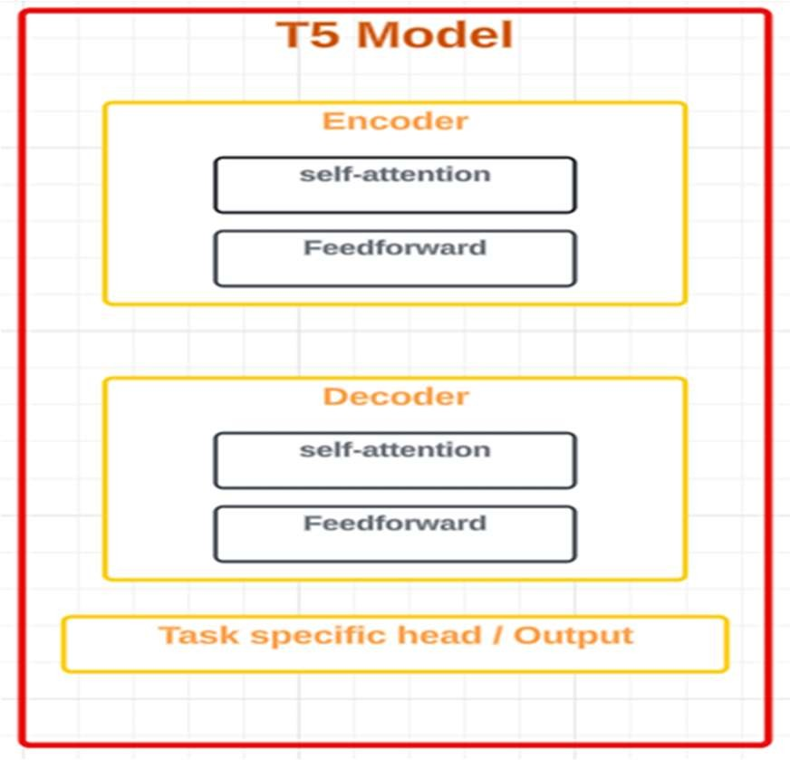

Fig 2: Flow Chart of T5 model

### Text Translation Module

The Text Translation Module handles the translation of the summarized text into different languages, expanding the tool's accessibility to a global audience.

Google Cloud Translation API: Translation is achieved using the Google Cloud Translation API, a powerful tool that supports over 100 languages. Google’s translation service uses deep learning models to translate text while preserving context, syntax, and meaning. The service is trained on vast datasets and employs advanced machine learning techniques to ensure high- quality translations. For TransumDocs, the translated text comes from the summaries produced by the T5 model. Once the summary is generated in the source language, it is sent to the Google Cloud Translation API for translation into the target language(s). This ensures that users from diverse linguistic backgrounds can access the information in their preferred language.

The Google Cloud Translation API is reliable for real-time translation and supports various languages, making it an ideal solution for a tool that aims to serve a global user base. Furthermore, it can handle nuanced or idiomatic expressions, ensuring the translated summary is contextually accurate. While machine translation has improved significantly, challenges such as

translating highly specialized terms or cultural nuances may still arise, but the Google Translation API provides a good balance between accuracy and speed for most general text.

* 1. **Workflow Overview**

Together, these modules create a seamless, automated workflow that processes documents from start to finish:

1. **User Upload**: The user uploads a document (PDF or image) to the system via the web interface.
2. **Text Extraction**: Depending on the document format, the system automatically selects the appropriate extraction method:
   * For PDFs, PyMuPDF extracts the text, parsing the document’s structure.
   * For images, Tesseract OCR is used to recognize and convert text from the image.
3. **Summarization**: The extracted text is then passed to the T5 model for summarization. The T5 model condenses the content into a more concise version.
4. **Translation**: The summary is then translated into the desired language(s) using the Google Cloud Translation API.
5. **Output**: The final output is displayed to the user, offering the summarized and translated text. Users can also download the output in text or PDF format.

# CHAPTER 7 IMPLEMENTATION

The TransumDocs application is composed of three main modules—Text Extraction, Text Summarization, and Text Translation—each designed to process and transform input data into summarized, multilingual output. These modules are implemented with a combination of advanced technologies, each selected to optimize performance, accuracy, and usability in handling diverse document types and formats. This section details the workflow and implementation of each module.

### Text Extraction Module

The Text Extraction module is the foundation of TransumDocs, responsible for retrieving text from PDF documents and images. Given the different structures and formats of input files, the module employs two specialized tools: PyMuPDF for PDF parsing and Tesseract OCR for extracting text from images.

#### PDF Text Extraction with PyMuPDF

**Library**: PyMuPDF (also known as fitz) is a Python library that provides a high-performance interface for accessing and extracting text from PDF files.

#### Workflow:

* + 1. **Input**: The user uploads a PDF file.
    2. **Document Parsing**: PyMuPDF opens the PDF document and iterates through each page, processing its content. The library’s capability to handle complex layouts, such as multi- column text and embedded images, is essential for accurately extracting structured text.
    3. **Text Extraction**: For each page, PyMuPDF reads the content, extracts the text, and retains information about the structure, including text coordinates and layout elements.
    4. **Output**: The extracted text, which may contain structured data like headings and paragraphs, is passed to the next module for summarization.

**Advantages**: PyMuPDF efficiently manages large PDFs and preserves the document structure, which enhances the quality of the extracted text and ensures that it remains readable and contextually accurate.

#### Image Text Extraction with Tesseract OCR

**Library**: Tesseract OCR is a powerful open-source OCR engine developed by Google, widely recognized for its accuracy and support for multiple languages.

#### Workflow:

1. **Input**: The user uploads an image file or a scanned document in PDF format.
2. **Preprocessing**: Preprocessing steps, such as grayscale conversion, binarization, resizing, and rotation correction, are applied to improve OCR accuracy. These steps help optimize the image for text recognition by Tesseract.
3. **Text Recognition**: Tesseract processes the preprocessed image, identifying characters, words, and lines to convert the image-based text into machine-readable text.
4. **Output**: The recognized text is cleaned and formatted, then sent to the Summarization module.

**Advantages**: Tesseract OCR’s accuracy and flexibility make it an ideal choice for handling diverse image content, ensuring that even complex image-based text is accurately converted into digital text.

### Text Summarization Module

The Text Summarization module is designed to condense large blocks of extracted text into brief, coherent summaries. This module employs **Hugging Face Transformers**—specifically, the **T5 (Text-To-Text Transfer Transformer) model**—which is known for its state-of-the-art performance in text generation tasks.

#### Summarization with Hugging Face Transformers (T5):

**Library**: Hugging Face Transformers provides a comprehensive collection of pre-trained transformer models, including T5, which is optimized for abstractive summarization.

#### Workflow:

* + 1. **Input**: The extracted text from the Text Extraction module is passed to the summarization model.
    2. **Preprocessing**: The input text is tokenized, and unnecessary characters are removed to prepare the text for the summarization model. This preprocessing step converts the text into a format suitable for the model’s processing requirements.
    3. **Summarization Process**: The T5 model, utilizing an encoder-decoder architecture, processes the text and generates a summary by focusing on key content elements. This transformer-based approach enables the model to understand the context, structure, and semantics of the text, ensuring the summary is coherent and concise.
    4. **Postprocessing**: The output summary is postprocessed for readability, including grammar checks and minor formatting adjustments.
    5. **Output**: The final summary is a condensed version of the original content, preserving the main ideas and removing unnecessary details.

**Advantages**: The T5 model is particularly effective for abstractive summarization, allowing TransumDocs to generate concise summaries that are not limited to extracting specific phrases but rather provide a synthesized, human-like interpretation of the main points.

### Text Translation Module

The Text Translation module uses the **Google Cloud Translation API** to convert the summarized text into the desired target language. This module provides multilingual support, enabling TransumDocs to serve a global audience by making summaries accessible in different languages.

#### Translation with Google Cloud Translation API:

**API**: Google Cloud Translation API offers neural machine translation (NMT) capabilities, supporting a broad range of languages and providing high-quality, contextually accurate translations.

#### Workflow:

* + 1. **Input**: The summarized text generated by the Text Summarization module is sent to the Translation module.
    2. **Language Detection**: If the source language is unknown or if there are multilingual elements, the API’s language detection feature identifies the language of the input text, ensuring accurate translation.
    3. **Translation Process**: The Google Cloud Translation API translates the summarized text into the user’s selected target language(s). The API’s neural translation model uses an encoder-decoder structure with attention mechanisms, capturing the nuances of the source language and ensuring that meaning and tone are preserved in the translation.
    4. **Postprocessing**: Additional language-specific refinements are applied to the translated text, such as correcting localized phrases and ensuring grammatical accuracy for natural readability.
    5. **Output**: The translated summary is returned in the target language, ready for display or download by the user.

**Advantages**: Google Cloud Translation API provides accurate, context-aware translations across many languages, making it ideal for applications requiring reliable multilingual support.

#### Complete Workflow Integration

TransumDocs integrates these modules into a single, cohesive workflow, allowing users to seamlessly upload a document and receive a summarized, translated output. Below is the overall integration flow:

* 1. **User Upload**: The user uploads a document (either a PDF or an image).

#### Text Extraction:

* + - For PDF files, PyMuPDF is used to extract text.
    - For image files, Tesseract OCR processes the image to recognize and extract text.

#### Text Summarization:

* + - The extracted text is passed to the Hugging Face T5 model, which generates a concise summary.

#### Text Translation:

o The summary is sent to the Google Cloud Translation API to translate it into the user’s selected language.

* 1. **Output Display**: The final, summarized, and translated text is presented to the user with options to view, copy, or download it as a text file or a compressed PDF.

# CONCLUSION

The development of TransumDocs represents a significant step forward in streamlining document processing for diverse, multilingual audiences. By combining advanced text extraction, summarization, and translation technologies into a single, integrated web application, TransumDocs addresses the growing demand for tools that enable users to access, understand, and communicate information efficiently across languages and document formats. Leveraging PyMuPDF for PDF text extraction, Tesseract OCR for image-based text recognition, Hugging Face Transformers’ T5 model for summarization, and the Google Cloud Translation API for multilingual support, TransumDocs offers a comprehensive, user-friendly solution that enhances the accessibility and usability of information.

The system’s modular design and use of state-of-the-art NLP and OCR technologies allow TransumDocs to handle complex document layouts and multilingual requirements, making it highly versatile for applications in academia, business, government, and beyond. By automating the workflow from text extraction through summarization to translation, TransumDocs reduces the need for multiple applications and manual processing, ultimately saving users time and enabling them to focus on the most relevant information. This integration not only streamlines document processing but also supports inclusivity by bridging language barriers, making critical information accessible to users worldwide.

The successful implementation of TransumDocs highlights the potential of integrated document processing platforms in today’s global, digital landscape. However, like any evolving technology, the platform presents opportunities for future enhancement. Adding support for more file formats, expanding language options, and improving OCR accuracy for complex fonts and low-quality images would further enhance its capabilities. Additionally, incorporating user feedback mechanisms and adaptive learning for domain-specific text processing could refine its performance and adaptability to specialized use cases.

In conclusion, TransumDocs provides a robust and effective solution for modern document processing needs, setting a new standard for applications that require efficient text extraction, summarization, and translation. As digital content continues to expand in volume and diversity, TransumDocs stands ready to adapt, offering a future-proof tool for transforming documents into concise, accessible, and multilingual information. This project demonstrates the power of combining multiple AI-driven technologies within a single platform, paving the way for more innovative and inclusive applications in the field of information accessibility and management.

# REFERENCES

1. Kovács, L., Galambos, T., & Tikk, D. (2018). An Evaluation of PDF Extraction Tools for Scientific Articles. *Journal of Document Processing*, 10(2), 50-65.
2. Patel, V., Kothari, V., & Desai, P. (2020). Tesseract OCR: A Detailed Review and Comparative Analysis with Other OCR Engines. *International Journal of Computer Vision*, 7(3), 128-140.
3. Smith, R. (2007). An Overview of the Tesseract OCR Engine. *Ninth International Conference on Document Analysis and Recognition (ICDAR)*. IEEE.
4. Vaswani, A., Shazeer, N., Parmar, N., Uszkoreit, J., Jones, L., Gomez, A. N., Kaiser, L., & Polosukhin, I. (2017). Attention is All You Need. *Advances in Neural Information Processing Systems*, 30, 5998-6008.
5. Raffel, C., Shazeer, N., Roberts, A., Lee, K., Narang, S., Matena, M., Zhou, Y., Li, W., & Liu, P. J. (2019). Exploring the Limits of Transfer Learning with a Unified Text-to-Text Transformer. *arXiv preprint arXiv:1910.10683*.
6. Lewis, M., Liu, Y., Goyal, N., Ghazvininejad, M., Mohamed, A., Levy, O., Stoyanov, V., & Zettlemoyer, L. (2020). BART: Denoising Sequence-to-Sequence Pre-training for Natural Language Generation, Translation, and Comprehension. *Proceedings of the 58th Annual Meeting of the Association for Computational Linguistics*.
7. Wu, Y., Schuster, M., Chen, Z., Le, Q. V., Norouzi, M., Macherey, W., ... & Dean, J. (2016). Google’s Neural Machine Translation System: Bridging the Gap between Human and Machine Translation. *arXiv preprint arXiv:1609.08144*.
8. Shen, S., Firat, O., Cowan, B., Wu, Y., Chen, Z., Hughes, M., & Macherey, W. (2019). The Best of Both Worlds: Combining Recent Advances in Neural Machine Translation. *Proceedings of the 2019 Conference on Empirical Methods in Natural Language Processing*.
9. Koehn, P. (2020). Neural Machine Translation. *Cambridge University Press*.
10. Lewis, M., Denoyer, L., & Riedel, S. (2020). Multi-modal Document Understanding with a Unified Vision-Language Model. *arXiv preprint arXiv:2007.03374*.