[Software Development](https://adsumoriginator.com/services/software-development)

We have extensive experience in software design, be it web, desktop, console or mobile. With our experience and skills we help you in every area of software product development including conceptualizing, designing, technical feasibility study, system design, implementation, testing, release etc.

* Data Analytics & Information Management
* Cross Platform Deployment
* Legacy Modernization
* Application Maintenance

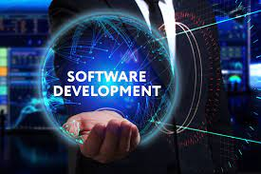

Expertise Of Software Development

Custom Software Services

Custom API Development

Application Development Services

App Maintenance

Data Backup And Recovery

Software Testing

For more information visit at - <https://adsumoriginator.com/>