Lab 0x06 Line Sensing and Following
Logan Ribarich | Arina Vetrova | ME 4305 Section 01 | October 23, 2026
Romi followed the printed 60 cm diameter circle for two consecutive passes during the recorded demonstration. The representative run saved 1,500 valid line measurements over 29.98 s and ended normally. The implementation reads eight of the array’s 13 outputs; the assignment specifies all 13, so the sensor count is a remaining requirement.

Sensor setup and calibration
The connected physical outputs are 3 through 10 in printed order. main.py reads them on PC2, PC3, PA4, PC4, PB0, PB1, PC0, and PC1, respectively. Their assigned lateral positions are +16, +12, +8, +4, 0, -4, -8, and -12 mm, at 4 mm spacing. Only the signal wires previously used by outputs 1 and 2 were moved: outputs 9 and 10 now use PC0 and PC1. The sensor uses the same 3.3 V supply and common ground.
Before scheduled tasks start, both motors are disabled. A missing or incompatible line_calibration.json makes main.py request black and white placements and save the measured ADC averages; the captured run then loaded that file. Startup calibration averages 50 ADC.read() calls per output. Runtime sensing also uses ADC.read(), averaging two reads per output per 20 ms update. Each output is normalized using (reading - white)/(black - white), clipped to 0–1, and included in a weighted centroid. If total weight falls below 0.1, the centroid is undefined and line following stops.

Tasks and cascaded control
Scheduled task | Period / priority | Owned hardware and output
Left_Motor | 10 ms / 5 | Left motor, encoder, and wheel speed P controller; writes PWM.
Right_Motor | 10 ms / 5 | Right motor, encoder, and wheel speed P controller; writes PWM.
Line | 20 ms / 2 | Eight ADC inputs; updates centroid and left/right speed requests.
User | 20 ms / 1 | USB VCP commands; prints buffered data after the wheels stop.

The Line task owns the sensor and sends two velocity_setpoint values (rad/s) through the motor shared-data objects. For this robot, negative wheel velocity moves toward the sensor side. The steering sign was reversed after a floor check so corrections turn toward the observed line. The implemented outer correction is the limited value of +0.55 times centroid (mm), bounded to ±3 rad/s. The left and right requested speeds are -5 plus and minus that correction, respectively, with requests capped at 0 rad/s to avoid a commanded wheel reversal. Each motor task compares requested and encoder-measured speed, applies wheel Kp = 1.0 V/(rad/s), and limits the calculated voltage to ±6 V. The taskmotor.py conversion uses a 7.2 V battery reference to obtain PWM duty cycle; this is a code setting, not a battery measurement.
TaskUser accepts v to set speed, k then p to set wheel gain, f to follow without logging, c for a finite capture, s to stop, and e to exit. The 1,500-sample capture buffers MCU time and centroid, stops motion, then transmits the data one row per User-task dispatch. The Mac script sets the trial inputs and saves both line_following.csv and line_following.png. Motor step-response commands remain available through l and r.

Implementation diagrams
Insert the finished diagrams in the spaces below. Keep the task names, periods, priorities, communication fields, and sign convention consistent with the final files used for the recorded run.
Figure 1. Updated task diagram.
INSERT HERE

Figure 2. User task state transitions.
INSERT HERE

Figure 3. Line task operating modes.
INSERT HERE

Figure 4. Motor task state transitions.
INSERT HERE

Figure 5. Cascaded line following controller.
INSERT HERE

Final settings and measured response
Setting or measured result | Final run
Sensor outputs / ADC reads | 3–10 (eight connected) / two reads each update
Base speed / wheel Kp | 5.0 rad/s magnitude / 1.0 V/(rad/s)
Line Kp / correction limit | 0.55 (rad/s)/mm / ±3.0 rad/s
Wheel voltage limit / nominal conversion | ±6 V / 7.2 V in taskmotor.py
Scheduled periods | Motors 10 ms; Line 20 ms; User 20 ms
Capture | 1,500 samples; 3–29,983 ms; stop_reason=complete

Figure 6. Measured line centroid during the 30-second capture.
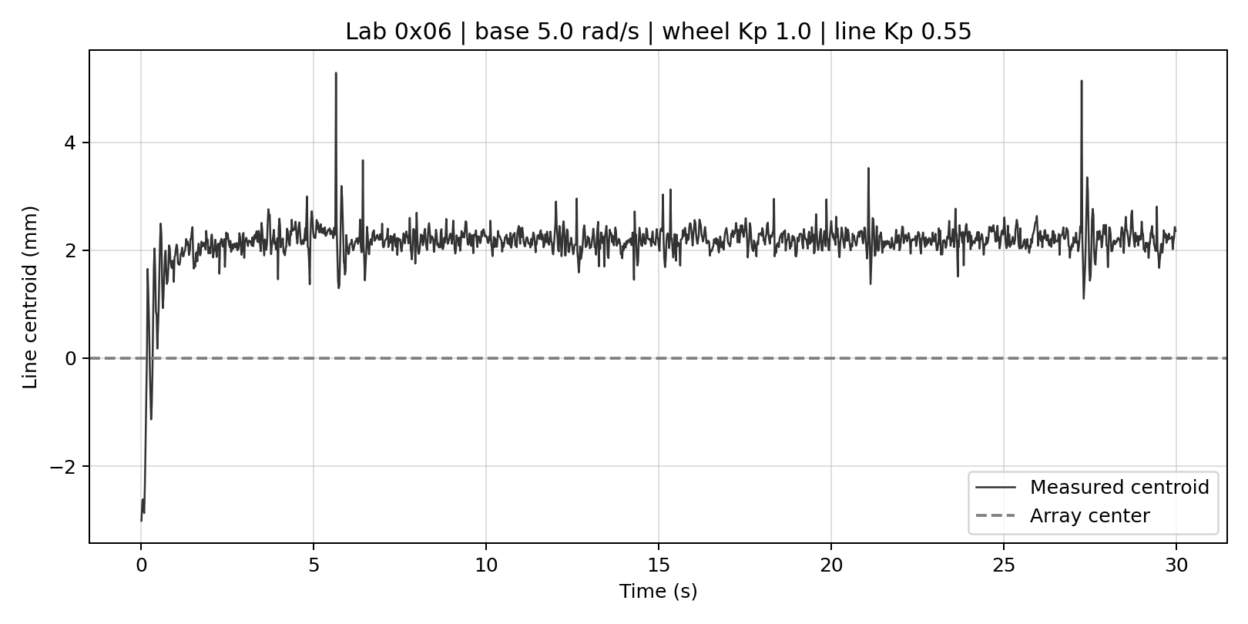
The CSV contains 1,500 numeric centroid values and no undefined readings. Intervals average 20.0 ms (observed range 8–32 ms), matching the intended Line task period on average. After the first 2 s, the centroid has a mean of +2.20 mm and a standard deviation of 0.24 mm. Short peaks approach 5.29 mm; none exceed the 5.45 mm centroid magnitude at which the ±3 rad/s correction would saturate. The persistent offset is consistent with proportional steering on a circle, which requires a nonzero correction to keep turning; sensor alignment may also contribute. The trace does not measure wheel speed or prove the number of laps by itself; the submitted video shows the laps.

Checks and remaining limitations
During the floor check, a 2 rad/s command did not move Romi reliably, so the recorded run used 5 rad/s. The working settings were wheel Kp = 1.0 V/(rad/s), line Kp = 0.55 (rad/s)/mm, and maximum steering correction = 3 rad/s. The line log does not contain wheel-speed or voltage traces, so it cannot quantify inner-loop tracking or determine whether motor voltage saturated.
The successful terminal run reported 1,500 samples, stop_reason=complete, and a saved CSV and plot. The startup printed “RuntimeError: name too long” on soft reboot; the PC script recovered by running main.main() from the REPL. The host script printed an expected-line-gain notice because its LINE_KP constant was 0.10, while the MCU actually used and logged 0.55. Set that host constant to 0.55 before submitting the source; it does not change the measurements already saved.
The timestamps check the captured sampling interval, but they do not replace an MCU scheduler-profiler check of task durations and latencies. That check should be performed during following if it has not already been done. The handout calls for all 13 physical sensor outputs; this eight-output implementation remains an exception to resolve with the instructor or by implementing and testing the other five outputs.

Attachments
MCU source: main.py, line_sensor.py, line_calibration.py, taskline.py, taskuser.py, taskmotor.py, MotorDriver.py, EncoderDriver.py, ClosedLoop.py, and MultiChar.py. PC source: romi_lab06_auto.py. Also submit the actual line_calibration.json, line_following.csv, line_following.png, and two-lap video. The firmware already supplies cotask; it is not included. Include boot.py only if its contents were customized for this application.

