**Proposal for the Development of Rural Development Strategy**

**Introduction**

This proposal outlines a comprehensive strategy for the development of rural areas in Saudi Arabia, focusing on the establishment and launch of non-profit developmental villages as part of the National Transformation Program. The project aims to develop innovative strategies that respond to local community needs and potentials while considering the geographical and cultural diversity of each area. This initiative is aligned with the Kingdom's Vision 2030 and seeks to enhance the role of the non-profit sector in contributing to sustainable development. The development of rural strategies will be executed through a phased approach, which includes comprehensive stakeholder engagement, detailed analysis of community needs, and the design of targeted initiatives. Each phase will involve thorough documentation and validation of findings through community workshops and expert consultations, ensuring that local voices are prioritized in the decision-making process.

Phases of Implementation: The project will be divided into clear phases including analysis, strategy design, and initiative implementation

|  |  |  |  |
| --- | --- | --- | --- |
| **Phase** | **Duration** | **Start Date** | **End Date** |
| Stakeholder Engagement | 2 months | 01/01/2024 | 02/28/2024 |
| Needs Assessment | 3 months | 03/01/2024 | 05/31/2024 |
| Strategy Development | 4 months | 06/01/2024 | 09/30/2024 |

**Technical Approach and Methodology**

The technical approach to this project will involve a systematic methodology that ensures the effective implementation of development strategies in rural areas. This section outlines the specific steps to be taken, the tools to be used, and the expected outcomes. The methodology will be divided into four main phases: Analysis Phase, Design Phase, Implementation Phase, and Evaluation Phase. The analysis phase will include conducting surveys and focus groups to gather both quantitative and qualitative data. The design phase will involve developing a comprehensive strategy document that outlines objectives, initiatives, and expected outcomes, incorporating stakeholder feedback to ensure alignment with community needs. The implementation phase will roll out initiatives in collaboration with local partners and ensure capacity building through training programs for local leaders. Finally, the evaluation phase will monitor the implementation process using predefined KPIs and conduct mid-term evaluations to assess progress and make necessary adjustments.

Continuous Evaluation: Implementing feedback mechanisms to refine strategies based on real-time data

|  |  |  |  |
| --- | --- | --- | --- |
| **Phase** | **Duration** | **Start Date** | **End Date** |
| Analysis Phase | 2 months | 10/01/2024 | 11/30/2024 |
| Design Phase | 2 months | 12/01/2024 | 01/31/2025 |
| Implementation Phase | 6 months | 02/01/2025 | 07/31/2025 |
| Evaluation Phase | 2 months | 08/01/2025 | 09/30/2025 |

**Vertical Technical Architecture**

The following VERTICAL diagram shows the proposed system architecture with layered design:

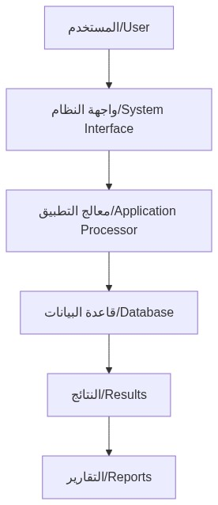

Note: The diagram is designed VERTICALLY to clearly show different system layers and top-to-bottom data flow.

The following vertical diagram illustrates the proposed system architecture with top-to-bottom data flow showing system layers.

System layers and external integrations

**Compliance and Qualifications**

This section outlines the compliance requirements and qualifications necessary for the successful execution of the project. It includes certifications, licenses, and proof of experience in similar projects. Essential compliance and qualifications for the project include valid business registration and licenses to operate in Saudi Arabia, ISO certifications related to project management and quality assurance, and proven experience in successfully completing at least three similar projects in the past five years. References from previous clients and stakeholders will validate experience and effectiveness. These qualifications are critical in ensuring that the project is executed in accordance with local laws and that the team possesses the necessary expertise to deliver impactful results.

Demonstrated Experience: Evidence of past performance in similar projects

|  |  |  |  |
| --- | --- | --- | --- |
| **Task** | **Duration** | **Start Date** | **End Date** |
| Licenses and Registrations | Ongoing | Immediately | Ongoing |
| Certifications | Ongoing | Immediately | Ongoing |
| Experience Validation | Ongoing | Immediately | Ongoing |