School of Computer Science and Engineering
Fall 2026-27

BCSE306L-Artificial Intelligence

Course Project

- Title
LabelGuard: A Hybrid Vision-Language and Rule-Based Approach for Personalised Food-Label Analysis for Indian Households
- Team members
Harsh Kulkarni (24BCT0137)
B S Srivallabha (24BCE0457)
Ayush Konar (24BDS0107)
Pratham Paudel (24BCE2940)
Faculty: Dr. D. Anuradha | Slot: C2+TC2
- Abstract
Packaged-food labels are hard to act on: sugar hides under dozens of names, additives appear as INS codes, front-of-pack claims are rarely checked against the ingredient list, and one household can have very different dietary needs. LabelGuard is a web application that analyses a packaged food for every member of a household. A multimodal large language model (Gemini) converts one to three photographs of a pack into structured data in a single call, while a deterministic rules engine with curated Indian knowledge tables (54 sugar names, 49 INS additives, 22 allergen groups and 34 diet rules) produces SAFE, CAUTION or AVOID verdicts with evidence for each member, checks label claims against FSSAI-style thresholds, compares the promises on the front of the pack with its ingredient list and computes a transparent 0-100 health score. Alternatives come from Open Food Facts and a local table of Indian products, intake is tracked against personal limits, and a weekly family report is generated. The language model is used only to read labels, understand the family profile and word summaries; every decision is made by rules, so the same input always gives the same output.
In tests on 12 labelled test labels the system reached an ingredient F1 of 1.00, hidden-sugar and allergen precision and recall of 1.00, and 100% nutrition-value accuracy on clean images. A plain LLM asked to score eight of the products was not exactly repeatable (standard deviation 1.1 points, 4 of 8 products changed between runs) and used a very different scale, whereas LabelGuard's score never changed. All 46 automated tests pass.
Key words: food label analysis, large language models, multimodal extraction, rule-based reasoning, personalised nutrition, FSSAI, Open Food Facts.
- Test Results
Test setup. The system was tested on a Windows laptop with the backend (Python, FastAPI) and frontend (React) running locally, using the Gemini API (gemini-3.6-flash with two fall-back models) [1] and Open Food Facts [2] over the Internet. Three kinds of tests were carried out: (a) functional test cases of the rules and of the end-to-end flow, covering 46 automated tests plus live runs (Table 1); (b) an accuracy experiment on 12 labelled test labels rendered as images, read three times unchanged and once each under blur, 15-degree rotation and low light (Table 2); and (c) a comparison with a plain LLM, a profile-parser test and a measurement of token use (Tables 3 to 5). For ingredients and nutrition values the ground truth is exactly what is printed on the test image; the ground truth for hidden sugars and allergens is obtained by applying the rules to the true ingredient list, so these experiments measure the reading stage.
Table 1: Functional test cases
No. | Test case | Input | Expected result | Result
1 | Allergy listed as an ingredient | 'Cashew (2%)' in the list; member allergic to cashew | AVOID, evidence 'Cashew (2%)' | Pass (pytest)
2 | Jain diet | 'Onion powder'; Jain member | AVOID: not Jain | Pass (pytest)
3 | Ambiguous source | 'Emulsifier (E471)'; vegetarian member; INS codes [3] | CAUTION: source unclear, check with the brand | Pass (pytest)
4 | False-positive guards | 'Coconut milk', 'fox nuts', 'buckwheat flour' | Not flagged as dairy, tree nuts or wheat | Pass (pytest)
5 | Hidden sugars | Sugar, invert sugar syrup, liquid glucose, maltodextrin | All four listed with position on the list | Pass (pytest)
6 | Serving-size trap | 34 g sugar per 100 g, 20 g serving | Warns that 6.8 g per serving hides a HIGH level | Pass (pytest)
7 | Claim check | 'healthy', 'no added sugar', 'made with whole wheat' [4] | All three marked misleading | Pass (pytest)
8 | Front vs back of pack | Front and back photos of a made-up mango drink (live Gemini call) | 7 of 7 front promises contradicted by the back | Pass (live)
9 | Determinism | Same extraction analysed 5 times | Identical analysis and score every time | Pass (pytest)
10 | Repeat scan | Same photo scanned twice | One LLM call; second scan from cache | Pass (pytest)
11 | Barcode look-up | 3017620422003 (live Open Food Facts) | Nutella found; analysed with 0 LLM tokens | Pass (live)
12 | Error handling | A non-image file; scan with no API key | Friendly {error, detail} JSON (400 and 503) | Pass (pytest)
13 | End-to-end flow | Profile, scan, summary, alternatives, feedback, log, tracker, compare | Each step succeeds; alternatives safe for all members and higher scoring | Pass (pytest)

Label extraction accuracy. Table 2 shows the results for the clean images and the three degraded conditions. On clean images the ingredient lists were read with an F1 of 1.00 and the printed nutrition values with 100% accuracy; hidden-sugar precision and recall and allergen precision and recall were all 1.00. Blur and low light caused no loss, and rotation by 15 degrees lowered nutrition accuracy to 96% (mean score error 0.9 points). Two of the 72 extraction calls were lost to Gemini service time-outs and appear as a smaller n. Reading each clean image three times gave an identical score for 12 of 12 images, and the rules gave an identical analysis for an identical extraction in every case.
Table 2: Performance metrics of label extraction
Condition | Ingredient F1 | Sugar P / R | Allergen P / R | Nutrition accuracy | Score error | n
Clean | 1.00 | 1.00 / 1.00 | 1.00 / 1.00 | 100% | 0.0 | 35
Blur | 1.00 | 1.00 / 1.00 | 1.00 / 1.00 | 100% | 0.0 | 11
Rotation 15° | 1.00 | 1.00 / 1.00 | 1.00 / 1.00 | 96% | 0.9 | 12
Low light | 1.00 | 1.00 / 1.00 | 1.00 / 1.00 | 100% | 0.0 | 12

Comparison with a plain LLM. The same model was asked, with a plain prompt, to rate the healthiness of 8 of the test products from 0 to 100, 5 times each, at temperature 1.0 and at temperature 0 (Table 3). The plain LLM was largely but not perfectly repeatable: 4 of 8 products received different scores in different runs at temperature 1.0 and 2 of 8 even at temperature 0. The practical weaknesses are the scale and the traceability: it rated every product far below the documented formula (for example 5 against 50 for a cola and 35 against 80 for white bread; Pearson r = 0.70), it cannot show how a number was obtained and it knows nothing about the family. Neither scale is a clinical standard; the LabelGuard number can be recomputed exactly and explained component by component.
Table 3: Score consistency: plain LLM versus LabelGuard
Method | Mean SD (points) | Mean range | Identical every run | Pearson r
Plain LLM, temperature 1.0 | 1.1 | 2.5 | 4/8 | 0.70
Plain LLM, temperature 0 | 0.6 | 1.2 | 6/8 | 0.71
LabelGuard (rules) | 0.0 | 0.0 | 8/8 | 1.00

Profile parsing and resource use. Ten free-text household descriptions with expected output were used to compare the keyword fall-back parser with the Gemini parser (Table 4): the keyword parser got 52 / 60 fields right (87%), failing on conditions it has no keyword for and on a missing family member, while the Gemini parser got 60 / 60 (100%). Table 5 gives the measured token use and latency of each LLM task; a new label costs about two thousand input tokens, while repeated photographs, barcode look-ups and every analysis module cost none.
Table 4: Field-level accuracy of profile parsing
Parser | Correct fields | Field accuracy
Keyword fall-back (no LLM) | 52 / 60 | 87%
Gemini parser | 60 / 60 | 100%

Table 5: Measured token use and latency per LLM task
LLM task | Successful / total calls | Avg input tokens | Avg output tokens | Avg latency (s)
Profile parsing | 1 / 1 | 523 | 378 | 4.1
Label extraction (vision) | 15 / 28 | 2108 | 455 | 4.8
Family summary | 25 / 35 | 336 | 175 | 4.5
Ask about a product (optional) | 4 / 5 | 573 | 67 | 1.8
Weekly report (optional) | 4 / 4 | 894 | 359 | 3.3

System output. Fig 1 and Fig 2 show the output for the made-up mango drink of test case 8, whose front claims 'real mango', '100% natural', 'no preservatives' and 'energy for active kids'. The score is 44/100 ('Limit this'). The front-versus-back check finds that mango pulp is only 8% of the product, that sodium benzoate is a preservative, that Sunset Yellow (INS 110) is a synthetic colour linked to hyperactivity in children [5], and that the drink has 15.8 g of sugar per 100 ml. The same product is AVOID for two household members and CAUTION for the other two.
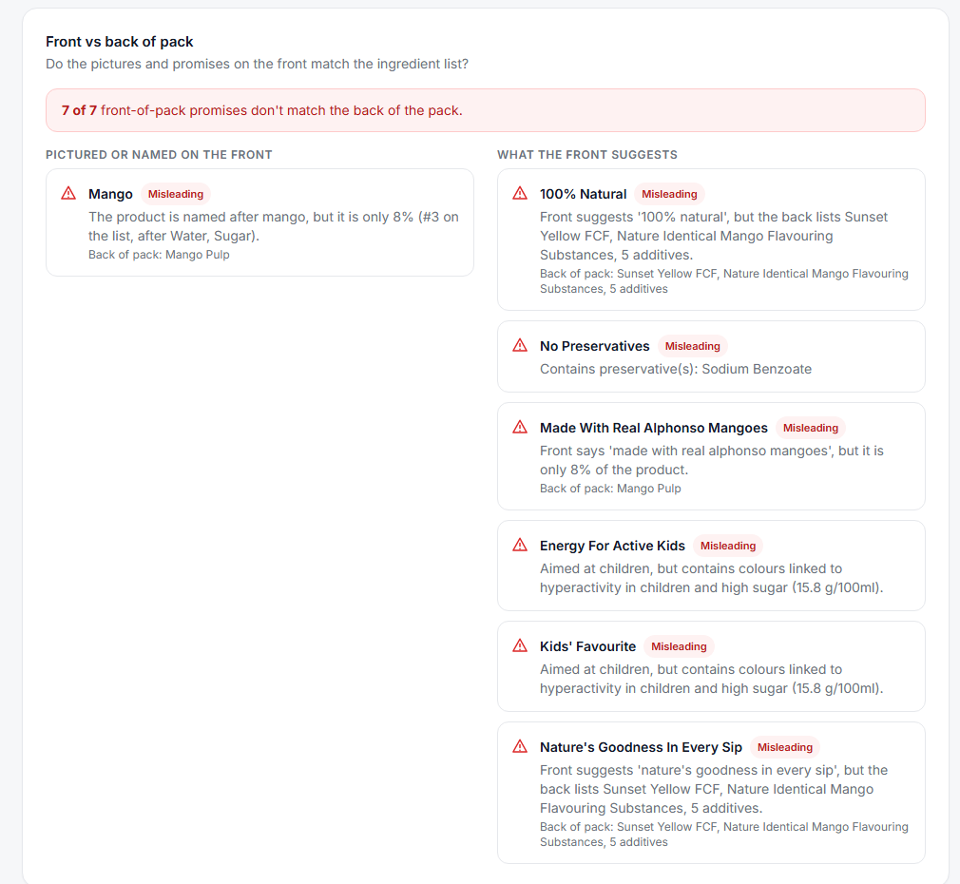
Fig 1: Front versus back of pack check
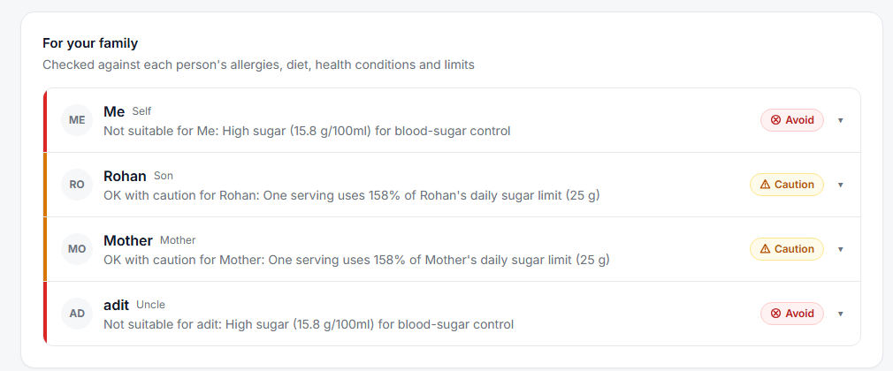
Fig 2: Per-member verdicts for the same product
Limits of the tests. The test labels are clean, synthetic renderings of 12 products, so the perfect scores on clean images show that the pipeline works end to end, not that every real photograph will be read perfectly; curved packaging, glare and small fonts are not covered. The plain-LLM comparison used one model and one prompt. The availability of the hosted model varied during testing, which is why the system uses caching and automatic fall-back models.
- Conclusion
LabelGuard shows that dividing the work between a multimodal language model and a deterministic rules engine gives personal, repeatable and inexpensive label analysis. The model read the test labels with an ingredient F1 of 1.00 and 100% nutrition accuracy on clean images, and the rules produced the same verdicts and scores every time they were given the same input, with evidence for every flag. A plain LLM was close to repeatable but not exact, used a different and unexplained scale and could not use the family profile.
The main limitations are the clean synthetic test images and small test set, keyword-based ingredient matching, approximate values in the local product table and a score that is a transparent heuristic rather than a clinically validated index. Future work includes live barcode scanning, a fully translated Hindi and Tamil interface, regional-language label reading, a dietitian review of the thresholds and a larger evaluation with real photographs and real families.
- References
[1] Google. Gemini API documentation: models, structured output and thinking. https://ai.google.dev/gemini-api/docs (accessed October 2026).
[2] Open Food Facts. Open Food Facts API documentation (v2). https://openfoodfacts.github.io/openfoodfacts-server/api/ (accessed October 2026).
[3] Codex Alimentarius Commission. Class names and the international numbering system for food additives, CXG 36-1989. Rome: FAO/WHO.
[4] Food Safety and Standards Authority of India, 2018. Food Safety and Standards (Advertising and Claims) Regulations, 2018. New Delhi: FSSAI.
[5] McCann, D., Barrett, A., Cooper, A., Crumpler, D., Dalen, L., Grimshaw, K., et al., 2007. Food additives and hyperactive behaviour in 3-year-old and 8/9-year-old children in the community: a randomised, double-blinded, placebo-controlled trial. The Lancet, 370(9598), pp.1560-1567.

