1. In the below elements which of them are values or an expression? eg:- values can be integer or string and expressions will be mathematical operators.

* (**Expression**)

'hello'(**Values**)

-87.8 (**Values**)

- (**Expression**)

/ (**Expression**)

* (Expression)

6 (Values)

2. What is the difference between string and variable?

Ans: A variable is the entity where we store the information in the form of “string”, “Integer”, “Float”, etc.

String is datatype that are stored in some variable.

3. Describe three different data types.

Ans: All different datatypes in Python programming language:

* **Integers**
* **Floats** (reals)
* **Booleans** (logical)
* **Strings**
* **Lists**
* None Type

4. What is an expression made up of? What do all expressions do?

Ans: An expression is a combination of operators and operands that is interpreted to produce some other value. Expression are used to perform the mathematical operations.

5. This assignment statements, like spam = 10. What is the difference between an expression and a statement?

Ans: Expression contains values, containers(variables), and mathematical operators (operands) whereas the statement is just like a command that a python interpreter executes like print.

6. After running the following code, what does the variable bacon contain?

bacon = 22

bacon + 1

Ans: 23

7. What should the values of the following two terms be?

'spam' + 'spamspam'

'spam' * 3

Ans:

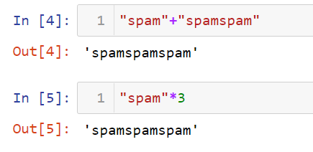

8. Why is eggs a valid variable name while 100 is invalid?

Ans: The name of variable can’t start with numbers.

9. What three functions can be used to get the integer, floating-point number, or string version of a value?

Ans: int(), float(), str()

10. Why does this expression cause an error? How can you fix it?

'I have eaten ' + 99 + ' burritos.'

