1.What are the two values of the Boolean data type? How do you write them?

Ans: The two values of Boolean are “True” and “False”.

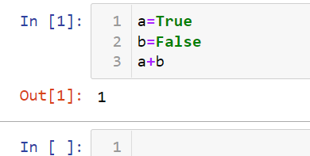

2. What are the three different types of Boolean operators?

Ans: The three types of the Boolean operators are OR. AND, NOT.

3. Make a list of each Boolean operator's truth tables (i.e. every possible combination of Boolean values for the operator and what it evaluate ).

|  |  |  |  |
| --- | --- | --- | --- |
| **OR Truth Table** | | | |
| TRUE | TRUE | | TRUE |
| TRUE | FALSE | | TRUE |
| FALSE | TRUE | | TRUE |
| FALSE | FALSE | | FALSE |
| **AND Truth Table** | | | |
| TRUE | TRUE | | TRUE |
| TRUE | FALSE | | FALSE |
| FALSE | TRUE | | FALSE |
| FALSE | FALSE | | FALSE |
| **NOT Truth Table** | | | |
| TRUE | | FALSE | |
| FALSE | | TRUE | |

4. What are the values of the following expressions?

(5 > 4) and (3 == 5)

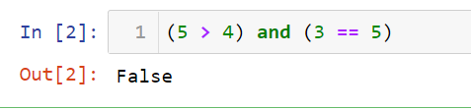

not (5 > 4)

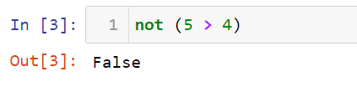

(5 > 4) or (3 == 5)

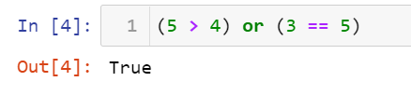

not ((5 > 4) or (3 == 5))

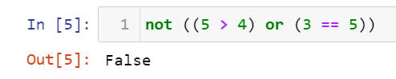

(True and True) and (True == False)

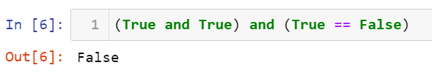

(not False) or (not True)

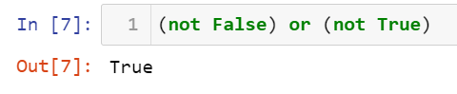

5. What are the six comparison operators?

Ans: Python has six comparison operators:

1. Less than (<)
2. Less than or equal to (<=)
3. Greater than (>)
4. Greater than or equal to (>=)
5. Equal to (==)
6. Not equal to (!=)
7. How do you tell the difference between the equal to and assignment operators? Describe a condition and when you would use one.

Ans:

* The “=” is an assignment operator which is used to assign the value of any variable.
* The ‘==’ operator checks whether the two given operands are equal or not. If so, it returns true. Otherwise it returns false.

8. Identify the three blocks in this code:

spam = 0

if spam == 10:

print('eggs')

if spam > 5:

print('bacon')

else:

print('ham')

print('spam')

print('spam')

1. Write code that prints Hello if 1 is stored in spam, prints Howdy if 2 is stored in spam, and prints Greetings! if anything else is stored in spam.

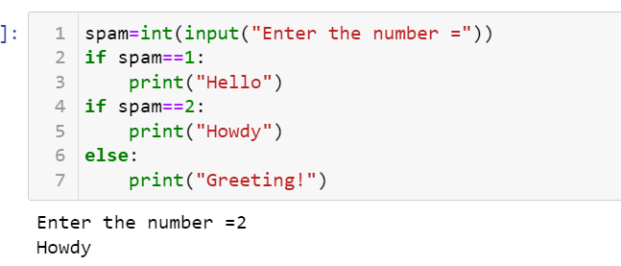

9.If your programme is stuck in an endless loop, what keys you’ll press?

Ans: CTRL + C, where C stands for Cancel

1. How can you tell the difference between break and continue?

Ans: The main difference between both the statements is that when break keyword comes, it terminates the execution of the current loop and passes the control over the next loop or main body, whereas when continue keyword is encountered, it skips the current iteration and executes the very next iteration in the loop.

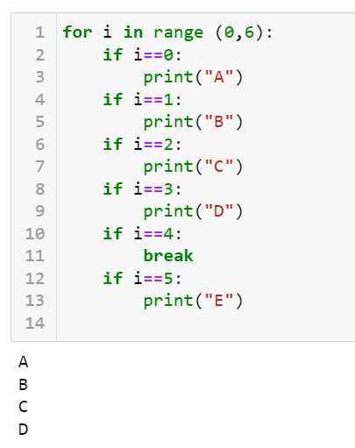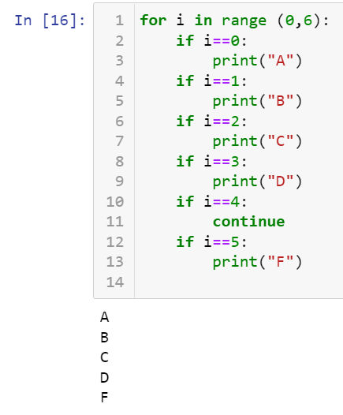

1. In a for loop, what is the difference between range(10), range(0, 10), and range(0, 10, 1)?

Ans:

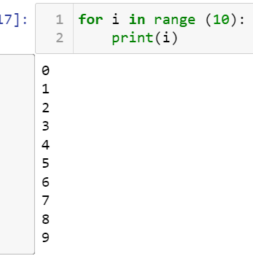 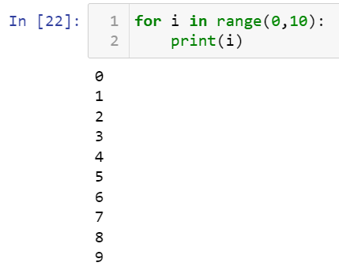 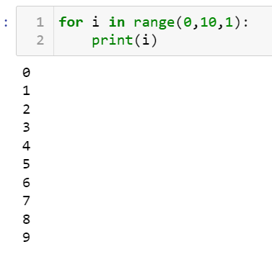

All the three syntax give the same result, this means we can use any of the form to get the conecutive series of number just by defining the range in which we want.

Range(10), this always consider the intial point as 0.

1. Write a short program that prints the numbers 1 to 10 using a for loop. Then write an equivalent program that prints the numbers 1 to 10 using a while loop.

Using the for loop:

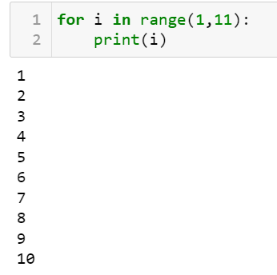

Using the While loop:

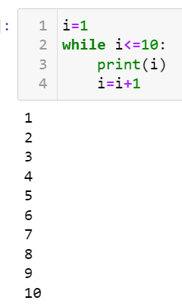

1. If you had a function named bacon() inside a module named spam, how would you call it after importing spam?

Import spam

spam.bacon()