OVERCOMING MODELING CHALLENGES IN THERMOSET SHAPE MEMORY POLYMERS: A MACHINE LEARNING APPROACH

# Abstract

[insert abstract here]

# Introduction

Shape-memory polymers (SMPs) are smart stimuli-responsive polymeric materials that respond to external stimuli including temperature, light irradiation, solvents, electrical current, magnetic field, and electromagnetic field to assume a memorized permanent shape that may be programmed[1]. Due to their self-healing capabilities, shape memory polymers are widely used in aviation, medicine, fashion, and structural models [2]. Predicting the thermomechanical properties of thermoset shape memory polymers (TSMPs) is crucial for their effective design and application. However, the complex topological nature of TSMPs presents a significant challenge in modeling these properties, often resulting in time-consuming processes.

## Objective

Predicting the thermomechanical properties of thermoset shape memory polymers (TSMPs) is crucial for their effective design and application. However, the complex topological nature of TSMPs presents a significant challenge in modeling these properties, often resulting in time-consuming processes. To address this challenge and expedite the prediction of the glassy modulus of shape memory polymers (SMPs), we propose the application of machine learning (ML) techniques, aiming to overcome the limitations inherent in traditional modeling methods.

# Methods

In this study, we utilized a small dataset obtained from various references to train our ML model. Ninety percent of the data was used for training and the remainder for validation.

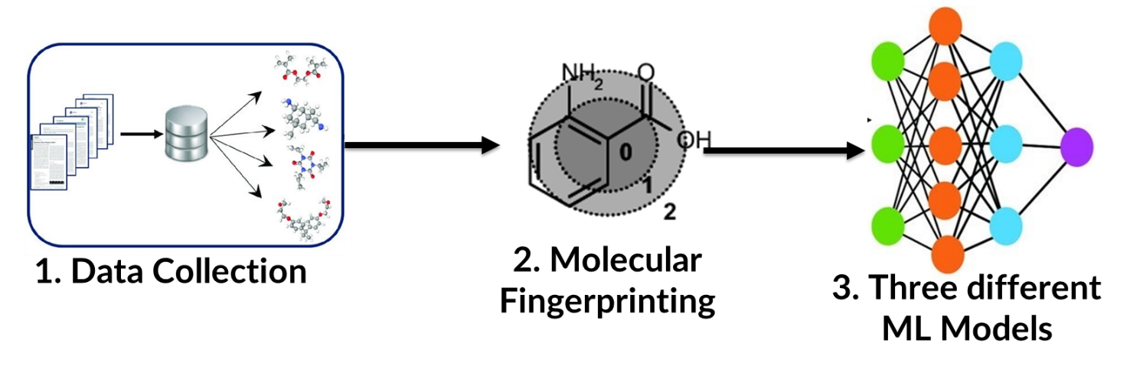

### ML Architecture

# Results

# Conclusion

# References

[1] S. Gopinath, N. N. Adarsh, P. R. Nair, and S. Mathew, “Shape-Memory Polymer Nanocomposites of Poly(ϵ-caprolactone) with the Polystyrene- block-polybutadiene- block-polystyrene-tri- block Copolymer Encapsulated with Metal Oxides,” *ACS Omega*, vol. 6, no. 9, pp. 6261–6273, Mar. 2021, doi: 10.1021/acsomega.0c05839.

[2] C. Yan, X. Feng, and G. Li, “From Drug Molecules to Thermoset Shape Memory Polymers: A Machine Learning Approach,” *ACS Appl. Mater. Interfaces*, vol. 13, no. 50, pp. 60508–60521, 2021, doi: 10.1021/acsami.1c20947.