Catching_Birds

Game Designed With Love Game Engine and animation physics with AnAl librarie

INSTALL

clone the repo using git command: git clone https:url

or Download the zip file

Full Screen Mode

-open the conf.lua file with textbox

-find the t.window.fullscreen in the conf function and set it to true

Screen shoots

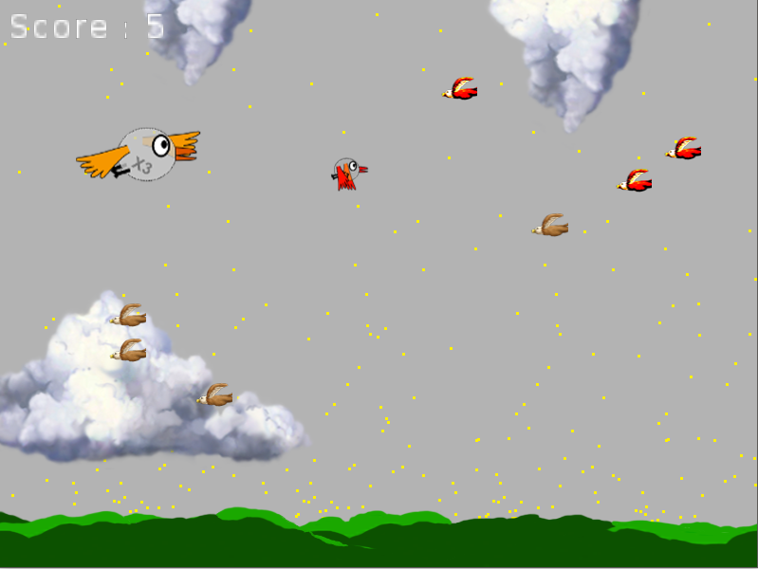

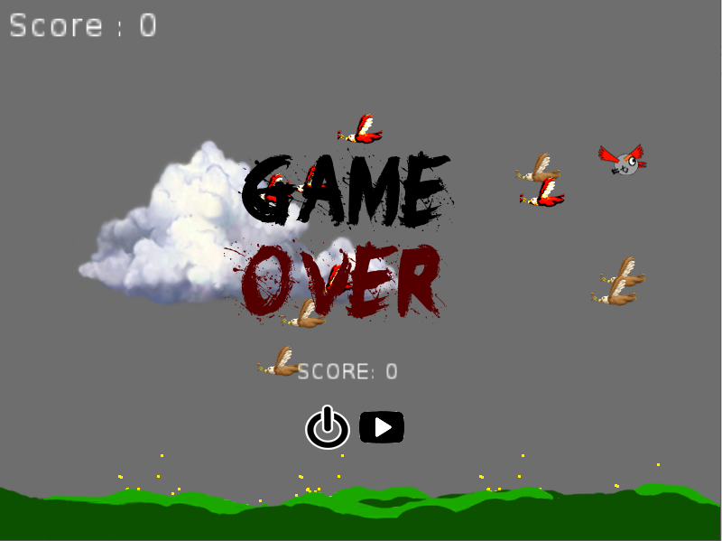

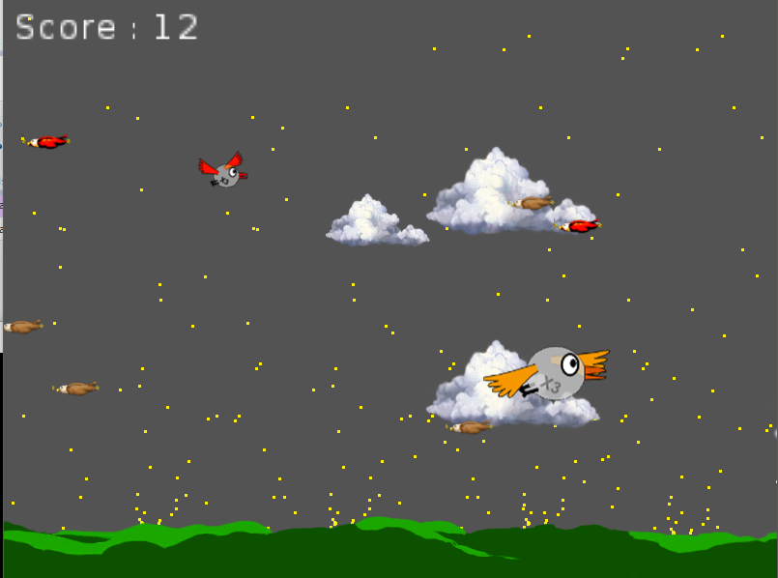

Youtube Video

<https://youtu.be/QWvYgmt7x0U>

GameJolt

<http://gamejolt.com/games/catching-birds/93254>