Banking System

This project was completed as part of a Object Oriented Programming (OOP) course which focused on learning the pillars of OOP including inheritance, polymorphism, and encapsulation. This project is a demonstration of those concepts used in the program to create various classes and subclasses.

The banking system will ask for a username and password to login. There will be two types of accounts; manager and customer. The manager account can be accessed by entering "admin" for both username and password. The manager account can create and delete customer accounts. Upon creating a customer account, the initial account amount will be set to $100. This will also create .txt file inside the folder where the first line represents the username, the second line represents the password and the third line represents the initial account amount. 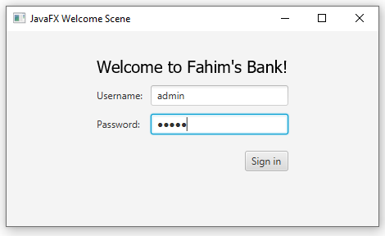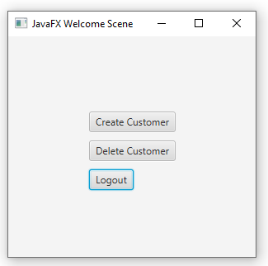

The customer can now login into their account by entering the username and password set by the manager. The customer can deposit, withdraw, make an online purchase, check their balance or logout. Any changes made to the customer's account amount via deposit, withdraw, or online purchase must be saved by the customer safely logging out afterwards. 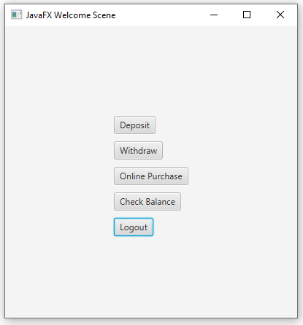

Customer will have 3 different membership levels; silver, gold and platinum. Silver membership customers have an account amount of less than $10000, gold membership customers have an account amount of at least $10000 and less than $20000, and platinum membership customers will have an account amount of at least $20000.

Online purchases must be of at least $50 value plus an additional fee based on the customer's membership level. Silver membership customers will be charged an extra $20, gold membership customers will be charged an extra $10 and platinum membership customers will not be charged an extra fee for their online purchase.