1. Installing Software and Updating System
for the first part I used commands:
sudo dnf update -y
sudo dnf install net-tools -y
then verified installations with
ifconfig
2. SSH-Connection
Firstly, I used
ip addr show
to find IP address of my VM, then downloaded PuTTY, but it didn’t want to work so installed and enabled SSH with
sudo dnf install -y openssh-server
sudo systemctl enable --now sshd
systemctl status sshd
then opened firewall for SSH and verified that it is listening
sudo firewall-cmd --permanent --add-service=ssh
sudo firewall-cmd –reload
ss -tlnp | grep 22
Entered VM IP to PuTTY and successfully logged in with login and password
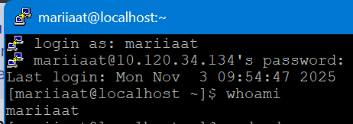
In PuTTYGen I generated a key, saved private and public files and copied public key text.
Prepared directory .ssh on VM with
mkdir -p ~/.ssh
chmod 700 ~/.ssh
created ~/.ssh/authorized_keys , pasted public key and set permissions chmod 600 ~/.ssh/authorized_keys .
Back in PuTTY went to Connection → SSH → Auth → Credentials, pasted private key file, saved the session and logged in successfully without password
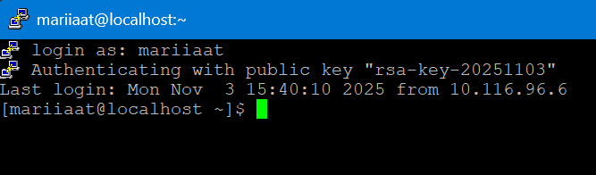

3. Cockpit
I happened to not have cockpit preinstalled so i did it with
sudo dnf install -y cockpit
sudo systemctl enable --now cockpit.socket
systemctl status cockpit.socket
sudo firewall-cmd --permanent --add-service=cockpit
sudo firewall-cmd –reload

Then created certificate
sudo mkdir -p /etc/cockpit/ws-certs.d
sudo openssl req -new -x509 -days 365 -nodes \
-out /etc/cockpit/ws-certs.d/0-self-signed.cert \
-keyout /etc/cockpit/ws-certs.d/0-self-signed.key

Went to browser https://10.120.34.134:9090
Accepted warnings and logged in with my VM user credentials, SSH key also worked.
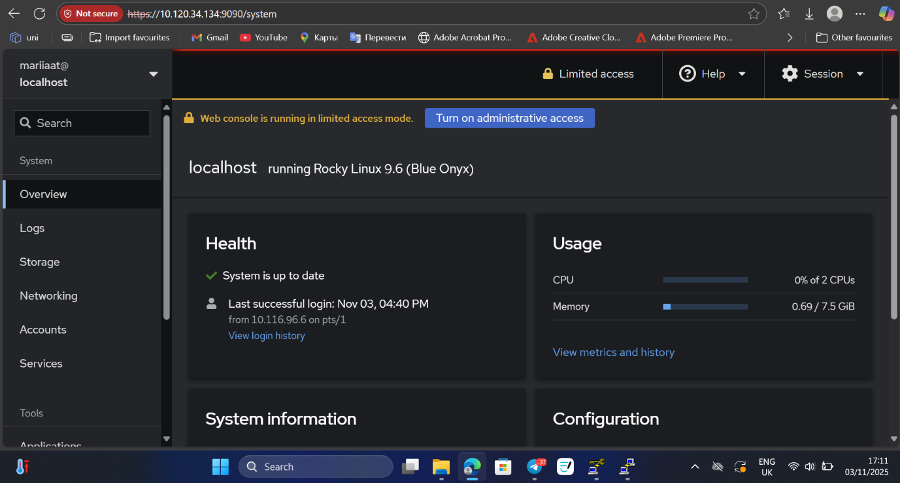

Mariia Atamanova

