Assignment 5

- Downloaded archive and extracted it to my home directory, created new text file with nano, saved short text and confirmed new file is here.
cd ~
wget https://users.metropolia.fi/~kuivi/unix/koe/koe.tar.bz2
tar -xjvf ~/koe.tar.bz2 -C ~
nano ~/unixkoe/my_note.txt
ls -l ~/unixkoe
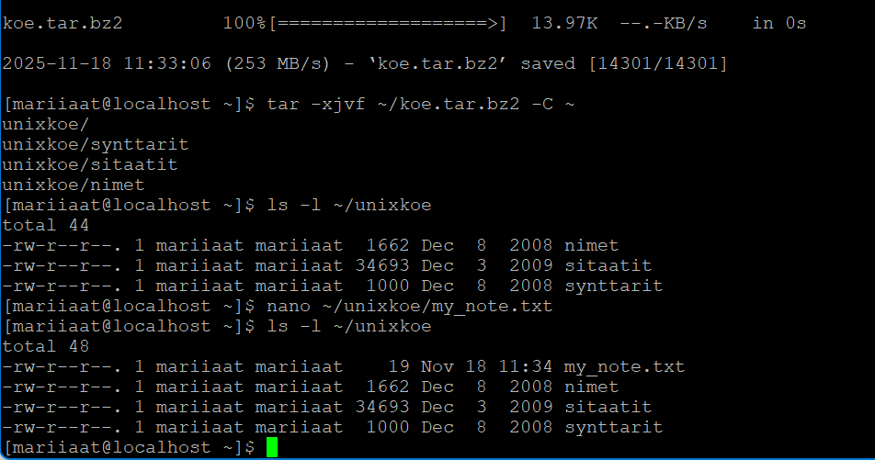

- Is it possible to add the new file straight to the archive?
its not possible to append on a compressed .tar.bz2.
we first would need to decompress to plain tar or fully extract, append file and recompress again
Created archive with only text file without .bz2 :
ls -l
cd ~/unixkoe
tar -czvf ~/unix_texts.tar.gz *.txt
tar -tzvf ~/unix_texts.tar.gz
- I didn’t have a chance to test it with a friend, so I created second VM to test it myself with two VMs.
On my first vm I created an archive tar -czvf ~/public_html.tar.gz -C ~ public_html
Then sent it to my second VM scp ~/public_html.tar.gz friend@<VM2-IP>:/home/friend/
On the second VM installed tar and extracted the archive
sudo dnf install -y tar
tar -xzvf ~/public_html.tar.gz -C ~
chmod -R 755 ~/public_html
chmod 711 ~
sudo dnf install -y httpd
sudo systemctl enable --now httpd
sudo firewall-cmd --permanent --add-service=http
sudo firewall-cmd –reload
sudo setsebool -P httpd_enable_homedirs 1
sudo chcon -R -t httpd_sys_content_t /home/friend/public_html
sudo systemctl restart httpd
And managed to open the file from second VM
