Write and develop plugin with following requirements:

* Register a post type named ‘Team Member’. Each team member has a Name, Picture, Bio and Position.
* Register a taxonomy to that post type named ‘Member type’. Should be hierarchical.
* Output should return by a shortcode named ‘team_members’.
* Shortcode must accept 3 parameters, number of team members to show, the position of image in the html template and if display or not ‘See all’ Button (See Figure 1.0 for example).
* There should be 2 designs of template based on shortcode parameters, first one is image position on top and second one is image position on bottom. Default is image position on top.
* Output returned by shortcode must have a button to go the archive page of all team members. By default, this button is visible. See the sample below:

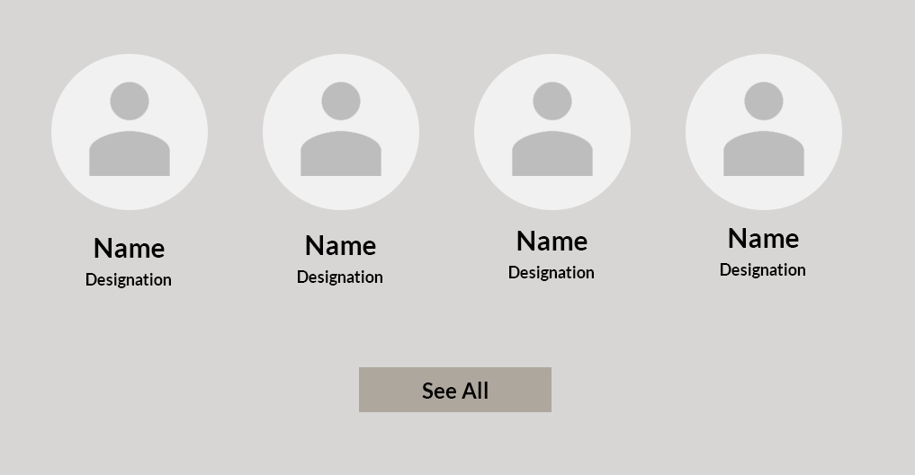

**Figure 1.0**

* Name and Image should be clickable and on click they should go to single page where bio of team member will also display.
* Design is up to you.

**Bonus options:**

If you can do the following things it will added as an advantage but this are not required.

* Pagination in archive page.
* A settings page for changing Post type name and URL slug.
* Try to do everything in Object Oriented PHP.

------------------------------------------------- Best of Luck and Happy Coding -----------------------------------------------