

#### VISVESVARAYA TECHNOLOGICAL UNIVERSITY

**“Jnana Sangama”, Belagavi - 590018, Karnataka, INDIA**

An Internship Report on

**SECOND HAND BIKE PRICE PREDICTION**

*Submitted in partial fulfillment of the requirement for the award of the degree of*

###### Bachelor of Engineering in Computer Science and Engineering *Submitted by*

**ARYAN 1DT19CS023**

Internship Carried out at

###### TEQUED LABS

**Internal Guide External Guide**

Ms. Shylaja B Mr. Aditya SK

Asst. Professor, Dept of CSE CTO and Director, Tequed Labs

**Department of Computer Science and Engineering**

###### (Accredited by NBA 2022-2025)

**DAYANANDA SAGAR ACADEMY OF TECHNOLOGY AND MANAGEMENT**

Kanakapura Road, Udayapura, Bengaluru - 560 082

**2022 – 2023**

### DAYANANDA SAGAR ACADEMY OF TECHNOLOGY AND MANAGEMENT

**Department of Computer Science and Engineering**

### CERTIFICATE

Certified that the Internship Work Entitled **“SECOND HAND BIKES PRICE PREDICTION”** carried out by **ARYAN**, bearing USN **1DT19CS023,** bonafide student of Dayananda Sagar Academy of Technology and Management, is in partial fulfillment for the award of the Bachelor of Engineering in Computer Science and Engineering from Visvesvaraya Technological University, Belagavi during the year 2022-2023. It is certified that all the corrections/suggestions indicated for Internal Assessment have been incorporated in the report submitted in the department library. The report has been approved as it satisfies the academic requirements in respect of the Internship work prescribed for the said Degree.

Ms. Shylaja B

_ _

Dr. Kavitha C Dr. M Ravishankar

Asst. Professor Professor & HOD Principal



Dept. of CSE Dept. of CSE DSATM, Bengaluru

DSATM, Bengaluru DSATM, Bengaluru

Name of the Examiners Signature with date

1. _

2. _



### DAYANANDA SAGAR ACADEMY OF TECHNOLOGY AND MANAGEMENT

**Department of Computer Science and Engineering**

### DECLARATION

I, **ARYAN**, bearing **USN 1DT19CS023**, student of Eighth Semester B.E, Department of Computer Science and Engineering, Dayananda Sagar Academy of Technology and Management, Bengaluru, declare that the Internship Work entitled **“SECOND HAND BIKES PRICE PREDICTION”** has been carried out by me and submitted in partial fulfillment of the course requirements for the award of degree in Bachelor of Engineering in Computer Science and Engineering from Visvesvaraya Technological University, Belagavi during the academic year 2022- 2023. The matter embodied in this report has not been submitted to any other university or institution for the award of any other degree.

###### ARYAN 1DT19CS023

**Place: Bengaluru Date:**



The satisfaction and the euphoria that accompany the successful completion of any task would be incomplete without the mention of the people who made it possible. The constant guidance of these persons and encouragement provides, crowned our efforts with success and glory. Although it is not possible to thank all the members who helped for the completion of the internship work individually, I take this opportunity to express my gratitude to one and all.

I am grateful to management and our institute **DAYANANDA SAGAR ACADEMY OF TECHNOLOGY AND MANAGEMENT** with its very ideals and inspiration for having provided me with the facilities, which made this, work a success.

I express my sincere gratitude to **Dr. M Ravishankar,** Principal, Dayananda Sagar Academy of Technology and Management for the support and encouragement.

I wish to place on record, my grateful thanks to **Dr. Kavitha C**, HOD, Department of CSE, Dayananda Sagar Academy of Technology and Management, for the constant encouragement provided to me.

I am indebted with a deep sense of gratitude for the constant inspiration, encouragement, timely guidance and valid suggestion given to me by my guide **Ms Shylaja B,** Asst.professor, Dept of CSE, Dayananda Sagar Academy of Technology and Management.

I am thankful to **all the staff members** for providing me an opportunity to carry out the internship work in their esteemed organization.

I am thankful to all the staff members of the department for providing relevant information and helped in different capacities in carrying out this project.

Last, but not least, I owe my debts to my parents, friends and those who directly or indirectly have helped me to make the project work a success.

**ARYAN 1DT19CS023**



|  |  |  |
| --- | --- | --- |
| **Sl. No** | **Particulars** | **Page. No** |
| 1. | COMPANY OVERVIEW | 1 |
| 1.1 | INTRODUCTION | 1 |
| 1.2 | OVERVIEW OF THE COMPANY | 1 |
| 1.3 | PRODUCTS & SERVICES | 1-2 |
| 2 | DEPARTMENT OVERVIEW | 3 |

* 1. INTRODUCTION 3
  2. WORKING DEPTARTMENT 3
     1. PROJECT DESCRIPTION 4
  3. INTRODUCTION 4
  4. OBJECTIVES OF THE PROJECT 4
  5. SNAPSHOTS/RESULTS 5
     1. REFLECTION NOTES 6
  6. EXECUTIVE SUMMARY 6-7
  7. TECHNICAL EXPERIENCE 8-9
  8. SOFTSKILLS 9
     1. CONCLUSION 10
     2. REFERENCES 11



|  |  |  |
| --- | --- | --- |
| **Figure No.** | **Figure Name** | **Page. No** |
| 3.1 | Actual Price vs Predicted Price | 5 |
| 3.2 | Price Predictor | 5 |
| 4.1 | System Architecture | 7 |
| 4.2 | Linear Regression | 9 |

# CHAPTER 1

**COMPANY OVERVIEW**

**CHAPTER 1**

**COMPANY OVERVIEW**

#### INTRODUCTION

Tequed Labs Private Limited is a Private incorporated on 22 January 2018. It is classified as Non-govt company and is registered at Registrar of Companies, Bangalore. Tequed Labs is a research and development centre and educational institute based in Bangalore. They are focused on providing quality education on latest technologies and develop products which are of great need to the society. They also involve in distribution and sales of latest electronic innovation products developed all over the globe to their customers. They run a project consultancy where they undertake various projects from wide range of companies and assist them technically and build products and provide services to them.

#### OVERVIEW OF THE COMPANY

They are continuously involved in research about futuristic technologies and finding ways to simplify them for their clients. This project was the world finalist in the international innovation challenge called MASTERPIECE in Dubai. It has been exhibited in NASSCOM Product Conclave and has received great appreciation from IT giants. This product has been patented bearing a patent number - 201741034208. They have developed a women’s safety device which sends the location of the woman in distress to the nearby police station. This product won the best ICT category project award in a state level exhibit and was exhibited at NASSCOM PRODUCT CONCLVE 2017. Their other research work includes development of a device for blind which can recognize objects and convert it into speech. This innovation has a lot of potential in helping the blind people.

#### PRODUCTS AND SERVICES

###### Products

* + - * Automation of production line and remote quality control monitoring system.
      * Development of mobile app and website for sales of artistic and antique products.
      * Development of an energy conservation system for paper machineries.
      * Development of an analytic tool for software-based vehicle condition analysis for resales.

Dept. of CSE, DSATM 2022-23 Page 1

###### Services

* + - * Workshops
      * Internships and Skill Development
      * Online Courses
      * Faculty Development Programs

###### Technologies

* + - * Cyber Security and Ethical Hacking
      * Internet of Things
      * Artificial Intelligence
      * Virtual and Augmented Reality
      * IC Engine Design and Management

Dept. of CSE, DSATM 2022-23 Page 2

# CHAPTER 2

## DEPARTMENT OVERVIEW

Used Bikes Price Prediction

**CHAPTER 2**

**DEPARTMENT OVERVIEW**

#### OVERVIEW OF THE DEPARTMENT

The department has around 18 members that specialize in a variety of fields including internet of things, skill development, machine leaning, artificial intelligence, project consultancy and hardware design. We worked under Machine learning (ML) domain, which is the scientific study of algorithms and statistical models that computer systems use to perform a specific task without using explicit instructions, relying on patterns and inference instead. It is seen as a subset of artificial intelligence. Machine learning algorithms build a mathematical model based on sample data, known as "training data", in order to make predictions or decisions without being explicitly programmed to perform the task. Machine learning algorithms are used in a wide variety of applications, such as email filtering and computer vision, where it is difficult or infeasible to develop a conventional algorithm for effectively performing the task.

#### WORKING DEPARTMENT OF THE COMPANY

Tequed Labs is a research and development center and educational institute based in Bangalore started by Mr Aditya S K and Mr Supreeth Y S. They are focused on providing quality education on latest technologies and develop products which are of great need to the society. They also involve distribution and sales of latest electronic innovation products developed all over the globe to our customers . They run a project consultancy where we undertake various projects from wide range of companies and assist them technically and build products and provide services to them . They are continuously involved in research about futuristic technologies and finding ways to simplify them for our students . Specialties involve internet of things, research and development, skill development, machine leaning, artificial intelligence, project consultancy, Software development, hardware design, and innovation. Tequed Labs assigns a group of 2-3 trainers for every class to overlook the training period and to assist the students regarding doubts.

Dept. of CSE, DSATM 2022-23 Page 3

# CHAPTER 3

## PROJECT DESCRIPTION

**CHAPTER 3**

**PROJECT DESCRIPTION**

#### INTRODUCTION

A used bike price prediction model is a tool that uses statistical analysis and machine learning techniques to forecast the price of a second-hand motorcycle based on various factors such as brand, model, year, mileage, and condition.

The model is typically trained on a dataset of past sales of similar bikes and their associated prices, as well as other relevant variables. The goal of the model is to learn the relationships between these variables and the final price, and then use this knowledge to make accurate predictions about the value of future used bike sales.

#### OBJECTIVES OF THE PROJECT

* To enable the customers to have an idea of the price of their used bikes for the process of re- sale in future.
* The goal of this project is to create an efficient and effective model that will be able to predict the price of a used car by using the suitable algorithms.
* It is easy for any company to price their new bikes based on the manufacturing and marketing cost it involves. But when it comes to a used bike it is quite difficult to define a price because it involves it is influenced by various parameters like bike brand, manufactured year and etc. The goal of our project is to predict the best price for a pre- owned bike in the Indian market based on the previous data related to sold cars using machine learning.

Dept. of CSE, DSATM 2022-23 Page 4

#### SNAPSHOTS/RESULTS

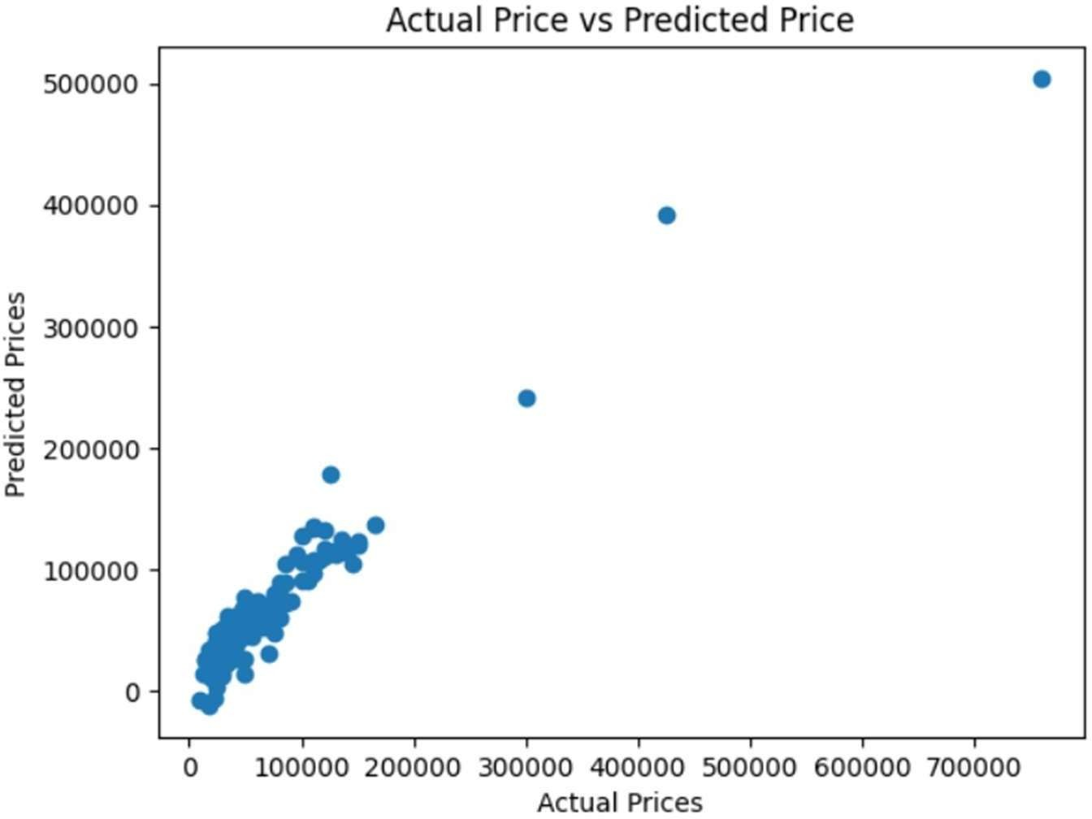

Fig. 3.1: Actual Prices vs Predicted Prices

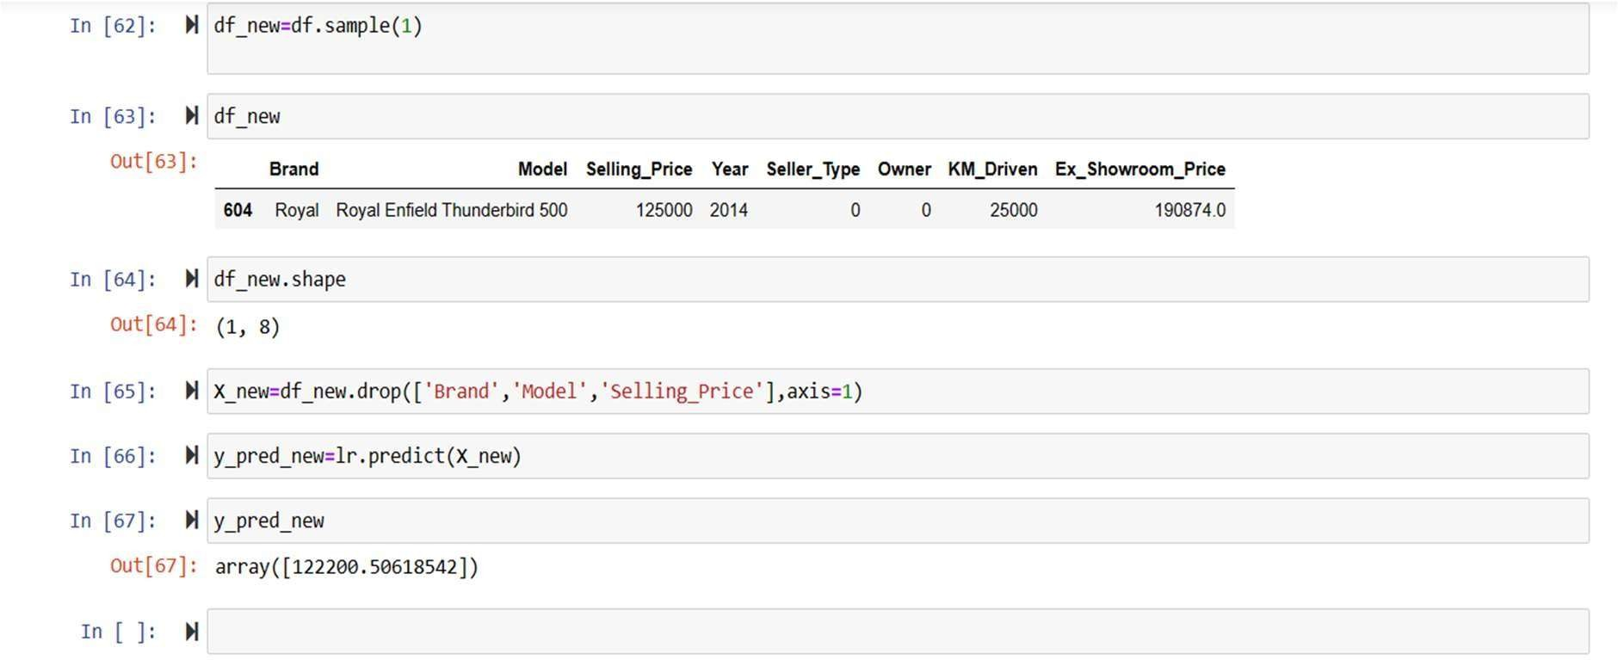

Fig. 3.2: Price Predictor

Dept. of CSE, DSATM 2022-23 Page 5

# CHAPTER 4

## REFLECTION NOTES

**CHAPTER 4**

**REFLECTION NOTES**

#### EXECUTIVE SUMMARY

This internship and project has been made based on the understanding of various concepts related to artificial intelligence and machine learning. Different machine learning algorithms were used in order to implement this predictive analysis model. I have understood the various types of regressions, different libraries of python used exclusively for the machine learning and I have also understood the importance of python programming language in the field of machine learning and data science. After the creation of the predictive model we have also deployed the model in the form of a web site so as to help the users to interact with the model easily. I have gained new experiences and have learnt many technical and soft skills which will definitely help in working in the corporate in a long run. This internship provided me a way to get the hands-on experiences of what was taught theoretically.

###### HARDWARE REQUIREMENTS

* + Processor: Intel core i5 or higher
  + RAM size: 8GB
  + GPU: 4GB
  + Disk-Space: 10GB

###### SOFTWARE REQUIREMENTS

* + Operating System: Windows 10
  + Platform: JUPYTER Notebook
  + Languages Used: Python
  + Domain: Machine Learning
  + Backend: Python and its various libraries like NumPy, Pandas, SKLearn.

Dept. of CSE, DSATM 2022-23 Page 6

###### SYSTEM DESIGN

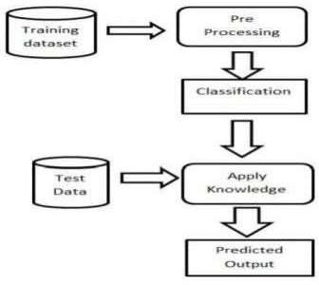

Fig 4.1 System Architecture

* + - * Data collection and preprocessing: This involves collecting data on used bikes, such as the make and model, year of manufacture, mileage, condition, and location, and cleaning and transforming the data so that it can be used for modeling.
      * Feature engineering: This involves selecting and creating features that are likely to be predictive of the price of a used bike. For example, features such as the make and model, age of the bike, mileage, and condition could be used.

##### Model selection: This involves selecting a machine learning algorithm that is suitable for predicting the price of used bikes. Commonly used algorithms include linear regression, decision trees, random forests, and gradient boosting machines.

* + - * Model training: This involves using the selected algorithm to learn the relationship between the features and the target variable (the price of the bike) using a training dataset.

##### Model evaluation: This involves evaluating the performance of the model using a separate validation dataset. Common metrics used for evaluation include mean squared error, root mean squared error, and R-squared.

Dept. of CSE, DSATM 2022-23 Page 7

#### TECHNICAL EXPERIENCE

Technical skills which are required for completion this project is

* Machine Learning:

ML is one of the main technical aspects of this project where the entire project runs on ML and its concepts.

* Datasets knowledge:

Bulk number of datasets are required to achieve efficiency and accurate results.

* Basic and most important libraries:

Libraries which integrate with ML are required to be included in project.

* Exploring the Data types:

Datasets which contains the information of hotel bookings and cancellations are required and large number of datasets make more accuracy results.

###### LINEAR REGRESSION MODEL

To build a model of this predictive analysis, we make use of random Linear Regression method. Linear regression is a statistical method used to model the relationship between a dependent variable and one or more independent variables. It assumes a linear relationship between the variables, meaning that a change in one variable is associated with a proportional change in the other variable. Linear regression is often used for prediction and can be used to identify the strength and direction of the relationship between variables.

Dept. of CSE, DSATM 2022-23 Page 8

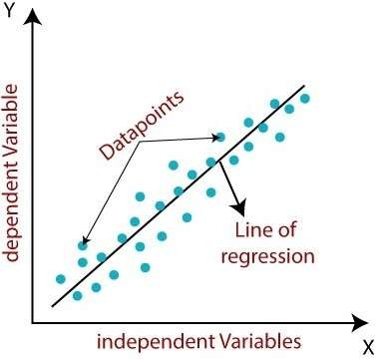

Fig 4.2:Linear Regression

#### SOFT SKILLS

* Communication: You will likely develop your communication skills as you interact with colleagues, clients, and supervisors. Effective communication can help you build relationships, convey your ideas clearly, and collaborate effectively with others.
* Adaptability: During your internship, you may be exposed to new tasks and challenges that require you to adapt quickly. This can help you develop your adaptability and flexibility skills, which can be valuable in any work environment.
* Time management: Internships often require you to juggle multiple tasks and responsibilities. Developing good time management skills can help you prioritize your work and meet deadlines.
* Problem-solving: As you encounter obstacles or challenges during your internship, you may learn how to solve problems creatively and efficiently.
* Professionalism: Internships provide an opportunity to develop professional skills, such as dressing appropriately, being punctual, and demonstrating a positive attitude.

Dept. of CSE, DSATM 2022-23 Page 9

### CONCLUSION

In conclusion, building a used bike price prediction model can be a valuable tool for buyers and sellers in the used bike market. The model can help sellers determine a fair asking price for their bike based on its characteristics and market trends, while buyers can use the model to ensure they are getting a fair deal.

However, it's important to note that the accuracy of the model depends on the quality of the data used to train it. Therefore, it's crucial to use a diverse and comprehensive dataset to ensure the model can make accurate predictions for a wide range of bikes.

Additionally, the model may need to be updated periodically to account for changes in the market or trends in bike sales. Overall, a well-built used bike price prediction model can be a valuable tool for anyone looking to buy or sell a used bike.

Dept. of CSE, DSATM 2022-23 Page 10

### REFERENCES

1. https://papers.ssrn.com/sol3/papers.cfm?abstract_id=3639177
2. https://[www.researchgate.net/publication/366407644_Price_Prediction_and_Classification_of_Us](http://www.researchgate.net/publication/366407644_Price_Prediction_and_Classification_of_Us) ed-Vehicles_Using_Supervised_Machine_Learning

Dept. of CSE, DSATM 2022-23 Page 11