電通二乙微處理器實驗 實驗結報

實驗名稱 | Lab03-類比輸入檔案
組別 |  | 組員 | 黃淳俊

- 實驗目的
使用USB-Serial作為輸入輸出
讀取類比輸入之數值

- 程式碼
int led = 7;
void setup() {
Serial.begin(9600);
Serial.print("Hello,World!\n");
pinMode(led, OUTPUT);
}

void loop() {
if (Serial.available()) {
char val = Serial.read();
if (val == '1') {
digitalWrite(led, HIGH);
Serial.print("led on\n");
}
else if (val == '0') {
digitalWrite(led, LOW);
Serial.print("led off\n");
}
}
}
float Analogin=0,Vin=0;
void setup() {
Serial.begin(9600);
}

void loop() {
for (int i=0;i<=5;i++)
Analogin = 0.7* Analogin + 0.3* analogRead(A0);
Vin = Analogin * 2.5 / 4095;
Serial.println(Vin);
delay(200);
}
int i;
void setup() {
Serial.begin(9600);
}

void loop() {
float sensorVoltage, sensorValue, R1;
for (i = 0; i <= 5; i++)
{

sensorValue = 0.7 * sensorValue + 0.3 * analogRead(A1);
}

sensorVoltage = sensorValue * 2.5 / 4095;

R1 = sensorVoltage * (3300) / 2.5;

//Serial.println(R1);
Serial.println(R1);
delay(100);
}
float r2=1017300;
void setup() {
// put your setup code here, to run once:
Serial.begin(9600);
}
void loop() {
// put your main code here, to run repeatedly:
float Analogin,sensorValue,sensorVoltage,ResisterValue;
float R1;

for (int i=0;i<=5;i++)
{
sensorValue = 0.7* sensorValue + 0.3* analogRead(A0);

Serial.println(analogRead(A0));
}

sensorVoltage = sensorValue *2.5 / 4095;
R1 = sensorVoltage * r2 / 2.5;

Serial.println(sensorVoltage);
Serial.println(sensorValue);
Serial.println(R1);
delay(1000);
}

- 實驗結果及分析

CHECK POINT1
PC輸入 | SerialMonitor 輸出 | LED 狀態
0 | 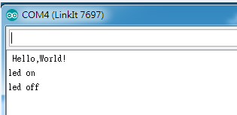 | 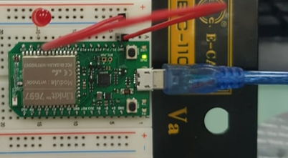
1 |  | 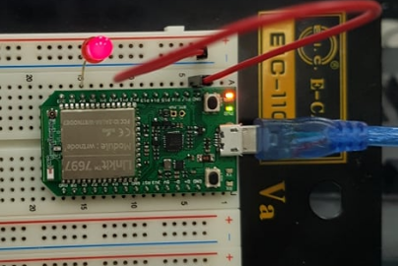

CHECK POINT 2
實際電壓 | AnalogRead讀質 | 推測電壓
0 | 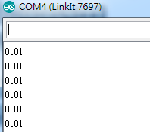 | 0
0.5 | 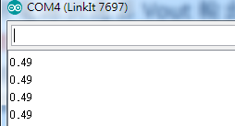 | 0.5
1 | 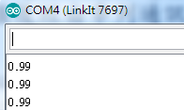 | 1
1.5 | 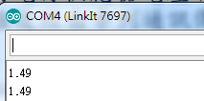 | 1.5
2 | 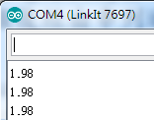 | 2
2.5 | 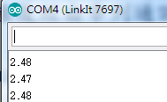 | 2.5

CHECK POINT 3

可變電阻  測量值 | AnalogRead  讀值 | 推測電壓  (V) | 推測電阻值  (歐姆) | Serial Monitor輸出
10169 | 375 | 0.2V | 887.89 | 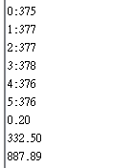
10169 | 4093 | 2.2 | 9643.8 | 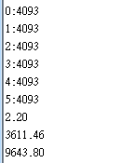
1001356 | 4 | 0.0 | 1137.06 | 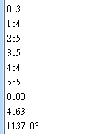
1001356 | 4093 | 2.2 | 886770.63 | 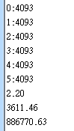
1017300 | 150 | 0.09 | 34775.53 | 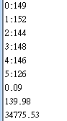
1017300 | 55 | 0.03 | 11811.97 | 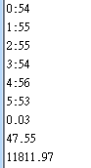

CHECK POINT 4
AnalogRead讀值 | 推測電壓(V) | 推測電阻值(歐姆) | SerialMonitor輸出
545 | 0.28 | 1515.79 | 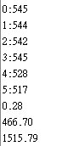
1560 | 0.80 | 4275.4 | 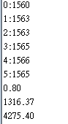
3567 | 1.93 | 10285.74 | 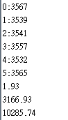

- 心得討論
這次實驗比較麻煩要量的東西很多 做不完，好幾天的放學都留下來做。

