電通二甲微處理器實驗 實驗結報

實驗名稱
組別 |  | 組員 | 黃淳俊

- 實驗目的
了解七段顯示器之顯示原理，共陰極與共陽極七段顯示器不同?如何控制四合一七段顯示器，如何讓四合一七段顯示器顯示四位數字
- 實驗步驟
Arduino接好四合一七段顯示器之電路，四合一七段顯示器每隔0.3秒跳一個數字，從0000->0059->0100->2359->0000。
於Pin按鍵，按下後歸零。
於Pin17按鍵，按下後倒數計時，放開後恢復正數
- 程式碼
Ch1
#include "SevSeg.h"
SevSeg sevseg;
int Hour = 0, Min = 1;
void setup() {
sevseg.setBrightness(90);
byte numdigits = 4;
byte digitPins[] = {2, 3, 4, 5};
byte segmentPins[] = {8, 9, 10, 11, 12, 13, 14, 15};
sevseg.begin (COMMON_CATHODE, numdigits, digitPins, segmentPins);

}
void loop() {
sevseg.setNumber(Hour * 100 + Min, 4);
Min = Min + 1;
if (Min == 60)
{
Min = 0;
if (Hour == 23)
Hour = 0;
else
Hour++;
}
for (int i = 0; i <= 541212; i++)
{
sevseg.refreshDisplay();
}
}

Ch2
#include "SevSeg.h"
SevSeg sevseg;
int Hour = 0, Min = 1, sw = 6;
void setup() {
sevseg.setBrightness(90);
byte numdigits = 4;
byte digitPins[] = {2, 3, 4, 5};
byte segmentPins[] = {8, 9, 10, 11, 12, 13, 14, 15};
sevseg.begin (COMMON_CATHODE, numdigits, digitPins, segmentPins);
pinMode(sw, INPUT);
}
void loop() {

if (digitalRead(6) == HIGH)
{
Hour = 0;
Min = 0;
sevseg.setNumber(Hour+Min, 4);
}

else
{
sevseg.setNumber(Hour * 100 + Min, 4);
Min = Min + 1;
if (Min == 60)
{
Min = 0;
if (Hour == 23)
Hour = 0;
else
Hour++;
}
}

for (int i = 0; i <= 541212; i++)
{
sevseg.refreshDisplay();
}
}
Ch3
#include "SevSeg.h"
SevSeg sevseg;
int Hour = 0, Min = 1, sw = 6, sw1 = 17, kkk = 9999, j = 0;
void setup() {
sevseg.setBrightness(90);
byte numdigits = 4;
byte digitPins[] = {2, 3, 4, 5};
byte segmentPins[] = {8, 9, 10, 11, 12, 13, 14, 15};
sevseg.begin (COMMON_CATHODE, numdigits, digitPins, segmentPins);
pinMode(sw, INPUT);
pinMode(sw1, INPUT);
}
void loop() {

if (digitalRead(6) == HIGH)
{
Hour = 0;
Min = 0;
}

else if (digitalRead(17) == HIGH)
{
Min = Min - 1;
if (Min == -1)
{
Min = 59;
if (Hour == -1)
Hour = 23;
else
Hour--;
}
}
else
{
Min = Min + 1;
if (Min == 60)
{
Min = 0;
if (Hour == 23)
Hour = 0;
else
Hour++;
}
}
sevseg.setNumber(Hour * 100 + Min, 4);

for (int i = 0; i <= 541212; i++)
{
sevseg.refreshDisplay();
}
}

- 實驗結果及分析
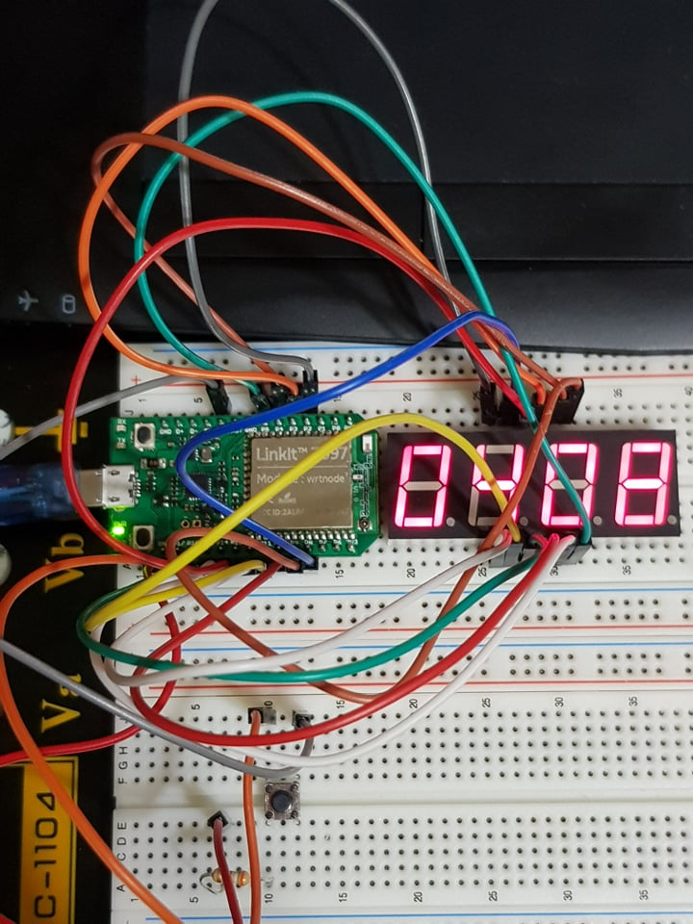

- 心得討論

我覺得這次的實驗滿好玩的，很多東西原本不懂講義上資訊也不多，但是自己從網路上找方法的學習還滿好玩，而且也可以訓練找資料的過程。

