電通二甲微處理器實驗 實驗結報

實驗名稱 | Lab06
組別 |  | 組員 | 黃淳俊

- 實驗目的
雲端平台，執行程式
例：Google App Engine、Amazon Web Services、Microsoft Azure
提供網頁介面，讓你「點按滑鼠」就能建立雲端程式
提供API程式存取介面
提供網頁介面，觀看與控制各種資料

- 實驗步驟
Prototype name：LED Manager (或自定)
Prototype version：1.0
Hardware platform：LinkIt Smart 7688 (MT7688)
Industry：自定
Application：自定

- 程式碼
Ch1
#include <LWiFi.h>
#include <WiFiClient.h>
#include "MCS.h"

// Assign AP ssid / password here
#define _SSID "fxxgg666"
#define _KEY "aa19990416"

// Assign device id / key of your test device
MCSDevice mcs("Dhr5FUu6", "gAJS50GsFtK3H72J");

// Assign channel id
// The test device should have 2 channel
// the first channel should be "Controller" - "On/Off"
// the secord channel should be "Display" - "On/Off"
MCSControllerOnOff led("123");
MCSDisplayOnOff remote("456");

#define LED_PIN 7

void setup() {
// setup Serial output at 9600
Serial.begin(9600);

// setup LED/Button pin
pinMode(LED_PIN, OUTPUT);

// setup Wifi connection
while(WL_CONNECTED != WiFi.status())
{
Serial.print("WiFi.begin(");
Serial.print(_SSID);
Serial.print(",");
Serial.print(_KEY);
Serial.println(")...");
WiFi.begin(_SSID, _KEY);
}
Serial.println("WiFi connected !!");

// setup MCS connection
mcs.addChannel(led);
mcs.addChannel(remote);
while(!mcs.connected())
{
Serial.println("MCS.connect()...");
mcs.connect();
}
Serial.println("MCS connected !!");

// read LED value from MCS server
while(!led.valid())
{
Serial.println("read LED value from MCS...");
led.value();
}
Serial.print("done, LED value = ");
Serial.println(led.value());
digitalWrite(LED_PIN, led.value() ? HIGH : LOW);
}

void loop() {
// call process() to allow background processing, add timeout to avoid high cpu usage
Serial.print("process(");
Serial.print(millis());
Serial.println(")");
mcs.process(100);

// updated flag will be cleared in process(), user must check it after process() call.
if(led.updated())
{
Serial.print("LED updated, new value = ");
Serial.println(led.value());
digitalWrite(LED_PIN, led.value() ? HIGH : LOW);
if(!remote.set(led.value()))
{
Serial.print("Failed to update remote");
Serial.println(remote.value());
}
}

// check if need to re-connect
while(!mcs.connected())
{
Serial.println("re-connect to MCS...");
mcs.connect();
if(mcs.connected())
Serial.println("MCS connected !!");
}
}

Ch2
#include <LWiFi.h>

#include <WiFiClient.h>

#include "MCS.h"

// Assign AP ssid / password here

#define _SSID "fxxgg666"

#define _KEY "aa19990416"

// Assign device id / key of your test device

MCSDevice mcs("DbxfPV4q", "nCOud22c00ogdPWb");

// Assign channel id

// The test device should have 2 channel

// the first channel should be "Controller" - "On/Off"

// the secord channel should be "Display" - "On/Off"

MCSControllerOnOff led("123");

MCSDisplayOnOff remote("456");

MCSDisplayInteger Temp("789");

#define LED_PIN 7

void setup() {

// setup Serial output at 9600

Serial.begin(9600);

// setup LED/Button pin

pinMode(LED_PIN, OUTPUT);

pinMode(A0,INPUT);

// setup Wifi connection

while(WL_CONNECTED != WiFi.status())

{

Serial.print("WiFi.begin(");

Serial.print(_SSID);

Serial.print(",");

Serial.print(_KEY);

Serial.println(")...");

WiFi.begin(_SSID, _KEY);

}

Serial.println("WiFi connected !!");

// setup MCS connection

mcs.addChannel(led);

mcs.addChannel(remote);

mcs.addChannel(Temp);

while(!mcs.connected())

{

Serial.println("MCS.connect()...");

mcs.connect();

}

Serial.println("MCS connected !!");

// read LED value from MCS server

while(!led.valid())

{

Serial.println("read LED value from MCS...");

led.value();

}

Serial.print("done, LED value = ");

Serial.println(led.value());

digitalWrite(LED_PIN, led.value() ? HIGH : LOW);

}

void loop() {

// call process() to allow background processing, add timeout to avoid high cpu usage

Serial.print("process(");

Serial.print(millis());

Serial.println(")");

mcs.process(100);

Temp.set(analogRead(A0));

if(!Temp.set(analogRead(A0)))

{

Serial.print("Failed to update remote");

Serial.println(Temp.value());

}

// updated flag will be cleared in process(), user must check it after process() call.

if(led.updated())

{

Serial.print("LED updated, new value = ");

Serial.println(led.value());

digitalWrite(LED_PIN, led.value() ? HIGH : LOW);

if(!remote.set(led.value()))

{

Serial.print("Failed to update remote");

Serial.println(remote.value());

}

}

// check if need to re-connect

while(!mcs.connected())

{

Serial.println("re-connect to MCS...");

mcs.connect();

if(mcs.connected())

Serial.println("MCS connected !!");

}

}

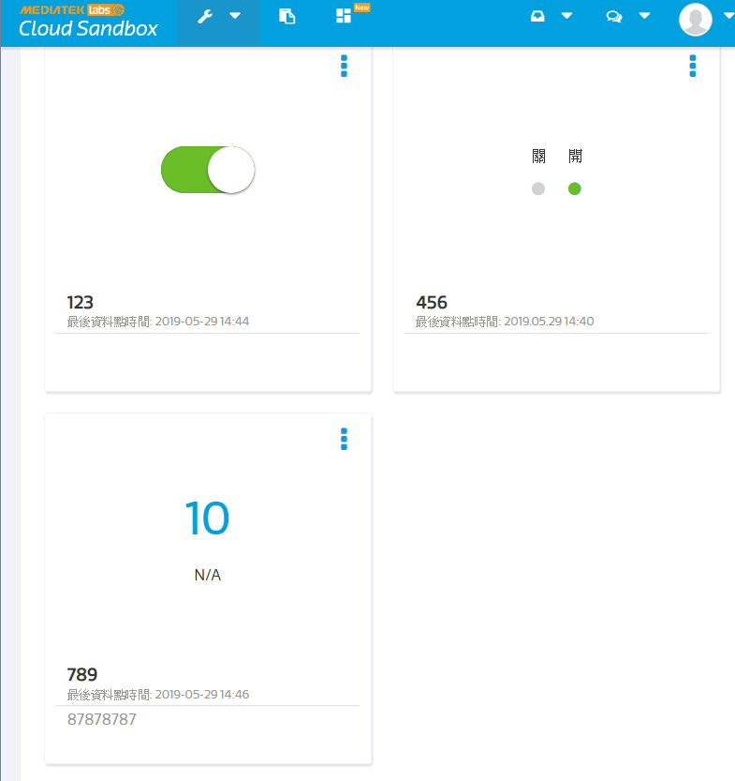
- 心得討論
用arduino發出聲音真的不太好聽，聽了很痛苦

