**Accessibility Conformance Test Report**

**Introduction**

This document outlines the results of two accessibility conformance tests conducted on my portfolio website using the WAVE tool. The first test was performed midway through development, and the second was conducted prior to submission. Both tests were aimed at ensuring the site conforms to **WCAG Level AA** standards.

**Test 1: Midway Through Development**

* **Purpose:** To identify early-stage accessibility issues and implement fixes before completing the website.
* **Findings:**
  1. **Missing Alternative Text:** Images across the site lacked alt attributes, which hindered accessibility for users relying on screen readers.
     + **Fix:** Added meaningful alt attributes to all images using alt="" for decorative images or descriptive text where necessary.
* **Screenshot:** Below the screenshots from the WAVE tool showcasing the errors identified during the first test:
* 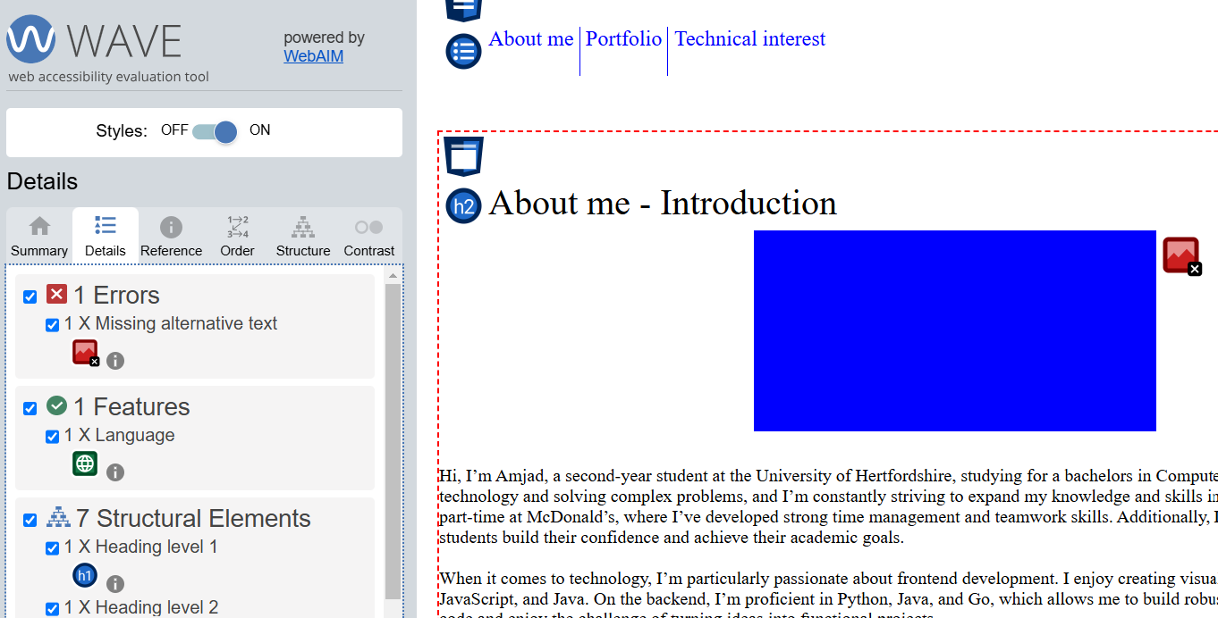
* 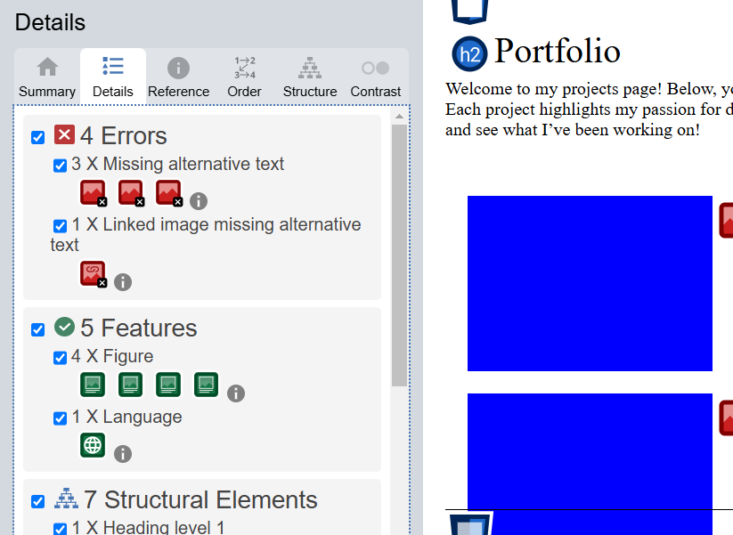
* 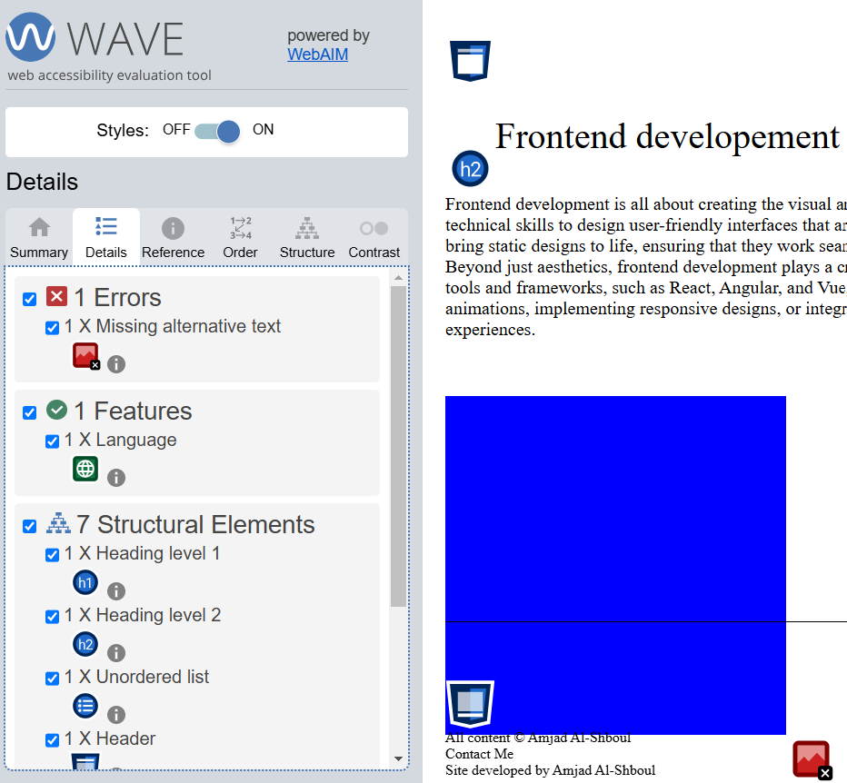
* 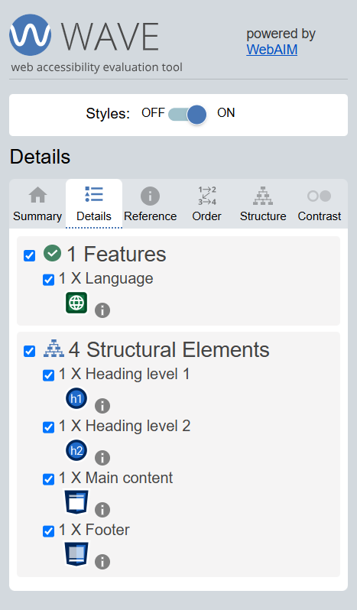
* **Actions Taken:**
  + Updated all <img> tags to include appropriate alt attributes.

**Test 2: Final Conformance Test**

* **Purpose:** To verify that all identified issues were resolved and the final site conforms to WCAG Level AA.
* **Findings:**
  1. **Missing Alternative Text:** All previous errors regarding missing alt attributes were resolved.
  2. **Color Contrast:** Verified that text and background colors across the site met the required contrast ratio.
  3. **Structure:** Confirmed that headings and structural elements followed logical and accessible hierarchy.
* **Screenshot:** Below the screenshots from the WAVE tool confirming that all errors were resolved:
* 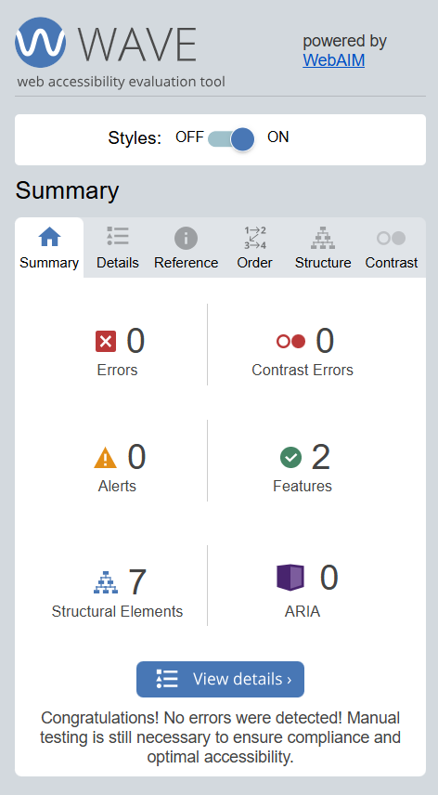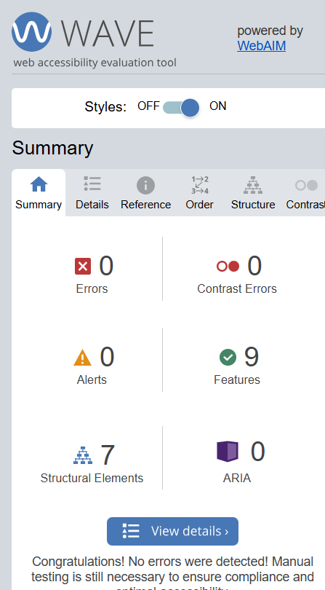
* 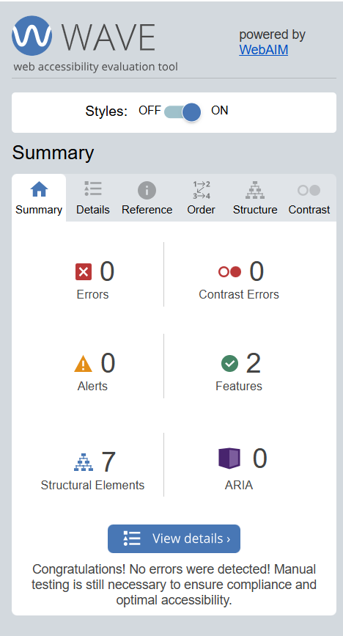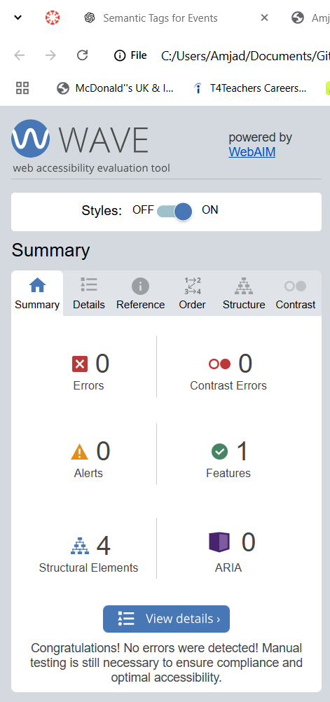

**Summary of Fixes Implemented**

* Added alt attributes to all <img> tags to ensure meaningful descriptions for images or mark decorative images with alt="".

**Conclusion**

The final accessibility conformance test confirmed that the portfolio website complies with WCAG Level AA standards. Screenshots from the WAVE tool demonstrate that all identified issues have been resolved, and no additional errors were found during the final evaluation. Further testing is recommended for future iterations to ensure continued compliance as the website evolves.